BULK RADIOACTIVE RESIDUALS FROM
CYCLOTRON DECOMMISSIONING IN THE
NETHERLANDS
An opportunity for recycling through conditional clearance

A.C. HENGEVELD
National Institute for Public Health and the Environment (RIVM)
Bilthoven, the Netherlands
Email: adriaan.hengeveld@rivm.nl

P.D.B.M. BEKHUIS
National Institute for Public Health and the Environment (RIVM)
Bilthoven, the Netherlands

Abstract

In the coming years and decades, growth in demand for PET radionuclides and associated growth in cyclotron commissioning and decommissioning activity is expected. Decommissioning of cyclotron facilities leads to the generation of radioactive waste in different shapes. In the context of ambitions toward a circular economy, it is important to know the activity concentrations in decommissioning residual material such that its fitness for recycling may be judged. One potential avenue toward recycling is conditional clearance. An inventory of radionuclide production cyclotrons in the Netherlands was made, along with an estimate of ‘activated mass’ of decommissioning waste per cyclotron. A literature study was performed in order to assess expected activity levels in cyclotron metals, bunker concrete and reinforcement steel after radionuclide production cyclotron decommissioning. These materials were all found likely to qualify for conditional clearance after five years post-shutdown. Applied to the Dutch situation, conditional clearance could lead to recycling of five to seven metric kilotons of cyclotron decommissioning material that would otherwise have to be stored in a conventional radioactive waste storage facility.

INTRODUCTION
Cyclotron-manufactured radionuclides play a significant role in modern nuclear medicine. The number of PET-scans performed in the Netherlands has risen by 75% since 1991 [1] and is expected to rise further both domestically and worldwide [2, 3]. Increasing demand of cyclotron-produced radionuclides will likely – at least in part – be met by modernization of cyclotron facilities, replacing machines by newer models that have higher production output. Cyclotron facilities that were commissioned thirty to forty years ago are likely nearing the end of their economic lifespan. Both factors combine to outline a context where decommissioning of cyclotron facilities is expected to be a growing concern in the coming years [4].
As a by-product of cyclotron operation, nearby material is expected to be radiologically activated. This includes the machine itself, as well as the concrete bunker that generally surrounds cyclotrons. Residual cyclotron decommissioning materials – ‘residuals’ hereafter - may be activated in a range of multiple orders of magnitude, depending on a variety of factors. Activation is achieved by irradiation of materials by either primary or secondary particles.
Primary particles in radionuclide-producing cyclotrons are usually protons that are accelerated to an energy where a nuclear interaction with a target is favorable. On the way to the target, primary particles may be lost through interaction with cyclotron components such as the vacuum chamber or attenuators. Protons can interact with different metals such as steel or copper to produce a host of exotic radionuclides that are mostly short-lived (T_{1/2} < 30 days). In these reactions, secondary particles such as neutrons can also be created. These can in turn activate nearby material. In the cyclotron components that experience primary (proton) activation, activities are generally high, but the quantity of activated material is low.
If primary particles are not lost on the way, nuclear reactions are triggered in the cyclotron targets, generating the desired radionuclides. In this reaction, secondary particles are usually created that can also activate surrounding materials. The most popular reaction for the production of ¹⁸F is an example: ¹⁵O (p,n) ¹⁸ F. Neutrons that are generated in either the cyclotron machine or in the targets can activate material in the environment to a much greater distance than beam loss protons, leading to a higher quantity of material that is however activated to a lesser degree. Half-lives of neutron activated nuclides can be very short, however certain neutron activation products in steel, copper, and concrete have half-lives on the order of years to decades. These activated residuals – which are present in bulk quantities - can constitute a challenge in terms of radioactive waste management for cyclotron decommissioning projects.
This paper attempts to clarify what quantities of radioactive bulk residuals to expect from cyclotron decommissioning, as well as the expected radioactivity content of these residuals. A preliminary assessment is made whether these materials may qualify for conditional clearance such that they may be recycled under conditions where the radiological risks to individuals caused by the practice are sufficiently low [5]. Finally, options for reduced generation of radioactive waste in the future are given.

MATERIALS AND METHODS
A literature search was performed in PubMed utilizing the search terms ‘decommissioning accelerator’ and ‘decommissioning cyclotron’. The resulting bibliography was searched for information on activity concentrations in residuals. Technical information and characteristics of international cyclotrons that was relevant to the activation of decommissioning residuals was recorded from these sources. The number of isotope production cyclotrons in the Netherlands, as well as their characteristics and technical information was obtained from permits, as well as online information and communication with cyclotron operators. Cyclotrons with a maximum proton energy of less than 8 MeV were not included in the analysis; these do not require a decommissioning plan as per Dutch law [6].
The resulting information was used to group cyclotrons in three categories (A, B, and C) based on the dominant physical process of radionuclide production (represented by accelerated proton energy E_{p}) and expected volume of activated bulk residual material. Moreover, cyclotrons belonging to category C were divided in two types based on the construction period of the facility. Where available, typical on-target beam current was recorded.
Bulk residual material was defined as residual material with a mass of above one thousand kilograms. Activated bulk residual material was estimated to be composed of material from the cyclotron machine itself and from the concrete walls, ceiling and floor of the cyclotron bunker and (potentially) target bunkers. Additionally, metal reinforcement bars present in walls and floors may be activated and must therefore be taken into account. Activated mass was estimated for all types of cyclotron bunker facility corresponding to the three different cyclotron categories.
The cyclotron machine component of the activated mass was estimated on the basis of cyclotron characteristics and dimensions, as obtained from manufacturers [7-10]. A simplification was made by estimating a contribution of ninety percent of the total cyclotron mass to be due to the magnet yokes, with the remaining ten percent estimated due to the magnet coils. The complete mass of the cyclotron machine was assumed to be activated.
Activated mass of bunker concrete was estimated assuming bunker dimensions as obtained from manufacturers for two of the cyclotron facility types corresponding to cyclotron categories A and B. For the two types of category C, dimensions of two Dutch sites visited by the authors were taken to be representative. Activation of concrete is limited to the inner 50 centimeters in cyclotron (and target) bunkers [11]. For all cyclotron categories, activated mass was calculated as this inner shell with corresponding dimensions, with concrete assumed to be ordinary (Portland) concrete with a density of 2350 kg/m³.
Activated mass of reinforcement steel was estimated as 2.5 % of activated mass of concrete. This number was modified from a study [12] to reflect Dutch facilities, where use of a single reinforcement mat in the activated 50 cm layer is common. For cyclotrons in category A, reinforcement steel is generally not present.
Activity concentration in materials was obtained from the literature. Where possible, average activity concentration for a material was calculated per cyclotron facility. When only single values were given for a material in the facility as a whole, these were assumed to be representative for the full activated mass of that material. Activity concentration numbers were scaled back to the year of end of cyclotron operation, as well as to the fifth year post-shutdown. Activity concentration was recorded or calculated for ‘relevant radionuclides’, which were defined for the study to be those that have a half-life greater than thirty days and of which measured activity concentrations were reported multiple times (more than once) in the literature. Reinforcement steel formed an exception to this rule as only one study reporting activity concentrations for reinforcement steel was found.
The method employed for the classification for clearance is analogous to the procedure for clearance as stipulated by Dutch legislation [13]. For every cyclotron facility, relevant radionuclides’ activity concentrations were weighted by nuclide-specific clearance levels and summed to combine into a single-valued weighted sum of activity concentrations (henceforth ‘clearance factor’) for each of the materials. Following the same legislation, material qualifies for generic clearance with a clearance factor below 1. Based on the clearance factor, the material of each cyclotron was grouped into three classes: class I, where the clearance factor is below 1, class II, where the clearance factor is above 1 but below 100, and class III, where the clearance factor is above 100. Class II materials were assumed to potentially qualify for conditional clearance.
The material classification was used to identify whether the activated mass could qualify for conditional clearance, thus being ‘saved’ from the generic radioactive waste disposal routes. This was done for a single cyclotron in every category as defined in the paper, as well as for the full cyclotron inventory of the Netherlands.

RESULTS
Three cyclotron categories were defined: cyclotrons in category A are those with a maximum proton energy of less than 18 MeV (though usually in the range of 11-14 MeV) that are equipped with self-shielding on the machine. Cyclotrons in category A are used for production of ¹⁸F, but they are also used for ¹¹C, ¹³N, and ¹⁵O. Three cyclotrons in category A were found to be present in the Netherlands. Category B was defined as containing cyclotrons with a maximum proton energy of 18 MeV that have no self-shielding on the machine. These are the most popular cyclotrons for production of ¹⁸F, counting six cyclotrons in the Netherlands. Category C was defined as containing cyclotron with a maximum proton energy of 30 MeV. Cyclotrons in category C are generally used to produce predominantly ¹²³I. These cyclotrons are equipped with separate bunkers for the irradiation targets. Category C was further divided into two types: older models (from before 1990) are generally larger than newer models: both the mass of the cyclotron machine itself as well as the mass of the material constituting the cyclotron and target bunkers are substantially higher. Typical on-target beam currents for the three cyclotron categories are shown in Figure 1.

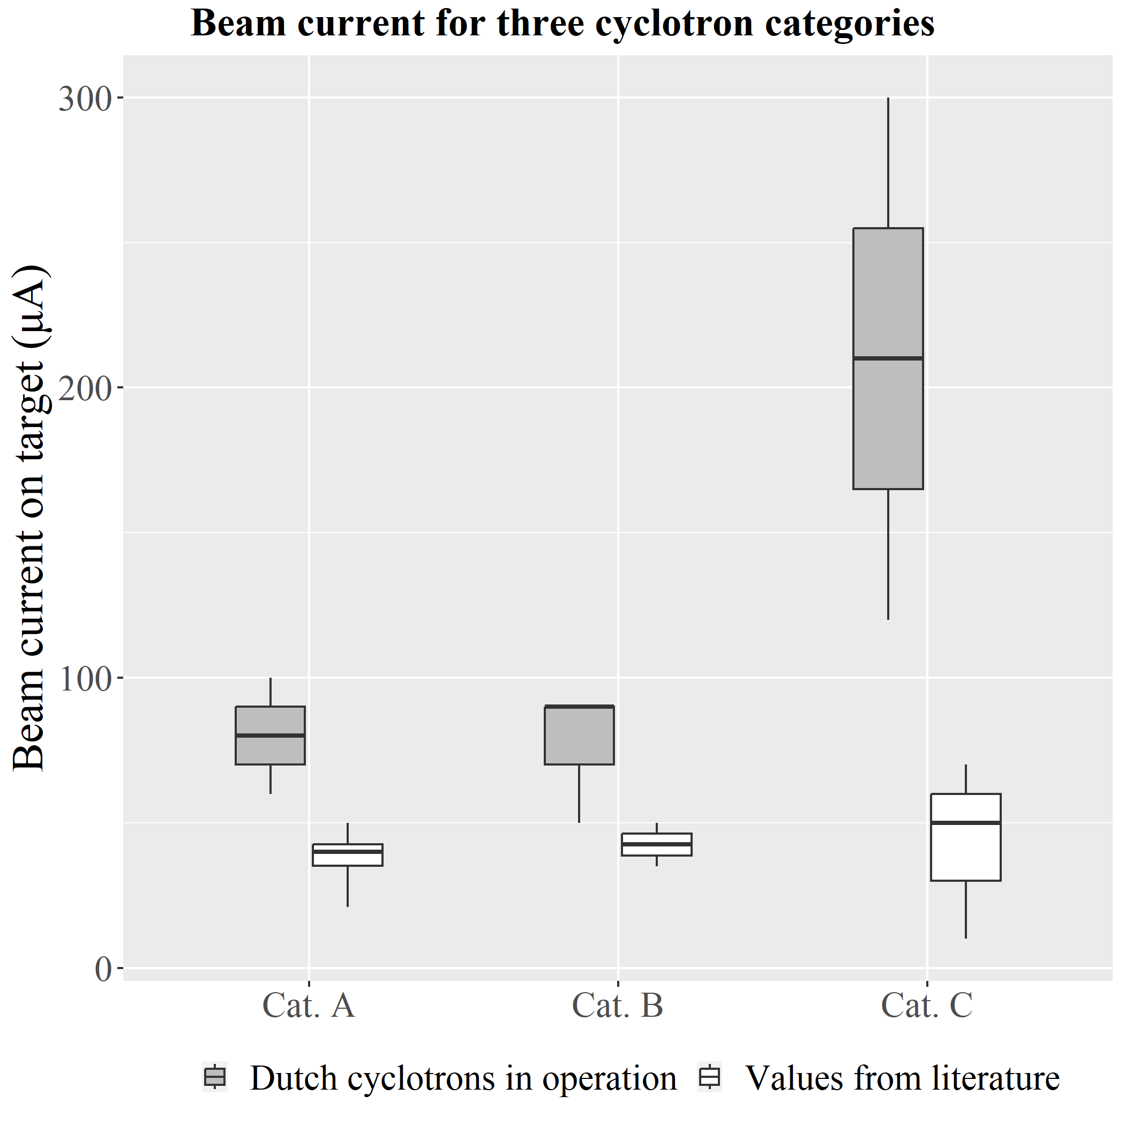
FIG. 1. Typical beam current on target for three categories of isotope production cyclotrons. The beam current is the cyclotron-specific, typically used instantaneous beam current, shown only for what is assumed to be the dominant production reaction: the production of ¹⁸F for cyclotron categories A and B, and the production of ¹²³I for category C.

Estimated activated mass for all cyclotron categories are given in Table 1. Three category C cyclotrons are in operation in the Netherlands, and there are two that have been inactive for many years.

TABLE 1. ACTIVATED MASS PER CYCLOTRON FOR THREE CYCLOTRON CATEGORIES

Cyclotron category | Metal (10³ kg) | Self-shielding (10³ kg) | Concrete (10³ kg) | Reinforcement (10³ kg)
A | 10 - 20 | 0 - 50 | 160 - 310 | 0
B | 20 | 0 | 110 | 3
C – old | 100 | 0 | 1400 | 35
C – modern | 50 | 0 | 600 | 15

Relevant radionuclides were identified per type of waste material. In metals belonging to the cyclotron machine, ⁵⁴Mn, ⁶⁰Co, and ⁶³Ni were identified as relevant radionuclides. In bunker concrete, the relevant radionuclides were found to consist of ⁵⁴Mn, ⁶⁰Co, and ¹³⁴Cs, ¹⁵²Eu, and ¹⁵⁴Eu. Relevant radionuclides in reinforcement steel were ⁵⁴Mn and ⁶⁰Co. The clearance levels – as obtained from the Dutch legislation - for the relevant radionuclides are shown in Table 2.

TABLE 2. CLEARANCE LEVELS OF RELEVANT RADIONUCLIDES

Radionuclide | Clearance level (kBq/kg) | Present in materials
⁵⁴Mn | 1.00 10⁻¹ | Metals, concrete, reinforcement
⁶⁰Co | 1.00 10⁻¹ | Metals, concrete, reinforcement
⁶³Ni | 1.00 10² | Metals
¹³⁴Cs | 1.00 10⁻¹ | Concrete
¹⁵²Eu | 1.00 10⁻¹ | Concrete
¹⁵⁴Eu | 1.00 10⁻¹ | Concrete

Activity concentrations in metals are shown in Table 3. In cases where the reference is followed by a bold number, we refer to different cyclotrons that were reported on in the same reference. Not all references have reported activity concentration values on all relevant radionuclides; in those cases, entries in the table were left blank.

TABLE 3. ACTIVITY CONCENTRATIONS IN METALS, 0 YEARS AFTER CYCLOTRON STOP

Cyclotron category | Reference | ⁵⁴Mn activity (kBq/kg) | ⁶⁰Co activity (kBq/kg) | ⁶³Ni activity (kBq/kg)
A | [14] |  | 0 | 1
A | [15] 1 | 5 | 1
A | [16] | 9 | 2 | 30
B | [15] 2 | 0.8 | 1
B | [17] |  | 3 | 10
C | [18] | 10 | 2

Activity concentrations in concrete are shown in Table 4. In reference [19], two different cyclotrons were reported on. In reference [12], the bold number refers to different values for the cyclotron bunker (1) and the target bunker (2). Not all references have reported activity concentration values on all relevant radionuclides; in those cases, entries in the table were left blank.

TABLE 4. ACTIVITY CONCENTRATIONS IN CONCRETE, 0 YEARS AFTER CYCLOTRON STOP

Cyclotron category | Reference | ⁵⁴Mn activity (kBq/kg) | ⁶⁰Co activity (kBq/kg) | ¹³⁴Cs activity (kBq/kg) | ¹⁵²Eu activity (kBq/kg) | ¹⁵⁴Eu activity (kBq/kg)
A | [14] | 1 10⁻² | 4 10⁻² |  | 7 10⁻² | 8 10⁻³
A | [19] 1 | 5 10⁻⁴ | 5 10⁻² | 9 10⁻⁴ | 2 10⁻²
A | [20] |  | 2 10⁻² |  | 2 10⁻²
B | [21] | 2 10⁻² | 7 10⁻² | 5 10⁻³ | 8 10⁻² | 1 10⁻²
C | [11] | 8 10⁻³ | 5 10⁻² | 2 10⁻³ | 5 10⁻² | 3 10⁻³
C | [12] 1 |  | 1 10⁻¹ |  | 3 10⁻¹
C | [12] 2 |  | 2 |  | 3
C | [19] 2 |  | 5 10⁻² | 2 10⁻² | 8 10⁻²

Activity concentrations in reinforcement steel were only found for category C cyclotrons and comprised of 1 kBq/kg of ⁵⁴Mn, and 10 kBq/kg of ⁶⁰Co, both at zero years post-shutdown. The corresponding clearance factor for the three cyclotron categories is shown in Figure 2. Clearance factors are below 100 (class II or under) for metals at five years post-shutdown, and for concrete from zero years post-shutdown. Reinforcement steel was found to have a clearance factor of 156 at zero years after shutdown, and 74 at five years after shutdown. With clearance factors < 100 for all materials, all activated mass (as detailed in Table 1) is likely to qualify for conditional clearance at five years after shutdown.

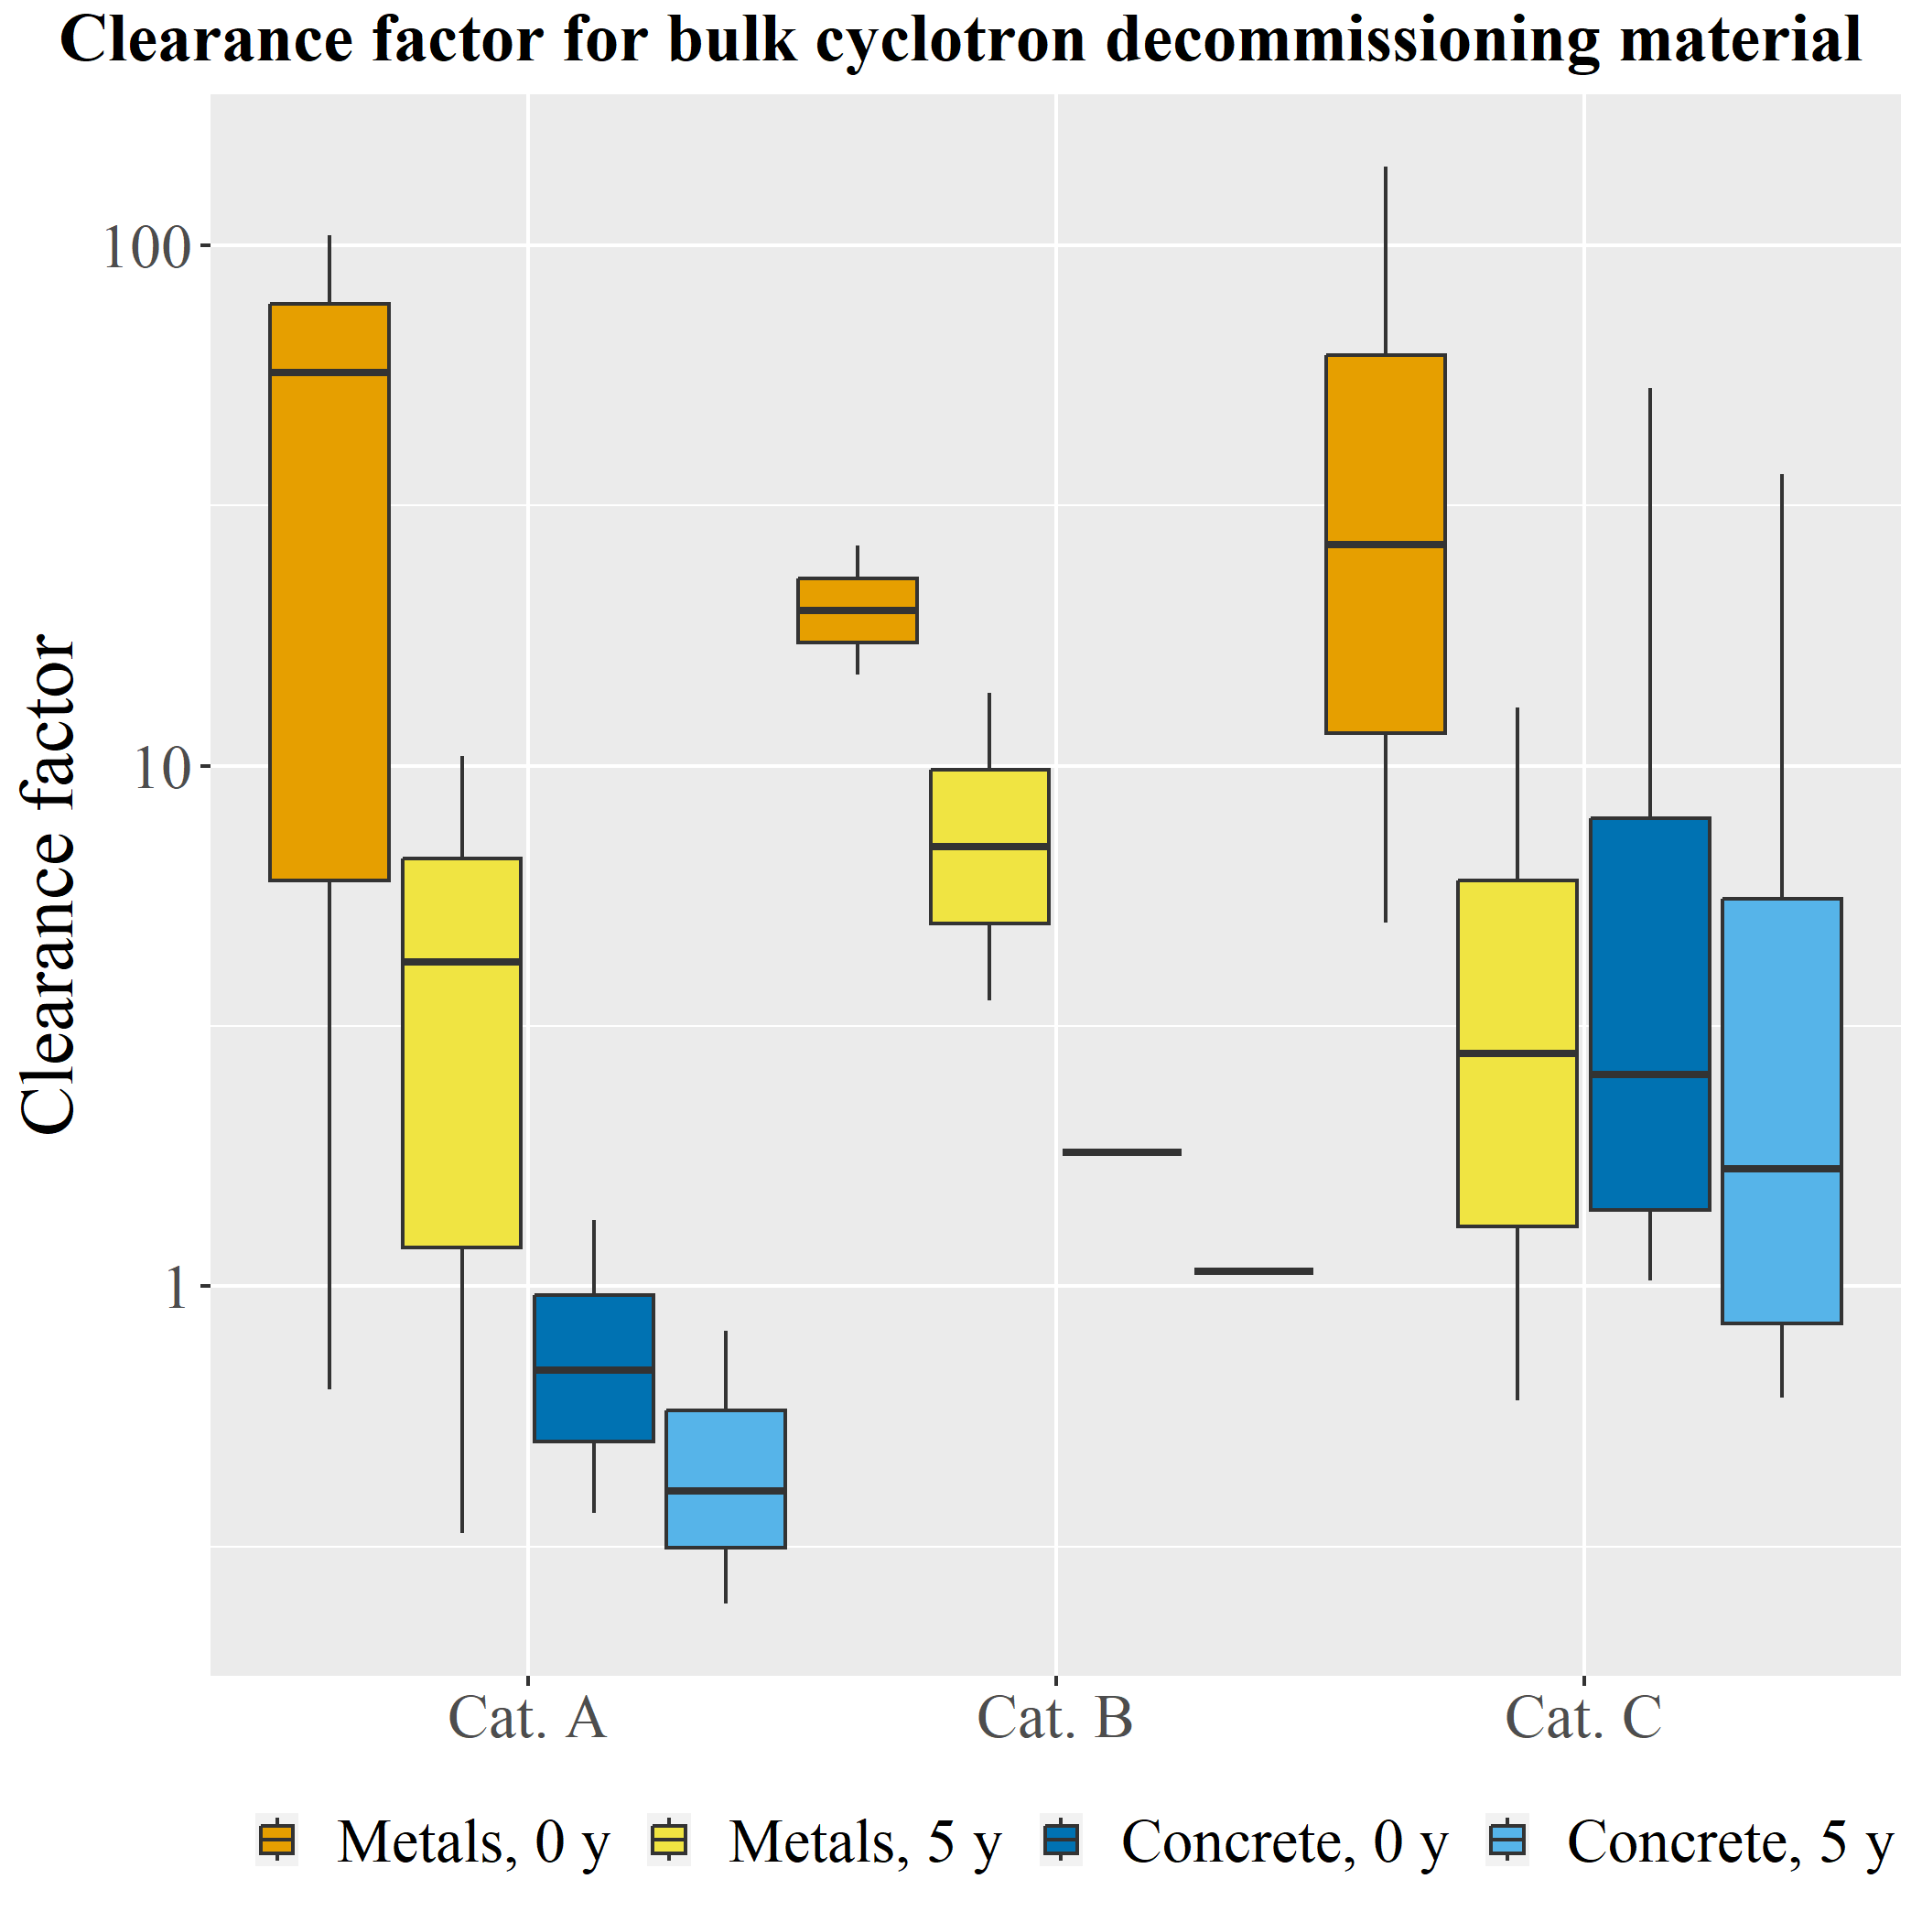
FIG. 2. Clearance factor in bulk cyclotron decommissioning residuals. The clearance factor is a weighted sum of relevant radionuclide activity concentrations. It was calculated for metals originating from the cyclotron machine, as well as bunker concrete, for three cyclotron categories. These quantities were calculated for the time at cyclotron shutdown (t = 0 y), as well as five years post-shutdown (t = 5 y).

DISCUSSION
Cyclotron facilities tend to differ on an individual basis in many if not all of the technical aspects relevant to activation of bulk material. Dimensions of bunkers, dominant reaction patterns, operational time, and on-target beam currents are some of the characteristics that exhibit variation. In this paper, the choice was made to divide cyclotrons into four types under three categories in order to give more specific indicative ranges of expected radioactive bulk residuals. The assumption that all cyclotrons used for radionuclide production have shared similar operational time characteristics due to the need for economic feasibility is likely unrealistic. The paucity of (internationally available) data has made it impossible to investigate the relationship between operational time and quantity of radioactive bulk residuals. Indeed, it is clear that information is scarce and in most cases more than a decade old. To improve estimates of radioactive bulk residual quantities, those involved in cyclotron decommissioning projects should share the results of their radiological characterization studies with the wider scientific and professional community.
An aspect in which the age of available information may play a negative role in the quality of the analysis is on-target beam current. Improvements in technology have led to cyclotrons being operated at higher average beam currents over the years [22]. The number of secondary neutrons generated during cyclotron operation is generally proportionate to the number of colliding protons and thereby to the on-target beam current. Radiological characterization of facilities run under modern beam-current conditions is necessary to potentially affirm the conclusions of this paper.
Activation of materials around cyclotrons is generally not homogeneous; hot and cold spots are expected. In decommissioning and recycling practice, it is difficult to separate material from different zones. As we have therefore assumed that the material will be mixed after melting (metals) or granulation (concrete), the average activity over the complete bunker should be a representative quantity. It is however possible that in some sources bias exists in the measurement campaigns for radiological characterization of cyclotrons and bunkers. An example would be that only those spots that previous measurements or operational knowledge had uncovered as high-dose spots were measured and reported on. If that is the case, average activity concentrations over the full range of activated mass could be lower, thus increasing the likelihood that conditional clearance might be possible.
The extent to which bulk residual materials (particularly those predicted in this paper to be in class II) qualify for conditional clearance is a choice that must be made on a case-by-case basis as a part of the regulations. For every cyclotron decommissioning project, exposure scenarios and resultant dose to members of the public and potentially to employees must be calculated for the specific type of post-clearance usage of materials, incorporating the activity of the material respective to that particular cyclotron decommissioning project.
The cost of conventional radioactive waste storage of the estimated amount of cyclotron decommissioning waste was projected for the Dutch situation according to the cost profiles discussed in [23]. A financial commitment of 35 to 50 million euros for radioactive waste storage was identified that could thus be avoided through the application of conditional clearance for these materials. It should be noted that such a cost estimation is highly time-dependent and likely will not be representative in a few years’ time.
It should be clear that this paper cannot be thought of as a reference for claims that all bulk cyclotron decommissioning residuals qualify for conditional clearance. This paper’s results do indicate, however, that there is potential for conditional clearance of residuals in most cyclotron decommissioning projects. Conditional clearance can work for removal and for recycling or reuse of materials, constituting a potential avenue to implement circular economy goals. Due to the half-lives of the most crucial radionuclides (⁶⁰Co, ¹⁵²Eu) a multiple-life-cycle process should pose no concern. A possibility like foundations for windmills seems feasible but other destinations may also be suitable. With the implementation of recycling, resources may be saved in the generation of new materials, as well as in financial and spatial provisions for storage of this radioactive waste. With a holistic view of public health, benefits outside of radiological effects would likely result from decreased mining or other resource generating processes [24]. It is up to scientists and policymakers to provide exposure scenarios and dose criteria, as well as up-to-date radiological characterization of cyclotron decommissioning materials to enable these developments.

CONCLUSION
When dismantling cyclotrons and their bunkers, five years post shutdown, the activity concentrations in metal bulk residuals, concrete and reinforcement steel appear to be well below 100 times the clearance level. The materials are therefore likely to qualify for conditional clearance. Our results indicate that bulk residue from dismantling cyclotrons (bunkers), after conditional clearance, can in most cases be recycled under specific conditions, complying with the safety levels for humans and the environment. Recycling can prevent the storage of a total of 5 to 7 metric kilotons of radioactive waste in the Netherlands. We recommend to scientists and policymakers that the possibility for conditional clearance for such materials should be further explored. This should be done such as to promote the likelihood that these materials are not wasted, and that funds and resources are not disproportionately used for standard types of radioactive materials storage in the case of cyclotron decommissioning.
With new cyclotrons to be built, a sustainable building construction needs to be considered. When designing for disassembly, so-called 'low activatable' materials can be used in the construction of both the cyclotron and the bunker, and reinforcement steel in the inner 50 centimeters of the walls can be omitted. In addition, walls can be built in such a way that the inner 50 centimeters of the concrete can be easily separated from the rest of the concrete.
References
- RIVM, Trend in het Aantal Nucleair Geneeskundige Onderzoeken (2023),
https://www.rivm.nl/medische-stralingstoepassingen/trends-en-stand-van-zaken/diagnostiek/nucleaire-geneeskunde/trend-in-aantal-nucleair-geneeskundige-onderzoeken
- Boudewijns, L., De Waard, I., Recente Ontwikkelingen in Medische Stralingstoepassingen, RIVM, Bilthoven (2019).
- Schmor, P., “Review of cyclotrons used in the production of medical isotopes for biomedical applications”, CYCLOTRONS 2010 (Lanzhou, 2010), Reviews of Accelerator Science and Technology: Volume 4 (2011).
- SCK-CEN, Vijf Belgische Bedrijven Richten CYCLADE op: Expertisecentrum voor de Ontmanteling van Versnellers en Cyclotrons (2023),
https://www.sckcen.be/nl/nieuws/vijf-belgische-bedrijven-richten-cyclade-op-expertisecentrum-voor-de-ontmanteling-van-versnellers-en-cyclotrons
- Basic Safety Standards, article VII.3.a, Euratom 2013/59, European Council (2013)
- Besluit basisveiligheidsnormen stralingsbescherming, article 10.8, Staatsblad van het Koninkrijk der Nederlanden, Den Haag (2017).
- IBA, Cyclone 30 Brochure (2010),
https://www.iba-radiopharmasolutions.com/brochures/
- IBA, Cyclone KEY Brochure (2022),
https://www.iba-radiopharmasolutions.com/brochures/
- IBA, Cyclone KIUBE Brochure (2022),
https://www.iba-radiopharmasolutions.com/brochures/
- NRC, ECLIPSE_Cyclotron_Concise_Tech_Specs – Radioisotope Production System. (2011),
https://www.nrc.gov/docs/ML1930/ML19303A779.pdf
- Kimura, K., et al, Residual long-lived radioactivity distribution in the inner concrete wall of a cyclotron vault, Health Phys. 67 6 (1994) 621-631.
- Vrije Universiteit Brussel, Evaluation of the radiological and economic consequences of decommissioning particle accelerators, European Commission, Luxembourg (1999).
- Besluit basisveiligheidsnormen stralingsbescherming, article 3.7.2, Staatsblad van het Koninkrijk der Nederlanden, Den Haag (2017).
- Calandrino, R., et al, Decommissioning procedures fora n 11 MeV self-shielded medical cyclotron after 16 years of working time, Health Phys. 90 6 (2006) 588-596.
- Toyoda, A., et al, Evaluation of induced activity in various components of a PET-cyclotron, J. Phys.: Conf. Ser. 1046 012017 (2018) 1-9.
- Calandrino, R., et al, Decommissioning procedure and induced activation levels, calculations and measurements in an 18 MeV medical cyclotron, J. Rad. Prot. 41 (2021) 1344-1365.
- Bonvin, V., et al, Detailed study of the distribution of activation inside the magnet coils of a compact PET cyclotron, Appl. Radiat. Isot. 168 109446 (2021) 1-13.
- University of Chicago, Building 211 Cyclotron characterization survey report, Argonne National Laboratory (1998).
- Wang, Q., et al, Evaluation of the radioactivity in concrete from accelerator facilities, J. Radioanal. Nucl. Chem. 273 1 (2007) 55-58.
- Fujibuchi, T., et al, Distribution of residual long-lived radioactivity in the inner concrete walls of a compact medical cyclotron vault room, Ann. Nucl. Med. 29 1 (2015) 84-90.
- Sunderland, J., et al, Considerations, measurements and logistics associated with low-energy cyclotron decommissioning, AIP Conf. Proc. 1509 1 (2012) 16-20.
- Eberl, S., et al, High beam current operation of a PETraceTM cyclotron for 18F-production, Appl. Radiat. Isot. 70 6 (2012) 922-930.
- Bekhuis, P., Hengeveld, A., Radioactieve rest- en afvalstoffen bij ontmanteling van cyclotrons in Nederland, Dutch National Institute for Public Health and the Environment (RIVM), RIVM Report 2023-0233 Bilthoven (2023).
- Nuclear Energy Agency, Recycling and reuse of materials from decommissioning, Organisation for Economic Co-operation and Development (OECD), Paris, (2016).

For the production of certain radionuclides cyclotrons may accelerate heavier ions (deuterium, helium, carbon ions).
In Dutch legislation, for a ‘moderate amount’ (< 1000 kg) of material, higher clearance levels are applied. Because of this fact and the scope of the report that prompted this paper, only material streams with a mass above 1000 kg were considered.
At the time of writing. Current decommissioning and subsequent commissioning projects are underway.

