Advancing sustainability practices through innovation in LILW pre-disposal radioactive waste management: outcomes from the Euratom PREDIS project

E.E. HOLT

VTT Technical Research Centre of Finland

Espoo, Finland

Email: [erika.holt@vtt.fi](mailto:erika.holt@vtt.fi)

M. OKSA

VTT Technical Research Centre of Finland

Espoo, Finland

A.W. BANFORD

National Nuclear Laboratory

Warrington, United Kingdom

**Abstract**

The collaborative Euratom R&D project *Pre-disposal of Radioactive Waste Management* (PREDIS, 2020-2024, 23.7 M€) has numerous dimensions that are focusing on improving sustainable practices when handling low- and intermediate-level radioactive waste (LILW). The paper shares how the project’s innovations on treatment and condition of metallic, organic and concrete package waste streams are striving to minimize wastes that require higher classes of geological final disposal, by supporting the waste hierarchy. Technical examples are given where the end user community of industry has identified areas where improvements could be made in treatment and conditioning also with more sustainable materials, such as geopolymers as replacements of traditional cement-based binders. The paper gives examples how life cycle assessment approaches have been applied to show the environmental impact of such waste treatment and processing technologies. The impact of the project results to adapting safety and sustainability in Member States’ policies and regulations is covered, with examples of evolution of waste acceptance criteria to account for new materials used in waste conditioning. The PREDIS project community of 47 expert organisations from 17 European countries is striving to bring innovation and better practices to the community, directly impacting the Member States’ practices in holistic waste management practices. This linkage between sustainable practices needs arising from decommissioning as well as final disposal is highlighted via the recently developed Strategic Research Agenda, in collaboration with the *European Joint Programme on Radioactive Waste Management* (EURAD).

## INTRODUCTION

Euratom Member States strive to improve their waste management practices in pre-disposal issues, especially with respect to efficiency of time, cost and material resources. Pre-disposal issues are those that include aspects of characterization, processing, conditioning and storage, as defined by the IAEA Safety Standard GSR Part 5 [1]. In 2020 the 4-year project “PREDIS: Pre-disposal Management of Radioactive Waste” was launched in response to the Euratom call, and a direct follow up to the earlier project “THERAMIN: Thermal treatment for radioactive waste minimization and hazard reduction” that resulted in secondary wastes from thermal treatment that still needed proper conditioning prior to disposal [2, 3]. PREDIS is a jointly funded project aimed at developing and implementing technologies to improve pre-disposal waste handling. The project focuses on low- and intermediate-level waste streams of liquid and solid organic wastes, metallic waste and cemented waste packages. The PREDIS consortium includes 47 partners from 17 Member States, with a total investment budget of 23.7 M€ of which roughly 60% is by the European Commission and 40% is by partners arranged national-level co-financing. The project has 24 industrial end user organizations or companies, whose role it is to help ensure the relevance and impact of the project’s tasks and outcomes.

The PREDIS project is complimentary to the European Joint Programme on Radioactive Waste Management, EURAD, [4] which includes one of seven themes on predisposal issues within its Roadmap [5], as shown in Figure 1. The focus of both projects is on technical innovation through research, development and demonstrations aimed at high impact for deployment by the end users, such as waste management organizations, waste generators and regulatory bodies. Both PREDIS and EURAD projects also include dimensions of knowledge management, such as capturing knowledge, fostering training and exchange of experts across various facilities.

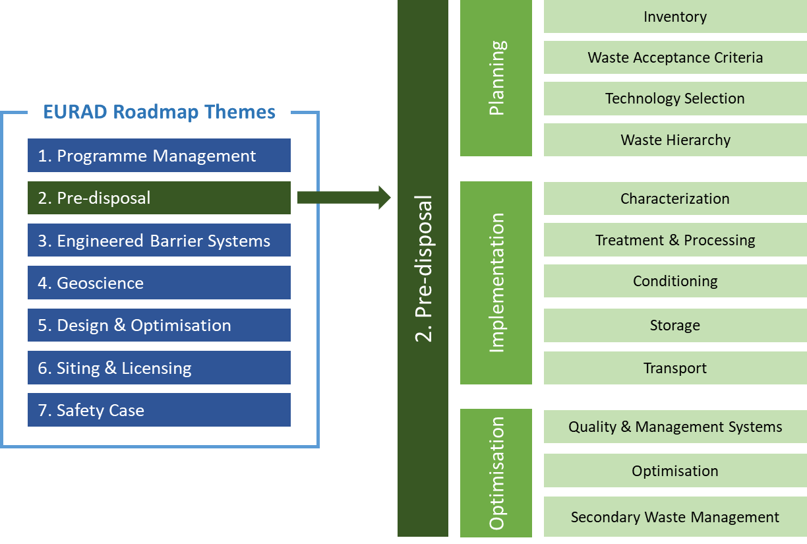

*FIG. 1. Pre-disposal alignment as Theme 2 within the EURAD Roadmap [5].*

## SUSTAINABILITY IN the scope of PREDIS objectives

Developing sustainable solutions for the management of radioactive waste has been a central driving force behind the project from initial project scoping, through the technical work packages and in the PREDIS Strategic Work Package (WP2). A crucial element of this was to focus the technical work programme on real waste management challenges identified by nuclear operators and waste management organisations where there was the potential to make advances in technology readiness/maturity within the project timeframe. To achieve this the PREDIS team built a very broad Stakeholder and End User Group [6]. The extensive stakeholder engagement has also been crucial in developing the PREDIS Predisposal Strategic Research Agenda (SRA) [7]. The SRA reinforces the need for future Research, Development and Demonstration to be driven by a holistic lifecycle approach, often known as Integrated Waste Management, to minimise waste through application of the waste hierarchy and drive towards circularity where possible.

### Waste Hierarchy Principles

The principles of environmental sustainability within the PREDIS project are well represented by the waste hierarchy objectives; to initially prevent wastes from being generated, but if or when it is generated to minimize the production, consider if materials can be used or reused or then recycle wastes for another use that may also include reconditioning or treatment methods. The last resort is the end-of-life waste disposal in safe geological repositories. These waste hierarchy principles are adopted across many disciplines, and generically illustrated with the preferred approach in Figure 2 [8]. These principles should be applied throughout the lifecycle from design through to decommissioning but crucially can effectively target research and development programmes [9, 10]. Indeed, each of the PREDIS technical work packages aims to improve the performance, minimise waste generated and enhance the sustainability of waste management approaches for their targeted wastes streams as described later.

It is crucial that radioactive materials are managed appropriately based on their inventory/hazard. For radioactive materials, the waste acceptance classification of inventory and waste acceptance criteria for deposition to repositories defines how waste is grouped and managed. Higher levels of inventory or classification are typically associated with higher safety requirements regarding handling, storage, confinement by natural and engineered barriers and duration of radioactive release risk. Actions that lower the radioactivity (such as chemical of physical removal of surface layers of radioactive materials on a metallic component) can result in lower classification of the bulk material that can then be either disposed of in a lower-level facility or ideally reused or recycled. Similarly, a reduction in waste volume can have significant environmental and economic benefits.

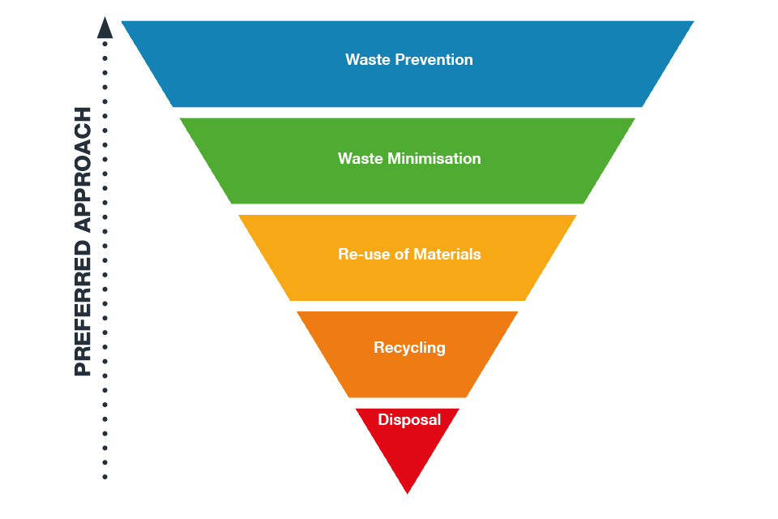

*FIG. 2. Waste hierarchy for supporting sustainable practices. [8]*

Waste Acceptance Criteria and Waste Acceptance systems are important factors in the application of the waste hierarchy when developing technological solutions. Different countries often have different approaches, some mature and some in the development stage. Within the PREDIS strategic work package partners have examined these different approaches and are currently producing guidance documents to inform future developers as they establish their own systems.

In the final phase of the project Life Cycle Analysis (LCA) and Life Cycle Costing (LCC) approaches will be used to objectively evaluate and compare the technologies under development in all the technical work packages of the PREDIS project against baseline technologies, from both environmental and economic perspectives respectively. The protocol for this is based on ISO standards and has been published [11] openly for transparency and guidance. The models have been built and case studies will be published in the final year of the project to evaluate the impact against a range of environmental indicators. The development of this approach is described in more detail in [12].

### PREDIS Research Objectives

Within the PREDIS work package on metallic wastes (WP4) the objective is to optimise chemical (liquids, gels, ionic liquids) and electrochemical decontamination methods applied to stainless steel and nickel-based Inconel metallic materials from the primary circuit of nuclear power plants. Also included are chemical and electrochemical decontamination methods for secondary effluents generated during these metallic decontamination processes. These decontamination treatments will ultimately reduce the dose to workers and also reduce the level of radioactivity.

Within the PREDIS work package on liquid organic wastes (WP5), the objective is to develop the most robust conditioning matrices for Radioactive Liquid Organic Waste (RLOW), and to characterize their properties and durability. Geopolymers reveal to be a relevant matrix to manage such RLOW, with a high robustness regarding waste variability.

Within the PREDIS work package on solid organic wastes (WP6), several thermal treatments are considered to change the chemical and physical properties of a selection of Radioactive Solid Organic Waste (RSOW) because they are difficult to handle under their current form or too highly reactive under the expected conditions prevailing in final repositories. Different types of matrices are investigated, but one aspect of both WP5 and WP6 for organic waste streams, some having been thermally-treated, is to assess the benefits using geopolymer matrices to immobilize the waste taking into account several parameters such as the waste loading and the long-term performance of the final products. The benefits of geopolymers as cement replacement in immobilization binders are related to the lower energy consumption required for production cement clinker.

The focus within the PREDIS work package on cemented waste streams (WP7) is digital solutions for cemented waste packages or containers and overall facility monitoring/management, modelling and decision making. The tasks and innovation are aimed at: increasing the safety of the facilities, minimize the exposure of workers, optimize the efficiency of operations. These issues also have ways that sustainability can be enhanced, as will be described in the next chapters.

## Project results

The following sections provide a short synopsis on the project sustainability-driven results from each of the technical work packages on the four waste streams. More in-depth results and analysis are presented in each of the PREDIS project annual workshops, with the final conference scheduled for June 2024 (see [2] for further details). Further information and the Life Cycle Analysis (LCA) and Life Cycle Costing (LCC) studies done within PREDIS are covered within a separate paper and presentation within this same IAEA event [12].

### Results from Metallic Waste Studies

Within the PREDIS work package on metallic wastes (WP4) inventories have been collected together with assessing the needs and opportunities for management of this waste streams. The categories of data needed to support analysis of costs and benefits of the technologies being demonstrated within the Work Package have been identified. Chemical decontamination processes as well as decontamination using gels on stainless steel and Ni-based alloys have been conducted. Parameters for the CORD chemical process have been specified. Surrogate oxidized metals as well as artificial coupons that replicate the UK’s reprocessing plants have been prepared. High decontamination factors were achieved with optimized CORD process. With regards the gel decontamination process, innovative gels using ferromagnetic particles are being developed. In parallel, decontamination of radioactive effluents has been carried out using co-precipitation as well as extraction using ionic liquids.

With regards the classification of the waste streams and their characterization, distribution of the different nuclear reactors metallic components has been obtained using detailed information on the reactors’ history (neutrons spectrum and flux, activation and corrosion products, DTM radionuclides, etc.). Furthermore, management routes for metallic waste have been identified and the methodology for the scaling factor is being developed. Non-destructive gamma spectrometry is optimized for metals characterization using MCNP simulations validated with experimental spectra.

For the reactive metallic waste encapsulation, emphasis is put on formulation optimization and magnesium phosphate cements (MPC) including raw material such as MgO sources selection and cost reduction. The tested parameters are mechanical and chemical durability as well as resistance to ionizing radiation. The leaching studies concerns metallic aluminium (Al), steel and beryllium (Be) in MPC.

Life cycle assessments (LCA) and life cycle cost (LCC) analyses approaches are being applied to the work package of radioactive metallic waste in particular by comparing two chemical treatment methods by testing parameters such as raw materials cost and procurement, environmental impact, effluents, etc.

### Results from Liquid Organic Waste Studies

### After collection and review of waste, regulatory, scientific and technical data involving PREDIS stakeholders, giving a description of RLOW inventories at the European level, four reference wastes were selected: oils, decontamination solvents, TBP/dodecane and scintillation cocktails. Robustness and optimisation studies were initiated with the aim to develop geopolymer formulations that could be scalable to different countries in Europe by using local raw materials. Three reference geopolymer matrix formulations were identified as candidates for direct conditioning solutions for RLOW. These formulations are respectively based on metakaolin, blast furnace slag and a mix of raw materials, namely metakaolin, blast furnace slag and fly ash.

### The matrix formulation has been optimized to reach the highest possible waste loading, around 30% WL, the best robustness regarding waste variability, raw materials and process variability. These reference formulations will be tested with actual RLOW and for process scale-up. The experimental activities conducted for the investigation, development, and assessment of innovative direct conditioning solutions for Radioactive Liquid Organic Waste, showed that specific geopolymers formulations based on metakaolin, blast furnace slags and innovative mixes of raw materials have very promising results in terms of improving waste loadings and waste form properties in comparison with traditional cementitious waste forms. The long-term behaviour of these formulations is currently under study, under endogenous, aerated or leaching conditions. The objective is to study the behaviour of the binders under irradiation, the binding and leaching of radionuclides as well as the thermal behaviour and fire hazard.

### Life cycle assessments (LCA) and life cycle cost (LCC) analyses allow comparing such geopolymers, considering geopolymers performances, production costs and reduction factor. It considers quantifying raw material and energy inputs, waste loadings, secondary waste streams and final waste products. Conditioning involving cementation will be also used as an LCA baseline for comparison against geopolymer conditioning matrices developed in WP5.

### Results from Solid Organic Waste Studies

Coming from different thermal processes, the resulting solid organic materials after treatment do not have the same initial chemical and physical properties, and thus specific formulations are often required prior to their final immobilization to stabilize the waste before final geological disposal. A selection of the most promising immobilization formulations is made depending on the treated waste, before optimizing the processes. This can be done by increasing the waste loading until the robustness and the integrity of the matrices starts to be compromised, but also by changing the raw materials constituting the geopolymer matrices to improve the properties of the matrix and/or to reduce costs.

One of the processes leads to the production of ashes coming from the incineration of ion exchange resins (IER). A geopolymer matrix is used for their immobilization and the efficiency of the final product is compared with two other final waste forms (Hot Isostatic Press and Densification technologies) aiming the immobilization of these ashes. The matrix formulation has been optimized to reach the highest possible waste loading, and the long-term performance of the three final waste forms is evaluated by performing leaching tests under generic conditions, yet representative, of final disposal. This study allows the comparison of three final waste forms stemming from different treatment processes coming from the same initial RSOW. Not only is the long-term performance of the final waste form evaluated, but also their production costs and reduction factor, as well as the requirements to handle the final products when they are disposed of by doing LCC/LCA studies [12].

Since geopolymer matrices are considered ‘novel’ materials in the radioactive waste management domain, their physicochemical properties and the long-term performance need to be benchmarked against those of commonly used cementitious based materials. To this end, an extensive experimental program has been designed to assess the immobilization of (1) thermally treatment resins and (2) molten salt residue coming from a process under development. Several geopolymer formulations are then tested for the immobilization of both type of treated materials, by modifying the composition and the fractions of precursors and solid activators, and the quantity of treated waste incorporated in the matrices. Cement-based materials matrices (Portland cement types CEM I and CEM III) are investigated for the immobilization of the two treated waste types as well, and most of the tests are performed in triplicate for a statistical evaluation. In this experimental program, about 300 samples are investigated by following the release of the major matrix constituents and tracers representative of radioactive elements that may be present in the RSOW, as well as the matrix properties after leaching.

In addition to the long-term performance of the final waste forms, their production costs are also considered in the evaluation of the considered processes in this work package. As for an example, the use of natural materials such as Volcanic Tuff is being studied to replace commercial raw materials entering the geopolymer formulations. This option has the advantage to be cost-effective and available worldwide. In a general point of view, whatever the immobilization matrix (geopolymer or cement-based materials), a maximum of 30% by weight waste loading is achieved.

## impacts

The following paragraphs provide a short synopsis on how the results from the project are utilized by industry and having an impact on sustainability practices from each of the technical work packages on the four waste streams. As in the previous section, more detailed analysis of the LCA and LCC impacts can be found in [12] and will be covered in the final PREDIS project conference scheduled for June 2024 (with details available at [2]). The PREDIS project is in the process of developing further End User impact case studies from the project results, to describe how the outcomes will be utilized in practice to enhance their own business. The engagement of Stakeholders for project impact is also further described in [6].

Development of WP4 on radioactive metallic waste has been realized in close collaboration with industrial stakeholders such as EDF in France. EDF provided Ni-alloys from steam generator that lasted several years in operating nuclear reactor. CORD process has been tested with success for these real samples and the optimized method could be used by EDF as well as European utilities. Having improved processes for decontamination of metallic materials provides the opportunity for greater volumes of material to potentially be free-released, recycled or utilised in lower repository waste classifications. Such actions directly support the waste hierarchy principles.

Although the processes investigated in work package 5 on liquid organic wastes or om work package 6 on solid organic wastes have not yet reached a sufficient maturity level to clearly propose which immobilization method is the most suitable for a specific RSOW / RLOW at full-scale industrial applications, progress has been made in the knowledge of (novel) immobilization matrices and in the long-term management of the final waste forms. The use of natural materials as an alternative to commercial raw materials has proven its advantages in term of costs productions without significant impact on matrix efficiency. Material replacements with more durable and environmentally sustainable footprints have provided to maintain performance. LCA analysis done in PREDIS for some of the reference mixtures in the WP5-6 studies has shown that the Climate Change Potential (kg CO2 eq.) of using 20% waste loading with geopolymer was 1.2 compared to equivalent cement impact of 3.3 (63% reduction) [12]. In many case, the work carried out in the liquid or solid organics waste work packages (WP5 / WP6) remains at laboratory scale with only a few up-scale tests in WP5 on liquid organic wastes, and the results were obtained under ‘generic’ experimental conditions, but this provides a robust basis for the End Users (such as Waste Management Organizations) to decide which processes merit further investigation. Together with Research Entities, more specific studied can be defined to upscale the processes, increase TRLs (often associated with the use of radioactive materials and specific facilities which is currently the limiting factor), extrapolate results to longer duration by calculation, and finally build models to avoid systematic study of the RLOW / RSOW.

The digital tools developed in PREDIS work package 7 on cemented waste packages will allow to test and monitor new solutions for waste immobilization and storage and to provide more and more reliable data for meeting waste acceptance criteria. This might avoid costly and unsustainable retreatment and repackaging operations and – in connection with better prediction using the digital twin models developed in WP7 - allow earlier transport to final storage. Such digitalization tools targeted for deployment in pre-disposal waste management will optimize operations in the storage facilities, e. g. by permanently attached sensors which will avoid moving hundreds of waste drums to transport a specific package to a testing site. This will not just reduce risks immanent to moving packages but also reduce operational cost and energy consumption. The availability of larger amounts of data in denser intervals and a longer time span are also foreseen to improve the prediction of mid-term and long-term behaviour and integrity of packages, which will help to avoid expensive and time/energy consuming retrieval operations from final storage.

## SUMMARY

For over three years the PREDIS project has aimed at enhancing waste treatment and conditioning to support the waste hierarchy through utilization of novel materials such as geopolymers as cement replacements in immobilisation and chemical cleaning of metallic wastes to allow greater volumes of free-release base materials. The needs of Member States and end users such as waste generators and waste management organizations have been addressed to have more efficient processes that generate less waste and lower volumes of material that will need final geological disposal. Digitalization technologies are being developed that improve the safety of interim storage and transport through better monitoring, modelling and decision-making frameworks that can avoid expensive time and energy consuming operations in the pre-disposal waste management phases.

ACKNOWLEDGEMENTS

This project has received funding from the Euratom research and training programme 2019-2020 under grant agreement No 945098. The contributions of the technical work package leaders to this paper are gratefully acknowledged: Abdesselam Abdelouas and Tomo Suzuki of IMT-Atlantique (France) for metallic wastes, Isabelle Giboire of CEA (France) for liquid organic wastes, Thierry Mennecart of SCK CEN (Belgium) for solid organic wastes, and Erns Niederleithinger of BAM (Germany) for cemented waste packages and digitalization.

References

[1] IAEA Predisposal Management of Radioactive Waste, (2009), IAEA Safety Standards, General Safety Requirements Part 5, No. GSR Part 5, International Atomic Energy Agency, Vienna, 56 p.

[2] Pre-disposal Management of Radioactive Waste, PREDIS (2020), Euratom project 2020-2024, <https://predis-h2020.eu/>

[3] HOLT, E., OKSA, M., NIEMINEN, M., ABDELOUASA, A., BANFORD, A., FOURNIER, M., MENNECART, T. NIEDERLEITHINGER, E. (2022), Predisposal conditioning, treatment, and performance assessment of radioactive waste streams. EPJ Nuclear Sci. Technol., 8(40), pp.1-6.

[4] European Joint Programme on Radioactive Waste Management, EURAD (2019), Euratom project 2019-2024, <https://www.ejp-eurad.eu/>

[5] EURAD, Roadmap Guide, Issue 2 (2021), 26 p. <https://www.ejp-eurad.eu/roadmap>

[6] JACOPS, E., BRUGGEMAN, C., HUYS, T., WAREING, A., BANFORD, A., HOLT, E., CARBOL, P., NIEDERLEITHINGER, E., “Example of how stakeholders can impact an R&D project and maximize their benefits – leading to increased safety and improved sustainability in radioactive waste management”, IAEA International Conference on the Safety of Radioactive Waste Management, Decommissioning, Environmental Protection and Remediation: Ensuring Safety and Enabling Sustainability, Vienna, Proceedings, 2023.

[7] WAREING, et al, Strategic Research Agenda, PREDIS Project, Milestone Report 2.4 (2023), 70 p.

<https://predis-h2020.eu/wp-content/uploads/2023/05/PREDIS-SRA_Milestone-Report-2.4_May-2023.pdf>

[8] Nuclear Decommissioning Authority (NDA), Radioactive Waste Strategy (2020), <https://www.gov.uk/government/consultations/nda-radioactive-waste-management-strategy/outcome/radioactive-waste-strategy-september-2019>

[9] TURNER, J., SPENCER, J., O'BRIEN, L., PALETHORPE, S., BANFORD, A., TAYLOR, R. (2021). Applying the Waste Hierarchy for Future Recycling of Nuclear Fuels. Nuclear Future, 17(6).

[10] Integrated waste management and R&D at the National Nuclear Laboratory, IL NUOVO CIMENTO 46 C (2023) 53, DOI 10.1393/ncc/i2023-23053-6

[11] STAMFORD, L., LCA and LCC protocol guidance, PREDIS Project, Milestone 2.4 Report (2021), 11 p. <https://predis-h2020.eu/wp-content/uploads/2021/09/PREDIS_MS14_T2.5-LCA-protocol-guidance_31.8.2021.pdf>

[12] KIRK, J., CLAYTON, R., BANFORD, A., STAMFORD, L., “Applying a life cycle environmental perspective to the development of radioactive waste treatment technologies”, IAEA International Conference on the Safety of Radioactive Waste Management, Decommissioning, Environmental Protection and Remediation: Ensuring Safety and Enabling Sustainability, Vienna, Proceedings, 2023.