International Conference on the Safety of Radioactive Waste Management, Decommissioning, Environmental Protection and Remediation:

Ensuring Safety and Enabling Sustainability

6 - 10 November 2023

Vienna, Austria

Ref: CN-318/ EVT2102343
BIOGRAPHICAL SUMMARY FOR SPEAKERS
Please ensure to include in a separate file of your photo saved in a JPEG format with a resolution of 200 x 200 pixels. Send the photo together with the following form to ICWEDR2023@iaea.org
NAME: | WACQUIER William
SESSION # | 146
PAPER/ POSTER TITLE: | PREPARATION OF THE SAFE AND SUSTAINABLE DISPOSAL OF LLW IN THE FUTURE SURFACE DISPOSAL FACILITY IN BELGIUM
AFFILIATION/COMPANY: | ONDRAF/NIRAS
SHORT BACKGROUND FOR INTRODUCTION (3-4 LINES): | William Wacquier is head of mission at ONDRAF/NIRAS. He is in charge of the admissibility program that aims to prepare the operation of the surface disposal facility in Dessel in order to ensure a safe disposal of the category A waste.  He started his carrier at SCK-CEN as Research Engineer in charge of R&D activities for the characterization of waste forms and waste packages. Then he joined TRACTEBEL ENGINEERING as Design Engineer and worked on international projects and became in charge of the Business Development of engineering and consulting services related to the Back-end of the Nuclear Fuel Cycle. He is a Civil Engineer in Physics (Catholic University of Louvain-La-Neuve, 1995) and also holds a Master in Nuclear Technology (University of Ghent, 1997).

Release of Electronic (MS PowerPoint) Presentation or Poster

I agree that my oral presentation or poster to be presented at Safety of Radioactive Waste Management, Decommissioning, Environmental Protection and Remediation: Ensuring Safety and Enabling Sustainability which will be held in Vienna, Austria from 6 to 10 November 2023, may be made available on the IAEA conference app and/or website as a PDF or MP4 Video.
YES X | NO  Signature: 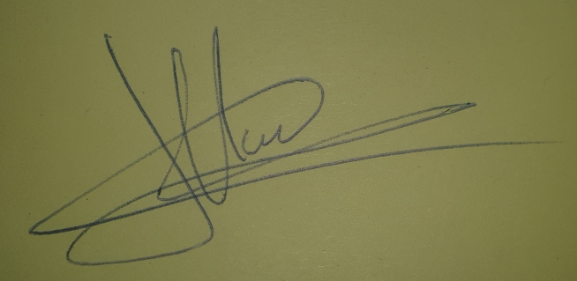
Please complete and return this form as Word document by email to: ICWEDR2023@iaea.org

