- Background and goal of present study
The Lithuanian National Radioactive Waste Management Programme states that placement of spent nuclear fuel and long-lived radioactive waste into the deep geological repository (hereinafter – DGR) is the only sustainable and safe way of final disposal to be addressed. Current activities in Lithuania belong to the generic phase of Research & Development in the DGR development: early stages of site selection, conceptual studying of the disposal system and generic safety assessments. The DGR project is on Site Selection stage now. This phase is one of the initial stages of the DGR project and comprises the overall process of survey, screening, and evaluation to identify potential sites’ areas, leading to further site selection.

- Determination of geological selection criteria for suitability of geological environment for DGR

2.1. A brief overview of the potential geological formations for the DGR in Lithuania

The territory of Lithuania is located within the central part of the Baltic sedimentary basin, located on the western part of the East European Craton with Earth's crust of Precambrian consolidation and significant distances to active tectonic zones. The crystalline basement occurs at the depth of 300-2400 m deepening to the SW and is overlain by a cratonic sedimentary sucession comprising all the geological systems from Ediacaran to Quaternary in W part of Lithuania..

In 2023 a potential geological formations suitable for Deep Geological Reppository (DGR) have been identified: the crystalline basement, the Lower Cambrian Baltija Series, the Lower Triassic and the Upper Permian formations.
- The Crystalline basement occurs at the depth of 300-2400 m and the depth of the crystalline basement less than 700 m is considered to be prospective for DGR construction being located at these depths in the E and SE part of Lithuania. The crystalline basement comprises different rock types, such as migmatites containing some supracrustal rocks (gneisses, amphibolites), mafic and felsic intrusions, cratonic (anorogenic) granitoids, and the other minor lithologies. The composition of the rocks is of minor concern in repository siting, as the lithology has relatively little control on the strength and isolating properties of rocks, in contrast to sedimentary deposits and in comparance with the tectonic dislocations.
- The Lower Cambrian Baltija Formation occurs only in the E part of Lithuania and partially overlaps with the crystalline basement. The top of this formation occurs at the depth of 200-800 m and the thickness attains 110 m in the easternmost part, whereas in the west the W it attenuates to 10-20 m. Detailed analysis of the borehole data showed rather changeable lithological composition of the interlayered clay, siltstone, and sand succession.
- The Lower Triassic Formation is distributed in the W and SW part of Lithuania. The thickness of the formation increases from a few meters to 250 m. The lithological composition of Triassic sediments consists predominantly of clay with sand, siltstone interlayers. Nevertheless, the sediments are quite lithologically homogenous, that most homogenous layers are distributed in the central part of the Triassic succession.

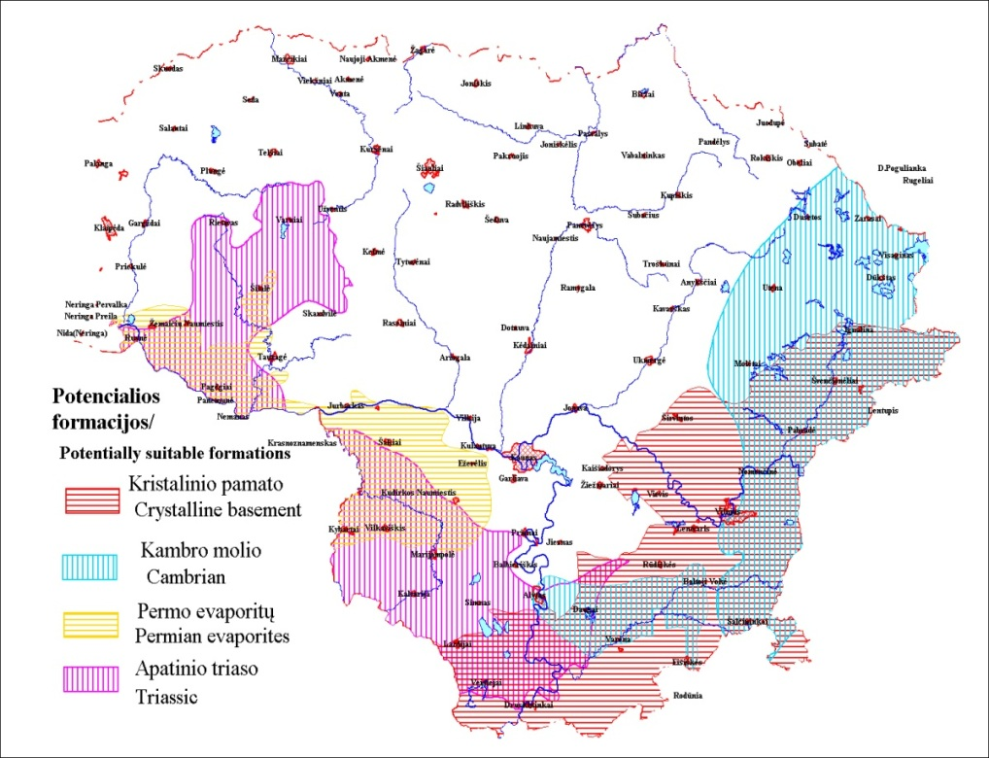
Geological formations potentially suitable for DGR construction in the territory of Lithuania (layout scheme):
purple indicates areas of distribution of the Lower Triassic; blue - Lower Cambrian; brown - Crystalline basement and yellow - Upper Permian (from 2022)

- The Upper Permian Formation comprises rock salt and anhydrite rocks. A Permian evaporite rocks with a thickness of 40-60 m occur in Southern and South-Western Lithuania at the depth of 150-790 m. Most of the formation (70-80%) consists of anhydrite. The rock salt occurs only localy.

  - Investigation of potential formations for DGR in Lithuania
For the furthered investigations of the geological formations described above, the negative screening has been performed, i. e. preliminary unsuitable regions have been identified by adopting the established formation depth and thickness boundary conditions, excluding water body protection zones; protected areas; areas of mineral deposits; cities; sites referred to the European Ecological Network Natura 2000, paleoincisions, fault zones, surface characteristics etc. After eliminating the regions according to the above-mentioned criteria, potential areas of ~ 10 sqkm for the further DGR site selection activities have been identified within the boundaries of all 4 potentially suitable geological formations – in total 110 potential areas have been defined.

Geological criteria determining the selection of the potential DGR sites

3.1. Geological criteria determining the stability of the DGR
The stability of potential sites for DGR was determined by a set of defined criterions, such as depth of the occurrence and thickness of formations, tectonic/neotectonic activity; seismicity, diapyrizm processes, karst processes, use of the drinking groundwater, He and Rn anomalies in the groundwater; distribution of the natural resources.

Geological criteria determining the isolation of the DGR from the biosphere

Based on the international best practices and IEAE recommendations, the suitability of the territory for DGR depends on the geometry (depth of the occurrence, thickness, lateral extent) of the potentially suitable geological formation, the tectonic and hydrogeological conditions of the territory, and the composition, homogeneity and properties of rocks comprising the formation. The isolation of potential areas for DGR from the biosphere has been determined by a set of defined geological criteria: characteristics defining the formation’s integrity: e.g. faults and tectonic deformation zones (TDZ) wihin the area of the DGR; distance of the area to fault or TDZ); natural resources (occurence of geothermal resources in the DGR research area; Intensity of use of fresh drinking groundwater); lithological homogeneity of formation rocks; isolating properties of formation rocks (permeability, structure of the upper seal of the formation; structure of the bottom seal of the formation); vertical and horizontal recent ground surface movements; physical properties of rocks (rock density; brittleness/plasticity); water pathways (distance to the paleo-incision; unconformities; acid-alkaline and oxic-anoxic conditions; prevailing direction of the piezometric pressure gradient); increased seismic activity.
3.3. Estimation of the prioritisation of potential DGR sites
In 2023, the Lithuanian Geological Survey under Ministry of Environment prepared a study of geological criteria and prioritization of potentially suitable DGR aeras according to these criteria was done. After prioritization of potential DGR sites according to the geological criteria, 79 potential DGR areas were remained for the future studies. Due to local occurrence the Permian evaporites were excluded from potential areas list.

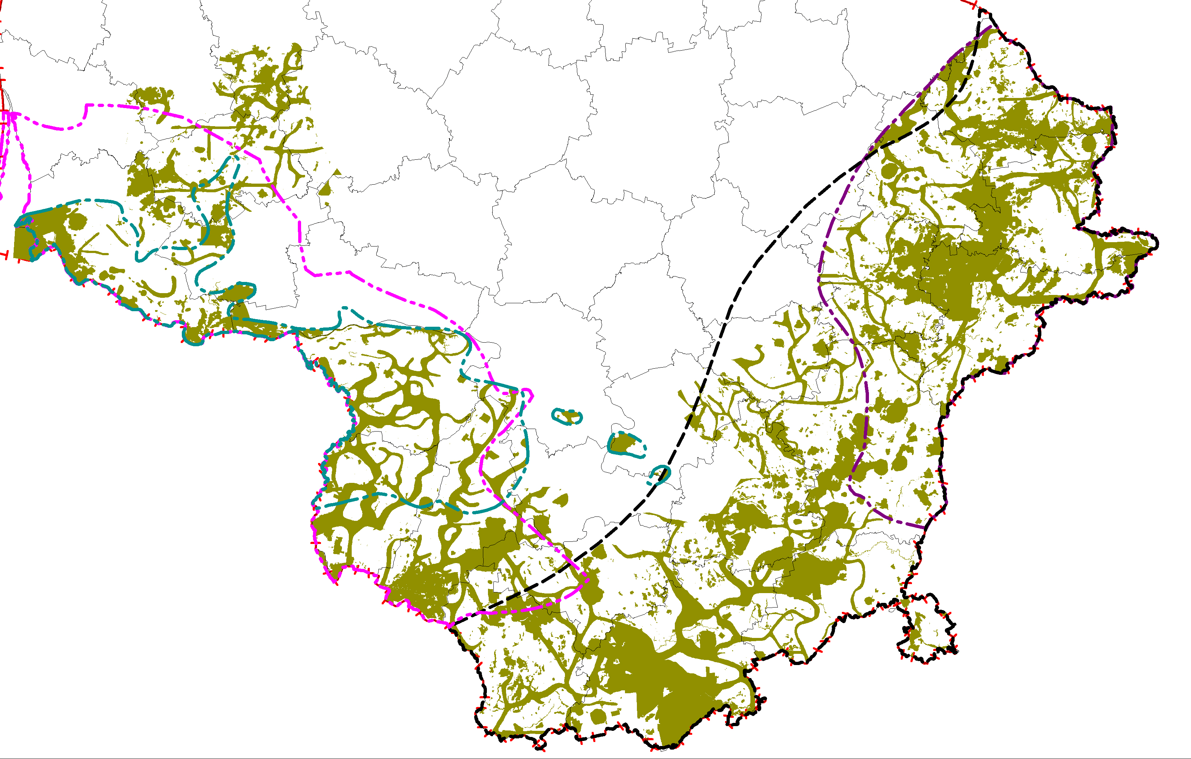 | Assessment scheme of the potential DGR sites within territory of Lithuania: purple line indicates areas of distribution of the Lower Triassic; blue line - Upper Permian; black line - Crystalline basement, dark purple line - Lower Cambrian; green areas- unsuitable for DGR areas

In 2022 a socio-economic assessment of all potential aeras for DGR installation was performed. During the study, 110 potential sites suitable for the DGR installation were evaluated using the multi-criteria decision-making AHP method according to non-geological parameters of three analytical dimensions (territorial planning, environmental protection, and socio-economic aspects). In the report, analysis was performed on the impacts of a potential DGR sites based on three dimensions, identifying subcriteria that were grouped into criteria. According to the results of socio-economic assessment 2 aeras were excluded from the list of potential areas.
Considering the results of the general safety assessment for the different formations in Lithuania, the Triassic clay host rock provides the most comparing to the other formations (Cambrian clay and crystalline basement).
- Conclusions
Considering all geological criteria, as well as safety and socio-economic criteria all potential areas for DGR were analysed and 77 potential areas are considered as suitable for the further investigations for DGR site selection.

- References

Detailed analysis of formations potentially suitable for the construction of the Deep Geological Repository of the radioactive waste and prioritization of potential sites according to the main geological (suitability) selection criteria. LGS, Vilnius, Lithuania. 2023;
Determination of the geological criteria for the suitability of the geological environment for the Deep Geological Repository of the radioactive waste. LGS, Vilnius, 2022;
Recommendations for the compilation of the programme of the geophysical investigations for the determining sitting for deep radioactive waste repository. INPP. Vilnius, Lithuania. 2020 (in Lithuanian);
Safety-related criteria for deep geological repository construction in Lithuania. Posiva Solutions Oy, Finland. 2023;
Social and Economic Evaluation for Selection of Potential Region for Deep Geological Repository (DGR). IDOM Consulting, Engineering, Architecture, S.A.U, Spain. 2022.

