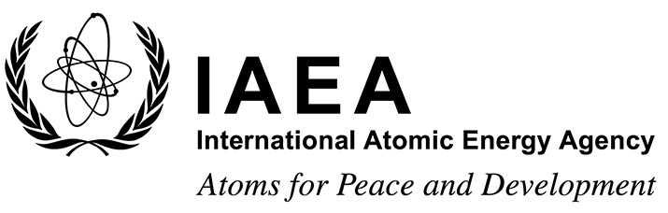 |  | Form C  EVT2204904
Grant Application Form
Technical Meeting on the Safety Approach for Liquid Metal Cooled Fast Reactors and the Analysis and Modelling of Severe Accidents
IAEA Headquarters, Vienna, Austria and virtula participation via Microsoft Teams
13–17 March 2023
To be completed by the participant and sent to the competent national authority (e.g. Ministry of Foreign Affairs, Permanent Mission to the IAEA, or National Atomic Energy Authority) of his/her country for subsequent transmission to the International Atomic Energy Agency (IAEA) either by email to: Official.Mail@iaea.org or by fax to: +43 1 26007 (no hard copies needed). Please also send a copy by email to the Scientific Secretary S.Massara@iaea.org and to the Administrative Secretary L.Sedlazek@iaea.org.

Deadline for receipt by IAEA through official channels: 16 December 2022
Family name(s): (same as in passport) |  |  | First name(s): (same as in passport) |  |  | Mr/Ms:
Mailing address: |  |  |  | Tel.:
 |  |  |  | Fax:
 |  |  |  | Email:
Date of birth (yyyy/mm/dd): |  |  |  | Nationality:
I plant to attend virtually: |  |  |  | Yes No
- Education (post-secondary):

Name and place of institution | Field of study |  |  | Diploma or Degree | Years attended  from to
- Recent employment record (starting with your present post):

Name and place of employer/ organization | Title of your position |  |  | Type of work | Years worked  from to

- Description of work performed over the last three years:

- Institute’s/Member State’s programme in field of event:

Date: | Signature of applicant: ___________________________
Date: | Name, signature and stamp of Ministry of Foreign Affairs, Permanent Mission to the IAEA or National Atomic Energy Authority ___ __

