GUIDELINES for ePOSTERS

AUTHOR INFORMATION
Based on the templates available below, fulfil biographical summary and release of ePoster and biography forms. Send the documents to Safeguards2022@iaea.org by 30 September 2022.

PREPARING YOUR ePOSTER
The ePoster should be a visual presentation of your full paper. Please use the provided PowerPoint template and submit your ePoster as a:
- Pre-recorded narrated single slide PowerPoint presentation (5 minutes max); OR
- PDF file.

To submit a pre-recorded PowerPoint presentation, follow the instructions below and see Annex 2:

Size and Design
You should design your ePoster in Microsoft PowerPoint as a landscape slide and ratio 16:9 using the provided Symposium ePoster template. The final ePoster will include a pre-recorded presentation using the ‘Record Slide Show’ function in PowerPoint and must be submitted to the IAEA as a MPEG-4 Video (*.mp4) File, not exceeding 500 MB.

Logos and ePoster Number
Insert the abstract ID (IAEA-CN303-XXX) on the upper right side of your ePoster.
Logos of author’s institution(s) can be inserted anywhere on the ePoster.

Title
The title should be the same as in your full paper.
The title of the full paper, name of the main author, his/her affiliation and email as well as name(s) of co-author(s) should be displayed at the top of the ePoster.

Headings
It is recommended to use capital letters for headings.

Lettering
Avoid using all-capital text in the body of the poster. Avoid using mixtures of type/font styles. The text and narration should be in English only.

Content
The text should be concise and easy to read. Avoid using full sentences, but rather use short text in bullet point format. Your poster’s message should be clear and understandable without the need for oral explanation. If relevant, methods should be presented simply and concisely.
Video
Mandatory Requirements for ePosters:
- Your submitted file must include the ePoster only (single slide) and not multiple slides;
- The video presentation must not exceed 5 minutes duration; and
- The final file size must not exceed 500MB.
Any ePoster that does not meet these requirements will be returned.
For more guidance on recording and uploading your video using Microsoft PowerPoint, see Annex 1 & 2.
Submission
Please submit your ePoster via WeTransfer (see attached instructions, #7). Should you not be able to use WeTransfer, please inform the Secretariat accordingly by email Safeguards2022@iaea.org using Subject line: your session code and abstract ID number (e.g. SG01, XXX).
Please save your file with the abstract ID number and your last name (XXX, first name, last name). The link to the file must be sent by email to Safeguards2022@iaea.org by Friday, 7 October 2022. This will allow sufficient time for the Secretariat to check the compatibility of the video presentations with the technical specifications and to upload them to the Conference App. ePosters attached to emails cannot be processed.

PRESENTATION DURING THE CONFERENCE
Your ePoster will be made available on the IAEA Conference and Meetings App (available for free download from the App Store and Google Play) prior to the start of the Symposium. There will be a commenting function for each ePoster to allow interaction between authors and participants, such as to answer questions and to initiate further discussions. Furthermore, if you are in Vienna and participate in the Symposium in-person, your ePoster Session will be featured during a break and you are encouraged to attend that Session to interact with participants and other authors in your ePoster Session, and answer questions about your work.
Attachment: Biographical summary and Release of ePoster and biography forms

BIOGRAPHICAL SUMMARY

Please ensure to include in a separate file your photo saved in a JPEG format with a resolution of 200x200 pixels. Send the photo together with the following two forms to Safeguards2022@iaea.org by 30 September 2022. Subject line: CN-303 Forms (session code, abstract ID number and full name).

FAMILY NAME:
FIRST NAME:
PAPER TITLE &
ABSTRACT ID NUMBER:
AFFILIATION/COMPANY:
COUNTRY /
INVITED ORGANIZATION:
BRIEF BIOGRAPHY for the CONFERENCE APP
(max. 250 characters)

RELEASE of ePOSTER and BIOGRAPHY
I agree that my ePoster and biography for the Symposium on International Safeguards: Reflecting on the Past and Anticipating the Future (CN-303/EVT2005412), 31 October–4 November 2022, Vienna, Austria, may be made available on the IAEA Conference website and Conference App as a MPEG-4 Video (*.mp4) File.

PAPER TITLE &
ABSTRACT ID NUMBER:
COUNTRY /
INVITED ORGANIZATION:
FAMILY NAME:
FIRST NAME:

YES ☐ | NO ☐ Signature:

ANNEX 1

TECHNICAL SPECIFICATIONS -
PRE-RECORDED VIDEO - ePOSTER

- Video Quality:
- Pre-recorded presentation must be made using Microsoft PowerPoint 2016 or later.
- Format: Slide Ratio 16:9, MPEG-4 Video (*.mp4), not exceeding 500 MB.
- Full HD 1080 x 1920 Pixels (if for any reason it is not possible to save the file at 1080p the file must at the very least be saved at 720p to avoid issues with video quality and with playback).

- Suitable location / background / preparation:
  - Record with as much natural light as possible. If it is too dark or the light is unbalanced, turn on the room light and position a desk lamp or other light source. The speaker should be evenly lit and brighter than the background.
  - Find a quiet location. Eliminate any background noise (e.g., switch off air conditioning and close windows to block traffic noise).
  - Dress appropriately as if present at the conference.
  - Practice the presentation before recording the final version.

- Audio:
  - If using a clip-on microphone fasten it at chest height.
  - If possible, use Bluetooth headphones with a built-in microphone or a headset to improve sound quality.

- Frame the video shot:
  - If using a laptop with a built-in camera rest the device on a stable surface; make sure the camera is straight with the lens just below eye level.
  - If using a webcam, camera or phone mount the device on a tripod if you have one; film horizontally (landscape) and not vertically (portrait mode); make sure the camera is straight with the lens just below eye level.

- Record the video:
  - The speaker should look directly into the camera lens to maintain eye contact with the viewers.
  - After pressing the ‘Record’ button, there should be a time gap of at least 3 seconds before the speaker starts to speak. Stop the recording at least 3 seconds after the speaker has finished.

- Playback to check the video recording:
  - For sound quality purposes, headphones should be used to check if the recorded sound is clear and understandable.
  - Check if the speaker is in focus and her/his exposure looks even.
  - Consider re-recording if the video and/or sound quality are not good.

ANNEX 2

USING MICROSOFT POWERPOINT TO PREPARE YOUR
PRE-RECORDED VIDEO ePOSTER

- Please prepare your ePoster using the provided template.
You should leave a blank space on your ePoster where your video will be inserted once recorded.

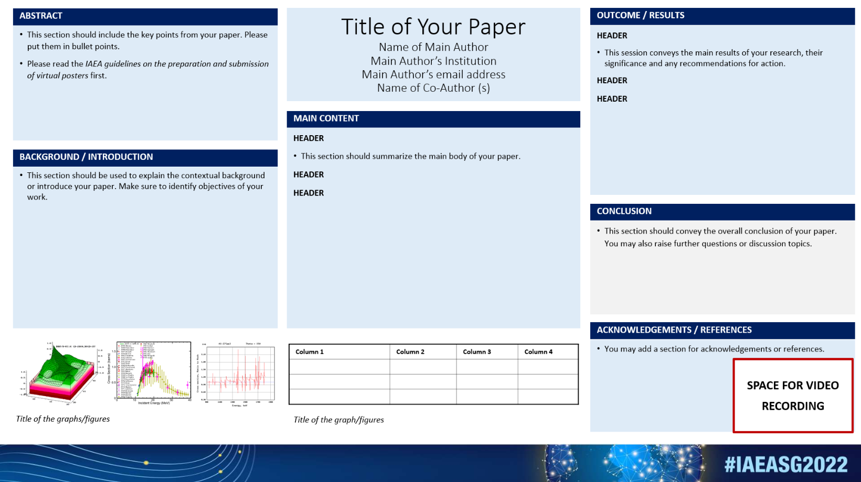

- Record your presentation using the Slide Show Function (5 minutes max):
- Open your PowerPoint ePoster
- Select Slide Show
- Select Record Slide Show
- Select Record from Beginning
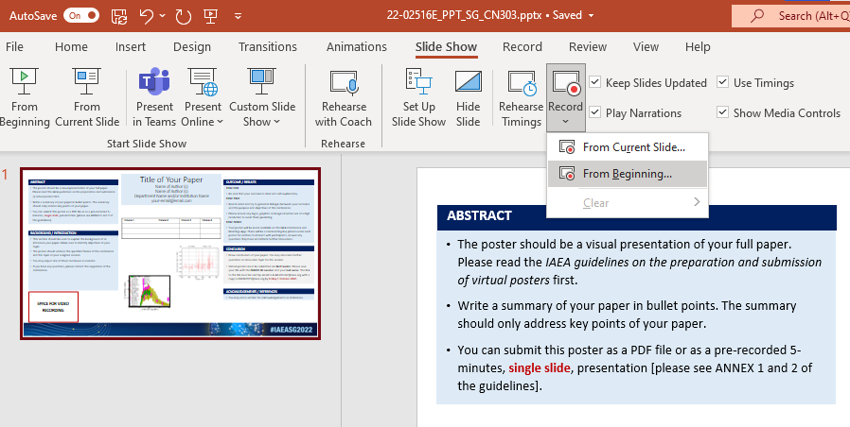
- After following the above steps, you will be taken to a presenter screen.
You will see the video projected on the bottom right corner of the slide. The video can be moved to a different position on the slide after the recording.

- Navigating the presenter screen
Along the top of screen, you will see from left to right:
- Record button – press to start the recording
- Stop button – press to stop the recording
- Replay button – press to replay the recording
- Notes dropdown – you can view your presenter notes here
- Clear recording button – you can clear the recording here should you not be satisfied
- Settings button – Here you can access your microphone and camera settings

Along the bottom of the slide, you will see from left to right:
- Eraser – To remove anything drawn in real time on the slide
- Pen and Highlighter - You can use the two pens as a pointer or to draw on the slide in real time
- Colour Selection - You can use the colour pad to select the colour of the pen
- Microphone Button – You can mute your microphone by pressing this button
- Camera Button – You can switch off your camera at any time by pressing this button
- Camera Preview Button – You can switch of the camera preview at any time by pressing this button
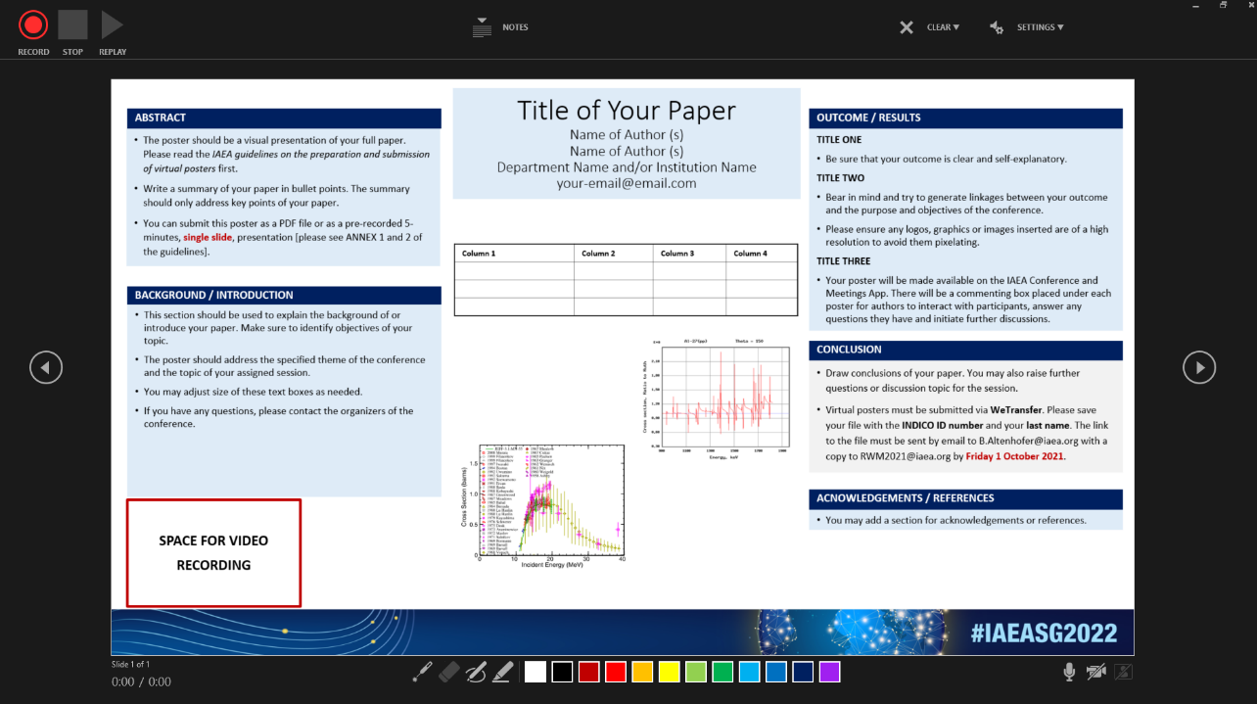
- Recording your presentation:
- To begin recording your presentation press the record button on the top left corner
- The presenter screen will countdown from 3 seconds and then begin to record
- Record your presentation discussing the various sections of your ePoster
- Once you have finished press the stop button on the top left corner
- You can preview your presentation by pressing the replay button on the top left corner
- Once you are satisfied with the recording close the presenter screen, you will return to the main PowerPoint screen and the recording will be automatically inserted into the ePoster

- Exporting your ePoster an MPEG-4 Video (*.mp4) file:
- Go to the File tab
- On the left side of the screen select Export
- Then select Create a Video
- The file should be saved as Full HD 1080x1920 Pixels or at the least 720p / maximum 1080p
- Keep selected Use Recorded Timings and Narrations
- Press Create Video
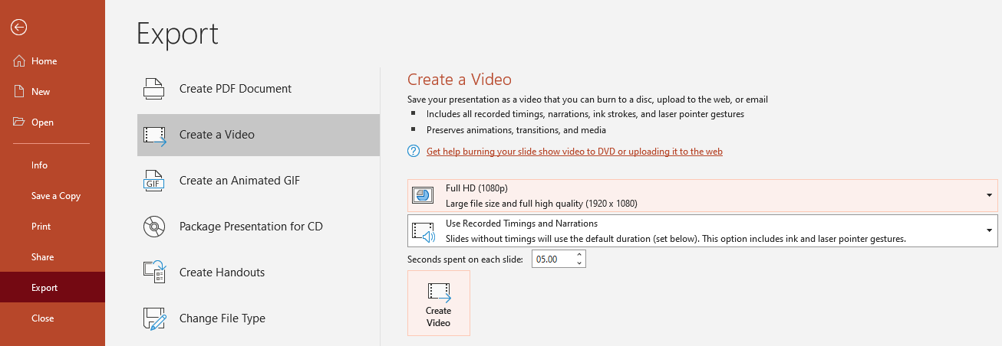
- A Save As dialogue box will appear
- Choose the location where you would like to save the recording
- Ensure the Save As type is MPEG-4 Video (*.mp4)
- Save the document with your abstract ID number and your last name and press the button to save the file (it will take a few minutes to export the video).
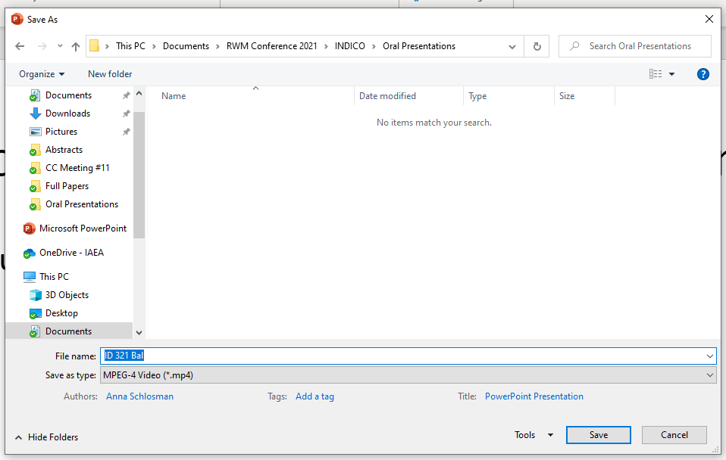
- Submit your ePoster via WeTransfer
• Go to the WeTransfer page by clicking here
• In case you are using WeTransfer for the first time, you will see this screen:
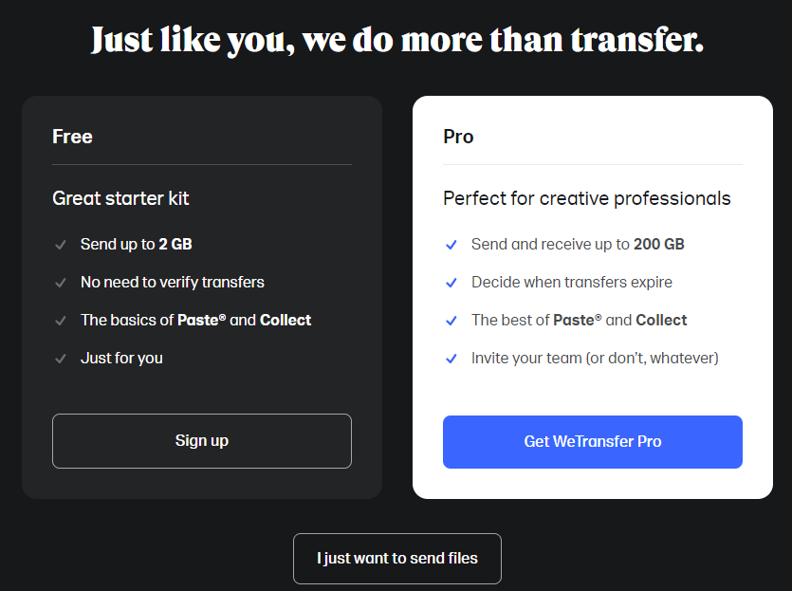
• Click on the below button saying either “No Thanks” or “I just want to send files”.
• After you click, the following page will appear:
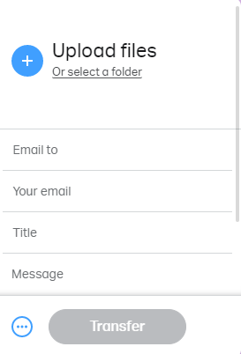
• Click on the blue “Plus” icon to upload your presentation in MPEG-4 Video (*.mp4) file. Enter Safeguards2022@iaea.org in the “Email to” box and your own email address in the “Your email” box. In the message box, please do not forget to enter your session code, abstract ID and full name.
• The Conference Organizers will confirm receipt of your file after submission.

If there are more than three names of authors/co-authors, a footnote/asterisk should be used and the affiliations listed elsewhere in the template.

