GUIDELINES FOR ESPACE PRESENTERS

What is ESPACE?
The ESPACE area is an open space in M-building dedicated to the Symposium, where you can present your work or demonstrate your research, tools, instruments, services and /or capabilities. You are given a 25 min slot, which includes interaction with audiences. To make it interactive, we suggest a 10-15 minute briefing with at least 5-10 minutes for Q&A and audience interactions before transitioning to the next speaker. The ESPACE will be available for IAEA staff, exhibitors, and selected external participants whose paper seemed to favour a visual presentation or demonstration.

Designing your ESPACE presentation
Designing your presentation at ESPACE is up to you – however, we would recommend making it interactive with audience. Here are some tips:
- Bring equipment or materials for demonstration
- Leave plenty of time for Q&A
- Create linkages to one (or more) of the technical sessions for further discussion. You may also ask relevant session owners to encourage participants of their sessions to attend your ESPACE.

Facility
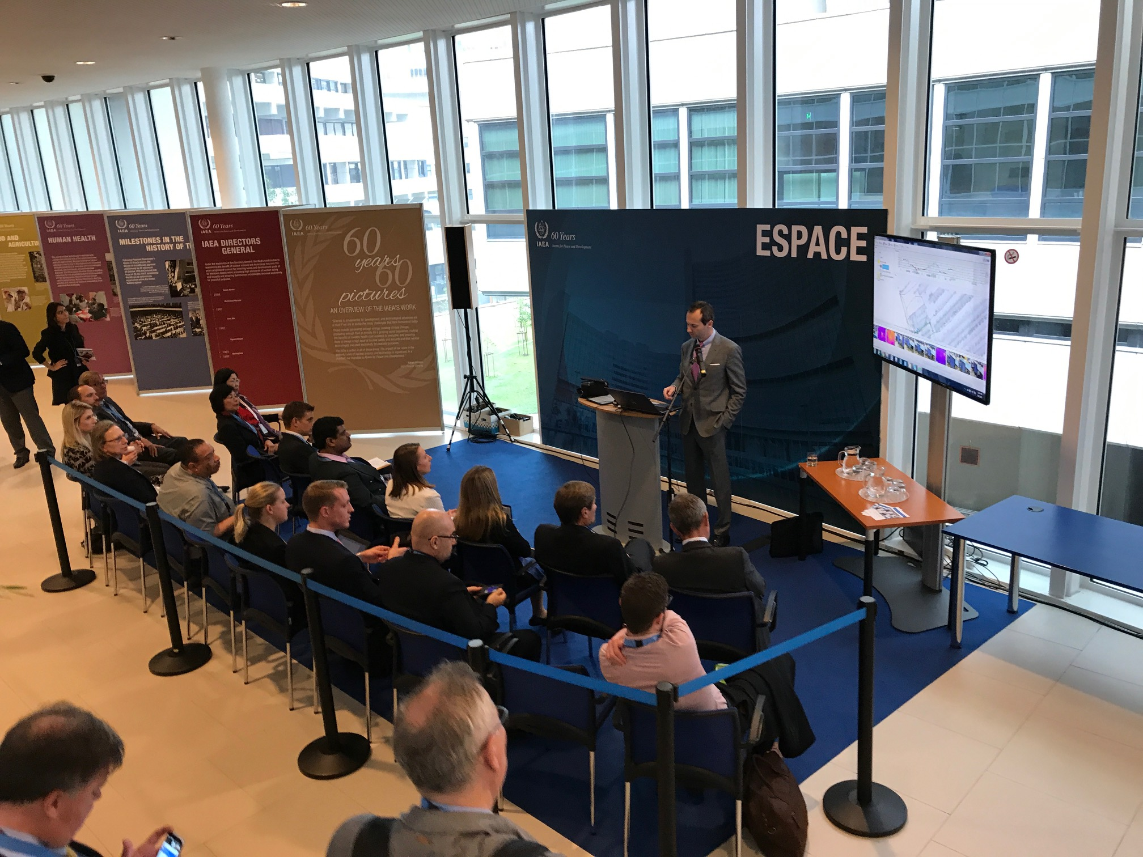ESPACE will look similar to the ones during IAEA General Conference. The following will be available:
- Podium with microphone
- Touchscreen Monitor*
- Approximately 20 chairs.

Please use your Agency Laptop for your presentation. An HDMI connection to the monitor will be available.

Your time slot will be reflected in the Programme. Please arrive 10-15 minutes early to set up.

ITEMS to be SUBMITTED

- Full-length paper (optional)
If you have submitted an abstract, you are welcome to submit a full-length paper as well (but this is optional). All full-papers must be submitted via INDICO.
- Summary of your presentation
If you did not submit an abstract, please send a title and 3 or 4 sentence description of your presentation, which we will put in the Symposium Programme and IAEA’s Conference App (and which will greatly help to attract an audience for your presentation). Please send this to the Safeguards Symposium Team at this email Safeguards2022@iaea.org by 30 September 2022.
- Presentation materials
Each ESPACE presenter is responsible for sending his/her presentation materials to Safeguards2022@iaea.org (together with the EPR clearance sheet for internal presenters), no later than 25 October. Please pre-load the presentation in your own laptop to be used during the ESPACE session. Please email A.Yeoh@iaea.org and I.Rodina@iaea.org if you have questions.

REFERENCE
OBJECTIVES of the SYMPOSIUM
The Symposium has three interrelated objectives:

- Reflect - celebrate the historic anniversaries and achievements thus far, building common understanding of experience gained and key milestones that have shaped safeguards, and reflecting on experience gained and lessons learned over the course of decades of safeguards implementation and on where we are today;
- Anticipate - anticipating nuclear energy’s role in addressing global challenges, envisage how the IAEA’s operating environment will likely evolve over the coming

decades, and identify what this means for safeguards in the form of both new challenges and opportunities.; AND
- Inspire - based on lessons from the past and insights about the future, identify actions to take and stakeholders and partnerships to support them, towards ensuring a safeguards system that is well prepared for continued success in the decades ahead.

Please download for free the Conference App from the App Store and Google Play prior to the start of the Symposium.
If you have any questions, please email to Safeguards2022@iaea.org.
Attachments: Biographical Summary and Release of Biography forms

BIOGRAPHICAL SUMMARY

Please ensure to include in a separate file your photo saved in a JPEG format with a resolution of 200 x 200 pixels. Send the photo together with the following two forms to your session owner with a copy to Safeguards2022@iaea.org by 30 September 2022. Subject line: CN-303 Forms (session code, abstract ID number and full name).

FAMILY NAME:
FIRST NAME:
PAPER TITLE &
ABSTRACT ID NUMBER:
AFFILIATION/COMPANY:
COUNTRY /
INVITED ORGANIZATION:
BRIEF BIOGRAPHY for the CONFERENCE APP
(max. 250 characters)

RELEASE of PRESENTATION MATERIAL and BIOGRAPHY

I agree that my presentation material and biography for the Symposium on International Safeguards: Reflecting on the Past and Anticipating the Future (CN-303/EVT2005412), 31 October– 4 November 2022, Vienna, Austria, may be made available on the IAEA website and the Conference App.

PAPER TITLE &
ABSTRACT ID NUMBER:
COUNTRY /
INVITED ORGANIZATION:
FAMILY NAME:
FIRST NAME:

YES ☐ | NO ☐ Signature: _________________________________

