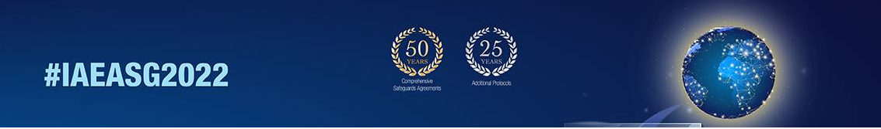

2022 Symposium on International Safeguards: Reflecting on the Past and Anticipating the Future
Guidelines for Authors on Preparations of Full Papers for Proceedings

- Submission of Papers

The full paper should be from 4 to 10 pages, and must be submitted through the INDICO platform in both PDF and Word-format. Please upload your full paper by taking the following steps;

- Log-in to your INDICO account (https://conferences.iaea.org/indico/event/292/).
- Click “My contribution” on menu.
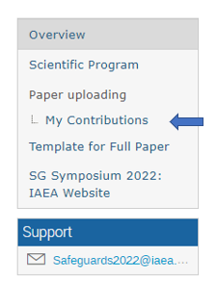

- Download the paper template.
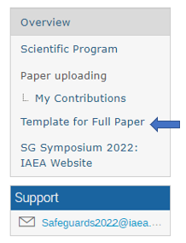
- Prepare your paper in both Word and PDF formats. Please make sure you title your paper ““ID xxx – [Last Name]”.
- Click “Submit paper”, then drag & drop your paper in Word and PDF formats.
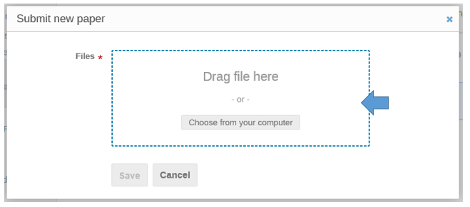

- Click “Save” to complete the submission.

- Check your submission status / presenter information

- Click again “My Contributions” on menu.
- Select your contribution. The status should show “Your paper is under review”.
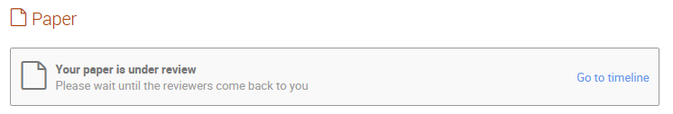
- Please also check if the speaker is indicated correctly. If you wish to make changes to speaker/primary author/co-author, please contact Safeguards Symposium Team.
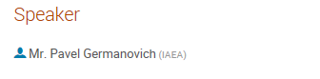

- Copy-Right

Before the conference, authors will have been requested to sign the “Form for Submission of a Paper” (Form B), assigning the IAEA either copyright or a non-exclusive, royalty free license to publish. Authors are responsible for ensuring that nothing in their papers infringes any existing copyright. If previously copyrighted material is included, authors must provide evidence that the copyright holder has given permission for its use.

The final decision on whether a paper will be published in the proceedings will be taken by the IAEA in prior to the conferences. Should the IAEA decide to publish the papers in another form, the authors will be notified.

- Format

The paper should be supplied in electronic form in PDF and Microsoft-Word format. The paper needs to follow the IAEA’s format and guideline. Template can be downloaded from https://conferences.iaea.org/indico/event/292/attachments/6645/8043/Template_-_full_length_paper.docx.

- Length

The paper must be 4 - 10 pages, including abstract/graphs/figures/references/bibliography.

- Deadline

The paper must be submitted no later than 31 August 2022.

- Contact

If you have any question, send email to Safeguards2022@iaea.org and include “uploading of paper” and your ID in the subject line.

<FAQs>

- I have submitted the paper but wish to make further changes to the paper.
- The paper needs to be send back to you with status “to be corrected”. Please contact Safeguards Symposium Team.

- I cannot submit my paper after 31 August.
- The submission system closes automatically on 31 August, therefore we kindly ask to submit by deadline. If there is absolute need, please contact Safeguards Symposium Team.

- How is my paper published?
- The papers will be published electronically through IAEA Conference App and/or website in prior to the conference. The papers will not be published in print.

Papers for Students Papers Competition have to be submitted by July 31, 2022.

