# ASN’s feedback of Fessenheim nuclear power plant shutdown

***Please name your file ‘Decom2023_AbstractID’. Extended abstracts should normally be between 3-5 pages in length.***

D. TAFANI

ASN (French nuclear safety authority)

Montrouge, France

Email: dominique.tafani@asn.fr

## INTRODUCTION

The year 2020 was marked by the final shutdown of Fessenheim nuclear power plant (NPP) that comprises two pressurized water reactors (PWR). As those two reactors are the first being shut down amongst the 58 PWR reactors of the French fleet, their decommissioning will provide the licensee and ASN with considerable experience feedback. This paper presents the ASN feedback of Fessenheim shutdown preparation and implementation of the first preparatory operations towards the start of the decommissioning phase itself.

## Fessenheim NPP

### Description

The Fessenheim NPP comprises two pressurized water reactors (PWR), each with a unit power of 900 MWe. As shows in Fig. 1, it is situated 1.5 km from the German border and about 30 km from Switzerland. It is built alongside the Grand Canal d'Alsace, a canal channeling the Upper Rhine river, from which it drew water for cooling. Thus the site has no cooling tower. The Fessenheim NPP nuclear island is made up of a reactor building and a fuel building for each reactor and a nuclear auxiliaries building shared by the two reactors, housing the effluent treatment, ventilation and air filtration facilities. The NPP has also one turbine hall housing the two alternators that produced electricity from the steam coming from each reactor.

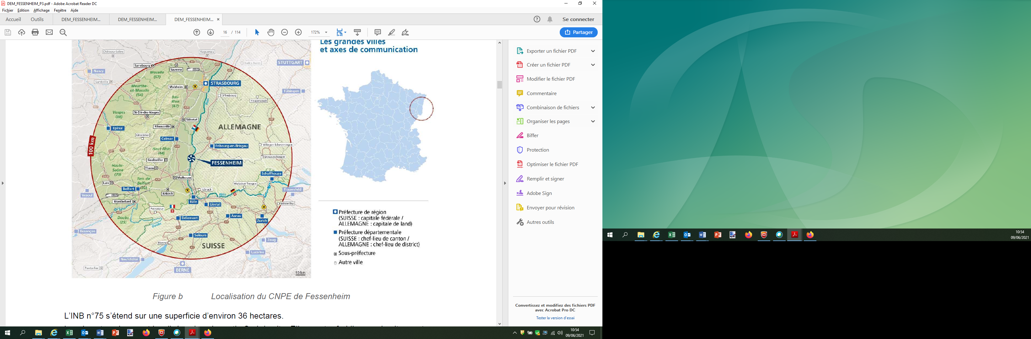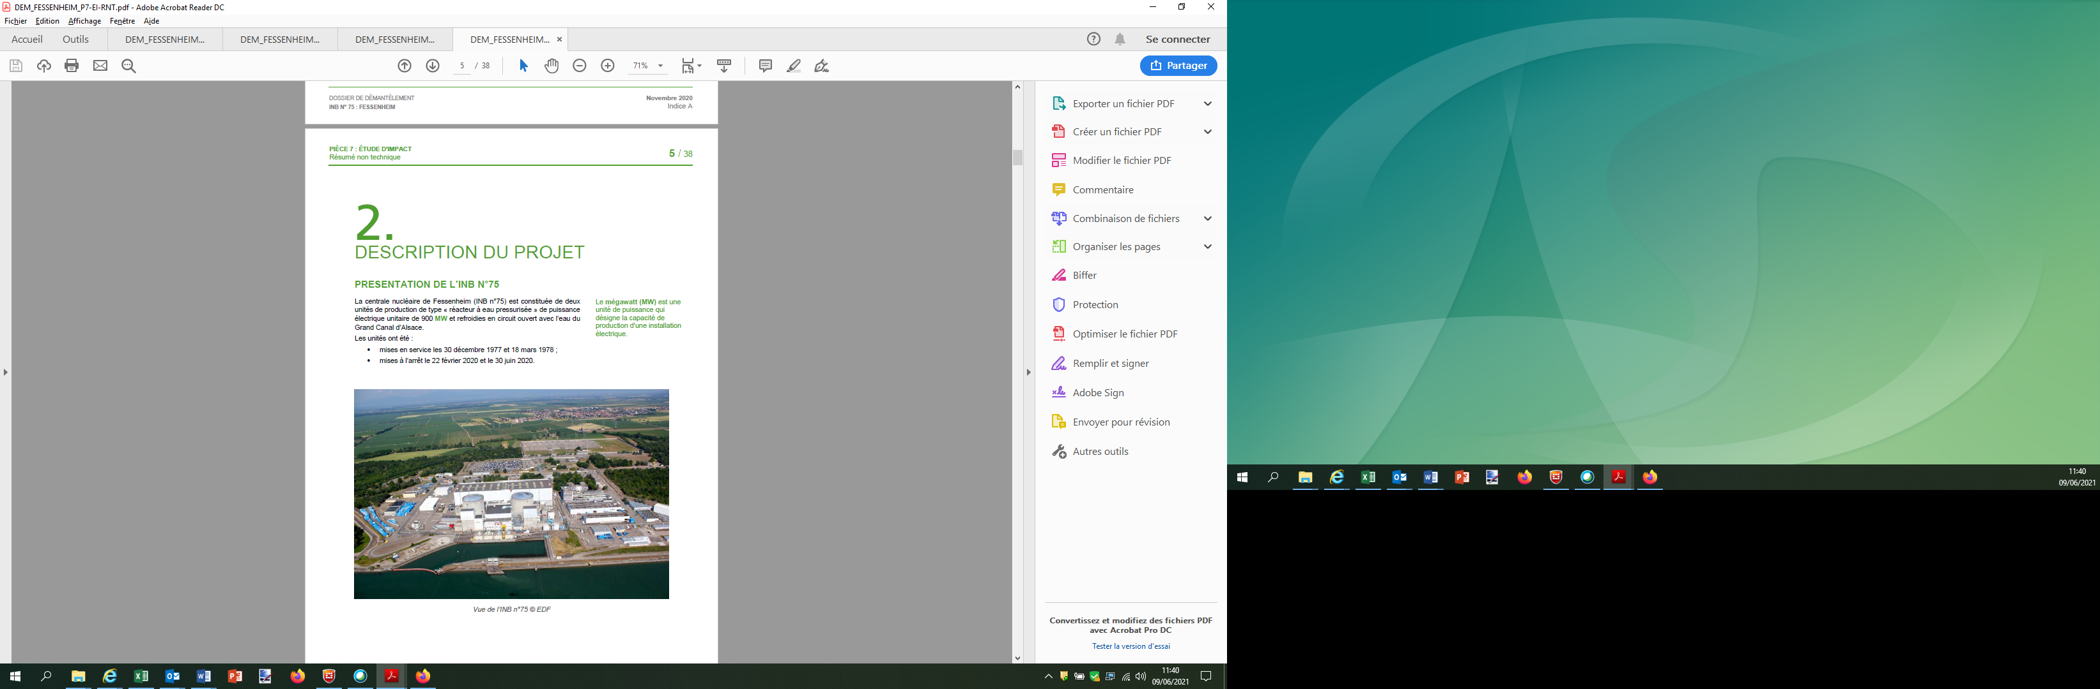

*FIG. 1. Fessenheim NPP location and view.*

### Administrative lifecycle

The creation of Fessenheim NPP was authorized by the Creation Authorization Decree (DAC) of the 3rd of February 1972, still in force and which specifies the operating conditions of the installation. The two reactors were commissioned in 1977 and 1978. The main key dates of the operation of the NPP are the following:

* 1989 and 1990: first ten-yearly outage of the two production units;
* 1999 and 2000: second ten-yearly outage;
* 2002: replacement of the steam generators (SG) of the production unit No. 1 and storage of the used SG onsite;∙
* 2009: third ten-yearly outage of the production unit No. 1;
* 2011: positive opinion of ASN on the conditions for the continued operation of the production unit No. 1 for the next 10 years;
* 2012: completeness of the third ten-yearly outage of the production unit No. 2 and replacement of the unit SGs, used SGs stored onsite;
* 2013: positive opinion of ASN on the conditions for the continued operation of the production unit No. 2 for the next 10 years.

Eventually, the licensee transmitted the declaration of the final shutdown of Fessenheim NPP to France national authorities (ASN and French ministry for nuclear safety) in 2019 and the two reactors were permanently shutdown in 2020.

The decommissioning file of the NPP has been submitted by the licensee to France national authorities in December 2020 and is being under examination in order to prescribe the Decommissioning Decree that will define the main steps and safety requirements of the facility decommissioning process and which is expected around 2026.

## Preparing for shutdown

### Final decommissioning plan preparation examination

With the declaration of final shutdown, the licensee transmitted in 2019 a revised decommissioning plan of Fessenheim NPP, pending the final decommissioning plan expected with the decommissioning file to be sent (see above). ASN examined this plan and requested the licensee for complements, in particular to provide justifications concerning the strategy applied in choosing the decommissioning preparation operations and the details concerning primary system decontamination and the spent fuel removal schedule. A new version of this revised plan was sent by the licensee in May 2020, thus considered by ASN as satisfying.

### ASN inspections

#### On site preparation

In 2019, the site started the planning and preparation of the reactors shutdown operations scheduled in 2020, and the management of the workforce and skills during the period prior to decommissioning. ASN carried out several onsite inspections and has observed the maintaining of a highly satisfactory level of personnel involvement which lead ASN to consider that the management of the organisational and human challenges entailed by the prospective closure of the site was very good. The Fessenheim NPP production activity ended with a highly satisfactory level of performance in terms of safety. Although the situation observed during these inspections was satisfying, it was noted that the insufficient anticipation of the final shutdown decision by the top management of the licensee has led to severe constraints on the planning of pre-dismantling operations and the modifications of baseline safety requirements.

#### In-depth inspection

During this preparation phase for shutdown and decommissioning, ASN carried also out an in-depth inspection at the licensee division in charge of the decommissioning project of Fessenheim NPP and on the Fessenheim site in November 2019 to control the licensee organization for planning the decommissioning. During that inspection ASN identified shortcomings in the management of the Fessenheim decommissioning project, which at the time did not give the licensee an overall picture of the project with all its interactions. In response to this, the licensee set up a project dedicated to the decommissioning preparation phase, the aim of which was to guarantee that the initial decommissioning state will be reached by the issuing of the Decommissioning Decree: this new organization integrates all the licensee contributing entities in this project, starting with the site. Through this project the licensee has also bolstered its organization in order to establish and validate the structuring decisions for the decommissioning preparation phase and then for the decommissioning itself. ASN then considered that the organizational changes proposed by the licensee were on the whole satisfactory. Since then ASN is controlling that these changes are reflected operationally in the management of the future operations.

## pending decommsissioning decree

### First operations and controls

Following final shutdown, the cores of the two reactors have been completely unloaded; the spent fuel has been stored in the site’s cooling pools pending transfer to the La Hague treatment facilities. In view of the ongoing personnel departures in the various departments and the end of production, the site’s organisation was modified after the final shutdown as regards the size of the operating teams, the organisation of the On-Site Emergency Plan (PUI), the fire teams’ service, the site’s organisation chart and the number of departments. Through its controls, ASN observed that contrasting with the situation observed during the period of production just before the final shutdown (see above), this period brought a transient increase in significant events with unusual “organisational and human factors” component, possibly linked to the disruption of organisational and managerial practices resulting from the ongoing reorganisation of the departments. Moreover, since production stopped, the on-site activity concerned systems, procedures, and configurations less familiar to the site’s teams than the previous habitual recurrent operating and maintenance operations. Consequently, in the area of the environment ASN observed a few events stemming from system management errors that could be attributed to such unusual operations. ASN thus expected the licensee to adapt its risk analysis practices to the site’s new activities and operations.

### Preparatory operations controls

#### Fuel evacuation

As mentioned above, fuel evacuation started from the final shutdown of Fessenheim NPP. ASN required the licensee to complete the fuel removal operations by the end of 2023. All the fuel was then evacuated before the end of 2021 for the production unit No. 1, while fuel evacuation was completed during summer 2022 for the reactor No. 2.

#### Primary circuits decontamination

The main operation of the preparatory phase of the decommissioning after fuel complete evacuation consists in the decontamination of primary systems, a first of its kind in France. The aim of this operation is to minimise the risks associated with ionising radiation during future decommissioning of the installation. This operation, submitted to ASN authorization, has already been run in several countries allowing to collate and capitalize on experience feedback. Furthermore, it has been the subject of exchanges between ASN and Germay and Belgium nuclear safety regulators.

#### Other operations

In addition of fuel evacuation and primary circuits decontamination, the licensee has schedule to implement in the former turbine hall a new facility for treating and packaging the waste resulting from the future decommissioning. Installation of new effluent treatment capacities, removal of a large number of spare parts and the work to develop new organisational baseline requirements for the site, such as the emergency plans have also to be done during the preparation phase before the enforcement of the Decommissioning Decree around 2026. The site has moreover undertaken an effective drive to remove the legacy waste from the site, along with chemical products that are no longer necessary.

ASN is performing controls on the site in order to check that these activities are proceeding satisfactorily, in accordance with the submitted schedules and the safety requirements.

## Conclusions

After its final shutdown in 2020, the Fessenheim NPP is now in the preparation phase towards the issuing of the Decommissioning Decree around 2026 that will define the main steps and safety requirements of the facility decommissioning process. While final shutdown was lead with a high performance and the preparatory operations implementation is overall satisfactory, main issues identified by ASN are relevant to the licensee organization to perform unusual operations in a context of changes in the management of these last onsite and in the central divisions of the licensee.