The development of requisite infrastructure and frameworks for effective and efficient decommissioning in Ghana; an ambitious nuclear power plant implementation Country

G. GBEDDY

Radiation Protection Institute, Ghana Atomic Energy Commission

Accra, Ghana

Email: g.gbeddy@gaec.gov.gh

E.T. GLOVER, Y. ADJEI-KYEREME, E. AKORTIA, P. ESSEL, E.M. AMEHO

Radiation Protection Institute, Ghana Atomic Energy Commission

Accra, Ghana

**Abstract**

## The vision of expanding the peaceful application of nuclear science and technology in tandem with international regulations and requirements such as the International Atomic Energy Agency’s Fundamental Safety Principles and General Safety Requirements has led to the passage of the Nuclear Regulatory Authority Bill 2014 by the Parliament of Ghana in August 2015. This has culminated in the decoupling and establishment of the Nuclear Regulatory Authority from the Ghana Atomic Energy Commission (GAEC). The Bill has stipulated the essential regulatory framework and infrastructure for effective and efficient decommissioning in Ghana. Ghana has successfully converted her 30kW research reactor from highly enriched Uranium (HEU) fuel to low enriched Uranium (LEU) fuel with repatriation of all the relevant components to the manufacturer in China. Therefore, Ghana does not have legacies from the application of nuclear science and technology except for disused sealed radioactive sources. This paper highlights some vital aspect of decommissioning processes including decommissioning plan, financing of decommissioning, obligations of an authorized person for decommissioning, and decommissioning of nuclear facilities. The actualization of the Bill will ensure that Ghana’s current and future nuclear energy activities will be conducted in a safe, secure, and sustainable manner.

## Introduction

Nuclear science and technology have been applied invariably across various sectors of the Ghanaian economy since 1950 including industry, medical field, agriculture, research, and education. Ghana currently operates a 30 to 34 kW research reactor referred to as GHARR-1 solely for research and educational purposes. The highly enriched Uranium (HEU) fuelled reactor was commissioned in 1994. After over two decades of peaceful utilization, the core of the reactor was converted into low enriched Uranium (LEU) fuel core. This conversion exercise was aimed at minimizing proliferation risks associated with the HEU while ensuring that scientific research is not impeded [1]. The successful conduct of the conversion exercise demands the existence or establishment of requisite infrastructure and framework akin to the conduct of any regular decommissioning exercise for a nuclear facility. In this context, the Ghana Nuclear Regulatory Authority Bill 2014 which establishes the Nuclear Regulatory Authority (NRA) with a clear mandate to ensure the effective implementation of Ghana’s international obligations and for related matters; provide for the protection of persons and the environment against the harmful effects of radiation hazards; regulate and manage all activities and practices for the peaceful use of nuclear materials or energy, radioactive materials, or radiation. The ACT essentially sets out the necessary legal framework for undertaking decommissioning of any nuclear installation or nuclear related facilities including facilities using sealed radioactive sources [2]. There are four sections in the NRA ACT with reference to regulating decommissioning of nuclear facilities in tandem with IAEA’s General Safety Requirements on the decommissioning of facilities which stipulates that government shall establish and maintain a governmental, legal, and regulatory framework within which all aspects of decommissioning, including management of the resulting radioactive waste, can be planned, and executed safely [2, 3]. This paper is aimed at illuminating existing framework and infrastructure in Ghana that are necessary for effective decommissioning of nuclear and other associated facilities with particular emphasis on the GHARR-1 core conversion from 90% HEU 235 to 13 % LEU 235 fuel [4].

## DECOMMISSIONING FRAMEWORK AND INFRASTRUCTURE

The decommissioning framework and infrastructure in Ghana can be classified as soft and hard as detailed in Figure 1 below. The soft component basically refers to the legal regime or framework whilst the hard component refers to physical infrastructure, human resource requirements, National Security, and stakeholder collaborations. Further details on these components are provided in the sub-sections below.

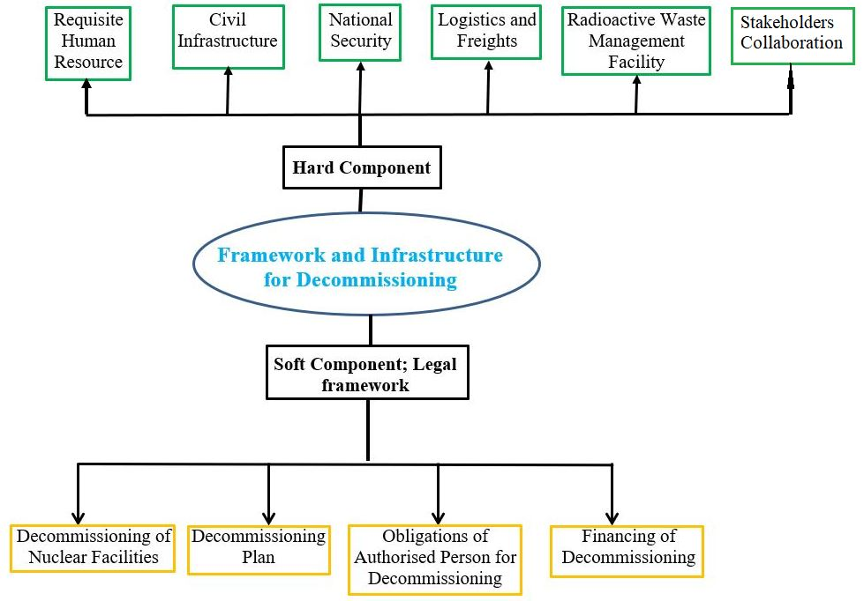

FIG. 1. Chart of decommissioning framework and infrastructure in Ghana

### Soft component; Legal framework

The soft component refers to the legal foundation or basis upon which decommissioning can be conducted safely and effectively in Ghana as elucidated below and in our previous paper Gbeddy, Glover [2]. The core conversion of GHARR-1 and the decommissioning of sealed radioactive sources are found on this legal framework.

#### Decommissioning of nuclear facilities

The conduct of nuclear facilities decommissioning shall among other rules comply with the following legislative framework [2, 5]:

1. The Authority shall require the applicant to construct and operate a nuclear facility; perform a baseline survey of the site to develop information for comparison with the end state after decommissioning, including radiological conditions before the construction.
2. The Authority shall, by a notice published in the Gazette, specify the procedure for the decommissioning of a nuclear facility.
3. The notice shall include:
4. Steps to be taken to resolve any safety and environmental issues and conditions of the end state of decommissioning;
5. Limits and conditions for the removal of regulatory controls for a facility that contains radionuclides;
6. Criteria for the clearance of material during and after decommissioning.
7. The Authority shall evaluate the end state of the facility after decommissioning activities have been completed to ensure that relevant regulatory requirements have been met.
8. The Minister shall on the advice of the Authority, by legislative instrument, make Regulations establishing the criteria for determining when a nuclear facility or part of a nuclear facility may be permanently shut down.
9. *Decommissioning plan*

The following legislative framework must be complied with by players in the nuclear industry [2, 5]:

1. An applicant for authorisation to construct and operate the nuclear facility shall at the design stage of a nuclear facility, prepare a decommissioning plan for approval by the Authority.
2. The Authority shall ensure that interested parties are provided an opportunity to review and comment upon the decommissioning plan before it is approved by the Authority.
3. The Authority shall require the authorised person to provide periodic reviews and updates of the decommissioning plan and shall specify the maximum time intervals between the reviews and the updates.
4. The Authority shall require that a proposed final decommissioning plan be submitted for approval two years before the cessation of authorised activities, unless an alternative schedule for submitting the final decommissioning plan is specifically authorised by Authority.
5. The Authority shall ensure that a programme to implement and monitor compliance with remaining regulatory requirements is established for sites where decommissioning has been completed, including restrictions on future use of the site.
6. The Authority shall ensure that appropriate records are maintained to confirm the completion of the decommissioning plan.
7. For the purposes of subsection (7), the records shall include records of the premises and the disposal of radioactive waste and material and documents that are necessary for responding to possible liability claims.
8. *Obligations of authorized person for decommissioning*

The Authority requires that an authorised person shall, for purposes of the decommissioning of the facility undertake the following obligatory actions [2, 5]:

1. Submit to the Authority a decommissioning plan which is commensurate with the type and status of the facility, and hazards that may be associated with its decommissioning.
2. Prepare safety and environmental impact assessments necessary for the implementation of the decommissioning plan for the approval of the Environmental Protection Agency acting on the advice of the Authority.
3. Conduct a baseline survey of the site in an effective and timely manner.
4. Be responsible for the safety, security and protection of persons and the environment, including any activities conducted by contractors or subcontractors.
5. Submit a final decommissioning plan two years before a permanent cessation of operation and inform the Authority of a decision to permanently shut down the facility two months before shutting down.
6. Maintain the facility in a safe configuration for effective and adequate decommissioning in the future in case of deferred dismantling.
7. Maintain a management and human resource development system within the organisation to ensure that decommissioning can be completed safely, and that responsible persons possess the necessary skills, expertise and training relevant to safe decommissioning.
8. Maintain an emergency planning arrangement correlative with associated hazards and to report significant incidents to the Authority.
9. Arrange for adequate financing at each stage of the decommissioning process including provisions for loss of life or personal injury up to thirty years from the date of decommissioning.
10. *Financing of decommissioning*

This is another vital aspect of the legal framework, and it states that [2, 5]:

1. An applicant for authorisation to construct and operate a nuclear facility shall ensure that adequate financial resources are available when needed to cover the costs associated with a safe decommissioning, including the management of the resulting waste during the operation of the facility.
2. The amount of the financial resources to be made available for decommissioning activities shall be commensurate with the specific cost estimate of the facility and shall be varied if the cost estimate increases or decreases.
3. The estimated cost shall be reviewed as part of the periodic review of the decommissioning plan.
4. The Authority shall on the advice of the Ministry of Finance, Accountant General’s Department and Bank of Ghana establish the necessary mechanisms to enforce the obligations of an authorised person under this Act.
5. For purposes of facilities in existence before the commencement of this Act for which financial resources are not available, proof of financial assistance shall be required before the renewal or extension of an authorisation. For instance in the case of GHARR-1 which was established prior to the enactment of the Act, the core conversion from HEU to LEU and the subsequent repatriation of the HEU core was sponsored by the United States of America (USA) under the American government’s Global Threats Reduction Initiative in collaboration with the International Atomic Energy Agency (IAEA). The initiative was aimed at eliminating the use of weapon grade uranium from civilian use. In this context, circa $20 million was used by the US Government to achieve this aim in Ghana since the Ghana Atomic Energy Commission (GAEC) lacks the requisite financial resources to undertake this project akin to decommissioning of nuclear facilities [4].

### Hard component

The hard component refers to all the various physical resources required to undertake a successful decommissioning of a nuclear facility as elaborated below. The Government of Ghana is in most cases responsible for providing these hard components.

#### Requisite human resource

The availability of requisite human resources who are specialized in the field of decommissioning is pivotal to the conduct of a successful decommissioning of any nuclear facility. When it comes to the decommissioning of DSRS facilities in Ghana, GAEC via the Graduate School of Nuclear and Allied Sciences (SNAS) has produced significant number of competent personnel who undertake the decommissioning. However, in terms of the GHARR-1 core conversion, a team of both local (GAEC and NRA Staff) and foreign ( USA, China, and IAEA) experts were involved.

#### Civil infrastructure

The provision or availability of critical infrastructure such as good road and rail network, airport and harbour are essential for conducting a successful decommissioning of a nuclear facility primarily due to the heavy weight of nuclear facility equipment and their associated components. In this regard, the quality of the road network from the GAEC site to the Kotoka International Airport (KIA) was improved during the GHARR-1 core conversion exercise since there is no inter-connecting rail network.

#### National security

The provision of adequate security that correlates with the threat and hazard levels posed by a nuclear facility is essential. As a result of the 90% HEU 235 core involved during the GHARR-1 core conversion, Ghana’s National Security in collaboration with the Ministry of Interior were put on high alert during the entire period for the exercise. Well trained Military, Police, Fire Service, and Ambulance Service personnels were deployed at the GAEC site and all other strategic locations during the exercise. Military guarded watch towers were mounted at strategic locations at the GAEC site.

#### Logistics and freights

The availability of competent freight and logistics companies either local or foreign are crucial for the transport of heavy weight and high-risk nuclear materials or equipment. As seen in FIG. 2, a haulage trailer loaded with TUK/145/C MNSR package containing the 90% HEU 235 core was successfully transported to the KIA for onward loading into the cargo plane.

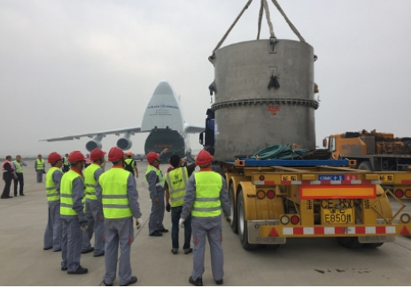

FIG. 2. Trailer loaded with HEU in a TUK/145/C MNSR package (adapted from Graphic Online [4])

#### Radioactive waste management facility

The availability of a well-equipped safe and secure radioactive waste management facility for either permanent or temporary management of radioactive materials or wastes during decommissioning is equally important. The Centralized Radioactive Waste Processing and Storage Facility (CRWPSF) at GAEC site is essential during the decommissioning of nuclear facilities in Ghana; there are many DSRS under storage which were retrieved from regulatory approved decommissioned user facilities. Moreover, the CRWPSF was used to temporarily store the 90% HEU 235 core that was retrieved from the GHARR-1 and kept under 24/7 watchful eyes of the National and GAEC Security.

#### Stakeholder collaboration

The conduct of a successful decommissioning of any nuclear facility involves many key stakeholders such as the Nuclear Regulator, the Operator, National Security, Logistic and Freight Companies, and Emergency Response Services. As such there must be a mutual understanding and collaboration between these stakeholders. Therefore, stakeholders’ engagement forum and training are crucial to attaining an effective collaboration before, during and after any decommissioning exercise.

References

1. IAEA. *IAEA Mission Sees High IAEA, 2018 Commitment to Safety at Ghana's Research Reactor After HEU to LEU Fuel Conversion*. 2018 [cited 2022 21st December 2022]; Available from: <https://www.iaea.org/newscenter/pressreleases/iaea-mission-sees-high-commitment-to-safety-at-ghanas-research-reactor-after-heu-to-leu-fuel-conversion>.

2. Gbeddy, G., et al., *Regulatory framework and standards for decommission and environmental remediation; a case study of Ghana*, in *IAEA International Conference on Advancing the Global Implementation of Decommissioning and Environmental Remediation Programmes*. 2017, International Atomic Energy Agency (IAEA): Spain.

3. IAEA, *Decommissioning of Facilities. General Safety Requirements, Part 6 (7)*. 2007, International Atomic Energy Agency (IAEA): Vienna, Austria.

4. Graphic Online, G. *Devt partners paid $20m to repatriate Ghana’s uranium to China*. 2018 [cited 2022 21st December 2022]; Available from: <https://www.graphic.com.gh/news/general-news/devt-partners-paid-20m-to-repatriate-ghana-s-uranium-to-china.html>

5. Parliament of Ghana, P. *Nuclear Regulatory Authority Bill*. 2014 [cited 2015 11th November 2015]; Available from: <http://www.parliament.gh/publications/36/762>.