# Risks in countries' strong safekeeping of future decommissioning funds

MARTIN MACÁŠEK

Slovak Nuclear Society

Stupava, Slovakia

Email: macasek@centrum.cz

**Abstract**

Countries execute oversight over funds aimed to finance their national nuclear back-end programs (including decommissioning) for two main reasons: to achieve safe-keeping of funds, to prevent loss or theft, and to prevent their managerial and financial mismanagement.

First safekeeping function is ensured via existence of public financial bodies and/or strong audit and supervisory powers.

Similarly, aims are to safely invest accumulated money in order to benefit from its compounding. Yet, meaning of “safe investments” differs from country to country, based on the scope of their nuclear industry, public/private ownership ratio, historical experience with financial investments and acceptability of the risk for national economy.

Presented paper shows inherent risks in strong safekeeping, at the expense of investments.

## INTRODUCTION

In every country with an existing public administrator of funds for the nuclear back-end cycle (NBEC) activities, collected from operators, this administrator has the obligation to carry out the said administration with due care and to ensure the safe investment of managed funds with the aim of their further appreciation.

However, the term “safe investment” is understood in a different way and scope in every country, based on each country’s unique legislation, economic a nuclear industry scope-wise character and acceptable ratio between (financial) risk-free management and profitability. Yet, the economic laws speak clear that as high-risk investments have the potential to bring the highest profit, so do risk-free investments bring adequately minimal, zero, or in some cases and periods of time even a negative appreciation.

In the same way that the nuclear industry does not rely on only one technical system or physical principle to ensure nuclear safety, experience from the financial results of several other national asset management systems of the NBEC shows that a similar approach is partially necessary to be applied in the appreciation of financial its designated resources. For this reason, some countries are starting to allow that these funds are not invested only in expressly risk-free financial market instruments, but also in (moderately and reasonably) riskier items.

## LaGGING OF INVESTMENTS BEHIND INFLATION

Not only during the period of Covid-19 pandemic in 2020-2022, but throughout the entire second decade of the 21st century the financial markets were characterized by extremely low (even negative) returns on the so-called risk-free financial instruments (represented mainly by term deposits in banks and government bonds), which are often the only financial market instruments in which are NBEC money managers allowed to invest. Reality has thus disrupted the original plan of the states that compound interest on risk-free investment instruments will help ensure sufficient financial robustness over time, which will be able to cover the planned costs, taking into account the planned long-term investment profit.

For example, during this period the annual inflation in Slovakia was oscillating in the range of -0,5% to +4,6% in years 2008-2020. At the same time, average net (after taxes) annual rate of returns were in the range of 0,74% to 4,11% - see Table 1.

TABLE 1. ANNUAL RATE OF RETURNS OF THE SLOVAK NATIONAL NUCLEAR FUND IN 2008-2021 AND INFLATION IN THE SLOVAK REPUBLIC

|  |  |  |  |
| --- | --- | --- | --- |
| **Year** | **Net interests (after taxes)** | **Inflation** | **S&P 500** |
|  | **[%]** | **[%]** | **[%]** |
| 2008 | 4.11 | 4.60 | -36.55 |
| 2009 | 2.36 | 1.60 | 25.94 |
| 2010 | 0.74 | 1.00 | 14.82 |
| 2011 | 2.87 | 3.90 | 2.10 |
| 2012 | 2.94 | 3.60 | 15.89 |
| 2013 | 2.76 | 1.40 | 32.15 |
| 2014 | 2.73 | -0.10 | 13.52 |
| 2015 | 2.70 | -0.30 | 1.36 |
| 2016 | 2.60 | -0.50 | 11.96 |
| 2017 | 2.43 | 1.30 | 21.83 |
| 2018 | 2.46 | 2.50 | -4.38 |
| 2019 | 2.35 | 2.70 | 31.49 |
| 2020 | 2.26 | 1.90 | 18.40 |
| 2021 | Not available | 3.20 | 30.92 |

### Inflation over time

In addition to the effect of compound interest, the value of money also changes during the monitored period due to inflation. Inflation manifests by a long-term increase in the price level of goods and services, or by a permanent reduction in the purchasing power of money.

Due to the influence of macroeconomic effects, there is a constant change in the value of inflation. A combination of data from the World Bank and Eurostat indicates that the average value of inflation in the countries of the European Union for the last 62 years (from 1960 to 2021) was 4.41% - see graph in Fig. 1 [1].

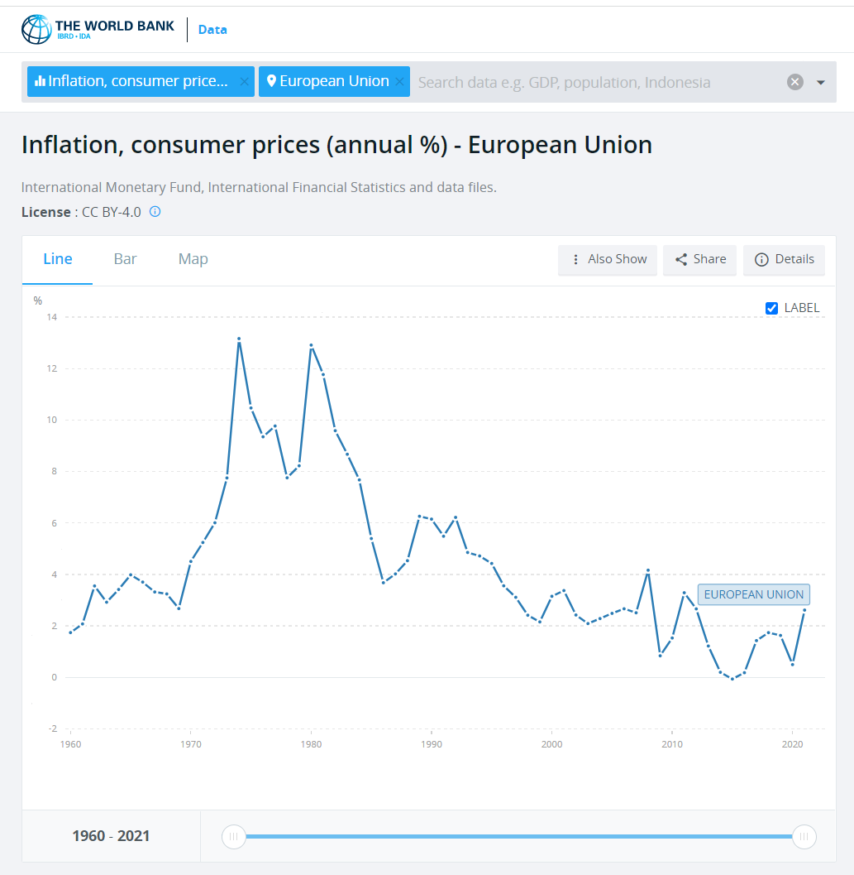

*FIG. 1. Annual inflation in European Union 1960-2021*

### Average values of interest income of stock market indexes since 1960

Due to fluctuating nature of both fixed term interest rates and inflation, it is necessary to use their averages in NBEC’s long term planning. The extended life span of NBEC fund accumulation is allowing to consider long-term average values as a valid factor.

Average values show that one of the most known reliable long-term tools of beating inflation is through the use of specialised investment vehicles called index funds. As an example - one of the oldest and most known indexes used is the American S&P 500 Index, which combines the 500 largest companies listed on the American stock exchange. It has been operating under this name since 1957, while its direct predecessor was created in 1926. During its entire existence (since 1926), the S&P 500 index has achieved an average annual appreciation of 10.49%. For the period from 1957, it achieved an average annual appreciation of 10.67%.

The appreciation curve of a one-time deposit of USD 100 from 1960 to the end of 2021 is shown in the graph in Fig. 2 [2].

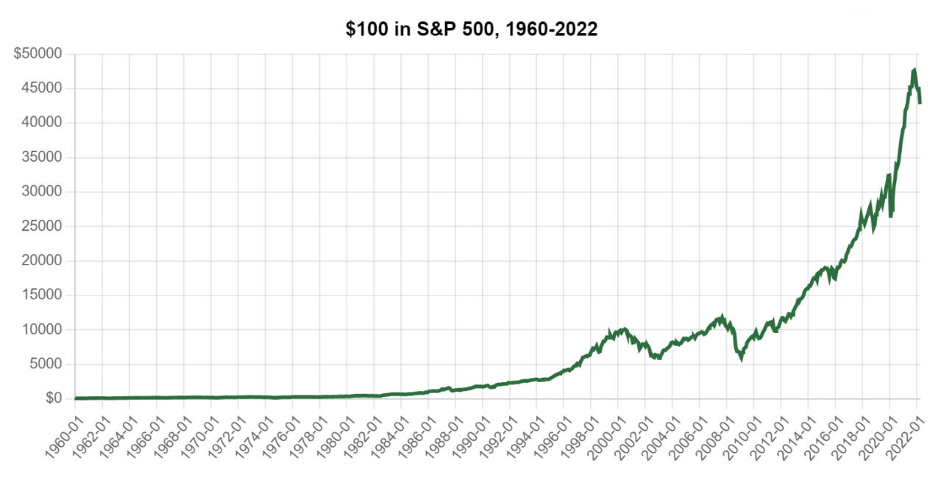

*FIG. 2. Appreciation of a single deposit in S&P 500 1960-2022*

From the long-time perspective, short time depressions do not represent a major risk. On the contrary – application of the principle of the price averaging principle allows to set solid growth foundations for the future rate of returns, as well as to minimise depression impacts that would otherwise effect one-time only investment.

## Way FORWARD

Presented data show that the price of risk-free nominal returns are outweighed by the minimum real appreciation of managed funds due to inflation.

An extremely opposite situation would be an effort to achieve high valuation through high-risk financial market instruments.

However, application of certain mix of these principles will require a unique national discussion of optimal diversification and spread of financial risk - at every moment decision is made as well as overall during the whole accumulation period. There must be a different risk ratio at the beginning of a nuclear facility’s operation and a different one in its final period.

With a considered long-term investment horizon (this paper will work with the premise of an NPP operating (and contributing) to nuclear fund for 60 years), returns are maximized through the law of compound interest, while risks are minimised through price averaging.

Specific examples of various financial outcomes depending on the investment strategy will be presented through a reference scenario of a new built of EMO 3,4 nuclear power plant in Slovakia, due to be put into commercial operation in 2023.

## Further information

### Author affiliation

Martin Macasek, [macasek@centrum.cz](mailto:macasek@centrum.cz)

Slovak Nuclear Society

Slovak Republic

ACKNOWLEDGEMENTS

Acknowledgements for encouraging researching this paper go to Prof. Ing. Vladimír Slugeň, DrSc., President of the Slovak Nuclear Society, for his relentless promotion of nuclear industry to the general public, as well as for his professional guidance during the research, in order to increase nuclear safety of national nuclear back-end program through securing sufficient funding over time of the facility’s operation.

The same acknowledgements go to Prof. Ing. Vladimír Nečas, PhD., Head of Department of Nuclear Physics and Technology at the Slovak Technical University in Bratislava, for his decades of diligent work in inspiring young students to study nuclear science.

References

1. EUROSTAT: The World Bank: Inflation, consumer prices (annual %) - European Union; [online], [quote: 2022-01-02], Available at: https://data.worldbank.org/indicator/FP.CPI.TOTL.ZG?end=2021&locations=EU&name_desc=false&start=1960&view=chart
2. Officialdata.org: Stock market returns since 1960; [online], [quote: 2022-01-01], Available at: [https://www.officialdata.org/us/stocks/s-p-500/1960?amount =100& endYear=2022](https://www.officialdata.org/us/stocks/s-p-500/1960?amount=100&%20endYear=2022)

BIBLIOGRAPHY

Official Journal of European Union: Council Directive 2011/70/Euratom of 19 July 2011 establishing a Community framework for the responsible and safe management of spent fuel and radioactive waste.

OECD Nuclear Energy Agency: Preparing for Decommissioning During Operation and After Final Shutdown, OECD/NEA PUBLISHING no. 7374, 2018, Paris.

Macášek, m., Slugeň, V, Šnírer, M.: Slovak legal system for ensuring feasible nuclear back-end system implementation, Part 1: Description of the current status; Nuclear Law Bulletin no. 105, OECD/NEA PUBLISHING no. 7534, 2021, Paris.

Macášek, m., Slugeň, V, Šnírer, M.: Slovak legal system for ensuring feasible nuclear back-end system implementation, Part 2: Outlook for future development; accepted for Nuclear Law Bulletin no. 107, OECD/NEA PUBLISHING, in print, 2022, Paris.

Macášek, m., Slugeň, V.: Legislatívne zabezpečenie realizovateľnosti zadnej časti jadrovej energetiky; Magasine Jaderná energie 3/2020 (66), ISSN 2694-9024; [online]. Available at: https://jadernaenergie.online/archiv/3-2020/

OECD Nuclear Energy Agency: Costs of Decommissioning Nuclear Power Plants, OECD/NEA PUBLISHING no. 7201, 2016, Paris.

OECD Nuclear Energy Agency: Financing the Decommissioning of Nuclear Facilities, OECD/NEA PUBLISHING no. 7326, 2016, Paris.

OECD-NEA: International Conference on Decommissioning of Nuclear Installations: Strategies, Practices and Challenges: MACÁŠEK, M.: The Slovak Strategy for Decommissioning: JAVYS – A National Decommissioning Company, 9-11 November 2015, Moskva; Dostupné na:https://www.oecd-nea.org/rwm/workshops/decom-installations 2015/.