# decommissioning of josé cabrera npp

Past, present, future and lessons learned from a regulatory perspective

***‘Decom2023_AbstractID#64’***

SOFIA LUQUE

CSN

Madrid, Spain

Email: slh@csn.es

SUSANA SOLÍS

CSN

Madrid, Spain

JOSÉ LUIS REVILLA

CSN

Madrid, Spain

**Abstract**

In Spain, the José Cabrera nuclear power plant (NPP) is facing the final stage of its decommissioning process, where the clean-up plan is currently ongoing.

In accordance with Spanish regulations, the Spanish Nuclear Safety Council (CSN) is responsible for ensuring that nuclear facilities are managed safely in all stages of their life cycle, including decommissioning, with the aim of protecting workers, population and environment from the harmful effects of ionizing radiation. In addition, the National Radioactive Waste Company, SA (Enresa) is responsible for planning and performing the decommissioning of nuclear facilities.

In this paper, we will overview the evolution of the decommissioning process of José Cabrera NPP, from a regulatory point of view, focusing on the current status of the site and the regulatory challenges to undertake in the near future, outstanding the lessons learned in this process, that have been analyzed by a working group established between CSN and Enresa for this purpose. The objectives of the group, the selected topics to be analyzed, the selected methodology, and the main conclusions obtained are also presented in this extended abstract.

## INTRODUCTION

José Cabrera NPP, was the first to be commissioned in Spain, back in 1968. It was a 160 Megawatt PWR power reactor, located in the municipality of Almonacid de Zorita, province of Guadalajara. In April 2006, after 38 years operating, José Cabrera was shut down, and its decommissioning was authorized on February 1st, 2010. This entailed the first full dismantling of a nuclear power plant in Spain. The dismantling activities include decommissioning and removal of conventional parts, segmentation with special cutting techniques of large radioactive systems and components, decontamination and demolition of buildings, and final site restoration. Currently, the clean-up plan is being carried out with the aim of applying for the licence termination in the next few years.

In this context, and taking into account the Spanish ongoing Closure Plan of all of its nuclear power plants before 2035 (PNIEC), the CSN and Enresa saw the need of recording and documenting the lessons learned from the decommissioning of José Cabrera NPP to be applied to the forthcoming decommissioning projects, that will begin with the decommissioning of Santa María de Garoña NPP in the second half of 2023.

## legal framework

In Spain, Law 15/1980, creating the Nuclear Safety Council, explicitly states that the CSN is the only competent body in matters pertaining to nuclear safety and radiological protection, including decommissioning activities. Therefore, the CSN elaborates rules, which will become part of the Regulatory Framework on the subject under the scope of the rule, and evaluates and inspects that these activities are carried out in safe conditions.

Additionally, Royal Decree 102/2014, for the responsible and safe management of spent fuel and radioactive waste, establishes that the dismantling and decommissioning activities are classified as a public service, and ENRESA is the public enterprise in charge of this task (see Fig. 1)

Transfer of

Ownership

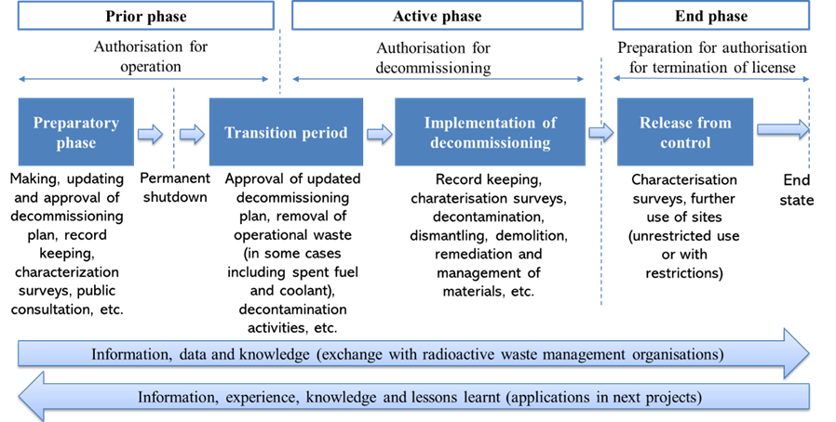

*FIG 1: NPP´s cycle: From commissioning to decommissioning*

On top of the previous Laws and Royal Decrees, there are several other regulations that serve as the framework for the regulatory requirements and conditions.

Furthermore, Art. 12 of the Royal Decree 1836/1999 provides for the regulation, by means of CSN Instructions, of aspects of nuclear safety and radiological protection during the dismantling and closure of the facility and during the post-closure surveillance and monitoring phase, including the scope and content of the safety demonstrations or studies at each stage.

Once the decommissioning activities are concluded, Article 33 of the Royal Decree 1836/1999 establishes that Ministry of Ecological Transition and Demographic Challenge (MINETAD), will issue a decommissioning statement (license termination) that will free the facility from CSN control after receiving the CSN favourable report. In the case of restricted site releases, the decommissioning statement also defines the restrictions on the future use of the site and the body responsible for maintaining and verifying the compliance of such restrictions.

## DISMANTLING OF josé cabrera npp

The José Cabrera nuclear power plant was shut down by Ministerial Order on 20 April 2006. This entailed the first immediate full dismantling of a nuclear power plant in Spain. Since the decommissioning permit was granted, the plant has been undergoing the dismantling of all of its structures, systems and components, until June 2022, when the clean-up plan was approved by the CSN (see Fig. 2).

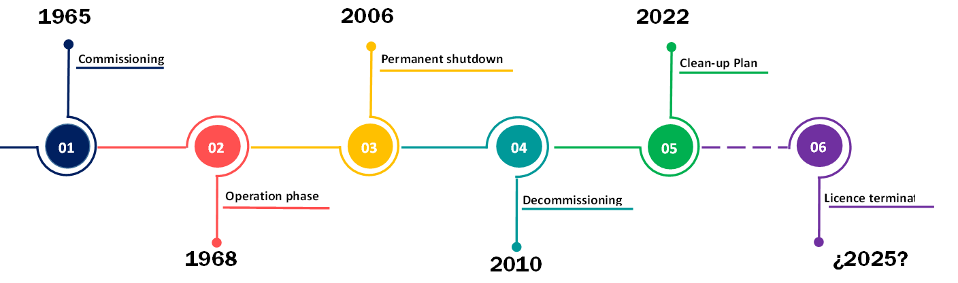

*FIG 2: José Cabrera NPP life cycle*

The permanent shutdown stage began with the approval by the MINETAD, after favorable report of the CSN, of the preliminary Dismantling Plan. In this stage, the main activities carried out were the licensing of a spent nuclear fuel storage facility onsite and other pre-dismantling tasks such as the conditioning of operational waste. The CSN has ensured that safety requirements were being met by reviewing the official decommissioning documentation, conducting inspections, and monitoring the status of activities (see Fig. 3).

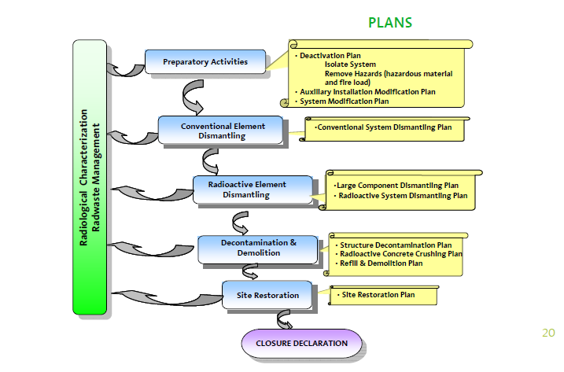

*FIG.3. Decommissioning strategy for José Cabrera NPP*

Between 2010 and 2011, once the decommissioning stage had begun, it was necessary to adapt some of the plant’s systems and auxiliary facilities to make them available and functional for the activities involved in dismantling. One of the most important was the transformation of the turbine building into the new Auxiliary Building for Dismantling, for the treatment and temporary storage of waste from the containment building, for which a tunnel that would connect both buildings was constructed. From a regulatory point of view, this meant the assessment by the CSN experts in terms of radiological impact to public and environment; radiation protection of workers; management of radiological waste; ventilation systems; fire protection systems and quality assurance, being a core building in the dismantling of José Cabrera NPP.

Additionally, non-radiological buildings, such as the diesel building, cooling towers, electrical building, control room and electrical transformer area, were fully dismantled.

Once these activities were finished, between 2012 and 2016, it was the time of the radiological components. The primary circuit was dismantled in the former spent fuel pool by cutting under water the reactor internals and the reactor vessel with remotely operated cutting tools. The rest of the primary circuit was also segmented and managed mainly as radioactive waste. These activities were supervised by the resident inspector of the CSN at José Cabrera NPP and by the CSN experts in the matters involved. After these components were removed, the surface decontamination tasks begun on the walls and floors of the various radiological buildings. An approved clearance methodology for surfaces was applied, which guaranteed the absence of residual contamination.

The next steps taken between 2017 and 2022, were the demolition of buildings and infrastructures using conventional methods. Management of materials was a key activity focused on optimizing the volume of waste that required treatment by promoting policies for waste segregation and recycling (see Table 1). Conventional materials were removed and sent to the relevant specific processing plants, and, very low, low and intermediate level waste was sent to the disposal facility at El Cabril (Córdoba).

TABLE 1. RADIOACTIVE WASTE MANAGED IN JOSÉ CABRERA NPP DISMANTLING (IN TONS)

|  |  |  |
| --- | --- | --- |
|  | PRIMARY CIRCUIT | REST OF THE NPP |
| High Level Waste | 40 | - |
| Very Low, Low and Intermediate Level Waste | 360 | 3600 |
| Total | 400 | 3600 |

In 2022, the last important building, the Auxiliary Building, was dismantled, and in June, the Site Restoration Plan was approved. This plan aims to ensure that the land to be released for industrial use is free of residual radioactivity above some approved release levels before application is made for the declaration of decommissioning, with the aim of returning the site to its owner.

## site restoration plan

Currently, the plant is implementing the so-called Site Restoration Plan, or clean-up plan, approved by the Ministry of Industry, after favourable report of the CSN. This plan intends to reduce radioactivity in surface, subsurface soils and groundwater to a level that accomplishes the radiological criteria established in the Spanish regulations.

These criteria are established in CSN Safety Instruction nº 13 about radiological criteria for the release of nuclear installations, as follows: “*The effective dose to the individual representative of the critical group, due to the residual activity present in the land of the site, once released, must not exceed the value of 0.1 mSv/year”.* This radiological criterion applies to the whole site, whether it is for restricted or unrestricted release. Additionally, the buildings, walls and structures to remain in the site must comply with the clearance levels recommended by the European Union in its publication Radiological Protection 113, "Recommended radiological protection criteria for the cleaning of buildings and debris from the dismantling of nuclear facilities».

The approval of this plan has been assessed by the CSN experts on radiological impact to public and environment, hydrogeological impact and radiological environmental surveillance. Inspections are conducted in a quarterly basis to follow the evolution of the restoration.

After scoping, characterizing and carrying out the necessary remedial actions, the license must demonstrate that a site complies with the radiological criteria. This can be achieved by the US Multi-Agency Radiation Survey and Site Investigation Manual (MARSSIM) methodology, which is included in the recommendations of the CSN Safety Guides 4.2 “Site Restoration Plan” and 4.3. “Methodology for the verification of the final status of the site prior to release. Generic release levels”.

## LESSONS LEARNED

Spain’s Ministry for Ecological Transition issued in 2019 a protocol for the orderly and staggered closure of the Spanish nuclear park between 2027 and 2035, taking into account the provisions of the National Integrated Energy and Climate Plan (PNIEC) 2021-2030.

In this context, and in order to derive lessons learned from the decommissioning of José Cabrera NPP for their implementation to the forthcoming decommissioning processes, and specifically, for its proximity, for the decommissioning of Santa María de Garoña NPP, a working group between CSN and Enresa was established to analyse such experience.

The objective of this WG was to identify the difficulties encountered by Enresa and CSN in the licensing process of José Cabrera NPP and establish improvement mechanisms to facilitate the decommissioning processes to come.

The aim was to address four focus areas:

* Quality and content of the documentation
* Coordination between CSN and ENRESA
* Authorization conditions
* Workers Licensing

To develop this work, five meetings were held with the participation of 10 decommissioning experts from both, CSN and ENRESA. The conclusions obtained were stated in nine fact sheets were a summary of the problem, the lessons learned and some improvement recommendations were exposed.

Regarding the quality and content of the documentation the main conclusion was that there was a necessity of a good planning and a meticulous preliminary review of the documentation before getting involved in the official assessment process, in order to optimize deadlines. All the technical information to be exchanged between CSN and Enresa should be centralized through the enabled channels, such as the one between the project manager of the CSN and the responsible for the licensing of the project in ENRESA. The information exchange should try to be agile, official, and accomplish with the deadlines established in the regulations. This, again, requires a good planning phase.

In terms of the authorization conditions, the main lesson learned was that it should be taken into account that in the decommissioning process, the facility is constantly changing, therefore, the conditions established in the decommissioning authorization should be sufficiently adaptable to the new situations generated and consequently the regulation process should adapt to it in a graded approach. This graded approach is applicable also to the worker’s licences.

## CONCLUSIONS

In February 2010, the decommissioning authorization of José Cabrera NPP was granted. This phase has been carried out successfully by ENRESA under the supervision and control of the CSN, and currently it is facing its last stage prior to the licence termination application. The CSN is currently involved in the process of licensing of Santa María de Garoña NPP decommissioning plan. In order to derive lessons learned from the decommissioning of José Cabrera NPP, of application to this licensing process, a working group between CSN and Enresa was established to analyse such experience. This has appeared to be a good practice in the Spanish decommissioning strategy.