Regulatory Inspection Strategy During Decommissioning Action of Research Reactors in Indonesia

HELEN RAFLIS
Directorate of Inspection for Nuclear Installation and Materials, BAPETEN
Jakarta, Indonesia
Email: h.raflis@bapeten.go.id

RIZAL PALAPA
Directorate of Inspection for Nuclear Installation and Materials, BAPETEN
Jakarta, Indonesia

LUKMAN HAKIM
Directorate of Inspection for Nuclear Installation and Materials, BAPETEN
Jakarta, Indonesia

Abstract

Indonesia has three research reactors that are TRIGA 2000 Bandung (2000 kW), TRIGA Kartini Yogyakarta (100 kW), and Multi-Purpose Reactor RSG GAS (30 MW), which is operated by the National Research and Innovation Agency (BRIN). Those reactors were old, with a service life of more than 25 years, so the decommissioning option must be considered. The regulatory body should prepare and establish the regulatory inspection strategy during decommissioning action of research reactors in Indonesia based on the decommissioning option of that chosen operating facility. BAPETEN’s regulation No 1 years 2017 stated that the inspection's purpose is to ensure nuclear requirements' fulfillment. The regulatory inspection strategy during nuclear decommissioning is a particular regulatory inspection program to continue regulatory approval based on a legal framework. The regulatory body must perform an appropriate inspection to verify that research reactors continue to comply with the conditions of the final decommissioning plan. The emphasis of regulatory inspection concerned essential inspection items, particularly for the activation material, nuclear waste consideration, radiation protection, the release of radioactive materials, and other safety issues. Finally, the appropriate regulatory inspection strategy can be implemented and established in Indonesia’s regulation.

INTRODUCTION
Indonesia has three research reactors that are TRIGA 2000 Bandung (2000 kW), TRIGA Kartini Yogyakarta (100 kW), and Multi-Purpose Reactor RSG GAS (30 MW), which is operated by the National Research and Innovation Agency (BRIN). All the reactors were old, with a lifetime of more than 30 years in operation. Because of that, the decommissioning action plan must consider soon. The regulatory body must conduct periodic inspections to verify that the facility continues to comply with the conditions for the final decommissioning plan. The decommissioning strategy chosen may differ for each country because this depends on the readiness of the supporting factors.
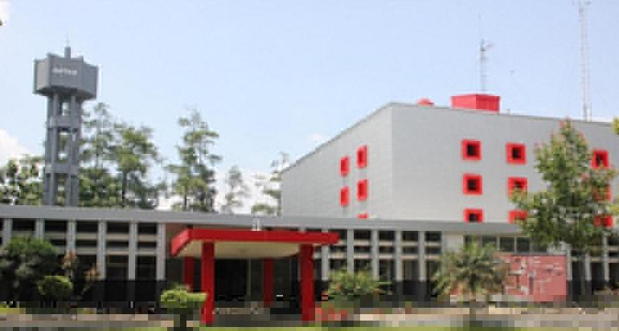 | 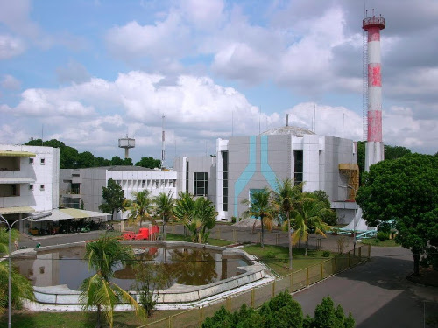 | 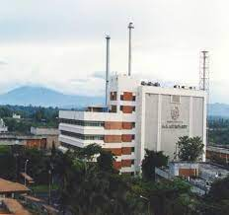
Fig. 1. Research Reactors in Indonesia
(a) TRIGA 2000 (1965) | (b) Reactor Kartini (1979) | (c) RSG GAS (1987)
The terminology ‘decommissioning’ is an activity to stop the operation of nuclear reactors permanently, including removing nuclear fuel from the reactor core, disassembling reactor components, decontamination, and physical protection based on Bapeten Regulation No 4 the Year 2009 about the decommissioning of the nuclear reactor. The regulation stated that when deferred decommissioning was selected as a decommissioning option, the licensee must confine the radioactive materials and maintain and surveillance the SSCs. Furthermore, The IAEA requirements state that decommissioning refers to the administrative and technical measures taken to enable the removal of some or all regulatory controls from a facility. The decommissioning is a part of the six major phases of the license installation life cycle, and the associated licensing process are terms siting, design, construction, commissioning, operation, and decommissioning. The level of decommissioning option that will be chosen to be implemented in the decommissioning program of a nuclear installation depends on various influencing factors in determining the selection of the decommissioning program.
The decommissioning option of the research reactor in Indonesia will combine immediate decommissioning and deferred decommissioning tailored to the plant's needs, national policy, waste disposal, site land, disposal costs, degree of the safety of the environment and the public, human resource skills, financial capability, and fund availability, and technological capability. Immediate decommissioning occurs when the facility is dismantled after removing materials and waste. In deferred dismantling, after the removal of materials and waste, the facility is kept in a state of safe enclosure for 30-100 years, followed by dismantling. On the other hand, the decommissioning action follows a graded approach to achieve a gradual and systematic reduction of radiation hazards. The decommissioning is based on planning and assessment to ensure the safety, protection of workers and the public, and protection of the environment. Decommissioning is the last life cycle phase of a nuclear facility. It needs licensing procedures where legally required or regulatory approval and regulatory inspection.
Nuclear reactors are designed for several reasons, including that they must be operated, maintained, and decommissioned easily and safely. This principle is emphasized not only in the mechanical aspect but also in terms of fuel design, reactor pool, reactor core, instrumentation, control, and electrical design. Therefore, the reactor parts should be easily and safely handled during the decommissioning phase. The research reactors in Indonesia require improvements to the instrumentation and control system (ICS), considering that the current ICS has been used since the 1990s. Reliable ICS will certainly get accurate control and monitoring. With the current state of the ICS, reactor operators must be extra-monitored for control, supervision, and products produced. On the other hand, from a mechanical point of view, the reactor pool and core are designed to be removable. Then, the Beryllium reflector, the reactor core, is also designed to be removable. It needs to use the proper cranes and the availability of a large enough space in the reactor building so that the decommissioning activities should be easy to handle through material access at the ground level of the reactor building. Therefore, when the decommissioning policy is implemented, the decommissioning action should be safe to conduct. The overall objective of the regulatory inspection strategy during the decommissioning action is to ensure that the decommissioning activities are conducted in accordance with the relevant regulatory requirements and standards. This paper is carried out in stages by reviewing the description of safety requirements contained in the primary standards issued by the IAEA for decommissioning, studying the inspection strategy during decommissioning, then conducting a challenge of decommissioning strategy through discussion and conclusion.

Method and Strategy
The laws and regulations related to the decommissioning of nuclear installations in Indonesia that is Act No 10 year 1997 about nuclear energy, government regulation No 33 the year 2007, government regulation No 54 the year 2012, government regulation No 61 the year 2013, government regulation No 2 the Year 2014, BAPETEN regulation No 4 the year 2009 about the decommissioning of the nuclear reactor, BAPETEN regulation No 6 the year 2011 about the decommissioning of nuclear installation of non-reactor, BAPETEN regulation No 4 the year 2013 about radiation safety in nuclear energy, BAPETEN Regulation No 7 the year 2013 about discharge limit of environmental radioactivity. The illustration of the regulation decommissioning of a nuclear reactor in Indonesia shows in Figure 2.
The regulatory requirements for decommissioning shutdown nuclear facilities must need increasing attention. Furthermore, the regulatory body should establish a particular inspection programme based on the national legal framework for decommissioning phase. The regulatory approaches to decommissioning vary widely in scope and depth of regulatory control. Indonesia regards decommissioning as part of the licensed activities covered by the post-operational phase. The reduction will influence the total inspection programme in risk potential, and regulatory inspection is continued in almost the same manner and under the same principles as the operation inspection.
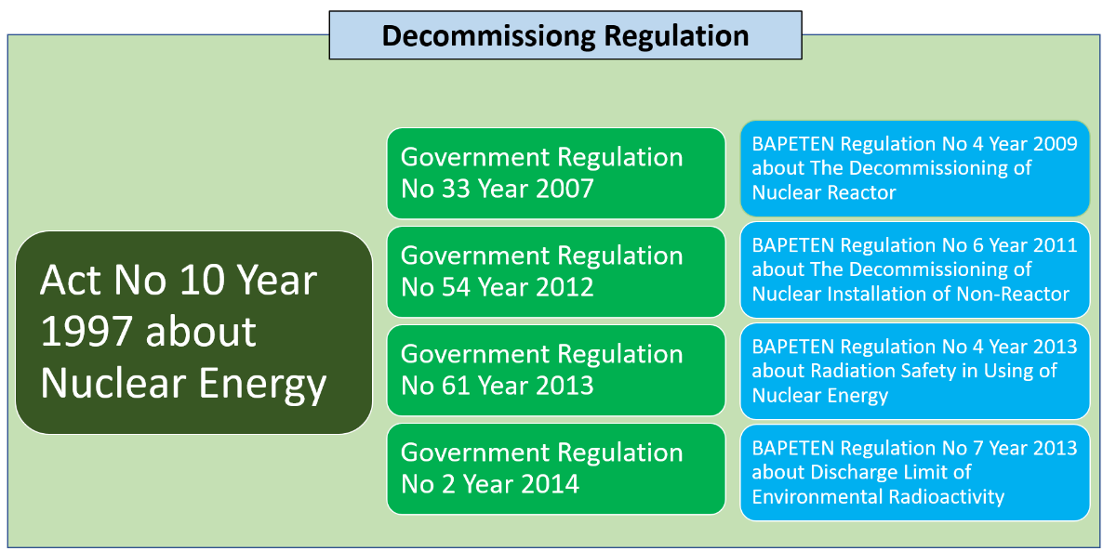
Fig. 2. Decommissioning regulation in Indonesia
The inspection strategy should concern systems and components left over from the plant's operation and continue while decommissioning takes place. The emphasis on regulatory inspection will improve from questions concerning nuclear safety precautions to other items of inspection, which then become more critical. These items are radiation protection problems, waste considerations, material release, and industrial safety. The on-site inspection is one of the elements of the regulatory regime, and the regulatory body should allocate adequate resources to this task. The regulatory body should develop an inspection plan based on a graded approach, which should include the following key elements, i.e., making a priority for inspections of SSCs, field observation by inspectors, the review of safety assessments, investigation and follow-up and gathering of information on compliance with safety criteria. Moreover, the inspection plan could also refer to the industrial safety aspect.
The inspections operation should verify compliance with the safety objectives and criteria defined in the final decommissioning plan, the results and conclusions of the detailed safety assessment, and the limits and conditions of the authorization for decommissioning. The regulatory inspections should be performed during the final radiological survey to verify that the procedures are correctly implemented and in compliance with requirements. The decommissioning techniques should focus on protection and nuclear safety, protection of the environment, the generation of waste and any potential negative impact on the storage and disposal of waste. New hazards may arise when decommissioning actions progress, like decontamination, cutting and handling of significant components. Decommissioning actions' impact on safety should assess and manage to prevent and mitigate the potential consequences and new hazards.
Table 1 compares the inspection aspect in Bapeten Regulation No 1, 2017, about the implementation of regulatory inspections in the utilization of nuclear energy. At the operational phase, the inspection should focus on operational safety, maintenance and aging management, radiation protection, nuclear emergency, and environmental management and monitoring. On the other hand, the inspection will focus on handling nuclear fuel, dismantling SSCs, decontamination, and physical protection during the decommissioning phase.
The regulatory process for decommissioning may differ from that required for reactor operation, as explained in table 2. Waste management during decommissioning needs a particular regulatory inspection plan because of the increased volumes and types of nuclear waste generated. Also, new regulatory issues may arise concerning the removal of used fuel from the reactor or site. The decommissioning inspection differs from Hazard profile and analysis, Work control and planning, workforce, personnel, SSCs, public and stakeholders. These have changing and dynamic hazard profiles, limited experience, degradation of SSCs, job-oriented, and focus on-site. The regulatory inspections must be flexible as the plant configuration is continuously changing.

TABLE 1. COMPARISON OF INSPECTION ASPECT IN INDONESIA’S REGULATION
No | Operation | Decommissioning
 | Operational Safety | Handling Nuclear Fuel
 | Maintenance and Aging Management | Dismantling of SSCs
 | Radiation Protection | Decontamination
 | Management System | Physical Protection
 | Nuclear Emergency
 | Environmental Management and Monitoring

The decommissioning regulation should perform in discrete, approved phases, and it ultimately approves the facility's or site's release. The general regulatory trend is to encourage the completion of decommissioning of research reactors as soon as possible after the final shutdown. While the same trend is actual for more extensive facilities, it is more relevant to research reactors, given the limited resources generally required for their decommissioning. Political and other realities influence the choice of strategy.

TABLE 2. COMPARISON OF OPERATION AND DECOMMISSIONING IN IAEA STANDARD
 | Operation | Decommissioning
Hazard Profile | Stable, well characterized, focus: radiological effects | Changing, less well-characterized, changeable working environment, industrial safety issues
Hazard Analysis | Operation-oriented, generally stable, focus on off-site | Dynamic, mainly task-oriented, changeable, focus on-site
Work Control and Planning | Routine operation and  maintenance, short tasks | Task-/job-oriented, new tasks, work planning for workplace safety critical
Workforce Experience | Facility familiarity operation and work according to design | New mission, limited experience, contractors with little facility experience
Staff | Permanent | Changeable (tasks and phases)
Permanent Structures | Constant with  maintenance | Interim facilities and degradation of structures
Publics and Involved Parties | Routine channels | Dynamic & changing (contractors)
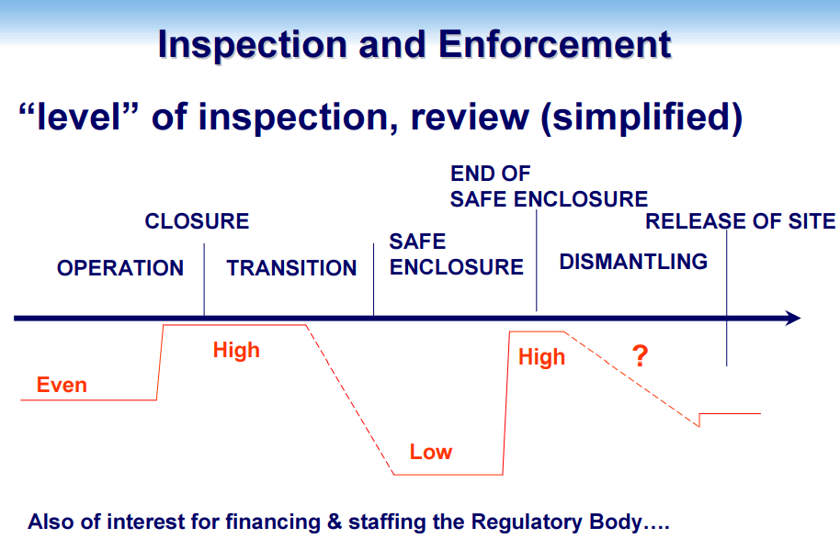
Fig. 3. Level of regulatory inspection
Figure 3. informs that the level of nuclear regulatory inspection varies depending on the type of nuclear facility. The nuclear regulatory inspections involve reviewing facility operations and compliance with established safety regulations. Inspections can range from a review of a facility’s record-keeping and paperwork to more in-depth investigations, such as examining safety systems, equipment, and procedures. Inspectors may sometimes take samples and conduct physical tests on components. The level of inspection is typically determined by the size and complexity of the facility and the potential safety risks associated with its operations. The benefits of a regulatory inspection strategy will improve nuclear safety and cost savings. However, this has challenges about the complexity of regulatory requirements and time and resources. Many factors must be considered when decisions on strategy selection have to be made. The many factors to be considered can be grouped into the following three categories policy and socio-economic, technological and operational, and long-term uncertainties.

RECOMMENDATION
The regulatory body should establish an inspection strategy plan for authorization of decommissioning within the framework of the national legislation. The inspection strategy should request an inventory list of material, including the amount and radioactive contents of the plant, updated regularly, and made available for information. This strategy allows improved decontamination, dismantling and waste management planning and is valuable information for regulatory inspection. The substantial differences in labour costs, disposal costs and decommissioning endpoints may explain the diverging findings and the decommissioning option.

CONCLUSION
The regulatory requirements for decommissioning shutdown nuclear facilities need significant attention. The regulatory body should establish a particular inspection program based on the national legal framework for decommissioning phase. The regulatory process for decommissioning may differ from reactor operation, especially waste and hazard management. The inspection strategy provisions for unexpected findings must be considered and duly dealt with to ensure nuclear safety. The emphasis on regulatory inspection should improve from questions concerning nuclear safety precautions which then become more critical.
References
- Act No 10 Year 1997, The Nuclear Energy, Indonesia (1997)
- Indonesian Government Regulation No 33 Year 2007, Safety of Ionizing Radiation and Radioactive Source, Indonesia (2007)
- Indonesian Government Regulation No 54 Year 2012, Safety and Security of Nuclear Installations, Indonesia (2012)
- Indonesian Government Regulation No 61 Year 2013, Management of Radioactive Waste Indonesia, Indonesia (2013)
- Indonesian Government Regulation No 2 Year 2014, Licensing of Nuclear Installations and Utilization of Nuclear Material, Indonesia (2014)
- BAPETEN Regulation No 4 Year 2009, The Decommissioning of Nuclear Reactor, Indonesia (2009)
- BAPETEN Regulation No 6 Year 2011, The Decommissioning of Nuclear Installation of Non-Reactor, Indonesia (2011)
- BAPETEN Regulation No 4 Year 2013, The Radiation Safety in Nuclear Energy, Indonesia (2013)
- BAPETEN Regulation No 7 Year 2013, Discharge Limit of Environmental Radioactivity, Indonesia (2013)
- BAPETEN Regulation No 1 Year 2017, The Implementation of Regulatory Inspections in the Utilization of Nuclear Energy, Indonesia (2017)
- INTERNATIONAL ATOMIC ENERGY AGENCY, Decommissioning of Facilities, General Safety Requirements (GSR) Part 6, Vienna (2014)
- NUCLEAR ENERGY AGENCY, COMMITTEE ON NUCLEAR REGULATORY ACTIVITIE, Working Group on Inspection Practices (WGIP), Regulatory Practices for Decommissioning of Nuclear Facilities with Special Regard of Regulatory Inspection Practices, NEA/CNRA/R(99)4, OECD (2000)
- INTERNATIONAL ATOMIC ENERGY AGENCY, Model Regulations for Decommissioning of Facilities, IAEA-TECDOC-1816, Vienna (2017)
- IAEA Regional Workshop: Legal and Regulatory Aspects of Decommissioning of Research Reactors, Inspection and Review of Decommissioning Activities for Compliance, Philippines (2006)
- ONR Guidance Document, Guidance for Inspection Strategy Planning and Recording, ONR-INSP-GD-059, Issue No.: 8.2, UK (2020)
- INTERNATIONAL ATOMIC ENERGY AGENCY, Decommissioning of Nuclear Power Plants, Research Reactors and Other Nuclear Fuel Cycle Facilities, Specific Safety Guide No. SSG-47, Vienna (2018)
- Sangmyeon Ahn, et.al., The regulatory framework improvement for safe decommissioning of nuclear power plants in Korea, PREDEC 2016, France (2016)
- INTERNATIONAL ATOMIC ENERGY AGENCY, Transition from Operation to Decommissioning of Nuclear Installations, Technical Reports Series No. 420, Vienna (2004)

