# REFRAMING Sustainability considerations in nuclear

# decommissioning

A discussion paper

S.CARROLL

Vattenfall

Stockholm, Sweden

Email: [simon.carroll@vattenfall.com](mailto:simon.carroll@vattenfall.com)

D. OUGHTON

Norwegian University of Life Sciences

Ås, Norway

**Abstract**

The need to ensure protection of the environment is a well-established aspect of the use of nuclear technologies, including during decommissioning of nuclear facilities. More recently these environmental protection efforts these have been broadened to begin to address various aspects of sustainability in the context of nuclear decommissioning. While these initiatives are to welcomed, the paper argues that the current conceptual approach to nuclear facility decommissioning is inherently limited and that a reframing is necessary if sustainability is to be genuinely addressed.

## Introduction

Decommissioning is a normal and inevitable stage in the lifetime of a nuclear facility. It involves the timely, safe and environmentally responsible removal of radioactive waste and other materials, leading to a progressive and systematic reduction in radiological and other hazards. While the need to ensure protection of the environment is a well-established aspect of nuclear decommissioning, additional considerations relating to the broader environmental impact of decommissioning activities, including addressing issues of sustainability, are receiving ever-increasing attention [1].

Initiatives to reduce the environmental footprint of decommissioning activities generally include efforts relating to radioactive waste management, refining the selection and use of materials and generally refining practices as part of a continuous process of improvement in decommissioning methods. Many of these initiatives are necessarily implemented by operators together with supply chain partners. Some organisations embed such initiatives within broader sustainability strategies, such as that developed by the United Kingdom’s NDA [2], or as part of wider government or society sustainability initiatives, such as ‘Green Public Procurement’ as applied by Sogin as part of its strategy for decommissioning of nuclear facility in Italy [3].

## A Waste hierarchy approach versus A circular economy model

The waste hierarchy gives priority to waste avoidance, minimisation, and recycling over disposal as management options, and has been applied to the management of radioactive wastes in the nuclear sector. A generic representation of the waste hierarchy is shown in the left hand part of Fig. 1.

Discussion of circular economy in academic circles can be dated back to the early 1980s [4], and interest within politics and wider society has gained strength in recent years. The circular economy approach aims to reduce resource use, prevent waste and optimise the environmental, social and economic value of products, components and materials through initiatives such as reuse, remanufacturing, and recycling. [5] From the outset, the discussion highlighted the importance of increasing the “use-life of goods” in transitioning to a more sustainable society, and theorized a self-replenishing economic system with different levels of replenishing loop (reuse, repair, reconditioning, and recycling) [6]. While a number of different definitions of circular economy have since emerged, they have in common the aim of better management of resources by reusing, rethinking, and reducing unnecessary consumption patterns [4]. Moreover, the model has the ultimate goal of retaining materials and resources circulating in the system at their highest value and within planetary boundaries, in a way that the need for additional inputs to the system to produce goods and services is reduced, and residual waste leaving the system is minimised or ideally eliminated altogether [4].

Fig 1. illustrates a graphical representation of the waste hierarchy alongside one of a basic circular economy model, the latter from [7]. At first glance, there are similarities between the two approaches. However it is increasingly recognised that the waste hierarchy is insufficient to be truly circular, since there is no clear linkage to design, and waste is not necessarily eliminated [1, 3]. A key difference between the two is that a circular economy approach contains several cascading loops through the product value chain, with the aim of recirculating resources already present in the socioeconomic system. [5]

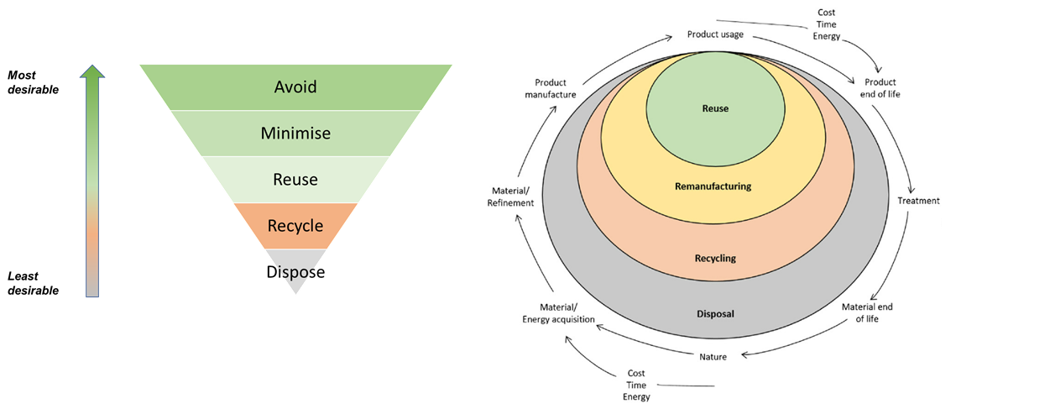

*FIG. 1. Generic waste hierarchy (left) and a circular economy model from [7] (right).*

An example of efforts to introduce a nuclear decommissioning approach more aligned to the circular economy model can be found at Sogin, the company responsible for the decommissioning of Italian nuclear facilities. Sogin has created and implemented a circular economy strategy to reduce the environmental impact of nuclear decommissioning activities from the early stages of its projects. Sogin has identified three drivers for applying the circular economy strategy in its activities, namely: re-use of structures, systems and components; material recycling; and overall environmental impact reduction [3].

## going beyond a linear facility life-cycle concept

A typical dictionary definition of lifecycle describes the series of changes and developments that an organism passes through from the beginning of its life until its death, or alternately the series of developments that an idea, product, or organization passes through from its inception beginning until the end of its usefulness. Thus, a conventional model for a nuclear lifecycle is one where a facility is designed, constructed, operated, shutdown and decommissioned. This linear nuclear facility lifecycle is illustrated in Fig. 2 below. Making decommissioning the final stage of a linear nuclear facility life-cycle model, risks narrowing attention to the efficient management of materials produced through the decommissioning process, rather than the more holistic considerations highlighted in a circular economy approach.

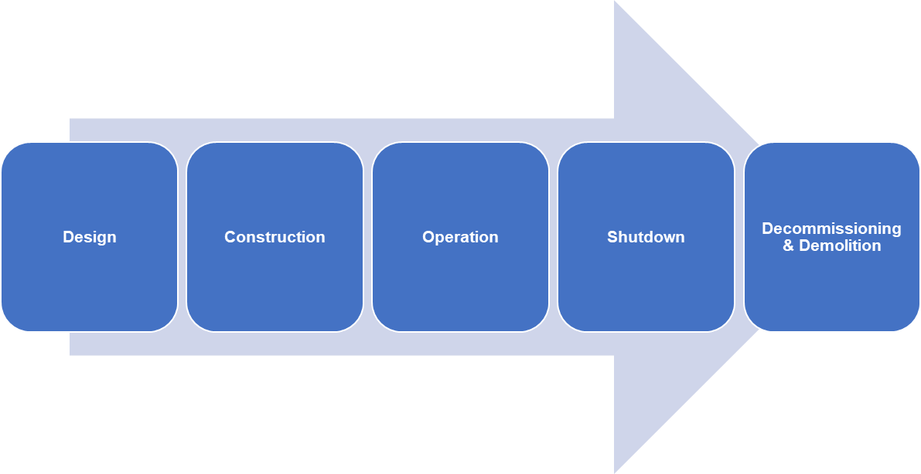

*FIG. 2. Linear representation of a nuclear facility lifecycle.*

### Towards a cyclical model

Such a linear “lifecycle” model can usefully be contrasted with a cyclical one. A cycle is a series of transformations or events which follow one after the other one, reaching the initial starting condition at the end of the cycle. Fig. 3 illustrates how this might be represented in the context of a nuclear facility. Recognizing that a fully cyclical lifecycle might not be possible, the figure includes an alternative pathway incorporating site release at the end of decommissioning and demolition, followed by alternative site reuse and development. Introducing such a cyclical lifecycle concept encourages the integration of consideration of the future uses of a facility or site at the outset, and also enables this thinking to be incorporated into all stages of the nuclear facility lifecycle. This in turn enables a more comprehensive consideration of other environmental impacts associated with facility decommissioning, for example by factoring in issues related to resources used in construction.

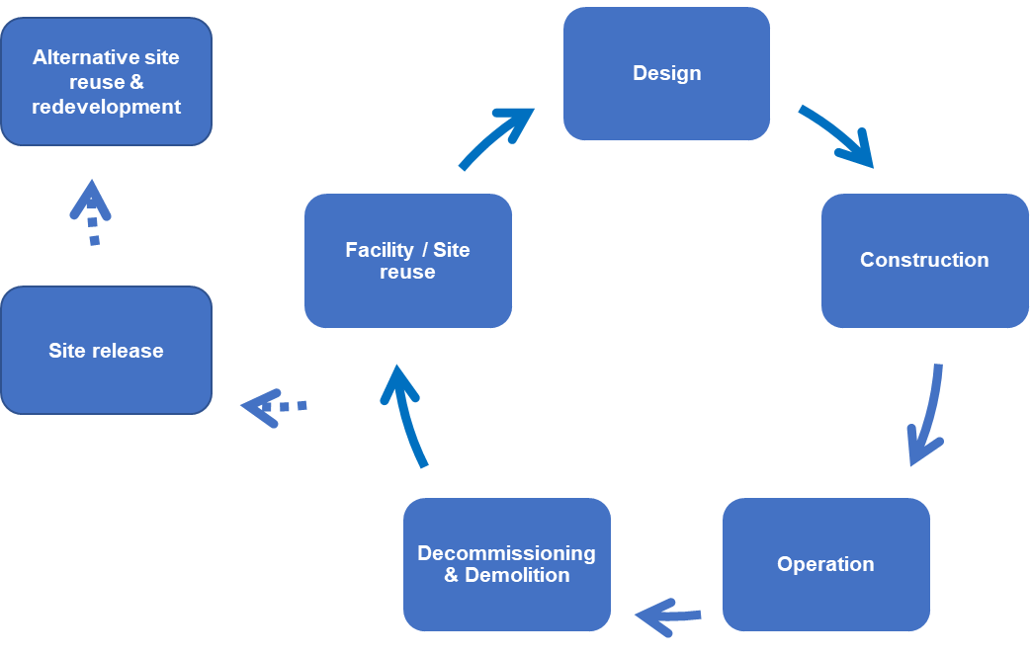

*FIG. 3. A cyclical depiction of a nuclear facility lifecycle, incorporating the concept of alternative site release, reuse and redevelopment.*

## A cyclical lifecycle model in the context of circular economy

Under the current model, construction requires extensive primary resource extraction and demolition generates a significant amount of waste. It has been estimated that, in the 20th century, global material extraction for building stocks grew from 7 to 78 Gt.year-1 [8], whereas actual construction uses more than 3 Gt.year-1 of raw materials [4]. Overall, during the 20th century, it has been estimated that discarded building stocks generated over 293 Gt of solid waste [8]. Material and energy consumption in construction will be further exacerbated if the current linear economy paradigm persists [5]. It has been estimated that adoption of circular economy principles could help reduce waste and save more than $100 billion per year by improving construction productivity [4].

Buildings embody a large amount of resource use in their pre-use lifecycle stages, i.e., from raw material extraction, manufacture, transportation, and construction [5, 8]. Lifetime extension is a critical strategy for sustainability, as keeping structures in use for as long as possible avoids unnecessary additional resource extraction, energy use and waste generation associated with replacing them [5,8].

In industrialized countries, the vast majority of built environment stocks were not constructed using sustainability and circular economy principles [5,8]. This is also the case for nuclear facilities now being decommissioned. While there are limitations to the extent to which circular economy models can be implemented for such facilities at the end of their operating lives, future construction (e.g., new builds) could be designed, built and operated with circular economy concepts in mind. In such an approach, facility and equipment reuse in a cyclical model, e.g., through refurbishment and renovation, offers potential benefits, especially when associated with material “re-looping” as part of an overall circular economy approach. Reuse of an existing industrial site, also offers additional potential overall reduced environmental impacts compared to development of new sites.

### Supporting the implementation of a circular economy approach

A more cyclical lifecycle approach embedding a circular economy model for decommissioning will require implementation of a circular economy approach also for design and construction of nuclear facilities. There has been some progress in describing how principles of a circular economy can be applied to the construction, as described for example in [9]. However it is recognized that progress in implementing circular economy initiatives has been slow so far [5, 8], and their application in construction has been limited due to its unique industrial characteristics and the complex nature of circular economy approaches [10].

To address this, further efforts are needed to improve understanding of circular economy concepts and its application in construction projects [5, 4, 10, 12]. Additionally, there is a need to further develop key strategic and practical project-level indicators [12], as well as decision support tools to support circular economy implementation in construction [10]. An approach to facilitate the implementation of circular economy with the use of standards has been put forward, with the standards providing the requirements, tools, and indicators to control each life cycle phase, and of key enabling technologies that together add circular value [11]. A circular economy design workflow which summarises principles which should be considered to maximize circularity, providing details of each principle, and justification of their order of consideration, is developed in [4] in line with the built environment hierarchy in [9], and is shown in Fig. 4 below.

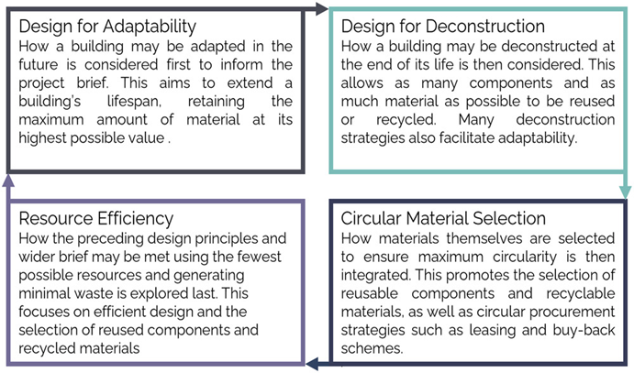

*FIG. 4. A circular economy* *design workflow for the built environment, providing details of each principle, and justification of their order of consideration, from [5].*

## Reframing the concept of decommisisoning

Current approaches to reducing the environmental footprint of decommissioning activities should be pursued as part of the continuous improvement of nuclear decommissioning activities. However this paper suggests that these efforts could be significantly strengthened through a wider framing of the issue, requiring an systematic and comprehensive engagement with sustainability and circular economy considerations throughout the entire life-cycle.

This wider framing comprises both a more cyclical facility lifecycle concept and more fully integrating circular economy considerations at all stages[13]. For decommissioning, this implies considerations of how and to what extent a facility and its equipment could be reused, and that these considerations should be embedded in design, construction, and operation of the facility. It also entails that future use of a site is integrated into development plans. In other words, a new conceptual framework for decommissioning to encourage the implementation of circular economy principles in the nuclear facility lifecycle . This conceptual framework would need to address the decommissioning of both existing and future (new build) nuclear facilities, and should incorporate a version of the design workflow along the lines described above and illustrated in Fig. 4.

In certain respects, the timing for developing a framework and revisiting regulations and standards from a circularity perspective could not be better. With increased awareness of and heightened expectations and requirements for progress in addressing sustainability issues, the nuclear industry, host communities and broader society have a lot to gain if nuclear facilities can be designed for a truly circular lifecycle. The current interest in advanced reactor designs and small modular reactors (SMRs) offers an ideal opportunity to begin to implement a new more sustainable and circular approach to nuclear decommissioning already at the design stage for new builds. Recent research identified and ranked the most relevant elements hindering and favouring circular economy in the case of SMRs [14].

While it is not possible to fully implement such a circular approach for facilities already in decommissioning or currently operating, there is nevertheless a responsibility to seek to address sustainability considerations through continuous improvement of the way in which decommissioning is conducted. Current initiatives to address sustainability in decommissioning of the current fleet of nuclear facilities should be strengthened and intensified with the aim of testing and refining circular economy approaches and inform design choices for the next generation of facilities.

ACKNOWLEDGEMENTS

This paper has been developed as part of work being undertaken by Simon Carroll as an Associated Scientist of the Centre for Environmental Radioactivity (CERAD) at the Norwegian University of Life Sciences (NMBU).

References

1. GILLIN, K., Nuclear decommissioning in a circular economy, Nuclear Engineering International, 2 November 2021, <https://www.neimagazine.com/features/featurenuclear-decommissioning-in-a-circular-economy-9208806/>
2. NUCLEAR DECOMMISSIONING AUTHORITY, The NDA group Sustainability Strategy (2022), <https://www.gov.uk/government/publications/the-nda-group-sustainability-strategy-2022>
3. PANCOTTI, F., Sustainability and Circular economy in nuclear decommissioning, paper presented to DIGIDECOM 2022, Halden, 2022.
4. GUERRA, B. C., SHAHI, S., MOLLEAI, A., SKAF, N., WEBER, O., LEITE, F., HAAS, C., Circular economy applications in the construction industry: A global scan of trends and opportunities. Jnl Cleaner Production 324 (2021) 129125
5. GILLOT, C., MIHKELSON, W., LANAU, M., CHESHIRE, D., TINGLEY, D. D., Developing regenerate: A circular economy engagement tool for the assessment of new and existing buildings. J. of Industrial Ecology 00 (2023) 1– 13.
6. STAHEL, W., The product-life factor. An inquiry into the nature of sustainable societies: The role of the private sector, NARC (1982) 74–96
7. MIHELCIC, J. CRITTENDEN, J, SMALL, M., SHONNARD, D., HOKANSON, D., ZHANG, Q., HUI CHEN, H., SORBY, S., JAMES, V., SUTHERLAND, J., SCHNOOR J.,. Sustainability science and engineering: The emergence of a new metadiscipline, Environ. Sci. Technol. 37 23 (2003) 5314–5324
8. KRAUSMANN, F., WIEDENHOFER, D., LAUK, C., HAAS, W., TANIKAWA, H., FISHMAN, T., MIATTO, A., SCHANDL, H., HABERL, H. (2017). Global socioeconomic material stocks rise 23-fold over the 20th century and require half of annual resource use. PNAS, 114 8 (2017) 1880–1885.
9. CHESHIRE, D., Building revolutions: Applying the circular economy to the built environment. Routledge, Oxfordshire, 2019.
10. YU, Y., YAZAN, D., JUNJAN V., IACOB, M-E., Circular economy in the construction industry: A review of decision support tools based on Information & Communication Technologies, Jnl Cleaner Production, 349 (2022) 131335
11. ÁVILA-GUTIÉRREZ, M., MARTÍN-GÓMEZ, A., AGUAYO-GONZÁLEZ, F., CÓRDOBA-ROLDÁN, A., Standardization Framework for Sustainability from Circular Economy 4.0., Sustainability 11 (2019), 11, 6490.
12. VELENTURF, A., ARCHER, S., GOMES, H., CHRISTGEN, B., LAG-BROTONS, A., PURNELL, P., Circular economy and the matter of integrated resources, Sci. Tot. Env. 689 (2019) 963–969
13. LAXMI, H., DE WIT, M., VON DANIELS, C., COLLORICCHIO, A., HOOGZAAD, J., The Circularity Gap Report, Circle Economy (2021), <https://www.circularity-gap.world/2021>.
14. MIGNACCA, B. Modular circular economy in energy infrastructures: The case of Small Modular Reactors. PhD thesis, (2021), University of Leeds.