# Current state and directions for the development of regulatory framework for nuclear facilities decommissioning in the Russian Federation

I. AFANASEV

Scientific and Engineering Centre for Nuclear and Radiation Safety (SEC NRS)

Moscow, Russian Federation

Email: iafanasiev@secnrs.ru

**Abstract**

The paper deals with a detailed review of the legislative and regulatory framework for safety ensuring during the planning, preparation and decommissioning of nuclear facilities adopted in the Russian Federation. Special focus is on the current system of the federal rules and regulations in the field of atomic energy use, approved by Rostechnadzor and establishing requirements for ensuring safety during the decommissioning of various categories of nuclear facilities. One of the most important requirements of the federal rules and regulations is "end-to-end" planning for the decommissioning of nuclear facilities throughout all of their lifecycle, considering their unique design features, experience of their operation, as well as the invention of new technologies.

The paper presents a comparative analysis of the approaches to the decommissioning planning in the Russian Federation and in the IAEA, which concluded that they are almost in full agreement. It is especially noted that all Russian federal rules and regulations have been developed in compliance with international experience and the IAEA recommendations.

At the conclusion of the paper, perspective directions for the development of regulatory framework for nuclear facilities decommissioning in the Russian Federation were considered, including the establishment of detailed requirements and the development of recommendations for:

* Development of a digital engineering and radiation model of a nuclear facility;
* Ensuring safety during the operation of nuclear facilities during the "transitional period";
* Risk management in the implementation of decommissioning projects.

## The structure of regulatory legal acts in the field of atomic energy use establishing requirements for nuclear facilities decommissioning in the Russian Federation

In order to effectively safety ensuring in the atomic energy use, a clear system of regulatory documents has been built in the Russian Federation. The basis of this system is the Federal Law of November 21, 1995 No. 170-FZ "On the Use of Atomic Energy" (FZ-170) [1]. Article 2 of FZ-170 [1] establishes the definition of national regulatory bodies in the field of atomic energy use. The list of regulatory bodies is established by the Government of the Russian Federation [2] and includes federal executive authorities, including: Federal Medical and Biological Agency (FMBA), Ministry of Emergency Situations, Ministry of Natural Resources, Rospotrebnadzor, Rostechnadzor. Each national regulatory body is authorized to issue its own regulatory legal acts in the field of atomic energy use and control their compliance.

In accordance with FZ-170 [1] the main regulatory legal acts in the field of atomic energy use in the Russian Federation are the federal rules and regulations in the field of atomic energy use (FNP). FNP establish requirements for the safety in the field of atomic energy use, including safety requirements for nuclear facilities, safety requirements for activities in the field of atomic energy use (including safety aims, basic principles and criteria).

In order to support compliance with the requirements of the FNP, the safety guides in the field of atomic energy use (RB) are approved and implemented. RB contain recommendations on compliance with the FNP requirements (including methods for performing works, techniques, conducting examinations and safety assessment, as well as explanations and other recommendations on the implementation of the safety requirements). The Government of the Russian Federation [3] has empowered Rostechnadzor to develop, approve and implement of the FNP and RB.

Overall, the current hierarchical structure of the regulatory documents in the field of atomic energy use in the Russian Federation includes: Federal Laws, the FNP and RB, sanitary and epidemiological rules, hygienic standards, guidelines and recommendations (Fig. 1).

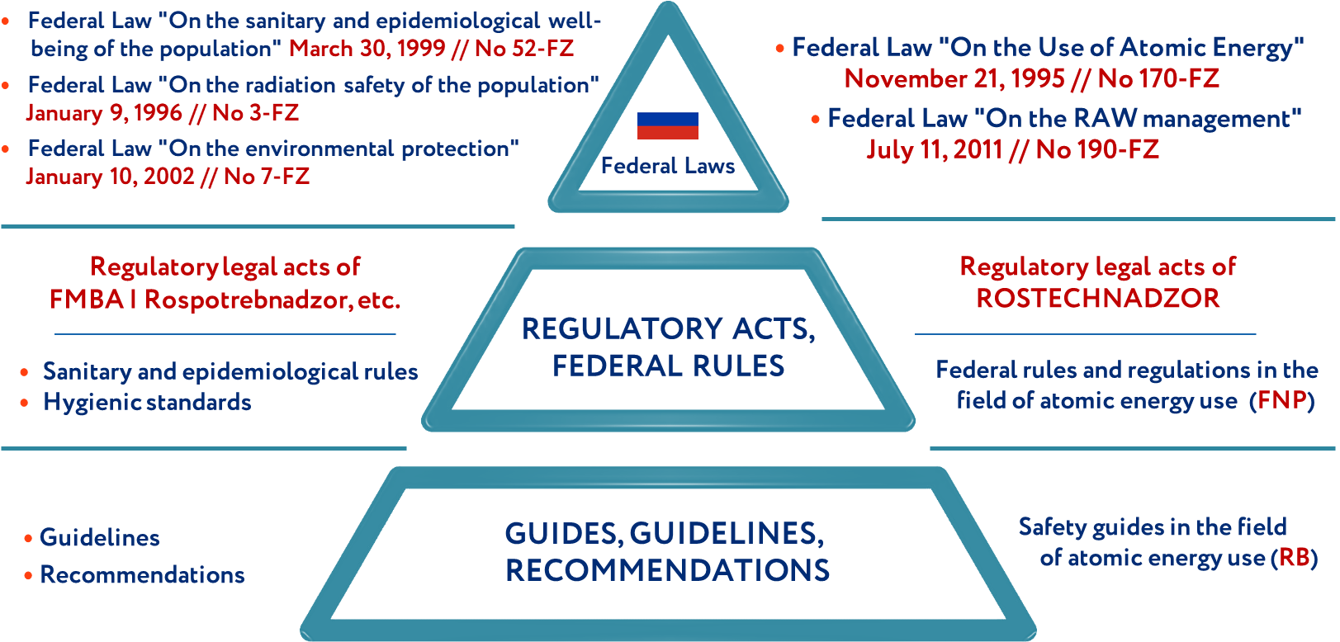

*FIG.1. Hierarchical structure of the regulatory documents in the field of atomic energy use in the Russian Federation.*

For the purpose of effective state regulation of safety during nuclear facilities decommissioning, Rostechnadzor has developed a structured system of federal rules and regulations in the field of atomic energy use (FNP), which includes 3 main levels (Fig. 2):

* FNP containing general provisions for ensuring safety during the decommissioning of all categories of nuclear facilities (NP-091-14 [4]);
* FNP containing general safety requirements for the decommissioning of specific categories of nuclear facilities, including NPPs (NP-001-15 [4]), nuclear fuel cycle facilities (NP-016-05 [4]), ships with nuclear installations (NP-022-17 [4]), research nuclear installations (NP-033-11 [4]), radiation sources (NP-038-16 [4]), spacecrafts with nuclear reactors (NP-101-17 [4]);
* FNP establishing safety requirements for the decommissioning of specific categories of nuclear facilities, including industrial uranium-graphite reactors (NP-007-17 [4]), NPP units (NP-012-16 [4]), research nuclear installations (NP-028-16 [4]), ships with nuclear installations and radiation sources (NP-037-11 [4]), nuclear installations of nuclear fuel cycle (NP-057-17 [4]), radioactive waste storage facilities (NP-097-16 [4]).

The division of FNP into 3 levels is due to two factors: the fundamental technical features of various categories of nuclear facilities and the features of specific activities in the field of atomic energy use.

In addition to the mentioned FNP, there are 16 safety guides (RB) containing recommendations on compliance with the requirements of the FNP for the decommissioning of nuclear facilities. 7 RB were put into effect in the last 5 years and are devoted to planning and preparing for the decommissioning of nuclear facilities:

* development of a nuclear facility decommissioning concept (RB-008-21 [5]);
* development of a NPP unit decommissioning program (RB-013-22 [5]);
* selection of nuclear facility decommissioning option and its justification (RB-153-18 [5]);
* conducting a comprehensive engineering and radiation survey of nuclear facilities during preparation for its decommissioning (RB-159-19 [5], RB-160-19 [5]);
* accounting for changes in the operating conditions of systems and elements of the permanently shutdown nuclear fuel cycle facility when determining the possibility of reducing the scope of its maintenance (RB-144-18 [5]);
* planning and justification for reducing the scope of maintenance, decommissioning of particular systems and elements, changing the number of the permanently shutdown NPP unit operational personnel for the NPP unit decommissioning (RB-158-19 [5]).

Thereby the current system of regulatory documents of Rostechnadzor for planning, preparation and decommissioning of nuclear facilities includes 13 FNP [4] and 16 RB [5].

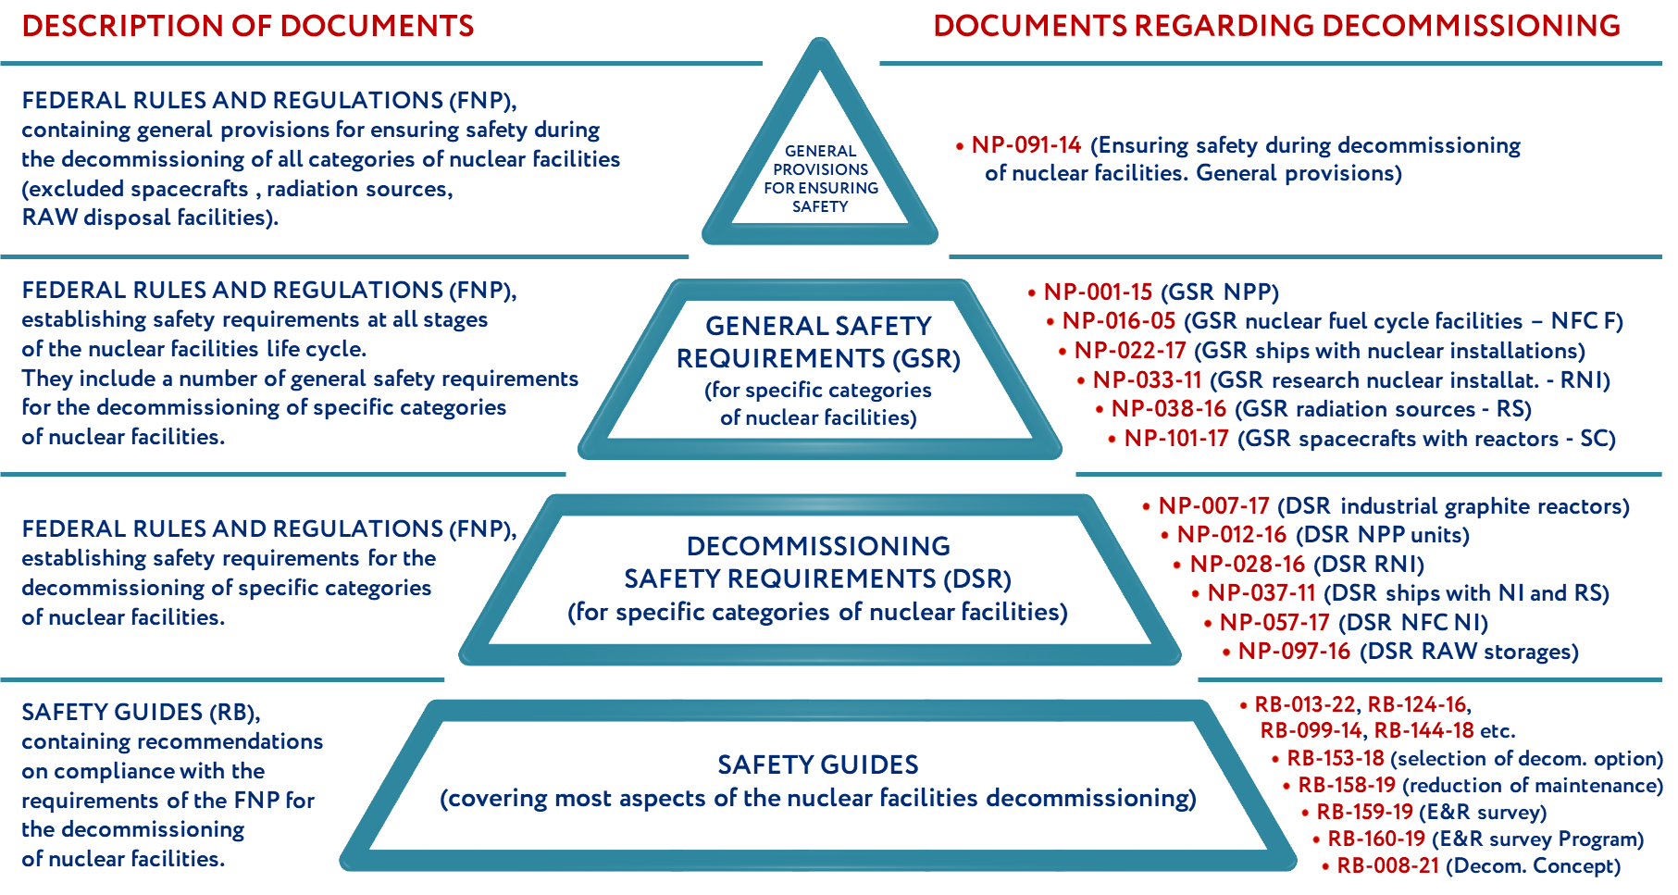

*FIG. 2. Hierarchical structure of the federal rules and regulations and safety guides in the field of atomic energy use on the nuclear facilities decommissioning.*

It is important to note that the regulation of safety during nuclear facilities decommissioning is not limited to the above-mentioned FNP and RB. There are also other FNP and RB dedicated to aspects of accounting and control of nuclear materials and radioactive substances, physical protection, quality management, emergency preparedness, radioactive waste management, etc. These requirements must be considered when planning, preparing and implementing nuclear facilities decommissioning (Fig. 3).

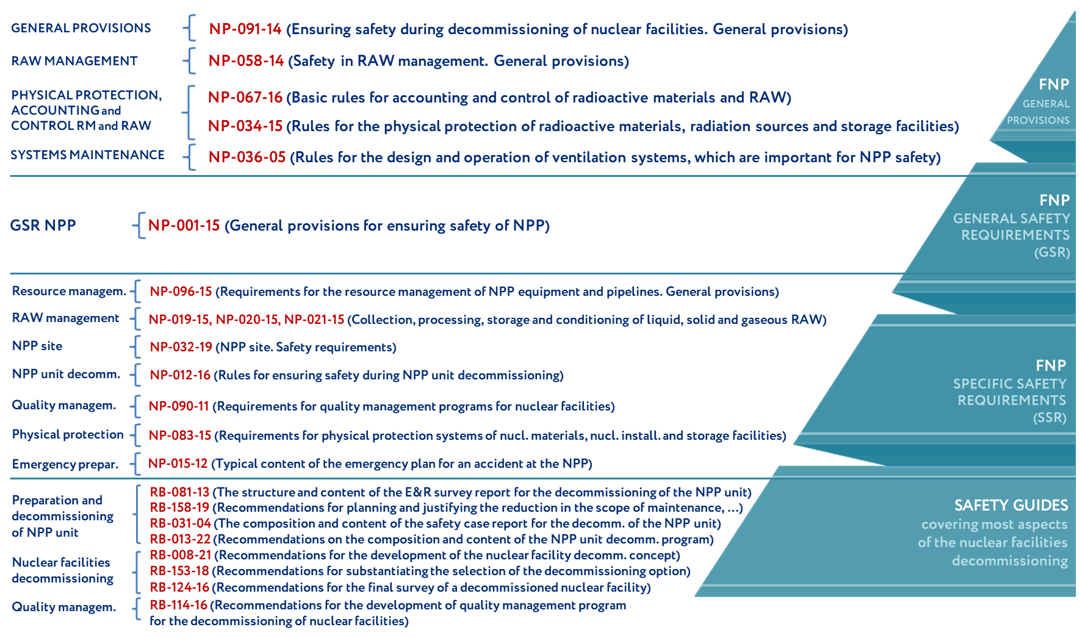

*FIG. 3. Structure of the FNP and RB on the nuclear facilities decommissioning (for NPP units as an example).*

In accordance with FZ-170 [1] the FNP in the Russian Federation are developed and periodically reviewed taking into account the recommendations of the International Atomic Energy Agency (IAEA) on the issues of nuclear facilities decommissioning, which are presented in the GSR. Part 6 [6], SSG-47 [7], and SSG-49 [8].

The Russian FNP for the nuclear facilities decommissioning have been developed considering the IAEA recommendations on "end-to-end" decommissioning planning (Fig. 4). For example, the project documentation for the construction of each nuclear facility should contain a decommissioning concept - a document that establishes the general procedure and measures to ensure safety during the decommissioning of a specific nuclear facility. During the entire nuclear facility life cycle, the decommissioning concept is updated and, as a result, transformed into a decommissioning program and decommissioning project documentation. Also, for the purpose of qualitative planning of nuclear facility decommissioning, operators must ensure the development and maintenance of an up-to-date decommissioning database. Any information relevant for nuclear facility decommissioning should be entered in the mentioned decommissioning database. In particular, information on radioactive contamination of premises and equipment, induced activity of equipment, structural and protective materials is important for planning and performing works on decommissioning of NPP units, which is also relevant for other categories of nuclear facilities. These data allow to estimate the amount of generated radioactive waste, radiation doses on personnel, reasonably select the nuclear facility decommissioning option, and also estimate the cost of decommissioning works.

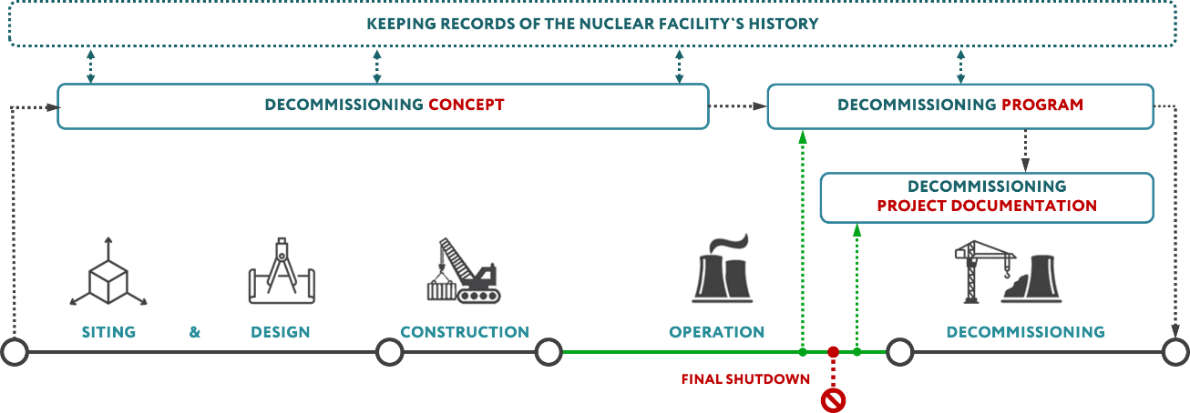

*FIG. 4. Scheme of the "end-to-end" planning of the nuclear facilities decommissioning.*

In order to comply with the principle of "end-to-end" planning for the nuclear facilities decommissioning, in 2021 the safety guide "Recommendations for the development of the nuclear facility decommissioning concept" (RB-008-21) [5] came into force. RB-008-21 [5] contains recommendations for the development of a decommissioning concept of a nuclear facility at early stages of its life cycle, including in terms of:

* considering in the decommissioning concept design solutions of nuclear facility aimed at to ensure the safe decommissioning of a nuclear facility;
* formation of a list of data, which are important for ensuring safety during nuclear facility decommissioning and should to be included in the nuclear facility decommissioning database;
* inclusion of a description of preliminary organizational measures and technical solutions for radioactive waste processing and disposal, as well as handling of non-radioactive waste materials in the decommissioning concept of a nuclear facility; and etc.

In general, the approach to nuclear facilities decommissioning planning adopted in the Russian Federation is similar to the IAEA approach, and the current FNP and RB are developed taking into account the IAEA recommendations to ensure safety during nuclear facilities decommissioning (Fig. 5).

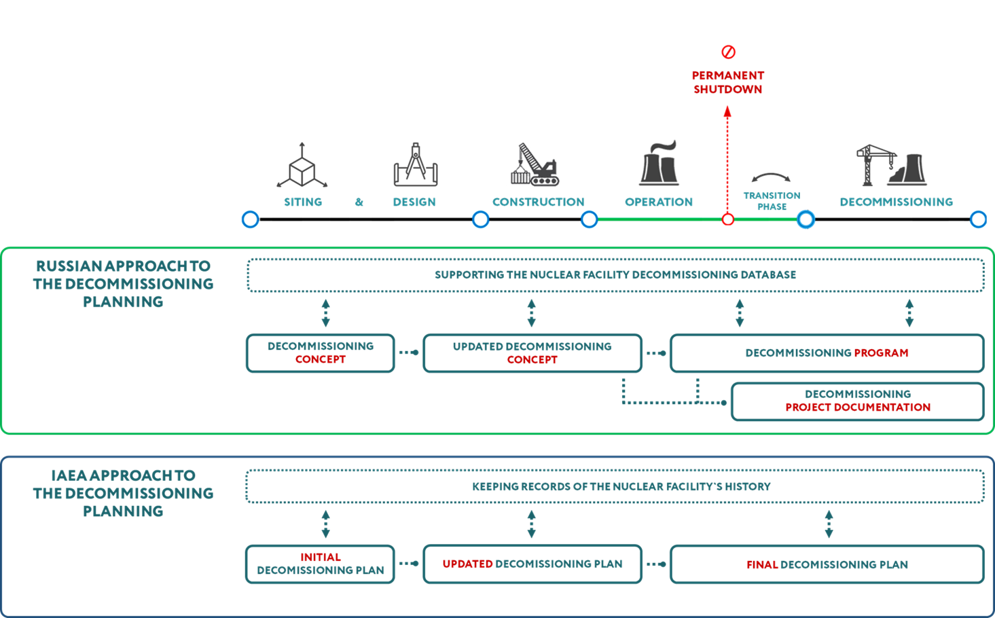

*FIG. 5. Approaches to the decommissioning planning approved in the Russian Federation and recommended by the IAEA.*

## The Promising directions for the development of regulatory framework for nuclear facilities decommissioning in the Russian Federation

Despite the comprehensively developed system of state regulation of safety during nuclear facilities decommissioning adopted in the Russian Federation, developed on the basis of the most modern international approaches and IAEA recommendations, a number of important issues should be considered.

In 2019, safety guides RB-159-19 [5] and RB-160-19 [5] for the first time mentioned the expediency of developing a digital engineering and radiation model of a nuclear facility (CIRM) during conducting a comprehensive engineering and radiation survey of a nuclear facility. At present in the Russian Federation, there are regulatory requirements for the development of CIRM during the nuclear facilities decommissioning and taking into account aspects of ensuring radiation safety. Thus, it is advisable to develop the relevant FNP and RB containing requirements and recommendations for the development of the nuclear facility CIRM.

In addition, special attention in planning and preparing for decommissioning of nuclear facilities should be given to ensuring the safety of nuclear facilities during the "transition period" - between the final shutdown of a nuclear facility and the start of decommissioning activities (Fig. 5). According to the FNP requirements [4] this period is a part of the nuclear facility operation stage. Thus, safety requirements are imposed on the nuclear facility final shutdown, similar to the requirements for operating nuclear facility, which do not consider the specifics of the operation of the permanently shutdown nuclear facility and often seem redundant. In order to take into account the specifics of the operation of permanently shutdown nuclear facility, it is advisable to establish the requirement to develop the operational configuration of the permanently shutdown nuclear facility - a technical document containing information on the composition (changes in composition, as well as interconnections) and the purpose of nuclear facility systems (elements) at the stage of its operation after the final shutdown. This requirement was established in 2016 in NP-012-16 [4] for NPP units, which allowed to accumulate sufficient experience in law enforcement practice. Accumulated experience shows the need to develop an operational configuration for permanently shutdown nuclear facilities of all categories, as well as the feasibility of establishing requirements for its structure and content.

It is also important to identify another promising direction - risk management in the implementation of decommissioning projects. Recently, the need to create and implement a risk management system in the field of atomic energy use has been recognized at the international level. Thus, at the initiative of the IAEA, in 2012, the International Project on Decommissioning Risk Management (DRiMa) was created, bringing together more than 70 nuclear facility decommissioning specialists and risk management experts from around the world, including from the Russian Federation. The result of the DRiMa project was the IAEA report SRS No. 97 "Management of Project Risks in Decommissioning" [9], dedicated to advanced approaches to risk management in the implementation of nuclear facility decommissioning projects. SRS report No. 97 [9] notes that risk management during nuclear facility decommissioning is aimed at preventing and compensating for risks associated with organizational, financial, economic, socio-political and other external and internal factors affecting the implementation of the nuclear facility decommissioning project. At present the Russian FNP and RB do not address aspects of non-radiation risk management during nuclear facility decommissioning. It should be noted that the analysis of non-compliance of nuclear facilities with the requirements of FNP can be mistakenly considered as an analogue of risk assessment. However, it does not consider the influence of economic factors of the external environment, the human factor and other aspects to be taken into account in accordance with ISO 31000:2018 [10]. Thus, it seems expedient to improve the current Russian regulatory framework in the field of atomic energy use in terms of risk management in planning, preparing and implementing the nuclear facilities decommissioning.

## Conclusion

Thus, the Russian Federation has created and maintains a comprehensive system of legislative and regulatory legal acts aimed at ensuring effective safety regulation in the planning, preparation and implementation of nuclear facilities decommissioning, considering internationally recognized approaches to safe decommissioning of nuclear facilities. However, a number of issues raised in the paper, requires careful study and appropriate analysis of the current Russian regulatory framework in the field of atomic energy use, as well as its periodic revision as experience is gained, new technologies emerge, and domestic and international approaches to nuclear facilities decommissioning develop.

References

1. The Federal Law № 170-FZ "On the Use of Atomic Energy", November 21, 1995.
2. Decree of the Government of the Russian Federation № 412 "On federal executive bodies and authorized organizations exercising state management of the use of atomic energy and state regulation of safety in the use of atomic energy", July 3, 2006.
3. Decree of the Government of the Russian Federation № 401 "On the Federal Environmental, Industrial and Nuclear Supervision Service", July 30, 2004.
4. List of current federal rules and regulations in the field of atomic energy use [Electronic resource] // Official website of SEC NRS. M., 2022. URL: https://www.secnrs.ru/science/development/fnp/ (access date: 01.11.2022).
5. List of current safety guides in the field of atomic energy use [Electronic resource] // Official website of SEC NRS. M., 2022. URL: https://www.secnrs.ru/science/development/rb/ (access date: 01.11.2022)
6. Decommissioning of facilities. IAEA Safety Standards Series No. GSR Part 6, IAEA, Vienna (2014).
7. Decommissioning of Nuclear Power Plants, Research Reactors and Other Nuclear Fuel Cycle Facilities. IAEA Specific Safety Guide No. SSG-47, IAEA, Vienna (2018).
8. Decommissioning of Medical, Industrial and Research Facilities. IAEA Specific Safety Guide No. SSG-49, IAEA, Vienna (2019).
9. Management of Project Risks in Decommissioning. Safety Reports Series № 97 (STI/PUB/1839), IAEA, Vienna (2019).
10. International standard ISO 31000:2018. Risk management - Guidelines, International Organization for Standardization (ISO), 2018.