# LESSONS LEARNED AND CHALLENGES IN THE

# DECOMMISSIONING OF FORMER IRAQI

# NUCLEAR FACILITIES

Saad Kadhum

Decommissioning Directorate of nuclear sites and facilities/Iraq Atomic energy Commission

Baghdad/Iraq

Email: [**saadrgt@yahoo.com**](mailto:saadrgt@yahoo.com)

Hussein Al-shamoosi

Decommissioning Directorate of nuclear sites and facilities/Iraq Atomic energy Commission

Baghdad/Iraq

**Abstract**

Decommissioning is the last phase of nuclear facility life cycle were measures is taken the administrative and technical taken to allow the removal of some or all of the regulatory controls from a nuclear facility. It is implemented to achieve a gradual and systematic reduction in radiological hazards and is taken on the basis of advance planning and evaluation to ensure safety during shut down operations. The radiological characterization of the facility is the key stage in order to support the decommissioning strategy and the radiological characterization of nuclear facilities is the process of determining the quantities, types, and locations of radionuclides. In Iraq there are difficulties in the process of decommissioning due to the lack of information about the exact operating period and accidents during the operating period as well as the components of these facilities due to the destruction of the these nuclear facilities during the Gulf War in 1991, and the looting of sites and facilities during the events of 2003. As a result of these events, many of these nuclear facilities have lost their containment of radioactive material and was an increased potential for spread into the environment. A main plan for decommissioning has been developed to shut down all nuclear facilities and sites in Iraq, which started from January 2008 until December 2025, and the plan consists of three phases, the first phase was between (2008-2010) to decommission three facilities with low radiological risks to build staff capacity and experiment, the second phase was between (2011-2015) is to decommission five high-risk facilities using the experience gained in the first phase and the third phase is between (2016-2025) to decommission the remaining nuclear facilities and sites based on a radiological risk prioritization plan. There are many challenges and lessons learned in the decommissioning processes in the first and second phases summarized in this paper.

## INTRODUCTION

There are many nuclear sites in Iraq that were previously used for nuclear activities and contain large amounts of radioactive waste. Al-Tuwaitha nuclear site is the largest and oldest of these sites. All of these nuclear facilities and sites were bombed and destructed during the Gulf War in 1991. During the events of 2003 and because the looting of many radioactive materials from nuclear sites and facilities which cause the increasing of the problem of the spread radioactive waste resulting from previous nuclear activities in Iraq. These problems have the potential to cause significant radiological issues for the public who live in the vicinity of these nuclear sites and the environment [1]. These events require the establishment of an Iraqi institution, in cooperation with the International Atomic Energy Agency, concerned with the decommissioning of all these sites and facilities to ensure radiological and non-radioactive safety for humans and the environment. The Iraqi Government has requested assistance to prepare plans and programs to decommission contaminated facilities in the country. The project´s groundwork was set at an IAEA meeting in Vienna in February 2006, attended by the Iraqi Minister for Science and Technology, representatives from sixteen countries, including the US, and the European Commission [2]. In fig.1. shows the status of the Tammuz 2 reactor and IRT-5000 reactor before the decommissioning process.

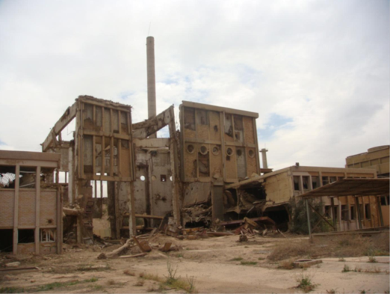 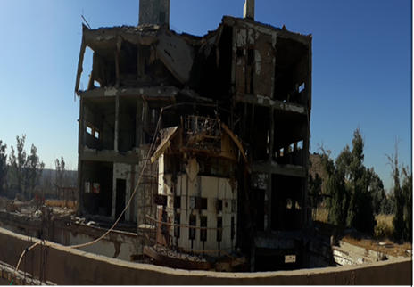

IRT-5000

*Tammuz 2*

*FIG. 1. The situation of the Tammuz 2 reactor and IRT-5000 reactor before the decommissioning process*

## DECOMMISSIONING PROGRAM IN IRAQ

The strategic plan to decommission all former nuclear facilities and sites in Iraq included three phases. These phases were developed based on many key factors including the lack of decommissioning experience, the lack of radioactive waste treatment and storage, and the lack of operational history of nuclear facilities. Fig.2. shows decommissioning schedule time.

|  |  |  |  |  |  |  |  |  |  |
| --- | --- | --- | --- | --- | --- | --- | --- | --- | --- |
| **Deco.**  **Phase** | **2008** | **2009** | **2010** | **2011** | **2012** | **2013** | **2014** | **2015** | **2016……..2025** |
| **Phase 1** |  |  |  |  |  |  |  |  |  |
| **Phase 2** |  |  |  |  |  |  |  |  |  |
| **Phase 3** |  |  |  |  |  |  |  |  |  |

*Fig. 2. Decommissioning schedule time of all nuclear facilities and sites in Iraq.*

First Phase: Already done, first Phase consisted of a short-term 3 years, (2008-2010) strategic plan in which three low radiological risk facilities were decommissioned. The target of this phase is to build decommissioning capabilities, rehabilitate the radioactive waste treatment facility, and build an interim storage and disposal facility.

Second phase: second phase planned for five years (2011-2015) strategic plan in which five high radiological risk facilities are to be decommissioned based on prioritization results. The target of this phase is to use the experience gained from first Phase in decommissioning complex, high-risk facilities.

Third phase: third Phase planned for ten years (2016-2025) strategic plan in which all remaining facilities and sites will be decommissioned based on prioritization results [1].

## CHALLENGES

There are many challenges faced Iraqi decommissioning program at the beginning of its work, the most important of these challenges are:

1. Lack of experienced personnel in the field of decommissioning of nuclear facilities.
2. Absence of information about the exact operating period and accidents during the operating period, as well as the components of these facilities due to the destruction of these nuclear facilities during the Gulf War in 1991.Iraq does not have sufficient specialized devises, equipment and instruments for decommissioning activities.
3. Looting of sites and facilities during the events of 2003, which exacerbated the problem.
4. Iraq has never had a radioactive waste disposal facility and the lack of a disposal facility means that ever-increasing quantities of radioactive material must be held in guarded storage.
5. The security situation in Iraq.
6. Due to the lack of information on the operational history of the IRT-5000 reactor, there was a high dose rate within the reactor pool of up to 2 Sv/hr. The exact location and cause of the dose has not been determined.

## Lessons learned

1. It is very necessary to seek the assistance of the International Atomic Energy Agency to assist in any decommissioning program, as it provides advices and provides training courses, workshops and meetings with experienced experts in this field as well as building Iraqi human capacities and acquiring expertise, as well as providing specialized decommissioning equipment.
2. In phase one decommissioning programme, three low risks projects were chosen to be decommissioned this programme will allow capacity building of the decommissioning workers and the regulatory staff as well as allowing the building of radioactive waste storage and disposal facilities.
3. The assessment of risks needs to be performed in all phases of a decommissioning project, even if the phases are short and pose little radiological risk.
4. Documentation and information of exact operating period and accidents during the operating period as well as the components of all nuclear facilities are very important for the process of radiological characterization and inventory of the radioactive isotopes generated inside the facility and thus affect the decommissioning strategy.
5. Iraq does not have disposal facility and there is high dose rate inside the pool of IRT-5000 (2 Sievert per hour, measured in 2018), so the safe enclosure strategy had chosen for dismantling the IRT-5000 research reactor.
6. It is important to clean-up of contaminated site specially that near public living and unstable security case as soon as possible to avoid dispreads of contaminated material.
7. To improve the radiological characterization of the IRT-5000 pool and to ensure the exact location of the hotspot inside the core, we performed a local collimator to perform additional measurements for this purpose and according to the recommendations of the IAEA experts and in order to find out the cause of the high radiation dose, retired workers who were working in the reactor were searched, And the reason was known.

## CONCLUSION

The process of decommissioning destroyed nuclear facilities is a complex and difficult process, since the decommissioning process depends mainly on radioactive characterization processes, based on which the decommissioning strategy is determined. Therefore, there were many challenges and lessons learned from this experience, especially since Iraq does not have previous experience in the field of decommissioning nuclear facilities. International Atomic Energy Agency has a very important and effective role in helping Iraq to overcome most of the challenges by providing advice, recommendations, providing equipment to carry out decommissioning activities.

REFERENCES

1. Bibi, A., Al-Musawi, F., Jassim, H., & Abd Alhadi, Q. "Decommissioning Challenge of Destroyed Nuclear Facilities and Sites in Iraq." *Revue Générale Nucléaire* 4 (2013): 37-41.‏
2. Cochran, J. R., Danneels, J. J., Phillips, C., & Chesser, R. "Iraq nuclear facility dismantlement and disposal project." *Proceedings from Waste Management'07* (2007).‏