F4E Quality Management System evolution and requirements propagation

R.Batista^{1,} , D. Rodrigues¹, V. Meigan^{1,}

¹F4E, Barcelona, Spain

With the collaboration of:
C. Brescan, E. Pozuelo, H. Lopes, J. Ilves, M. Emidio, M. Chiappone, S. Guerra, A. Esteve, M. Emidio, F. Misceo, G. Verzichelli
¹F4E, Barcelona, Spain

Email contact of corresponding author: rita.batista@f4e.europa.eu

Background
On 2007 F4E was established with the mission to bring fusion, the energy of the Sun and the stars, to Earth.
F4E is involved in three major fusion R&D projects. At ITER Project, F4E represents the European Domestic Agency (EU DA).
In 2008 F4E developed a Management and Quality Programme (MQP) [1] that allowed F4E to act as an external provider to IO with respect to the French Nuclear Regulation [2].
The Management and Quality Programme (MQP) describes and establishes the dedicated F4E Quality Management System (QMS) to achieve the quality criteria for all technical activities performed by F4E in providing Europe’s contribution to the ITER project and, in particular, for safety relevant components and activities. And also the need to cascade the requirements in a comprehensive and appropriate way to the supply chain, composed of a broad type of stakeholders that vary from universities, research institutes to private companies.
Also, the broad range of Europe’s free issue items to deliver to ITER and their complexity raised the need to create a “formal approach” in order to ensure that all the management requirements are identified and cascaded to the stakeholders in an adequate way for the work to be developed.
Below are resumed the main steps implemented in the last fifteen years; more information will be provided in the final document.

Work developed
In 2008 F4E developed a Management and Quality Programme for ITER Project (EUDA QAP) [1] which covered the whole Management System and addressed the two control environments in which F4E operates - the ITER-wide Quality System, which is intended to ensure the performance of ITER against the various technical requirements, including the nuclear safety requirements, and the European Commission Internal Control Framework.
The F4E Integrated Management System (IMS) encompassing the Quality Management System is customer oriented, taking into account equally:
(i) the requirement definitions;
(ii) the customer feedback;
(iii) F4E compliance with the requirements.
Operationally, this system is implemented through the Quality Management System (as described in the F4E Management and Quality Programme [1]) that provides an effective and efficient method to perform the tasks, a perspective on the organisation and its risks.
The Management and Quality Programme provides the overall framework to establish, to execute, to evaluate and to continually improve the Quality Management System following the same approach as outlined in ISO 9001 [3] and in IAEA GSR Part 2 (Leadership and Management for Safety, 2015) [4] in order to ensure alignment to the IO MQP and the quality of the in-kind items and services which relates to the business executed in F4E according to the ITER Agreement.
F4E acts as an external provider to IO as per the French Nuclear Regulation [1], and F4E’s Management and Quality Programme describes and establishes the dedicated Quality Management System to achieve and comply with the quality criteria for all technical activities performed by F4E in providing Europe’s contribution to the ITER Project and in particular for the safety relevant components and activities.
The MQP is reviewed periodically to ensure that is up-to-date, and continually improve the way of working and to reinforce the F4E corporate culture towards the stakeholder’s expectations.
The version applicable at the moment v3.0 from 11 December 2019.

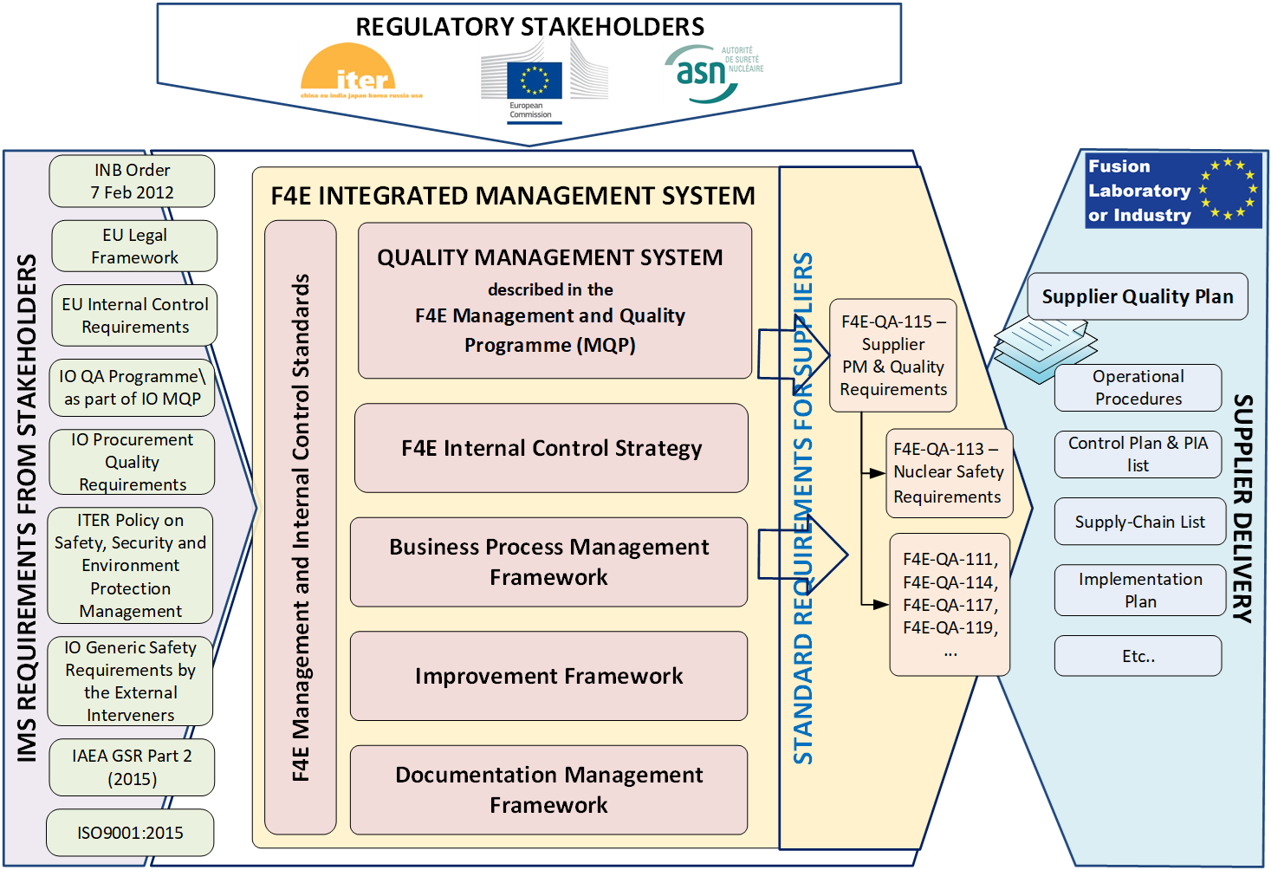

FIG. 1. F4E IMS and Quality Management System map

One of the first steps in the development of the MQP was the creation of a standard set of requirements for suppliers.

The first key document was the F4E-QA-115 Supplier Quality Requirements (later renamed to Project Management and Quality Requirements).

The QA-115 was created as a definition of the standard quality requirements for the performance of the F4E contracts, and thus avoiding the need to re-write the quality requirements in each procurement process, ensuring a minimum requirements baseline for the supply chain.

The propagation of the Nuclear Safety requirements to the supply chain was achieved through F4E-QA-115 in its earlier versions, but in its latest version (v5.5) [5] in an effort to have separate standards for key compliance matters, it relies on F4E-QA-113 (Supplier Nuclear Safety Management Requirements) [6] for the propagation of the Nuclear Safety requirements.

For the correct identification and cascading of the requirements through the supply chain, a grading approach was implemented. The grading approach is based in the Quality Class defined in the associated Procurement Arrangement (PA), and the Quality Class Determination and Implementation (QA-010) [7].
The grading approach allows to tailor the requirements levels to be applied to the items in line with their Safety Class, Quality Class and Failure Consequence Factors. The identified applicable requirements to a given item, or supply, are identified in Annex A of the contract.

Being set as baseline for contract implementation, follow up of requirements and verification of the achieved compliance.
Conclusion
F4E implemented Quality Management System that complies with the requirements set by ASN and ITER.

The Quality management system had a natural development and regular updates in line with the need to better and more precise definition of applicable requirements.

F4E implemented Quality Management System provides confidence that:

- Requirements are properly identified based on the Safety Class, Quality Class and Failure Consequence Factors.
- Nuclear Safety and Management Requirements are properly cascade to all supply chain.
- Compliance is ensured through the supply chain

References
- P-01.18 Management and Quality Programme for ITER Project (F4E_D_22MCBA_v3.0)
- République Française - Arrêté du 7 février 2012 fixant les règles générales relatives’ aux installations nucléaires de base
- ISO 9001:2015, Quality management systems — Requirements
- IAEA General Safety Requirements - GSR Part 2 - Leadership and Management for Safety (2015)
- F4E-QA-115 - Supplier Project Management and Quality Requirements (F4E_D_ 22F8BJ v5.5)
- F4E-QA-113 ‘Supplier Nuclear Safety Management Requirements’, Supplier Standard, (F4E_D_22JRQY v2.1))
- SOP-01.29 Quality Class Determination and Implementation (QA-010) (F4E_D_22MD99 V3.0)
- Quality Classification Determination (ITER_D_24VQES v5.2)
- [3] INTERNATIONAL ATOMIC ENERGY AGENCY, The Management System for Nuclear Installations, Specific Safety Guides, 2009
- F4E-QA-013 Management of the Propagation of Generic Safety Requirements in the Supply Chain (F4E_D_23CA9U v4.5)
- ITER Policy on Safety, Security and Environment Protection Management (ITER_D_43UJN7 V3.1)

