# THE BEHAVIOUR OF MA956 AND 316L-ALUMINIZED STEELS IN SUPERCRITICAL WATER

M. MIHALACHE, M.E.FULGER, I.M. DUMITRESCU,

RATEN-ICN, Institute For Nuclear Research, Pitesti, Romania

Email contact of corresponding author: maria.mihalache@nuclear.ro

The contemporary requirement for energy has conducted at the developing of the fourth-generation nuclear reactors for fission. New generation nuclear reactors for fission and the reactors for fusion operates in aggressive environment conditions and requires new cladding materials which was a proper behaviour in high temperature, high dose and high-pressure conditions for extended operation period, and, in this context, the supercritical water reactor (SCWR) retained attention due to higher thermal efficiency and simplified design. The conditions of supercritical water involve great attention at materials selection for using as cladding tubes or structural materials in contact with cooling agent.

Development of new materials for structural applications in advanced generation IV reactors is historically a long process and potential candidates for fuel cladding in SCWR include ferritic-martensitic and austenitic steels, solid solution and precipitation hardening alloys and oxide dispersion–strengthened (ODS) alloys, a part of those being simulated, developed and tested in international programs for fusion, due to the requirement for working at high temperature.

The impact of supercritical water on new materials in the absence or presence of radiation on reactor operations is unknown at this time. Also, in lead fast reactors (LFR) international programs, a special attention is paid to improvement of different stainless steels by aluminium addition in alloy or by deposition of different protective layers that protect the surfaces at liquid metal embrittlement.

The research and development gained in manufacturing of new materials as oxide-dispersed strengthened steels (ODS steels), retained attention due to their good basic mechanical properties at operating temperatures. An addition of small oxides dispersion strengthens the ferritic matrix by increasing of grain boundaries, and therefore the yield stress and ultimate tensile stress can increase at high values.

In Supercritical Water Reactors high chromium content is desired in cladding, because chromium is providing a good corrosion resistance. The supercritical water is an aggressive media and the behaviour of new materials in this environment have to be studied and this requires coolant compatibility assessment and qualification for safety assessment. Studies [1],[2] related on the effect of fine structures on the corrosion of austenitic steels in superheated steam demonstrated an improvement of oxidation resistance due to development of a protective chromium oxide layer (Cr2O3) containing fine grain microstructure on the alloy surface. The oxide layers enriched in chromium seem to protect the austenitic steels in supercritical water by suppression of oxygen and iron diffusion. Other studies[3],[4] have compared the corrosion behaviour in static supercritical water of ODS steel with base stainless steel, e.g. 304ODS (304L strengthened with yttria and Titania additions) with 304L, and have conduct at conclusion that 304ODS did not contains internal oxidation zones like 304L basic alloy and the oxide grown on 304ODS is more protective.

In this paper we assessed the behaviour in SCWR coolant of three steels by oxidation experiments in demineralised water at 550oC temperature and 25 MPa pressure. The tests have been performed on austenitic 304 L stainless steel, 316L aluminised steel and MA 956 ferritic steel. 316L aluminised steel was improved by Al introducing in 316L as alloying element, knowing that aluminium can be a valuable element in steels candidate for GIV, having the possibility for forming a protective oxide in lead fast reactors and in other GIV reactors for fission. MA956 is a ferritic ODS steel with high chromium content, obtained by mechanical alloying, strengthened with yttrium oxide dispersion and 4.4 wt.% aluminium added as alloying element.

Table 1 CHEMICAL COMPOSITION OF STEELS (wt. %)

|  |  |  |  |  |  |  |  |  |  |  |  |  |  |
| --- | --- | --- | --- | --- | --- | --- | --- | --- | --- | --- | --- | --- | --- |
|  | C | Si | Cr | Ni | Mn | Al | Co | Cu | O | Ti | Y2O3 | N | Fe |
| MA956 | 0.15 | 0.07 | 19.97 | 0.04 | 0.11 | 4.44 | 0.03 | 0.02 | 0.21 | 0.40 | 0.53 | 0.022 | rest |
| 316-Al | 0.01 | 0.89 | 18.73 | 10.79 | 0.17 | 3.25 | - | - | 0.21 | - | - | - | rest |
| 316L |  |  |  |  |  |  |  |  |  |  |  |  |  |

The morphology of oxides grown on 316L-Al and MA956 unirradiated steels has been evaluated by scanning electron microscopy and compared with the morphology on benchmarking 304 L unirradiated stainless steel.

On MA956 steel, the experiments have been performed on two microstructure types: plates with parallel and perpendicular to the rolling direction. The variation in time of weight gains (Fig. 1.) on MA956 has proven low weight gain values which suggest the development of thin and adherent oxide that protects against corrosion. In comparison with 304L steel, both MA 956 coupons types after 65 days of exposure show a low weight gain, under 5mg/dm2, proving a better corrosion behaviour in supercritical water in given conditions. The weight gain on 304L is 4 times higher than on MA 956 (Fig. 1.). Large difference between weight gains of 304L and 316-Al steel coupons has been recorded. However, in the first stage of oxidation, 316 – Al proves a loss of weight and that suggests an unprotective oxide and a metal dissolution in cooling agent. A comparation with 304 L suggests a better behaviour of 316-Al at exposure in supercritical water.

*FIG. 1.* *Comparative oxidation kinetics in SCW (550oC, 25MPa) of MA956* *alloy, 304L, 316-Al*

A duplex oxide is present on MA956, 304L and 316-Al steels surface (Fig. 2a.): one inner oxide consists in very small crystallites covering entire surface and an outer layer containing large crystallites. The inner oxide layer on MA 956 steel seems to be very compact and dense (Fig. 3.) after 68 exposure days. The outer oxide layer, on all steels, contains crystallites with sharp edges grouped like islands and porous oxide morphology. The crystallite sizes have increased and also the covered surface extents with exposure time. At limits of outer layer On MA956 another oxides morphology appears with very connected crystallites and aligned in same direction. These characteristics could be attributed to different oxide types.

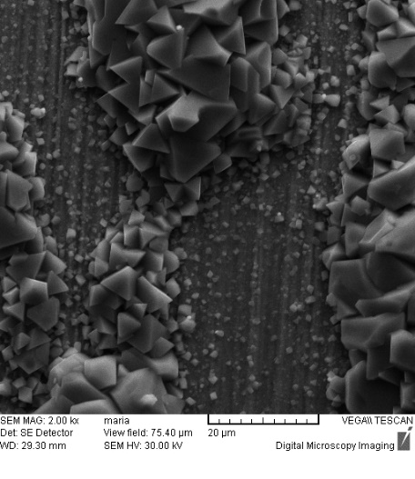

1. *b) c)*

*Fig. 2. SEM micrographs showing oxide morphology on MA956 (54 exposure days), respectively 316-Al (40 exposure days), 304L (44 exposure day)s.*

** 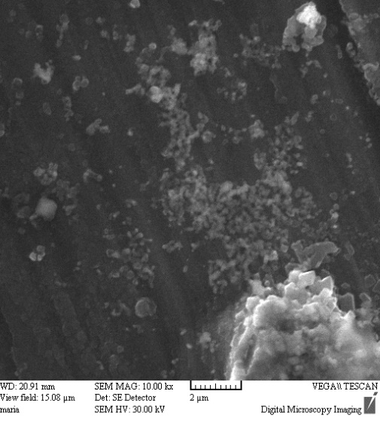

1. *b)*

*Fig. 3. SEM micrograph showing internal oxide layer structure after 68 days of exposure on MA956 alloy, respectively 40 exposure days on 316-Al alloy*

The backscattered electron images from Fig. 4a – c show the structure of cross sections in the oxide layer developed on MA 956 steel in supercritical water. In general, the duplex oxide is visible. The inner oxide is more compact and presents cracks or atomic contrast lines placed parallel with metal oxide interface. The outer layer has a porous morphology containing pores and cracks placed transverse to oxide. The oxides thickness developed on samples depend on microstructure, on rolling direction fig 4a and 4b.

**

*a)*

**

*b) c)*

*FIG. 4. BSE* *images showing oxide layer stratification after 68 exposure days in static supercritical water of MA956 alloy: a) longitudinal sample; b) transverse sample; c) internal oxide layer at the metal oxide interface.*

A detail image (fig. 4c) shows the diffusion waves at metal oxide interface, which at lower magnification seem to be cracks and pores. These waves, darker than the entire oxide, suggest the formation of oxides from alloy elements with lower atomic number.

In Fig. 5a) an optical image of duplex oxide grown in static supercritical water on MA956 alloy after 68 exposure days are presented and in Fig 5b) a BSE image and an EDS composed mapping of a small area on 304L oxidized stainless steel after 56 exposure days.

a)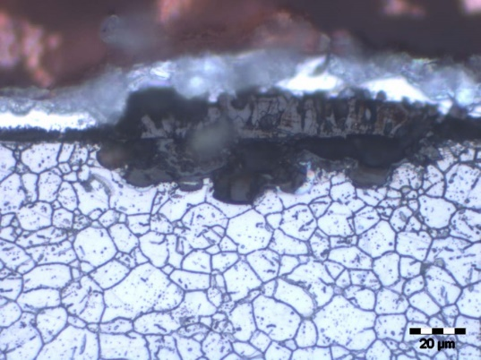

b)

*FIG. 5. Oxide layer stratification on a) 316-Al alloy, 68 exposure days b) 304L, 56 exposure days*

The 304L steel (Fig. 5b) displays an undesired internal oxidation very dangerous for structural components, the EDS composed map displaying the chemical element distribution in the oxide layer.

In Fig. 6 is presented a BSE image of duplex oxide grown in static supercritical water on MA956 alloy after 68 exposure days. The EDS microanalyses have been performed in cross-section on MA956 in the P2 - P8 points marked on this picture. Table 2 displays the results obtained at different deepness in oxide.

The EDS analysis on MA956 in P2 confirms the chemical composition of alloy: 20% Cr, 4.5% Al, 0.9% Mn, 0.7% C, 86% Fe, or 19.8% Cr, 4.6% Al, 0.9%Mn, 0.7%C, 86% Fe. The other chemical elements are present in low concentration. The EDS multipoint analysis proves the stratification of oxide grown in supercritical water. Thus, a layer at metal-oxide interface enriched in chromium (37-40%) and aluminium (9.3 – 7.2%) was observed with composition determined in P3 and P4 points. An intermediate layer enriched in chromium, while iron and aluminium contents is lower than normal. Composition was determined in P6 and P7 points. A third layer at SCW – oxide interface has a composition determined in P8 point and contains iron oxides.

**

*FIG. 6. EDS analysis points in the oxide layer grown on MA956 steel*

Table 2 CHEMICAL COMPOSITION IN POINTS (wt. %)

|  |  |  |  |  |  |  |  |  |  |
| --- | --- | --- | --- | --- | --- | --- | --- | --- | --- |
|  | C | Si | Cr | Mn | Al | Cu | O | Ti | Fe |
| P2 | 0.7 | - | 19.8 | 0.9 | 4.6 | 1.3 | - | - | 72.8 |
| P3 | - | - | 30.2 | 0.8 | 9.3 | 1.3 | 13.0 | 0.7 | 44.1 |
| P4 | 1 | 0.7 | 39.9 | 1.0 | 7.2 | 1.8 | 18.4 | 0.4 | 29.6 |
| P6 | 0.7 | - | 37.1 | 1.1 | 3.1 | 1.1 | 0.5 | 17.4 | 36.0 |
| P7 | 0.8 | - | 3.8 | 0.5 | 1.5 | 0.5 | - | 16.1 | 68.3 |
| P8 | 0.8 | 0.3 | 40.9 | 1.5 | 4.5 | 1.5 | 0.9 | 9.6 | 33.0 |

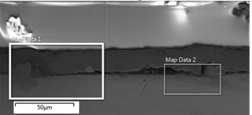

*FIG. 7. BSE image in 316-Al sample, 2016 exposure hours*

EDS microanalysis has been performed on 316-Al (Fig. 8), in Fig 7 being presented an BSE image of oxide layer. It can observe at surface an aluminium layer, 3-25 microns thickness, and a chromium-iron oxide at oxide-alloy interface. In aluminium enriched layer, silicon dioxide is incapsulated.

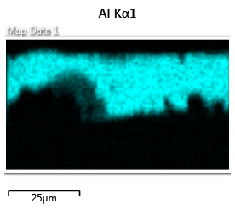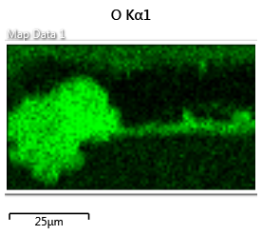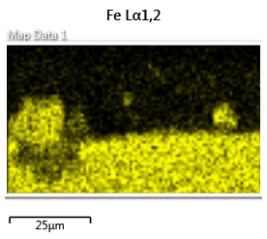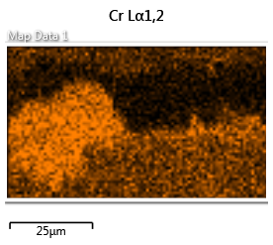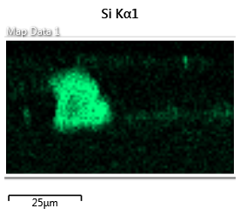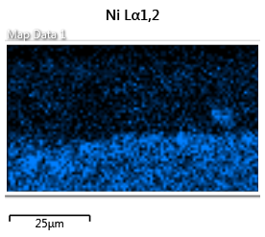

*FIG. 8. EDS elemental maps Map Data 1 selected area from Fig.7*

References

1. ABE, H., HONG, S.M., WATANABE, Y., Oxidation Behavior of Austenitic Stainless Steels as Fuel Cladding Candidate Materials for SCWR in Superheated Steam, Nucl. Eng. Des. J, 280(2014) 652-660
2. PENG, X., YAN, J., ZHOU, Y., WANG, F., Effect of Grain Refinement on the Resistance of 304 Stainless Steel to Breakaway Oxidation in Wet Air, Acta Mater. J. 53(2005) 5079–5088
3. PENTTILÄ, S., TOIVONEN, A., LI, J., Effect of Surface Modification on the Corrosion Resistance of Austenitic Stainless Steel 316L in Supercritical Water Conditions, Supercrit. Fluids J. 81(2013) 157–163
4. MIHALACHE, M., FULGER, M., DINU, A., MIHALACHE, M., Investigation of the Oxides Formed on 304ODS and 304L Steels in Supercritical Water Environment, Nucl. Res. Develop. J., 7(2014) 45-50.