FUSION ENERGY INDUSTRY: FROM DREAM TO REALITY

A. SOLDATOVA
PJSC “NOVATEK”
Moscow, Russian Federation
Email: anna.soldatova@aol.com

The paper arranges and summarizes the conditions of investment attractiveness of the nascent fusion industry. It presents a glance overview of fusion competitiveness among existing power generation facilities and its perspectives in the future. Advances in plasma physics and technology over recent years, coupled with advanced manufacturing and computing capacities now available, were the key drivers for the development of private commercial fusion projects. The Fusion Industry Association is counted for 27 member companies that had risen more than $4 billion in private investment.
The increase in the world’s population for 25% in the next 30 years – from 7.7 billion currently to 9.7 billion in 2050 according to UN estimation (1) – and the corresponding economic growth will lead to a proportional increase in our needs, including for energy. Global electricity demand is expected to roughly double in less than 20 years, rising from 3.5 TW in 2020 to 7 TW in 2040 (2). The growing consumption is a main reason for a multiple increase in greenhouse gases emissions from our vital activities.
These gases heat the planet’s atmosphere and result in global climate change, associated with natural disasters and consequent economic loss. In 2015 under the Paris Agreement, almost all countries in the world had come to the consensus to limit its greenhouse gases emissions to reach the target of 1.5°C increase in the average global temperature up to 2100. It became a trigger for rising climate action, and most countries had committed to achieve carbon-neutrality in 2050.
Significant growth of EU carbon permits price during 2018-2019 Fig. 1, eminent worldwide decrease of renewables’ levelized generation costs (LCOE) during the decade starting from 2010 Fig. 2 and official ceasing of funding for fossil fuels projects by European Investment Bank (3) in the end of 2019 were rationales for significant investment shift.
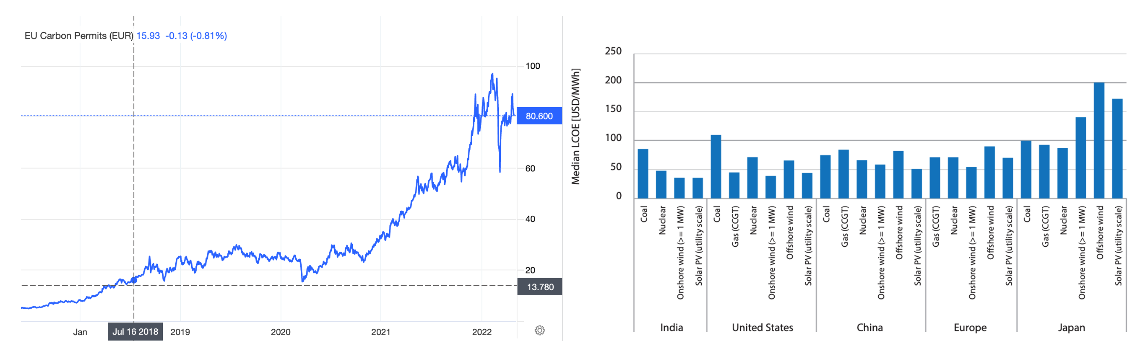
FIG 1. EU carbon permits price FIG 2. Median LCOE by region
Source: tradingeconomics.com Source: IEA
Market signals had dictated Power industry majors and big institutional investors to step in Net-zero race and transfer spare funds to renewables, CCUS technologies, digital climate solutions, etc. Thus, half of Fortune 500 companies had already made commitments to reduce its carbon emissions (4), set time scales for carbon neutrality, and launch their own climate venture capital initiatives Table 1.
TABLE 1. OIL & GAS MAJOR COMPANIES’ LOW-CARBON GOALS AND VENTURE CAPITAL INITIATIVES

Company | 2030 CO2 reductions  (absolute) | 2050 goal | Venture capital initiative | Comments
Eni | 25% | Net Zero | Eni Next | early-stage startups developing solutions for CO2
TotalEnergies | 30% | Net Zero | TotalEnergies Ventures | funding and fostering high-potential start-ups which will contribute to creating a low carbon future
bp | 30-40% | Net Zero | bp ventures | private, high growth, game-changing technology companies, who can help deliver bp’s net zero ambition
Shell | - | Net Zero | Shell ventures | renewable energy, new fuels for transport, connected mobility and freight, or digital
Equinor | - | Net Zero | Equinor Ventures | startups can drive change, and transition the energy industry towards a low-carbon future
Repsol | - | Net Zero | Repsol Corporate Venturing | startups that develop innovative technology or businesses to implement them at Repsol
Occidental | - | Net Zero | Oxy Low Carbon Ventures | nascent technologies and approaches to help find net-zero fuel solutions
Conoco-Phillips | - | Net Zero | Technology Ventures
Chevron | - |  | Chevron Technology Ventures | ways to produce and deliver affordable, reliable and ever-cleaner energy now and into the future
ExxonMobil | - |  | Exxon Capital Ventures
Source: energytracker.asia, corporate web-sites
It’s become obvious, the transformation of the global energy sector from fossil-based systems of energy production and consumption to renewable energy sources like wind and solar, as well as lithium-ion batteries. The increasing penetration of renewables into the energy supply mix by electrification and improvements in energy storage is a key driver of the energy transition. However, to ensure system reliability, intermittent renewables need to be complemented by technologies which can provide power when the wind is not blowing, or the Sun doesn’t shine. Controlled thermonuclear fusion (CTF) could provide sustainable, low-carbon, baseload power to satisfy future growing demand for energy.
To commercialize CTF and build a completely new Fusion industry, it’s crucial to supply funds for technology development right now. Capitalists’ decisions, whether to invest money, require simple explanations of fusion energy basic principles, precise evaluation of market size and clarifying its perspectives among the global Power landscape.
Starting with the demand side, let’s try to define a possible range of fusion market volume. The recent IEA World Energy Outlook (5) predicts, we’ll need 0.8-1.5 GW installed capacity of other low-carbon sources in the nearest 20 years Fig. 3. Therefore, a niche for CTF could be around 5-8% of the entire electricity generation market in 2040. With the global Power market being almost $3.5 trillions in 2021 (6), expected to double in 20 years, the floor estimation of fusion market size would be $0.4-0.6 trillion in 2040.
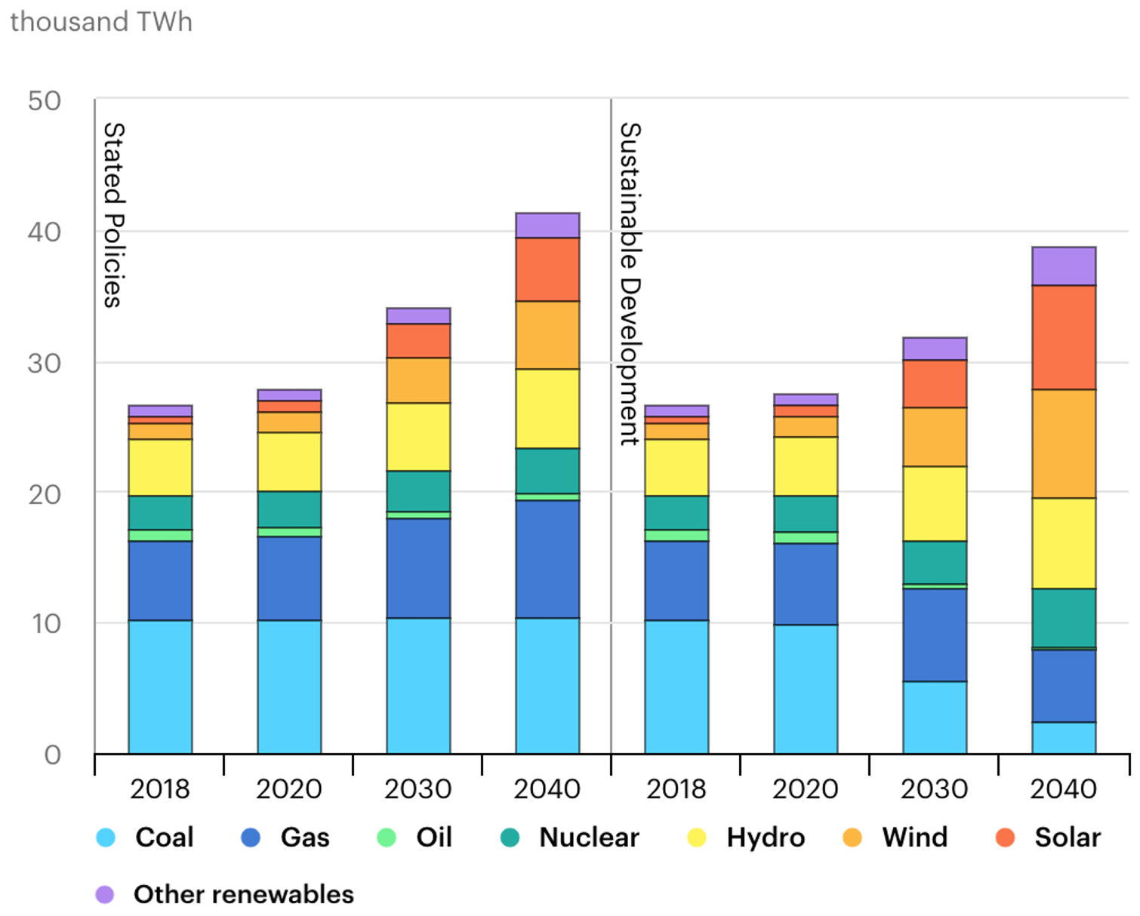
FIG 3. Actual and forecasted electricity generation by fuel
Source: IEA
Bloomberg’s assessment (7) shows that, global energy-related emissions need to drop 75% below 2019 levels by 2040 to reach net-zero in 2050. As CTF is a low-carbon energy source, there is a room for almost 25 Gt CO2 emissions reduction per year in the nearest future Fig. 4. With current EU emissions permits price $89 per t and the current level of cost for CCUS varying $20-200 per t (8), the ceiling estimation of fusion market size would be $2.2-5 trillion in 2040.
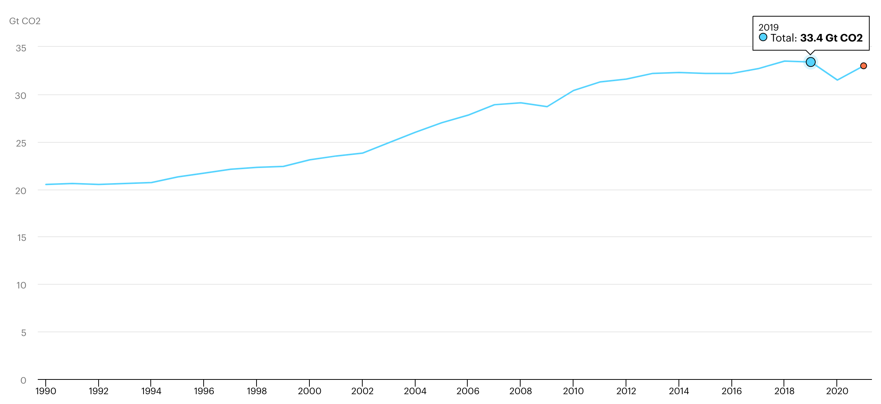
FIG 4. Global energy-related CO2 emissions, 1990-2021
Source: IEA
So far, the development of fusion technologies was mainly funded by governments. Today, 25 countries officially have national fusion R&D programs, involving over 70 universities and laboratories worldwide. According to IAEA FUSIS system (9) there are 107 fusion reactors publicly financed, including leading international project – ITER. ITER is an experimental fusion reactor of magnetic confinement (tokamak) being constructed in southern France and supported by 35 nations.
Estimating the latest budgets Fig. 5, apparent leaders are China, Japan, the USA and the UK, spending an enormous amount of money on fusion energy exploration. However, even approximate costs for ITER – $22 B – drop in the bucket in comparison with the global energy market size. Climate urgency probably could transform the situation and stimulate the financing of fusion. The more we spend, the closer we are to the further breakthroughs to step into the market and cut out its share.
3 451 790

FIG 5. Global energy market vs. estimated upcoming public funding on fusion energy, $M
Apart from cash inflows the UK, the USA, China and Japan are working on complex long-term strategies of fusion development Table 2. Although each country pursues different goals, all of them strongly backing fusion and are interested in deployment of the first power generation facility. While the UK would like to become a world-leading exporter of fusion technology, the USA is mostly attempting to create new jobs and assist national private sector. Japan and China are trying to deal with their import fossil fuels dependency and satisfy its growing energy demand.
TABLE 2. STRATEGIC TARGETS OF CERTAIN GOVERNMENTS
 | UK | USA | China | Japan
Strategic goals | Demonstrate the commercial viability of fusion by building a prototype fusion power plant in the UK  Build a world-leading fusion industry which can export fusion technology around the world | Accelerate viable commercial fusion energy | Operate fusion machines economically and permanently | Achieve technological solution for DEMO  Promote balanced research on helical and laser fusion
Published strategic document | the UK fusion strategy | expected | - | expected in the second half of 2022
Time horizon | up to 2040 and further | up to 2032 and further | not specified | up to 2035 and further
Government bodies involved | BEIS  Environment Agency  Health and Safety Executive  UKAEA | Department of Energy  Nuclear Regulatory Commission  Fusion Energy Sciences Advisory Committee  ARPA-E | not specified | MEXT – Ministry of education, culture, sports, science and technology
Regulation principles declared | alternative to fission | inventory regulated by NRC  alternative regulation for facilities | not specified | not specified
Demonstration facility and its timeline | STEP – spherical tokamak  Concept design by 2024  Construction around 2040 | not specified | CFETR for steady-state operation and tritium production (200 MW)  Complete in 2030s  Prototype plant in 2050 | DEMO  Construction in 2030s
Number of private companies | 3 | 21 | 1 | 3
Source | (20) | (21) | (22) | (23)
Public spending imposes its own limitations (red tape, strict regulation, several levels of reporting etc.) on the already complex subject of scientific research. For these reasons, the progress in fusion energy development for the last decades was slow paced. The difference today is the number of private initiatives. Their entrepreneurship approach makes it possible to achieve significant results with limited resources. Fusion private companies have become a game-changer in the same way, the commercial entrance had changed the American space industry.
Unsurprisingly, in 2018 Fusion Industry Association (FIA) was found in the USA as a non-profit independent trade association for the international fusion industry. For the last decade, the number of private fusion companies grew 3 times, and today FIA supports 27 member companies working on different technical approaches. Most of them explore magnetic confinement, especially with tokamaks and spheromaks, f.e. CFS, Tokamak Energy, CTFusion, etc. The other two most popular concepts are magneto-inertial (General Fusion, TAE Technologies, Zap Energy, etc.) and inertial confinements (First Light, Marvel Fusion, Focused Energy). Recently, interest in inertial fusion confinement has increased substantially.
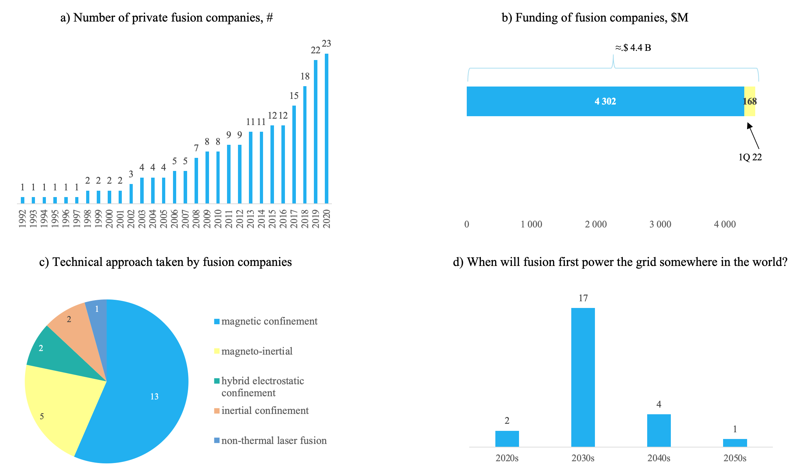
FIG 6. Fusion industry highlights
Source: FIA
The most considerable matter from the FIA data Fig. 6 is the amount of money has already been invested in fusion start-up companies. Over 100 capitalists had provided more than $4 B for FIA’s members, over $168 M during the first quarter of 2022. Private capital, with a flexible approach within limited resources, is ready to take part in creating a fusion energy source. Almost 5% of total investment in fusion was made by oil and gas majors – Eni, Equinor and Chevron Fig. 7. In addition, early 2022 Japanese oil and gas corporation – Inpex – has announced (24) its plan to provide funds for national fusion start-ups and the intention to collaborate with foreign companies.
Famous billionaires such as Jeff Bezos, Bill Gates and George Soros have already asserted fusion and spent their own money on its development. Among investors, significant share (62%) is gained by Private equity and Venture capital funds. Some funds have even diversified their fusion portfolios and invested in more than 1 start-ups: Temasek, Google Ventures, Jameel Investment and LowerCarbon. Others – Energy Impact Partner and LowerCarbon – have declared creation of new funds with focus on the fusion technology. With the apparent aim of multiple yields on their investment via increase in enterprise value, they recognize the viability of business models of existing start-ups and believe in future market growth.
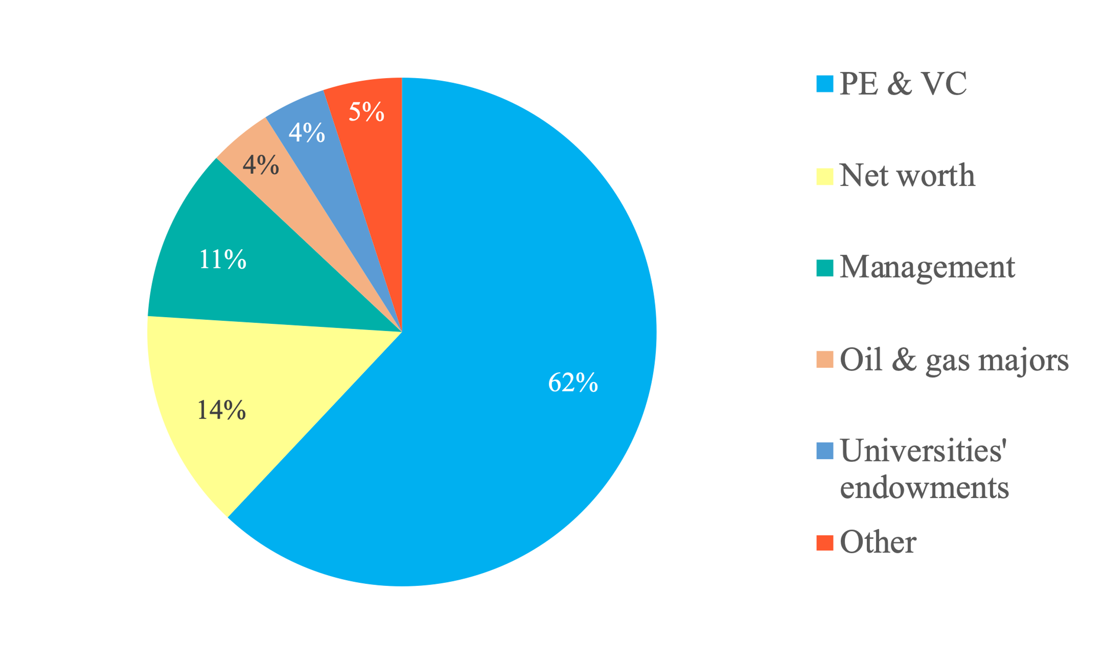
FIG 7. Fusion investors analysis
Source: FIA, author’s estimation
As well as the diversity of technical approaches, fusion companies propose a variety of business models. Three leading FIA’s members – CFS, Helion Energy and General Fusion have raised over $3 B of the total private investment. All of them have completely different monetization plans. CFS developing tokamak reactor is going to get first dollar revenue by selling superconducting magnets and now builds its manufacturing plant. Meanwhile Helion Energy advocating magneto-inertial confinement with D-He3 fuel mix suggests recapturing as electricity the change in field induces current. This clean fusion electricity will power homes, communities and provide cash flows for Helion Energy. According to FIA’s members estimations, we might to wait for the first fusion kilowatt in to a grid in the 2030s Fig. 6.
If and when fusion is proven at scale, it is likely to be disruptive energy technology, but it is necessary to validate its competitiveness among existing approaches. Analysing supply side, get the estimation of possible LCOE for fusion power plant with 400 MW installed capacity Table 4 with existing references on capital expenditures (CAPEX) and operational costs (OPEX) for fusion power plant Table 3. For LCOE see Eq. (1) below:
$LCOE=\frac{\sum_{n=0}^{N}{\frac{{CAPEX}_{n}}{{(1+r)}^{n}}} + \sum_{n=0}^{N}{\frac{{OPEX}_{n}}{{(1+r)}^{n}}}}{\sum_{n=0}^{N}{\frac{{Energy output}_{n}}{{(1+r)}^{n}}}}$ (1)

TABLE 3. CAPEX AND OPEX ESTIMATION IN 2020 PRICES
# | Project Name | Capacity to the grid, MW | Project’s cost, $B | CAPEX, $M/MW | OPEX, $/MW•h | Source
1 | DEMO2 | 1 000 | 9.39 | 9.39 | 6.5 | [25]
2 | ARC | 200 | 4.3-5.4 | 22-27 | - | [26]
3 | ALPHA | 150 | 0.76-2.1 | 5.1-14 | 14.8-31.2 | [27]
4 | BETHE | 400 | 2 | 5 | 5 | [28]
5 | Estimation | 400 | 1.2 | 3 | 2.69 | [29]
Weighted average |  |  |  | 10.1 | 7.85
TABLE 4. SENSITIVITY ANALYSIS OF LCOE DEPENDING ON THE CAPEX AND OPEX LEVELS, $/MWH ESTIMATION IN 2020 PRICES
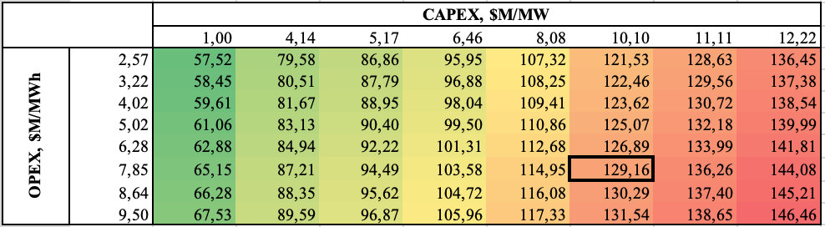
Comparing with current levels of LCOE by technology, fusion energy could hardly compete with mature nuclear, coal and gas-fired generation Fig. 8, until the technology would be scaled up and CAPEX level would drastically decrease. The ability of self-sustain tritium production is another crucial cost driver. With the current market price of tritium – $30 thousand/gram and 40-50 kg annual inventory requitement for 400-500 MW plant, the fuel costs would be skyrocketing. So, it’s vitally important to implement a tritium breeding system for power plant functioning.
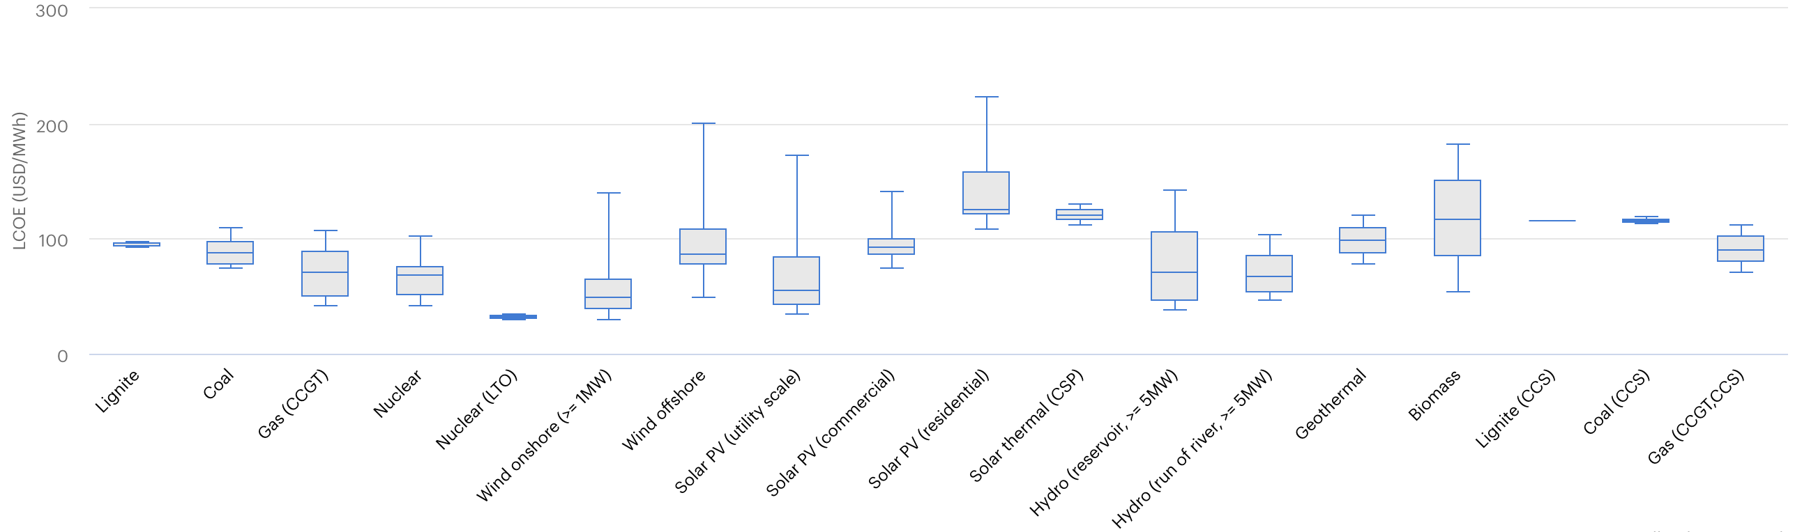
FIG 8. LCOE by technology
Source: IEA
However, being a source of clean, abundant, safe, affordable energy fusion could be a complement to renewables. On the other side, present electricity prices worldwide could be a barrier for fusion energy to enter the several countries. This is reasonable, as every territory has its own pros and cons, and we should spread and deploy the cheapest sources of energy.
Regional variation in the price of electricity is driven by fuel costs volatility, local carbon price and renewables potential. Considering recent power market volatility, there are places in the world where fusion could be potentially competitive, f.e. Germany, UK, Japan and Singapore Fig. 9. Meanwhile fusion deployment for integration of the other low-carbon technologies such as hydrogen production, use of waste heat to power direct-air carbon capture, etc. could improve fusion economics, bring revenue and ease its market penetration.

FIG 9. Electricity prices by countries, $/MWh in 2021 prices
Source: globalpetrolprices.com
The overview of international investment activity, market perspectives and benchmark prices, presented in this paper, could be a convincing argument for intensifying spending on CFT worldwide. It could be a bridge between scientific research and business interest to get a margin on investment. Such kind of collaboration would speed up fusion development and assist in creation new, sustainable and low-carbon future.
References
- https://www.un.org/en/global-issues/population#:~:text=The%20world's%20population%20is%20expected,nearly%2011%20billion%20around%202100
- https://www.rff.org/publications/reports/global-energy-outlook-2021-pathways-from-paris/
- https://www.reuters.com/article/us-climate-europe-eib-idUSKBN1XO2OS
- https://www.visualcapitalist.com/climate-targets-of-fortune-500-companies/
- IEA. World Energy Outlook 2019: https://www.iea.org/reports/world-energy-outlook-2019/electricity
- https://www.researchandmarkets.com/reports/5240353/electric-power-generation-transmission-and?utm_source=CI&utm_medium=PressRelease&utm_code=782l4t&utm_campaign=1512252+-+Global+Electric+Power+Generation%2c+Transmission%2c+and+Distribution+Market+Report+(2021+to+2030)+-+COVID-19+Impact+and+Recovery&utm_exec=jamu273prd
- https://about.bnef.com/new-energy-outlook/?utm_medium=Adwords_SEM&utm_source=pdsrch&utm_content=bnef-search&utm_campaign=477539&tactic=477539&gclid=Cj0KCQiAnaeNBhCUARIsABEee8ViBmfHbqTpF29CDOur2Txq5h3gw2PPUowEFEzqlI_rknICtsfAsMEaAs3aEALw_wcB
- https://www.belfercenter.org/publication/carbon-capture-utilization-and-storage-technologies-and-costs-us-context#:~:text=Cement%20production%3A%20%2419%E2%80%93%24205%20per,plants%3A%20%2420%E2%80%93%24132%20per%20ton
- https://nucleus.iaea.org/sites/fusionportal/Pages/FusDIS.aspx
- http://www.iter.org/faq#Do_we_really_know_how_much_ITER_will_cost
- https://energypost.eu/nuclear-fusion-u-s-and-china-race-to-build-worlds-first-commercial-plant/
- http://www.tj.kyushu-u.ac.jp/evergreen/contents/EG2017-4_4_content/pdf/Pages%2016-23.pdf
- https://www.fusionindustryassociation.org/post/support-for-fusion-energy-in-the-house-passed-build-back-better-legislation
- https://assets.publishing.service.gov.uk/government/uploads/system/uploads/attachment_data/file/1010003/UKAEA_Annual_Report_and_Accounts_2020_21_P52_Double_page_spead.pdf
- http://www.innov-rosatom.ru/about/o-portale/%D0%A4%D0%9F%203.pdf
- https://www.cleanenergywire.org/news/germany-should-continue-nuclear-fusion-research-fight-climate-change-opinion
- https://www.iisd.org/sustainable-recovery/news/clean-recovery-spain-offers-eur-181-million-for-renewable-energy-projects/
- https://nucleus-new.iaea.org/sites/fusionportal/Shared%20Documents/FEC%202018/fec2018-material/material0900.pdf
- https://www.nature.com/articles/nature.2013.12251
- https://www.gov.uk/government/publications/towards-fusion-energy-the-uk-fusion-strategy
- https://www.whitehouse.gov/ostp/news-updates/2022/03/15/fact-sheet-developing-a-bold-vision-for-commercial-fusion-energy/
- https://table.media/china/en/feature/hope-for-inexhaustible-energy-from-nuclear-fusion/
- https://www.fusion.qst.go.jp/fusion-energy-forum/topics/topics2019/MEXT_en.pdf
- https://asia.nikkei.com/Business/Energy/Japan-s-Inpex-to-join-nuclear-fusion-race-with-startup-investments
- Slavomir Entler, Jan Horacek, Tomas Dlouhy, Vaclav Dostal. Approximation of the economy of fusion energy
- https://www.computerworld.com/article/3028113/mit-takes-a-page-from-tony-stark-edges-closer-to-an-arc-fusion-reactor.html#:~:text=MIT's%20ARC%20reactor%20is%20projected,to%20five%20years%2C%20Sorbom%20said.
- https://www.researchgate.net/publication/318215383_Conceptual_Cost_Study_for_a_Fusion_Power_Plant_Based_on_Four_Technologies_from_the_DOE_ARPA-E_ALPHA_Program
- https://arpa-e.energy.gov/technologies/programs/bethe
- Samuel E. Wurzel, Scott C. Hsu. Progress toward fusion energy breakeven and gain as measured against the Lawson criterion

Carbon capture, utilization and storage
25-30% load factor assumed
Including Canadian General Fusion building demonstration fusion power plant on the territory of UKAEA Culham Campus
Not included fuel costs

