Moose Framework For Research and Development of Fission and Fusion Reactors

Gyanender Singh¹, Alexander Lindsay¹, Pierre-Clément A. Simon¹, Paul Humrickhouse²

¹Idaho National Laboratory, Idaho Falls, USA
²Oak Ridge National Laboratory, Oak Ridge, USA

Email contact of corresponding author: Gyanender.Singh@inl.gov
The Multiphysics Object Oriented Simulation Environment (MOOSE) framework is an open-source code mostly written in C++ that provides a framework to develop finite element-based applications for performing computational analysis [1]. The framework enables massively parallel computation and has been successfully run on up to 50,000 processor cores. It provides interfaces to the user through which customized physics, geometries, boundary conditions, material models can be easily implemented by the user without any need to consider the intricacies of the finite element solve which are handled internally by the framework. Thus, one of the unique features of the framework is that it provides users the ability to solve a problem of interest involving complex underlying physics.
The framework has been used to develop several applications which are used for research and development of light water reactors, high temperature gas cooled reactors, molten salt reactors, liquid metal fast reactors, and microreactors [2-9]. Figure 1 shows an overview of the MOOSE framework, different applications based on the framework and using specific modules from it, and several applications which, while not directly based on MOOSE, can still be used alongside with MOOSE based applications to perform analyses. Due to easy couple-ability of different applications with parallel scalability, multiphysics and multiscale analyses can be easily performed.
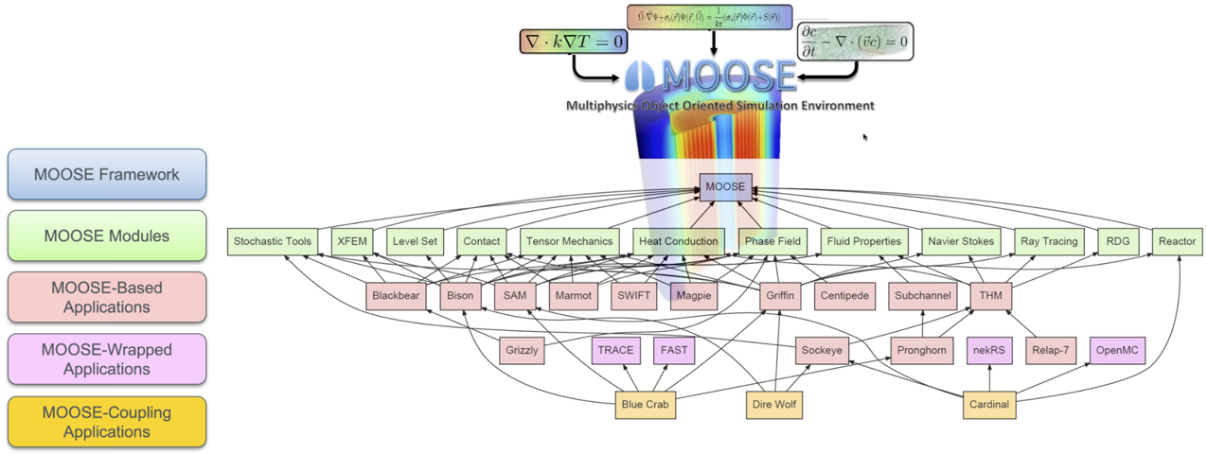
FIG. 1. The MOOSE framework is comprised of several physics and mathematics modules which are leveraged upon by the several applications built using MOOSE. Several other applications which are not based on MOOSE can be also coupled with MOOSE based applications and used alongside in performing a computational analysis.
More recently, MOOSE has been used to develop the application Tritium Migration Analysis Program (TMAP8) for supporting research and development for fusion reactors. TMAP8 is a MOOSE based application that is currently being developed for system-level mass and thermal transport calculations related to migration of hydrogen isotopes. The TMAP code was first written in FORTRAN in late 1980s for safety analysis of fusion systems. Several extended versions of the code were released later: TMAP4 (1992), TMAP2000 (2000) and TMAP7 (2004). The code has been used for several real-world applications which include analysis of advanced systems such as International Thermonuclear Experimental Reactor (ITER), for supporting fusion safety related experiments and estimates involving tritium production technologies.
The TMAP7 code could model trapping of three separate traps and up to ten diffusing species. The code could automatically generate the heteronuclear molecular partial pressures using the solubilities and partial pressures of the homonuclear molecular species. Several species present at the metal surface do not themselves diffuse but contribute significantly to the reactions with diffusing hydrogen isotopes. The code accounted for the dynamic generation of these surface species and their role in the diffusion of the isotopes. The TMAP8 code is being developed to retain as well as significantly improve the modelling capability of the previous versions of the code. All these features of TMAP7, regarding heat transfer, mass flow between the enclosures and chemical reactions within the enclosures, will be retained in the TMAP8 code, however, the capability of the code in terms of the size and complexity of the analysis will be significantly improved by taking advantage of the MOOSE framework and modern parallel computing resources.
The MOOSE framework is an excellent example of technologies that are supports both fission and fusion research and development. Many of the applications that have been developed using MOOSE are being actively used for the advancement of fission reactors. With the development of TMAP8 and potentially other applications in the future, we expect to see significant contribution of the MOOSE framework to the development of fusion reactors.

References
- Permann, Cody J., Derek R. Gaston, David Andrš, Robert W. Carlsen, Fande Kong, Alexander D. Lindsay, Jason M. Miller et al. "MOOSE: Enabling massively parallel multiphysics simulation." SoftwareX 11 (2020): 100430.
- Williamson, Richard L., Jason D. Hales, Stephen R. Novascone, Giovanni Pastore, Kyle A. Gamble, Benjamin W. Spencer, Wen Jiang et al. "BISON: A flexible code for advanced simulation of the performance of multiple nuclear fuel forms." Nuclear Technology 207, no. 7 (2021): 954-980.
- NRC, 2020. NRC Non-Light Water Reactor (Non-LWR) Vision and Strategy, Volume 1 – Computer Code Suite for Non-LWR Plant Systems Analysis. https://www.nrc.gov/docs/ML2003/ML20030A176.pdf
- Lange, Travis, Experience with DireWolf for Heat-Pipe Microreactor Analysis to Support Early Demonstration, Technical report INL/EXT-20-59691, Idaho National Laboratory, 2020.
- Wang, Yaqi, Zachary M. Prince, Joshua Thomas Hanophy, Changho Lee, Yeon Sang Jung, Hansol Park, Logan H. Harbour, and Javier Ortensi. Performance Improvements for the Griffin Transport Solvers. No. INL/EXT-21-64272-Rev000. Idaho National Lab. (INL), Idaho Falls, ID (United States), 2021.
- Novak, A. J., R. W. Carlsen, S. Schunert, P. Balestra, D. Reger, R. N. Slaybaugh, and R. C. Martineau. "Pronghorn: A multidimensional coarse-mesh application for advanced reactor thermal hydraulics." Nuclear Technology 207, no. 7 (2021): 1015-1046.
- Hansel, Joshua E., Ray A. Berry, David Andrs, Matthias S. Kunick, and Richard C. Martineau. "Sockeye: A One-Dimensional, Two-Phase, Compressible Flow Heat Pipe Application." Nuclear Technology 207, no. 7 (2021): 1096-1117.
- Zhou, Yukun, Alejandro Perez, and Jun Wang. "Development and application of System Analysis Module from the user’s view." In Nuclear Power Plant Design and Analysis Codes, pp. 313-332. Woodhead Publishing, 2021.
- Capps, Nathan, Aaron Wysocki, Andrew T. Godfrey, Benjamin S. Collins, Ryan Sweet, Nicholas Brown, Soon Lee, and Nicholas Szewczk. Full core LOCA safety analysis for a PWR containing high burnup fuel. No. ORNL/TM-2020/1700. Oak Ridge National Lab. (ORNL), Oak Ridge, TN (United States), 2020.

