The key enabling role of ductile amorphous oxide coatings for Generation IV and fusion nuclear power plants

B. Paladino^{1,2}, M. Cabrioli^{1,2}, A. Stinchelli^{1,2}, S. Bassini³, M. Utili³, M. Angiolini³, M. Tarantino³, P. Agostini³, F. Di Fonzo¹.

¹Center for Nano Science and Technology@PoliMi, Istituto Italiano di Tecnologia, Milano, Italy
²Dipartimento di Energia, Politecnico di Milano, Milano, Italy
³ENEA FSN Department, C.R. Brasimone, Camugnano (Bo), Italy

Email contact of corresponding author: fabio.difonzo@iit.it

Nuclear fusion is on the verge of maturing into a sustainable and safe power generating technology. The most consolidated designs of power plants envisioned have in common the deuterium-tritium fusion reaction, which implies the production of the latter from Li, in a breeding blanket (BB), the technological cornerstone for a self-sustaining power plant. Whatever the specific design of the BB, two issues are omnipresent: T permeation from the breeding zone and corrosion of the structural materials by the Li compounds used. These problems will actually affect also the Generation IV (GIV) nuclear systems in different degrees, given the generation of tritium inside the fuel rods and the presence of corrosive heavy liquid metals used as coolant. Here we present the summary of our work on Ductile Amorphous Ceramic (DACs) coatings deposited by Pulsed Laser Deposition (PLD) to overcome these challenges. In particular, PLD will allow to grow a dense, compact and well-adherent coating, also on complex geometries, with the final aim to have a protective barrier on the steel substrates, able to insulate the structure from the harsh environment of the selected nuclear system [1,2]. This new class of ceramic coatings have unique properties: high strength and ductility and a high density amorphous structure. As a matter of fact, it was recently demonstrated that 50 nm thick, defect-free films exhibit an elastoplastic response under both tensile and compressive tests at room temperature [3]. A clear onset of plastic deformation has been observed and a yield stress as high as 4 GPa (tensile and compressive) has been measured, with a plastic deformation as high as 7 % in tension and 100 % in compression. The mechanical properties assure the reliability of coated steel parts under the most extreme thermal cycles and the isotropic, homogeneous structure impermeability to gases (H₂, D₂, O₂) even at high temperature. Nuclear relevant tests were also performed in the last years. Hydrogen and deuterium permeation tests demonstrated the excellent performances of the PLD coatings to suppress permeation. The Permeation Reduction Factor (PRF) is the main figure of merit to be considered in these experiments, which is calculated as the ratio of the flux of gas permeating through the bare reference sample and the flux of gas permeating through the coated sample, at a given temperature. In the case of the breeding blanket, in order to assure the proper tritium balance, a PRF in the order of 10³ in gas phase or a PRF in the order of 10² in Pb-16Li at 450 °C should be guaranteed. PLD-Al₂O₃ coatings showed an unprecedented PRF > 10⁵ at 450 °C (gas phase) with negligible temperature dependence (employing deuterium). Moreover, in the previous years it was demonstrated that the PRF values are affected neither by electron irradiation (1,8 MeV) nor severe thermal cycling. In addition, PLD samples were exposed to corrosion tests involving the most common breeding materials envisioned for DEMO and cooling media (namely, Pb and PbBi) of GIV systems, showing optimal resistance and substrate protection [4-12]. PLD-Al₂O₃ were exposed to static and flowing Pb-16Li at 550 °C and 500 °C up to 7000 h, since this alloy is the most prominent breeding medium expected in a future fusion power plant. The characterization of these samples is still ongoing, nevertheless from a morphological point of view, no signs of corrosion, neither generalized (no thinning of the coating) nor localized could have been identified. Nevertheless, it is known that from the interaction between Li and Al₂O₃, the ternary compound LiAlO₂ arises (confirmed by X-Ray Diffraction (XRD) analysis). Although it was proven to be stable in Pb-16Li, its mechanical properties are scarcely investigated. This is why it is of fundamental importance to understand till where the Li is able to diffuse inside the coating. Atom Probe Tomography (APT), X-ray Photoelectron Spectroscopy (XPS) and Time-of-Flight Secondary Ion Mass Spectroscopy (TOF-SIMS) analyses are ongoing to undertake this task. In parallel with the corrosion tests in Pb-16Li, it was possible to expose PLD samples also to the solid breeding medium expected in the Helium Cooled Pebble Bed (HCPB) concept. Experiments have been carried out at 800 °C, for 730 hours. Two different kinds of ceramic pebbles were employed in these experiments: lithium orthosilicate and lithium metatitanate. Scanning Electron Microscope (SEM) micrographs show that the uncoated sides of the steel plates suffered intense corrosion due to solid state reactions between the steel and the ceramic pebbles, while the only side coated with PLD- Al₂O₃ does not show any sign of corrosion. However, confocal microscope observations showed that the surface of the coating is characterized by micro-sized cracks, due to the crystallization process triggered by high temperature. Nevertheless, the coating was still well-adherent on the substrate also after facing these severe conditions and the protective capability of the coating is maintained. The coating were also tested in static and flowing lead at different temperatures and different oxygen contents up to 10000 h, and also in Pb-55Bi (1000 h, 550 °C). As it was illustrated before, also in these cases the material did not manifest any sign of degradation, delamination or thickness reduction, nor the steel substrate displayed any corrosive attack, showing the optimal corrosion resistance of the PLD coatings. Fig. 1 shows a summary of the main results obtained in different corrosion tests involving PLD coatings.
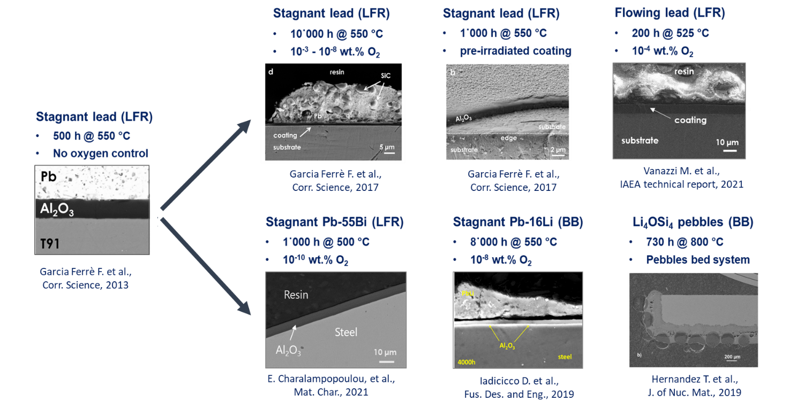

Fig. 1: Summary of the corrosion tests involving PLD-Al₂O₃.
Finally, thanks to their excellent qualities, the PLD coating were selected to be part of one-of-a-kind experiment in a research nuclear reactor. As a matter of fact, two steel cylinders coated with PLD-grown aluminium oxide (3 µm and 5 µm thick) were mounted in a special capsule together with Pb-16Li. The samples were then in contact with the corrosive medium and also exposed to neutron irradiation (720 h). In addition, tritium was produced by the 6Li(n;α)T nuclear reaction, thus it was possible to evaluate the PRF value in fusion relevant conditions. Furtherly, since between the top and the bottom of the capsule a temperature gradient of more than 100 °C was present (due to the vertical profile of the neutron flux inside the nuclear reactor), the natural circulation of the liquid eutectic alloy was established (flow speed of about 2,5 cm/s). The calculated PRF value in these conditions was > 250, still above the minimum requirements. In addition, the coatings were characterized in hot-chambers in order to investigate their integrity after the test. Also in this case, both coatings were found to be smooth and free of cracks in all the cross-sections investigated. No damaging of the coatings related to the exposure in the Pb-16Li capsule was observed. The investigation of the cross-sections did not show any loss of adhesion or delamination effects at the coating-steel interface. The performed Energy Dispersive X-ray (EDS) line-scan shows presence of Al and O corresponding to the Al₂O₃ layer deposited by the PLD technique on the pristine steel showing no change in its chemical composition after the experiment in the reactor. This shows that the PLD-grown aluminium oxide can protect the steel substrates even under neutron and gamma irradiation.

References
- F. Di Fonzo et al., Applied Physics A: Materials Science and Processing 93 (2008) 765–769
- F. García Ferré et al., Acta Materialia 61 (2013) 2662–2670
- E. J. Frankberg et al., Science 366, 864–869 (2019)
- D. Iadicicco et al., Nuclear Fusion 58 (2018)
- F. García Ferré et al., Corrosion Science 124 (2017) 80-92
- F. García Ferré et al., Corrosion Science 77 (2013) 375–378
- T. Hernandez et al., Journal of Nuclear Materials 516 (2019) 160-168
- F. García Ferré et al., Scientific Reports 6 (2016) 33478
- F. García Ferré et al., Acta Materialia 143 (2018) 156-165
- A. Zaborowska et al., Ceramics International (2021)
- E. Charalampopoulou et al., Materials Characterization 178 (2021) 111234
- M. Vanazzi et al., “Alumina nanoceramic coatings: an enabling technology for heavy liquid metal-cooled fast”, Structural Materials for Heavy Liquid Metal Cooled Fast Reactors Proceedings of a Technical Meeting, 2021

