Leveraging Particle Accelerator and RADIOACTIVE Material Safety Paradigms for Regulating Fusion Devices

SACHIN DESAI
Helion Energy, Inc.
1415 75th St SW, Everett, WA 98203
sdesai@helionenergy.com

MICHAEL HUA
Helion Energy, Inc.
1415 75th St SW, Everett, WA 98203
mhua@helionenergy.com

Introduction:
Fusion promises unlimited, safe, carbon-free electricity. Recent advancements in both the public and private spheres have raised the prospect that commercial deployment of fusion energy systems may happen before the end of the decade. This includes several potential mid-decade technical accomplishments, such as Helion Energy’s planned demonstration of net electricity from fusion in 2024.
As a result of the rapid advancement in the field, there has been increased interest in establishing regulatory frameworks for fusion devices that can enable their expeditious deployment while protecting public health and safety. Although there remains no immediate need for regulation of fusion devices, early effort to learn about the diversity of technologies and approaches to regulation in place today can help ensure an appropriate framework is in place by the late 2020s and early 2030s.
To this end, there are a variety of applicable precedent for the regulation of fusion devices. This presentation examines the current frameworks that exist for regulating particle accelerators and certain radioactive materials licensees (such as irradiators). These frameworks provide applicable precedent for regulating future fusion power plants as described below.
Operational Safety:
Fusion devices are fundamentally akin to particle accelerators in comparing operational hazards and safety systems.
The primary hazard associated with both types of devices is in the form of photon and neutron radiation from the device. In the Helion device, this is specifically in the form of photons and 2.45 MeV neutrons. Particle accelerators such as linear accelerators and cyclotrons comprise a wide range of radiation profiles, including neutron and photon emissions with energies ranging from a few MeV to more than a GeV. The means of addressing the hazard is likewise identical in both cases and include borated concrete, hydrogenous materials, lead, and other shielding coupled with external monitoring and sensors. Correspondingly, a key differentiator between fusion and fission devices is that fusion devices are incapable of undergoing criticality. Thus, safety approaches for to criticality management uniquely associated with fission systems are not required for fusion.
A secondary hazard during operation is management of the tritium. Tritium management is similar in this context to medical cyclotrons that produce radioactive materials through target bombardment with accelerated particles (e.g., PET radioisotopes). As a particular case in point, Helion’s fusion devices use D-3He fusion fuel. The D-3He fuel is stable and fusion produces tritium as a byproduct. Thus, tritium produced is captured in exhaust and is separately managed via glovebox and isotope separation systems for eventual storage and potential disposal. This enables the tritium management paradigm for such types of fusion devices to be very similar to medical cyclotrons that produce radioactive materials as part operation (and likewise handle those materials in gloveboxes and separation systems after the fact).
A tertiary hazard during operation comes in the form of activated shielding. This is also similar for both fusion devices and particle accelerators, and can be managed in a similar fashion. In the case of the Helion device, activated concrete shielding comprises the largest volume of waste, and can potentially be held to decay on site and be disposed of in accordance with national regulations related to disposal of very low level radiological waste.
Our presentation will describe these comparisons in further detail with quantitative support, using the Helion device as an example.
Figure 1: Comparison Fusion Device & Accelerator Operational Hazards
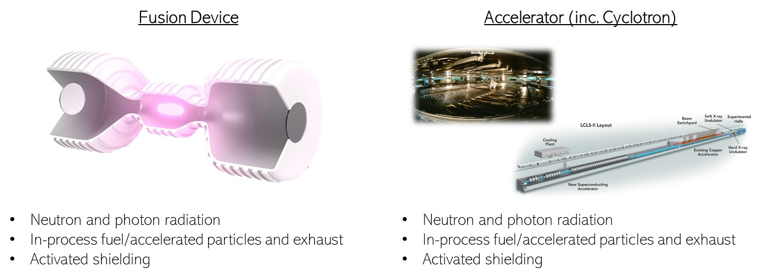
Accident Safety:
Any fusion accident analysis is fundamentally different from a fission accident analysis because the inventory associated with a fusion device is less dynamic. Fusion immediately stops upon essentially any device fault (or operator action), at that time eliminating any ability to produce additional or altered inventory. This is as opposed to in fission, where there is always a material risk of uncontrolled fissioning of uranium into new, highly radioactive daughter products during or even after an accident—which must be uniquely accounted for. Therefore, the safety paradigm for managing fusion device accidents is much simpler in nature than for fission and can take from what is in use today for many types of industrial facilities that work with mobile radioactive materials. Such facilities and industries, including those that use tritium, thus can provide helpful precedent for a fusion safety analysis.
The presentation will discuss how safety systems incorporated into such facilities, including detritiation systems, vent filtration, and stacks, can safely manage accidents that may occur at a fusion power plant. It will further provide quantitative analysis for accident scenarios involving a hypothetical Helion or generic fusion power plant, evaluating safety systems employed to address risk, and potential estimates of public impact in design basis and beyond design basis events.
Furthermore, the presentation will reflect on additional safety benefits reflected in the Helion approach to fusion by separately locating the device and tritium management systems (because in the Helion system, the tritium is a exhaust product and not a fuel). This simplifies the accident analysis as events and impacts involving tritium storage facilities can be more easily analysed separate from events and impacts involving the device itself.
Precedent:
Any future safety framework for fusion should consider frameworks in place today. The presentation will discuss Helion Energy’s licensing of its 6th and 7th generation devices under the State of Washington’s regulatory regimes for particle accelerators and radioactive materials, and how such regimes may be leveraged for regulation of fusion power plants at scale.

