Synergies between Fusion and Fission Energy conversion systems

L. Candido, M. Tarantino, M. Utili

L. Candido
Politecnico di Torino
Torino, Italy
Email: luigi.candido@polito.it

M. Tarantino
ENEA
Brasimone, Italy
Email: mariano.tarantino@enea.it

M. UTILI
ENEA
Brasimone, Italy
Email: marco.utili@enea.it

The main goal of power plants is to take a fuel like uranium, and transform it into electricity, this makes power plants an energy conversion technology, and they are the largest energy conversion technologies by far. According to the IAEA [1], the number of nuclear power plants in operation worldwide at the end of December 31st, 2019 was 443 with a net electrical output of 392 GW_{e}, Figure 1, in front of a total installed power for electricity generation of approximatively 2.8 TW_{e}. The annual electricity consumption will grow up till the end of this century with the rate of at least 1.5% and by the end of century will reach about 9.1 TW.
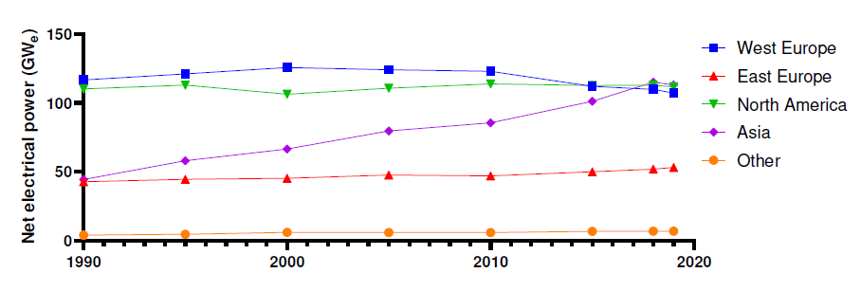
Figure 1 - Net electrical power, 1990 to 2019.
Globally, the number of nuclear power plants has increased by 6.5% compared to 1990, Figure 2. The trend in Western Europe is downwards, mainly due to Germany’s decision to shut down its nuclear power plants (NPPs) by 2022. On the other hand, China has greatly expanded the construction of nuclear power plants since 1995, increasing from 3 installed NPPs to 48 in 2019. In 2020, these supplied 2553 TWh, about 10% of the world’s electricity. Several countries with existing nuclear power programmes are planning or building new nuclear power reactors or extending their operating lives. In addition, about 30 countries, from advanced economies to developing countries, are planning or starting nuclear power programmes. For the period 2021-2027, the construction of 51 NPPs is planned or already underway. Finally, 76.5% of the planned NPPs will be built in Asia; of these, 46.2% will be in China and 17.9% in India.
In IAEA “high” scenario, current nuclear power generation capacity is projected to double by 2050. This is based both on extending the life of existing plants and on about 550 GW of new reactors. Under the “low” scenario, on the other hand, unwillingness to embrace nuclear power could result in almost no change in capacity by 2050 [2].
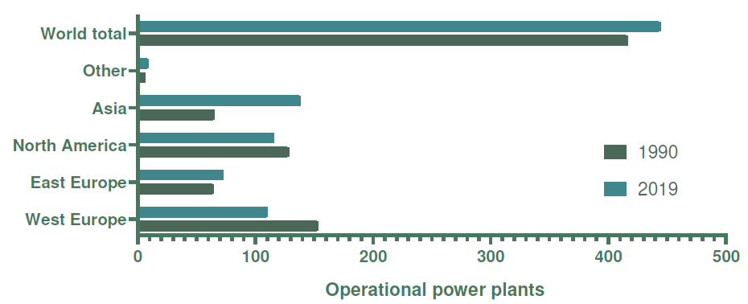
Figure 2 - Operational reactors, 1990 to 2019.
In its World Energy Outlook, the IEA considers different scenarios [3]. In the 2020 edition, Stated Policies Scenario forecasts an 18% growth in installed nuclear capacity (with about 480 GWe of installed capacity) for the period 2019-2040. The scenario estimates total generation capacity at 13418 GW_{e} by 2040, with most of the growth concentrated in Asia, particularly India and China. In this scenario, the share of nuclear power in global electricity generation is about 8.5% in 2040, but this limited role of nuclear power would lead to an increase in global carbon dioxide emissions in 2040. Other scenarios, such as the 450 scenario (which aims to keep CO2 concentrations at a level of 450 ppm to have a 50% probability of keeping the temperature rise below 2°C), are considered as transition scenarios. Among these, the Sustainable Development Scenario, which aims to “measures needed to simultaneously deliver energy access, clean air and climate goals”, foresees an increase in installed nuclear power capacity to 599 GWe by 2040.
The Red Book [4], produced jointly by the Nuclear Energy Agency (NEA) and the International Atomic Energy Agency (IAEA), contains analysis and information from 45 producing and consuming countries to address resource, demand and supply issues. The stocks published in this book should be interpreted as stocks at a particular point in time and not as an indication of “ultimate” available resources. Uranium resources are divided into two categories: primary resources, which are the uranium resources themselves, and secondary resources, which consist of stocks and materials that can be extracted from spent fuel. Primary resources are divided into conventional resources, which correspond to active uranium-producing deposits, and unconventional resources, which may consist of uranium of very low grade or of products from which uranium can be recovered only as a by-product of secondary importance. Primary resources are subdivided into reasonably assured resources (RAR), which are the identified uranium resources, and inferred resource (IR), which are only estimated and present a major challenge in estimating total resources. The total primary resources, i.e. the sum of RAR and IR, amounted to 8070.4 Mt in 2019, an increase of 1% over 2019. The total consumption of uranium in 2019 was 59200 t.
Generation IV reactors are being developed under the Generation IV International Forum (GIF) project, founded in 2001, “as a cooperative international endeavour seeking to develop the research necessary to test the feasibility and performance of fourth generation nuclear systems, and to make them available for industrial deployment by 2030”. The GIF selected six reactor technologies for further research and development activities: the gas-cooled fast reactor (GFR), the lead-cooled fast reactor (LFR), the molten salt reactor (MSR), the sodium-cooled fast reactor (SFR), the supercritical water-cooled reactor (SCWR) and the very high-temperature reactor (VHTR). The fast neutron reactors of the IV generation are able to fully reprocessing the fuel, as they are capable of multi-recycling plutonium (without limitation linked to an evolution of isotopic composition) and to value all uranium resources (including depleted and reprocessing uranium).
G-IV Nuclear Reactor will represent a suitable energy production system in the middle period, however taking into account the huge request of energy in the word a parallel solution able to satisfy the actual trend in long period with the possibility to create less radioactive material than fission and a nearly unlimited fuel supply has to be developed. In Fusion reactor, since Fusion's fuel is abundant, namely, light atoms such as the isotopes of hydrogen, and essentially limitless are one of the possible solution. Fusion has the potential to provide the kind of baseload energy needed to provide electricity to our cities and our industries, however, a number of open technical issues have yet to be solved to demonstrate the feasibility of exploiting the nuclear fusion reaction to produce electricity. In order to save time and use the competence and knowledge developed in the frame of fission reactors a dedicated R&D program has to be established. The main area identified related cross cutting R&D research are:
- Development of structural material able to operate under extreme neutron flux and environments (liquid metals or pressurised gas);
- Development of mitigation system able to protect the materials;
- System able to operate with liquids metals and high pressure gas;
- Waste management system;
- Detritiation technologies;
- Diagnostic and instrumentations;
- Modelling and simulations;
- Safety analysis;
- Manufacturing and supply chain;
- Operational and maintenance.
The transfer of the competence developed in fission application and the identification of common issue between the two programs will allow to progress faster in fusion research than in the past. A first database related common experimental facilities for material characterisation, component and system qualification has to be defined.

References
- IAEA. Reference Data Series no. 2 - Nuclear Power Reactors in the World. IAEA, 2020.
- IAEA. Nuclear Energy for a Net Zero World. IAEA, 2021.
- IEA. World Energy Outlook 2020. IEA, 2020.
- Nuclear Energy Agency and the International Atomic Energy Agency. Uranium 2020: Resources, Production and Demand. Nuclear Energy Agency, the Organisation for Economic Co-operation, and Development, 2020.
- BAE, K., and KIM, M. H., Core Design for Heterogeneous Thorium Fuel Assemblies for PWR (I)-Nuclear Design and Fuel Cycle Economy, Nuclear Engineering and Technology 37 (2005) 91-100.

