Neutron Economy: A Key Factor in Design of Fusion Fission Hybrid System

Minghuang WANG, Yunqing BAI, Qi YANG, Yican WU, FDS Team

International Academy of Neutron Science, No.168, Jinshui Road, Qingdao, Shandong, China

Email contact of corresponding author: minghuang.wang@fds.org.cn

Nuclear energy is an economic and clean source of base load energy, which provides about 10% of the world’s electricity today. Nuclear capacity will keep increasing to meet energy demand and climate change challenge as a competitive large-scale alternative to fossil fuels. However, there are challenges to make nuclear energy as a sustainable technology, such as low efficiency utilization of uranium sources, growing inventory of nuclear waste, nuclear safety issues and so on. Generation IV reactors have more advances in sustainability, economics, reliability and proliferation-resistance than conventional reactors. And fusion energy may also provide a potential solution to meet increasing global energy demand, but still needs further work before commercial applications.

Fusion-fission hybrid system is a highly promising approach as a bridge between fission and fusion energy development, by combining a fusion-powered core with a fission blanket shown in Fig.1. Meanwhile, hybrid system shares lots of vital technologies with fission and fusion reactors. For example, lead-based reactor technologies could be employed in both Generation IV fast reactor system and liquid PbLi blanket.

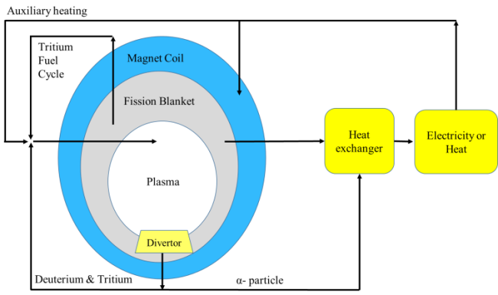
Fig.1. Schematic of fusion fission hybrid system

Hybrid system has many features, which can reduce the requirements of fusion facilities and achieve the early application of fusion energy. It also could solve the problems of fission energy by using the excess neutrons to transmute long-lived radionuclides and breed fissile fuels. Compared with fusion reactor, hybrid system is based on easy-achieved plasma parameters and can achieve higher tritium breeding ratio. Compared with current fission reactor, hybrid system has better sustainable features, more flexible fuel loading and can achieve deep burnup.

Although hybrid system has good characteristics, but its neutron economy has great challenges. Hybrid system driven by fusion neutron sources and the fusion facilities is very large and complex compared with critical reactor or accelerator driven subcritical system. This means that a large number of neutrons are absorbed by other non-fission materials or leaked out of the functional area. The large structure of fusion facilities will also need huge demand for fission material loading, it will bring challenges from the perspective of safety, economy and non-proliferation.

References
[1] www.world–nuclear.org
[2] Y. Wu. Progress in Fusion-Driven Hybrid System Studies in China[J].Fusion Engineering and Design, 2002, 63-64: 73-80.
[3] M. Wang. Neutronics Design and Study on Subcritical Spent Fuel Burner[D]. University of Science and Technology of China, 2012.
[4] M. Kotschenreuther, S. Mahajan, P. Valanju. Fusion Drivers for Hybrids[R]. Report of the conference on hybrid fusion-fission systems. Washington, D.C., May 19-20, 2009.
[5] U. Fischer, C. Bachmann, J. Jaboulay, et al. Neutronic performance issues of the breeding blanket options for the European DEMO fusion power plant[J]. Fusion Engineering and Design, 2016,109-111:1458-1463.
[6] K. Ishibashi, S, Fujumoto, T. Matsumoto. An optimization study of structure materials, coolant and tritium breeding materials for nuclear fusion-fission hybrid reactor[J]. Nuclear Science and Technology,2014,4:130-133.
[7] G. Kessler. Sustainable and safe nuclear fission energy: Technology and safety of fast and thermal nuclear reactors[M]. Springer Science & Business Media, 2012.

