ReaL-TIME measurements of RELEVANT nuclear and radiation quantities in fusion experiments

N. FONNESU, M. ANGELONE, S. LORETI, R. VILLARI
ENEA, Department of Fusion and Nuclear Safety
Frascati (Rome), Italy
Email: nicola.fonnesu@enea.it

Email contact of corresponding author: nicola.fonnesu@enea.it

Quite often, detectors for measuring nuclear performance and radiation quantities of importance in fission and fusion reactors have in common the requirement of withstanding harsh working conditions dictated by intense neutron and gamma radiation fields. More specifically and in reference to the contents of the present work, fusion environments are usually characterized also by intense magnetic fields for plasma confinement and intense electromagnetic fields from heating systems delivering power to the plasma, which can act as relevant source of noise and interference in the detection process. Moreover, high temperature constitutes a further harsh element in some locations of the machine where it is necessary to perform some on-line measurements.
The aim of the present work is to analyze the results obtained with some detection systems for measuring nuclear performance and radiation quantities in a thermonuclear fusion experiment under the mentioned hostile working conditions. These systems are installed at the Joint European Torus (JET) located at Culham Centre for Fusion Energy in Oxfordshire, UK. JET is currently the world’s largest tokamak in the world, designed to study fusion in conditions approaching those needed for a power plant and it is the only experiment that can operate with the deuterium-tritium (D-T) fuel mix which is of particular interest for future commercial fusion power. JET has also recently achieved new energy production records during the deuterium-tritium campaign DTE2 ended in December 2021 with a total neutron production of about 8.5x10²⁰ neutrons.
The first detection system discussed in this paper is devoted to measure the nuclear performance of tritium breeding blankets (BB) in terms of tritium production. The development of this important component is one of the main challenges on the path of a fusion plant and some Test Blanket Modules (TBMs) will be installed in ITER to provide the first experimental data to validate the predictions on tritium production and recovery. Among detectors capable of working in TBMs, diamond detectors are considered to provide a real-time measurement of their nuclear performance through the measurement of neutron flux (and energy spectrum) and tritium production rate, both based on the detection of neutrons. In particular, Single Crystal Diamond detectors (SCD) are of interest. This type of detector is an intrinsic artificial diamond obtained through chemical vapor deposition (CVD) [1] and the deposition of two metallic contacts on the major surfaces of the SCD for collecting electron-hole pairs created by the interaction of radiation with the crystal. The 14-MeV neutrons produced by D-T fusion reactions can be directly detected in the bulk of the intrinsic diamond crystal through the reaction ¹²C(n,α)⁹Be. The produced ⁹Be and alpha particles have a total energy E_{α}+E_{Be}=E_{n} -5.7 MeV, where E_{n} is the energy of the impinging neutron. The peak corresponding to such reaction is used for the detection of fast neutrons. As for thermal neutrons, the energy threshold of the above mentioned reaction ¹²C(n,α)⁹Be being > 6.1 MeV, it is necessary to add a converting layer as ⁶LiF coating on top of one electrode. The ⁶LiF interacts with thermal neutrons through the nuclear reaction ⁶Li(n,α)T producing 2.73 MeV tritium and 2.07 MeV alpha particles, detected by the diamond device thanks to the subsequent production of electron-hole pairs. These peaks are used for the detection of thermal neutrons. In Figure 1 the detection mechanism is sketched for fast and thermal neutrons.
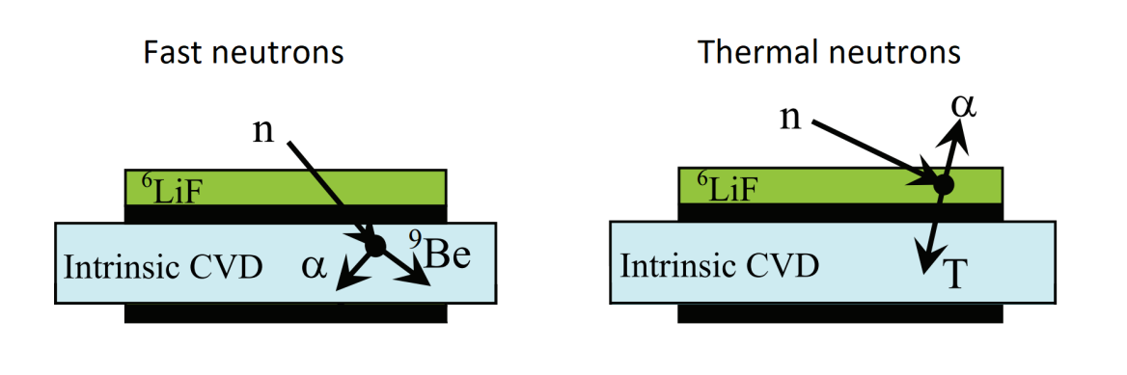
FIG. 1. Schematic views of SCD-⁶LiF neutron detector and the detection mechanisms for fast and thermal neutrons.
A differential measurement is also possible to discriminate fast from thermal neutrons by employing two identical SCD and featuring one of them with the converting layer.
A mock-up of the Helium Cooled Pebble Bed Test Blanket Module (HCPB TBM) [2] was realized and installed at JET to take advantage of the high neutron emission expected during DTE2 in order to test some detectors and for benchmarking numerical codes used for breeding blanket assessment. A SCD-⁶LiF detector was inserted into the HCPB TBM mock-up (⁶Li enrichment is 95% by weight) and calibrated to measure tritium production inside the module [3]. In facts, considering that the isotopic reaction rate of the SCD-⁶LiF detector, R_{Li6}, is defined as the number of ⁶Li(n,T)α reactions per second per atom of ⁶Li and it is equal to the product of the cross section σ of the reaction by neutron flux φ averaged over the neutron energy spectrum, the calibration factor K_{cal} can be defined as follows:
$$R_{Li6}= <σφ> = \frac{cps M_{Li6}}{N_{Av} m_{Li6} ε k}=K_{cal} cps$$ | (1)
where cps (counts per second) is the net count rate of the α+T peak, M_{Li6} is the molar mass of ⁶Li, N_{Av} the Avogadro number, ε the detection efficiency and k is a factor that accounts for electronics and settings of the measuring chain. Calibration factor resulting from the calibration at the thermal neutron facility of ENEA is Kcal=(2.504±0.039)x10⁻¹⁸.
The layout of the system in sketched in Fig. 2. The HCPB TBM mock-up is located on a dedicated holder near octant 8 in the JET torus hall (J1T) and shown in Fig. 2 (a). The SCD-⁶LiF detector is inserted in the second (of four) most distant vertical channel from the tokamak as shown in the same figure in (b). Some pictures and a schematic section of the detector are given in the same figure in (c). The detector is connected to a standard preamplifier ORTEC 142PC, about 2-3 meters far from it. The preamplifier provides high voltage (HV) to the diamond and sends the signal with improved signal/noise ratio (SNR) to the cubicle in the hall J1D through coaxial cable type RG214, about 100 meters long. The preamplifier is connected to the digital MCA model CAEN DT5780, 14 bit of resolution, which means 16384-bin neutron energy spectra as output. HV is provided to the preamplifier by the power supply CAEN R1419ET. The system is controllable from the PC located in the cubicle through a dedicated software both from J1D and from remote.
The main outcome from this system is that as far as neutron emission rate is approximately below 10¹⁵ s⁻¹, the number of counts per unit of time of the TBM diamond are closely superimposed to the JET neutron monitor (KN1), showing that with a certain detection efficiency, neutrons are properly detected along the D-T plasma discharge evolution. Moreover, the amount of tritium measured (E) is 1.4x10⁻¹² tritons per neutron source, while the prediction (C) coming from MCNP simulation is 1.083x10⁻¹². This means a ratio C/E=0.77 which is considered a promising result.
At higher rates, a saturation of the detector output is observed preventing the system from the proper measurement of the tritium production and this is under investigation. It is believed that the measuring chain of the TBM diamond is not sufficiently fast to process each detection event occurred in the diamond thus causing a pile-up of pulses. Some viable solutions could be devoted to reduce the detection efficiency or to improve the speed of the measuring chain by acting on the bottleneck responsible of slowing down the acquisition process.
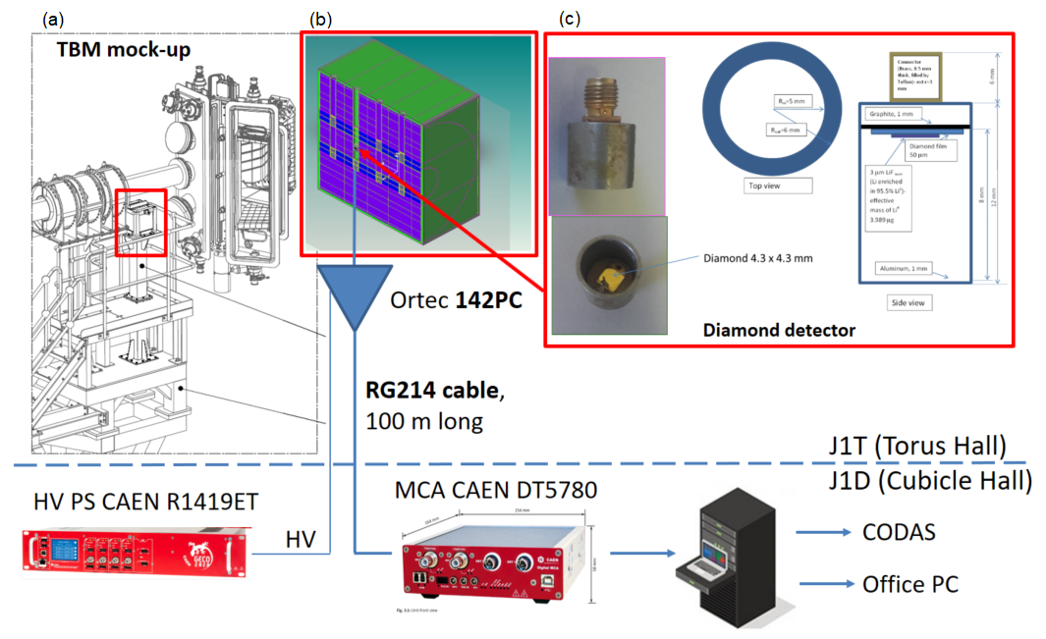
FIG. 2. Setup of TBMD system at JET with some components installed in the torus hall (J1T) and some others in the cubicle hall (J1D). (a) 3D view of octant 8 with TBMD mock-up holder; (b) section of TBMD mock-up with diamond detector; (c) some picture and schematic section of SCD-⁶LiF detector.
The second detection system of interest is a dosimetry system based on three ion chambers (ICs) installed at JET in some ex-vessel positions. ICs must operate uninterruptedly across experimental campaigns with intense pulses where neutron production can often exceed 10¹⁸ and even 10¹⁹ neutrons per single pulse, as in the last DTE2 campaign. The main goal of this system is to measure air kerma rate during inter-pulse periods and at the end of the experimental campaigns with the aim of producing experimental data for benchmarking the simulation tools employed for Shutdown Dose Rate (SDR) prediction, methodologies and nuclear data on which such numerical simulations are based [4-6]. The improvement of these numerical tools is mainly devoted to refine more and more the accuracy of SDR analyses for ITER. Measurements and SDR predictions are compared in terms of air kerma rate, which is equivalent to absorbed dose rate in air as long as the condition of charged particle equilibrium holds [7].
The layout of the experimental assembly and data handling is shown in Fig. 3. Two ex-vessel positions have been selected for the location of ICs, close to the JET horizontal ports of octants 1 and 2. The position in octant 1 is close to the Radial Neutron Camera and the position in octant 2 is on the top of the ITER-like Antenna (ILA). Two 140 mm diameter air-vented spherical ionization chambers (ICs) are installed both in octant 1 and 2 and a third IC, 44 mm diameter, is located in octant 1 close to the bigger one. It was installed specifically for DTE2 campaign as less sensitive to the radiation field so more suitable for measuring higher dose rate level.

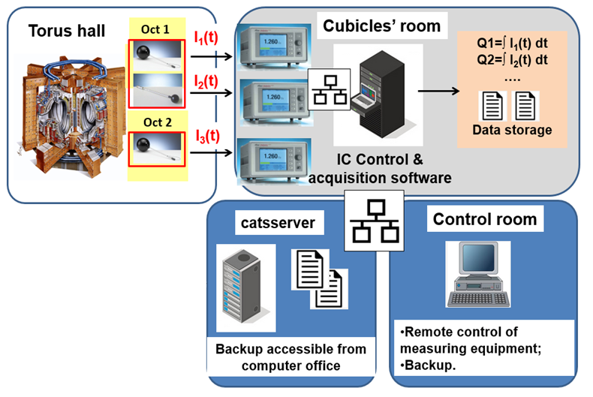
FIG. 3. Layout of the experimental assembly and data handling of the dosimetry system for air kerma rate measurement.
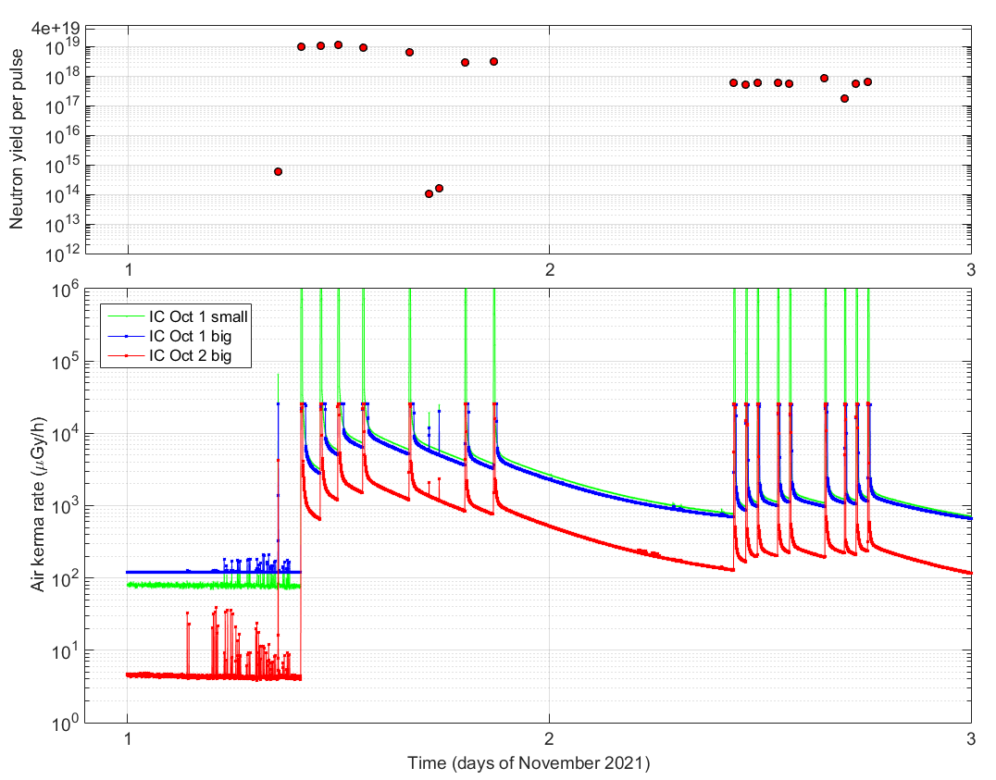
FIG. 4. Neutron yield per pulse (top) and air kerma rate in µGy/h (bottom) in the first days of November 2021 during DTE2 campaign measured with the three ion chambers installed in octants 1 and 2 at JET.
The ICs are air-vented and operated in current mode and the output signal, i.e. ionization current, is analysed by three suitable electrometers, one for each dosimeter. These electrometers are equipped with an Ethernet interface for integrating them in the laboratory local network (LAN) for remote access and are located in the JET cubicles’ room J1D. Triaxial cables serve as low noise connection. The measuring assembly and data acquisition are controlled from a PC located in J1D through a proper piece of software which permits also the remote control of electrometers through a TCP/IP connection, data handling and storage. The software gives also a complete instrument reading and some information related to the communication with electrometers.
To evaluate the influence of some physical quantities and phenomena in the SDR measurement process and to mitigate their effects, some reference dosimetry codes of practice have been employed [7,8] to assess a number of correction factors then applied to the raw measurement to account for variations from the reference calibration conditions (e.g., air pressure and temperature, the concentration of oxygen in the air of torus hall which is reduced as preventative fire measurement when JET is operated with tritium). Such dosimetry system has proven its robustness and reliability across different experimental campaigns providing real-time SDR measurements almost uninterruptedly and it has produced a significant amount of experimental data so far employed for code benchmarking. As an example, air kerma rate measurement in the first two days of November 2021, during DTE2 campaign, is plotted in Figure 4, bottom plot. Upper plot represents the neutron yield produced during each plasma discharge, on the same time axis. Code benchmarking on the previous JET campaigns have shown a general good agreement with measurements and the data recorded during DTE2 will allow to extend such activity to fusion conditions of major relevance for ITER.
References
- Ricardo S. Sussmann (edited by), CVD Diamond for Electronic Devices and Sensors, 2009 John Wiley & Sons
- F.Cismondi et al., Design update, thermal and fluid dynamic analyses of the EU-HCPB TBM in vertical arrangement, Fusion Engineering and Design, Volume 84, Issues 2–6, June 2009, Pages 607-612
- M. Angelone et al., Calibration and test of a 6LiF-diamond detector for the HCPB mock-up experiment at JET, Fusion Engineering and Design 146 (2019) 1755–1758
- P. Batistoni et al., Technological exploitation of Deuterium–Tritium operations at JET in support of ITER design, operation and safety, Fusion Eng. Des., 109–111 (2016) 278-285
- R. Villari et. al., Neutronics experiments and analyses in preparation of DT operations at JET, Fusion Eng. Des., 109-111 (2016) 895-905
- N. Fonnesu et al., The preparation of the Shutdown Dose Rate experiment for the next JET Deuterium-Tritium campaign, Fusion Eng. Des., 123 (2017) 1039-1043, http://dx.doi.org/10.1016/j.fusengdes.2017.01.030
- International Atomic Energy Agency (IAEA), Absorbed Dose Determination in External Beam Radiotherapy: An International Code of Practice for Dosimetry Based on Standards of Absorbed Dose to Water, Technical Reports Series No. 398, IAEA, Vienna, 2000
- American Association of Physicists in Medicine (AAPM), AAPM's TG-51 protocol for clinical reference dosimetry of high-energy photon and electron beams, Med. Phys. 26 (9) (1999) 1847–1870

