COMMONALITIES BETWEEN MATERIALS DEVELOPMENT IN FISSION AND FUSION TECHNOLOGIES.

G. AIELLO¹, G. PINTSUK², J. HENRY³, SERGEI L. DUDAREV⁴, M. RIETH⁵, D. TERENTYEV⁶

¹ EUROfusion Consortium, Programme Management Unit, 85748 Garching, Germany
² Forschungszentrum Jülich GmbH, Institut für Energie- und Klimaforschung – Plasmaphysik, Partner of the Trilateral Euregio Cluster (TEC), 52425 Jülich, Germany
³ Université Paris-Saclay, CEA, Service de Recherches Métallurgiques Appliquées, 91191, Gif-sur-Yvette, France
⁴ Culham Centre for Fusion Energy, UK Atomic Energy Authority, Culham Science Centre, Oxfordshire, OX14 3DB, UK
⁵ Karlsruhe Institute of Technology, P.O. Box 3640, 76021 Karlsruhe, Germany
⁶ Belgian Nuclear Research Centre, SCK CEN, Mol, 2400, Belgium

Email contact of corresponding author: Giacomo.Aiello@euro-fusion.org

The development of next generation fission nuclear systems (Generation-IV) and future Fusion Power Plants (FPPs) is driven by the common goal of achieving higher efficiencies, longer lifetimes and better sustainability. A common requirement to achieve these goals is the availability of high performance structural materials, capable of prolonged operation at high temperature under fast-neutron irradiation doses and chemical attack from diverse types of coolants. Despite the variety of operating conditions involved in the different reactor’s concepts, the underlying technological issues and the investigated solutions in materials’ R&D are indeed similar in fission and fusion technology.
In fact, fusion has already benefitted from the extensive experience acquired from operation of and R&D dedicated to structural materials in existing and next generation fission reactors. One can cite, for example, the choice of the austenitic stainless steel 316L-(N) for the ITER Vacuum Vessel (VV) and Shielding Blanket, the development of 9%Cr Ferritic/Martensitic steels for the ITER Test Blanket Module and the DEMOnstration reactor and the R&D on prospective materials like Oxide Dispersion Strengthened (ODS) steels, refractory alloys or ceramic materials. Fusion, in return, has produced a considerable amount of data of interest for the development of next generation fission systems, like data on material properties at high irradiation doses, development of design rules for high-temperature, highly-irradiated components and alternative fabrication and joining techniques for advanced materials. These commonalities between materials’ development in fission and fusion technologies are not surprising in view of the overlap existing in the choice of materials, coolants, operating conditions and target end of life doses between Gen-IV systems and future fusion power plants. From the point of view of materials, the main differences lie in the characteristic neutron energy spectra for fission and fusion as well as the requirement of reduced activation for fusion In-Vessel materials. In the following, this paper will focus on materials developed for In-Vessel components of the next European DEMOnstration reactor and first generation FPPs, and in particular the R&D implemented through the EUROfusion Consortium. Existing synergies as well as possibilities for future collaborations in R&D for advanced fission systems will be highlighted.

The reference structural materials currently foreseen for several Breeding Blanket (BB) concepts throughout the world are the Reduced Activation Ferritic Martensitic (RAFM) steels developed from “second generation” Ferritic Martensitic (FM) steels [1]. In Europe, the reference grade is called EUROFER97 and is the material selected for the ITER Test Blanket Module (TBM) as well as the baseline DEMO driver blanket. EUROFER97 is derived from conventional mod. 9Cr-1Mo steels (or grade 91), with high activation elements (Mo, Cu, Nb, Ni) replaced by their low activation equivalents (e.g. W, V and Ta) and impurity content reduced to the minimum achievable by current industrial processes. One of the objectives in its development was to achieve a Low Level Waste (LLW) classification after ~100yr from reactor shut-down. Incidentally, they also present better properties after irradiation than the corresponding T91 grade [2]. A series of “fusion” welding technologies have been developed for EUROFER (GTA/TIG, Narrow Gap-TIG, Electron Beam, Laser- and hybrids), as well as “diffusion” welding processes (Hot Isostatic Pressing – HIP), in particular in view of the TBM fabrication [3],[4]..

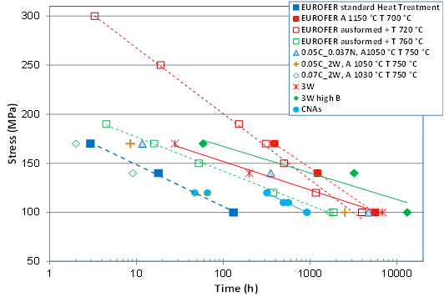
Figure 1: Stress as a function of time to rupture for creep tests performed at 650°C on EUROFER subjected to non-standard TT/TMT and new RAFM alloys, data for Castable Nano Alloys (CNAs) are included as well for comparison.
EUROFER97 is a satisfactory choice for the relatively low fluences expected in the DEMO reactor (20-50 dpa), but its use in future FPPs is jeopardized by the limited operational temperature window [4], determined by dpa-induced irradiation embrittlement at temperatures below ~350°C [5] and creep lifetime above 550°C. Therefore, new advanced RAFM steels are being developed with the objective to achieve superior creep properties and allow for an extension of the operational range toward 650°C without significantly degrading ductility properties at low temperature. Two strategies are being followed, based respectively on the use of advanced Thermal and Thermo-Mechanical Treatments (TT/TMT) and modification of the reference EUROFER97 chemical composition using computational thermodynamics [6]. This is the same approach followed for the optimization of next-generation fission FM steels, with the additional constraint of avoiding high activation elements (eg. Co) and strict control of impurity levels. EUROFER97 subjected to alternative TT showed indeed improved high-temperature properties while hot rolling (TMT) proved less effective. However, such treatments result in a degradation of impact properties at lower temperatures. In contrast, RAFM steels with W contents up to 3 wt% and with isotopically tailored B additions (avoiding additional He-transmutation/generation under neutron irradiation) appear as a promising option. In particular, the creep test at 650 °C/100MPa for the 3 wt% W and high B alloy composition showed a final creep lifetime of ~13,000h, the highest value measured so far for alloys investigated as part of the DEMO Programme (Figure 1). The next step will be to investigate effects of advanced TT on modified chemical compositions.
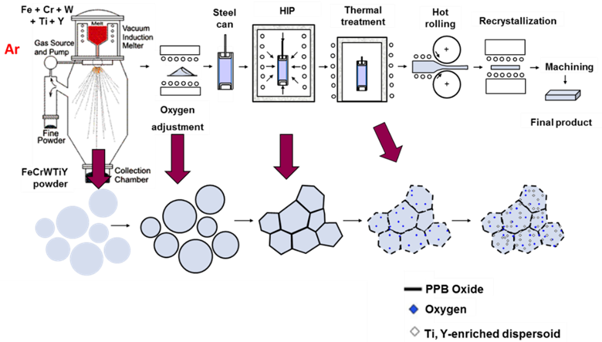
Figure 2: Schematic representation of the STARS route

The use of “high temperature” RAFM steels will however not solve the issue of He-induced embrittlement, in particular under 14 MeV neutron irradiation where transmutation rates are one order of magnitude greater than in fission (10 appm He/dpa). The use of Oxide Dispersion Strengthened (ODS) steels could in this case represent a solution to enable extending the operational domain up to 100 dpa. There are indeed indications that the dispersed oxides provide precipitate sites to trap the helium gas and thus prevent formation of bubbles at grain boundaries and enhanced embrittlement. Incidentally, the ODS steels also exhibit reduced radiation-induced hardening and better creep properties than conventional RAFM steels. For this reason, the EUROfusion program includes the development of thick semi-finished products for ODS-steels following the “conventional” Mechanical Alloying (MA) route as well as alternative and less costly fabrication methods (Surface Treatment of gas Atomized powder followed by Reactive Synthesis – STARS route, Figure 2). Thin plates of 2 mm thickness have already been manufactured, in collaboration with industrial partners following the MA route. After this first successful trial, additional ODS grades with Cr contents ranging from 9 to 14%Cr will be produced using the same route for upscaling. The STARS route [7] could avoid instead the time consuming MA step, by starting with atomized powder containing Y and Ti and introducing the required oxygen content in a subsequent oxidation step: an ultra-thin metastable Cr-rich oxide layer is formed on the surface of powder particles and during subsequent heat treatments, this metastable oxide layer is dissociated. Accordingly, oxygen can react with Ti and Y dissolved in the ferritic matrix, forming the desired nano-oxides. The process can intrinsically scale from several to hundreds of kilograms and, consequently, production costs of ODS steels may be dramatically reduced. Development at lab-scale has reached a level where powder batches whose chemical compositions are within specifications are routinely produced. The method is robust and leads to reproducible results, although improvement of the final material properties is still required.
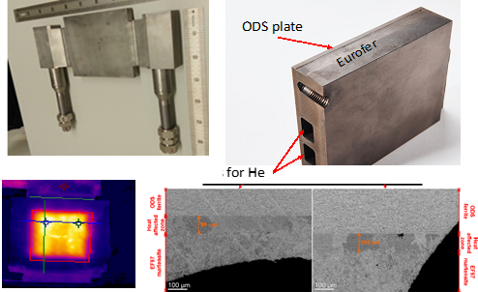
Figure 3: EUROFER+ODS mockup welded by HIP. High Heat Flux testing at 650°C in HELOKA facility at KIT + post-mortem examination [9],[10]
One major accomplishment in the development of ODS steels was the fabrication and testing under representative heat-fluxes of a He-cooled First Wall mock-up consisting of a massive base plate of EUROFER97 HIP-bonded to a 3mm-thick ODS plate. The mock-up survived heat-flux testing under DEMO-relevant heat-fluxes in the HELOKA facility at the Karlsruhe Institute of Technology. Under such conditions, the surface temperature was close to 650 °C. The helium cooled mock-up successfully completed the tests without any visible structural damage (Figure 3).

At the same time, the combination of new materials and more demanding operating conditions must be supported by the extension of the domain of application of existing nuclear Codes&Standards (C&S). For this reason, specific DEMO Design Criteria for In-Vessel Components (DDC-IC) are under development [8], in particular to address the cyclic softening of FM steels and its effects on ratcheting and creep-fatigue interaction as well as specific criteria for multiaxial fatigue and prevention of fast fracture in brittle materials. The approach followed combines deterministic and probabilistic methods, supported by statistical analysis of material properties for which the objectives are to improve the confidence interval with scarce data as well as to optimize test matrixes for future characterization activities. It must be noted that DDC-IC will not be a stand-alone code and rules developed in DDC-IC could in the future be included in existing C&S.

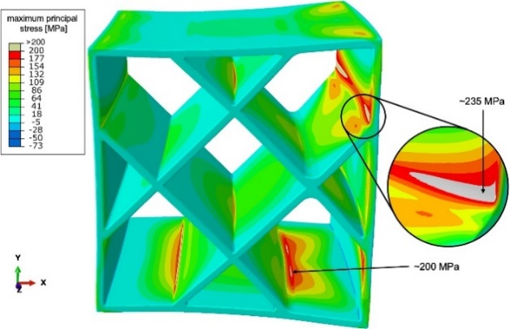
Figure 4: First example of analysis of neutron induced swelling calculated from atomistic simulations on stress fields in a reactor component
Moreover, in the absence of a specific 14 MeV neutron source, a considerable effort is being devoted in the fusion community to the understanding and modeling of radiation induced degradation of material properties. New methods are being developed with the emphasis on linking atomistic simulations with the dislocation-based representation of microstructure, supported by experimental verification. For example, the Creation-Relaxation Algorithm (CRA) developed in [9], which enables simulating high dose effects by randomly generating a very high concentration of Frenkel pairs in the material, has enabled simulating high dose (10s of dpa) defect and dislocation structures on a million-atom scale. The microscopic modelling of radiation defects has then been linked to FEM simulations (Figure 4) by relating the density of relaxation volumes of defects to the macroscopic treatment of elastic fields through the notion of spatially varying eigenstrain [10]. This has enabled FEM simulations of blanket structures exposed to similar level of dpa as fuel claddings in fission reactors. While in fission reactors deformations are caused by the crystal anisotropy and texture of the cladding material, e.g. zirconium alloys, in fusion, stress and deformations result from the spatial heterogeneity of the neutron exposure. The underlying theories and algorithms are broadly similar, with the added challenge that the stress and strain developing in a fusion reactor structure is expected to self-consistently affect the evolution of microstructure and the eigenstrain, acting as a source of macroscopic stress.

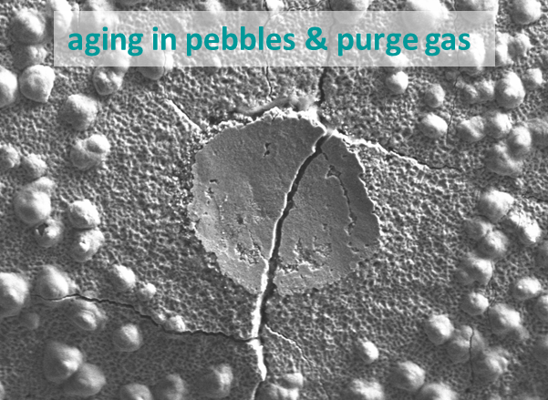
Figure 5: chemical attack on LCF specimens in contact with ceramic breeder pebbles in He atmosphere.
Another selection criteria for structural materials in DEMO and future FPPs is the compatibility with the selected coolants (water, helium) and breeder materials (PbLi alloy, Be and Li-compounds in the form of ceramic pebble beds). Irradiation Assisted Stress Corrosion Cracking (IASSC) is a concern for water-cooled concepts, while Helium coolant gas always contains small levels of impurities (H₂, H₂O, CO, CO₂) that can interact with the metallic components and cause degradation of properties. Although FM steels present better corrosion resistance than austenitic steels in PbLi environment, they are susceptible to Liquid Metal Embrittlement (LME). In DEMO, an additional technological constraint is to limit Tritium permeation from breeder material to the coolant. For this reason, alumina-based coatings that also act as corrosion barriers are being considered [11]. Several deposition processes, depending on application requirements, are being investigated and characterized in several facilities (e.g. PICCOLO in KIT and IELLO in ENEA). Modeling and quantification of corrosion phenomena for RAFM and 316LN steels (and their joints) in water at Pressurized Water Reactors conditions is also being carried out, in conjunction with development of dedicated Activated Corrosion Products (ACP) codes (OSCAR-Fusion). A dedicated experimental corrosion loop (HTHP – High Temperature High Pressure) has recently been commissioned at RINA Consulting-Centro Sviluppo Materiali (RC-CSM) to carry out additional tests. Finally, recent results have shown compatibility issues between EUROFER and ceramic breeders in He atmosphere [12], causing a remarkable reduction of lifetime under Low Cycle Fatigue (Figure 5). Further investigations to characterize this phenomena are foreseen in the HELOKA facility at KIT.

Finally, a common need to qualify materials envisaged for future nuclear systems is the availability of data on degradation of properties after irradiation. This problem is particularly exacerbated in fusion by the present lack of a suitable – in terms of fluence and irradiation volumes – 14 MeV neutron source, which should be built in the next years [13]. However, in order to get early data and optimize the eventual 14 MeV neutron irradiation campaigns, EUROfusion has launched an extensive program of irradiation in a number of fission Material Test Reactors available worldwide. This program will continue in the following years, with irradiations of isotopic tailored EUROFER scheduled in the HFIR reactor to study the effects of He embrittlement as well as in the BR2 reactor, where several irradiations for screening of advanced materials (advanced RAFM steels, ODS, coatings) are already planned. When possible, these irradiations (and the corresponding Post Irradiation Examinations) could include both materials for fission and fusion systems, sharing the costs and allowing for direct comparison of different options. In this sense, a common requirement is the availability of “standardized” data on irradiated properties determined on small size specimens: for this reason EUROfusion is also co-funding participation to the IAEA CRP “Towards the Standardization of Small Specimen Test Techniques For Fusion Applications”.

In conclusion, several topics of common interest in materials R&D for future fission and fusion systems can be identified, such as development of heat and radiation resistant materials (F/M steels, ODS), upscaling of manufacturing and welding/joining techniques, understanding of effects of irradiation (microstructure stability, He embrittlement, irradiation creep and swelling), compatibility with coolants (He, water) and development of corrosion barriers (against Pb alloys). Synergies could likely be implemented in order to reduce both costs and time for development in the following technological areas:
- Sharing of facilities for component mock-ups testing
- Common irradiation and PIE of materials
- Development of simulation tools (material modeling, but also neutronics, thermo-hydraulics…)
- Development of (nuclear) C&S

REFERENCES:
- D. Stork et al., Developing structural, high-heat flux and plasma facing materials for a near-term DEMO fusion power plant: The EU assessment, J. Nucl. Mat., Volume 455, Issues 1–3, 2014, Pages 277-291.
- C. Cabet, F. Dalle, E. Gaganidze, J. Henry, H. Tanigawa, Ferritic-martensitic steels for fission and fusion applications, J. Nucl. Mat., Volume 523, 2019, Pages 510-537
- M. Zmitko et al., The European ITER test blanket modules: Progress in development of fabrication technologies towards standardization, Fus. Eng. & Des., Volumes 109–111, Part B, 2016, Pages 1687-1691.
- M. Rieth et al., Technological processes for steel applications in nuclear fusion. Appl. Sci. 2021, 11, doi:10.3390/app112411653.
- D. Stork et al., Materials R&D for a timely DEMO: Key findings and recommendations of the EU Roadmap Materials Assessment Group, Fus. Eng. & Des., Volume 89, Issues 7–8, 2014, Pages 1586-1594.
- E. Gaganidze, J. Aktaa, Assessment of neutron irradiation effects on RAFM steels, Fus. Eng. & Des., Volume 88, Issue 3, 2013, Pages 118-128.
- G. Pintsuk et al., Materials for in-vessel components, Fus. Eng. & Des., Volume 174, 2022.
- D. Pazoset al., ODS ferritic steels obtained from gas atomized powders through the STARS processing route: Reactive synthesis as an alternative to mechanical alloying, Nuclear Materials and Energy, Volume 17, 2018, Pages 1-8.
- M. Rieth et al., Fabrication routes for advanced first wall design alternatives. Nucl. Fusion 2021, 61, 116067, doi:10.1088/1741-4326/ac2523.
- M. Rieth et al,. Impact of materials technology on the breeding blanket design – Recent progress and case studies in materials technology. Fusion Eng. Des. 2021, 166,
- M. Gorley et al., Materials engineering and design for fusion—Towards DEMO design criteria, Fus. Eng. & Des., Volume 136, Part A, 2018, Pages 298-303.
- P. M. Derlet, S. L. Dudarev et al., Microscopic structure of a heavily irradiated material, Physical Review Materials 4 (2020) 023605
- L. Reali, M. Boleininger, M. G. Gilbert., S. L. Dudarev, (2022). Macroscopic elastic stress and strain produced by irradiation. Nuclear Fusion, 62, 016002 (25pp).
- M. Utili et al, Development of anti-permeation and corrosion barrier coatings for the WCLL breeding blanket of the European DEMO, Fus. Eng. & Des., Volume 170, 2021.
- J. Aktaa, M. Walter, E. Gaisina, M.H.H. Kolb, R. Knitter, Assessment of the chemical compatibility between EUROFER and ceramic breeder with respect to fatigue lifetime Fus. Eng. & Des., Volume 157, 2020.
- D. Bernardi, et al., Towards the EU fusion-oriented neutron source: The preliminary engineering design of IFMIF-DONES, Fus. Eng. & Des., Volume 146, Part A, 2019, Pages 261-268,

