# Cross-cutting issues in fusion and fission Tritium management

M. Utili, C. Alberghi, L. Candido, D. Diamanti, F. Papa, A. Venturini

M. Utili

ENEA

Brasimone, Italy

Email: marco.utili@enea.it

C. Alberghi

Politecnico di Torino

Torino, Italy

Email: ciro.alberghi@polito.it

L. Candido

Politecnico di Torino

Torino, Italy

Email: luigi.candido@polito.it

D. Diamanti

ENEA

Brasimone, Italy

Email: dario.diamanti@enea.it

F. Papa

UniSapienza

Roma, Italy

Email: f.papa@uniroma1.it

A. Venturini

ENEA

Brasimone, Italy

Email: alessandro.venturini@enea.it

Nuclear fusion and fission Generation IV (GIF: Generation IV International Forum) reactors can be part of the global energy mix needed to meet sustainability goals and address climate change [1]. One of the most ambitious goals of fusion energy is to ensure fuel self-sufficiency of future D-T fusion power plants. Tritium consumption for a 2000 MWth fusion power reactor is 112 kg per full power year, higher than the current global availability estimated at 20-30 kg [2]. It is clear, therefore, that efficient characterization of the processes and engineering solutions to manage and control tritium transfer and release is a critical factor in the success of fusion electricity deployment. As far as the supply of tritium to D-T fusion power plants is concerned, one solution is to produce tritium in the blanket surrounding the area of the D-T fusion reactions. Tritium can be produced with the help of lithium after these nuclear reactions:

|  |  |
| --- | --- |
| $${}_{}^{6}{Li}+n\left(slow\right)→{}_{}^{4}{He}+T+4.9 MeV$$ | (1) |
| $${}_{}^{7}{Li}+n\left(fast\right)→{}_{}^{4}{He}+T+n-2.5 MeV$$ | (2) |

The eutectic LiPb alloy (15.7 at. % Li) with the function of tritium breeder, tritium carrier and neutron multiplier is used in several test blanket modules of ITER, such as the Water-Cooled Lithium-Lead (WCLL) Test Blanket Module (TBM), as well as in different concepts of Breeding Blankets (BB) of the European DEMO, for instance the WCLL-BB. The LiPb alloy is enriched to 90% with6Li. The Helium-Cooled Pebble Bed (HCPB) uses a lithium-containing ceramic breeder compound, lithium orthosilicate Li4SiO4 or lithium metatitanate Li2TiO3, which fulfils the tritium breeding function. An intermetallic beryllium alloy is used as a neutron multiplier.

In the G-IV reactors in general, tritium is produced in the core by ternary fissions and by nuclear transmutation of boron used in the control rods and can then diffuse through fuel claddings and through structural materials. The mobility of tritium is particularly increased at higher temperatures. It is clear that the management of tritium in both fission and fusion reactors share common strategies and common engineering solutions.

A common approach for the tritium management for fission and fusion systems is to use a combination of these techniques:

* Developing coating barriers to prevent the tritium permeation;
* Removing tritium from the liquid metal or the cover gas;
* Monitoring the tritium concentration in the reactor.

For instance, High Temperature Gas Reactors (HTGRs), using helium as coolant, in the past used purification systems mainly to eliminate impurities causing the oxidation of the graphite moderator and the corrosion of the materials working at high temperature [3]. These Coolant Purification Systems (CPSs) also included devices to remove hydrogen isotopes. Comparing the CPSs of HTGRs [4], it is possible to note that, with the exception of Fort St. Vrain reactor, all the systems foresee the presence of an oxidizing bed to transform Q2 (Q = H, D, T) into Q2O. Apart from Dragon Reactor Experiment [5], in which a freezer heat exchanger removed Q2O, in the remaining purification systems, a molecular sieve bed adsorbs the water [4]. In addition to the molecular sieve beds, at very low temperature (83 K), also the cooled charcoal beds are effective to remove hydrogen isotopes from helium coolant [4]; however, the molecular sieve beds seem simpler both from a constructive and operational point of view. Metallic getters are able to react with specific gas species, such as hydrogen.

More in detail, in the Fusion Reactor the fuel cycle is composed of five subsystems listed in Table 1, for which a block diagram is reported in Figure 1 as a conceptual scheme. These subsystems include several different components which perform different functions and are defined by their own physical description. This scheme is general and works also for a generic fusion power plant.

Table 1 - Subsystems of tritium, fuelling and vacuum system of DEMO

|  |  |  |
| --- | --- | --- |
| Position number | Name | Classification ID |
| 1 | Direct Internal Recycling Loop | TFV.DIRL |
| 2 | Inner Tritium Plant Loop | TFV.INTL |
| 3 | Outer Tritium Plant Loop | TFV.OUTL |
| 4 | Conventional Vacuum Systems | TFV.CV |
| 5 | Tritium Management and Control | TFV.TMC |

The fuel cycle of the DEMO power plant differs from that of ITER not only in the different types of breeding blankets to be tested but also in additional requirements. For example, DEMO must guarantee a minimum dwell time, i.e. the time between two plasma pulses, to meet the requirement of high availability. Another important difference concerns isotope separation, which as far as DEMO is concerned, does not require complete separation, but only a D-T mixture with a stoichiometric ratio of 1:1. For this reason, a Direct Internal Recycling Loop (DIRL) was implemented, in addition to the Inner Tritium Loop (INTL) and the Outer Tritium Loop (OUTL), which are the main systems of the DEMO fuel cycle loops. In addition, two further systems, namely the Tritium Monitoring and Control system (TMC) and the Conventional Vacuum system (CV), are planned.



Figure 1 - Fuel cycle foreseen for DEMO.

On the other hand, the availability and the need for sustainable uranium resources are one of the major problems for nuclear fission power plants. For this reason, the new Generation IV reactors, especially the Sodium Fast Reactors (SFRs) and Lead Fast Reactor (LFR), are designed with closed fuel cycles to reuse the energetic potential of the spent fuel and reduce the production of final wastes. In addition, Generation IV will be characterized by safety and security (both from a technological and non-proliferation point of view) and reliability, since the probability of reactor core damage is very low [6].

Concerning SFRs [9][10] and LFR, the tritium source transferred from the reactor core to the primary system migrates to all other circuits due to various phenomena:

1. By permeation through metallic walls due to concentration gradients in the different circuits and enhanced by higher temperatures: the major contribution to the transfer is through intermediate heat exchanger tubes, but also through the piping of auxiliary circuits.
2. In the argon cover gas above the primary liquid metal, a concentration equilibrium at the interface between the liquid phase and the argon gas phase controls the tritium transfer into the cover gas and it is used for the calculation of the tritium release due to gas leaks in the purification circuits of the cover gas.
3. In the case of Sodium Reactor a large amount of the tritium transferred to the primary sodium is trapped in purification systems (cold traps) integrated into the primary and also into the secondary circuits.

In order to establish an overall balance of the tritium inventory in the circuits and the potential releases to the environment (to the atmosphere and to the fluid of the tertiary circuit), it is necessary to evaluate the transfers to other circuits and the quantities trapped in the purification systems. A schematic representation of a Sodium Fast Reactor highlighting the tritium generation and permeation to the different parts is shown in Figure 2.

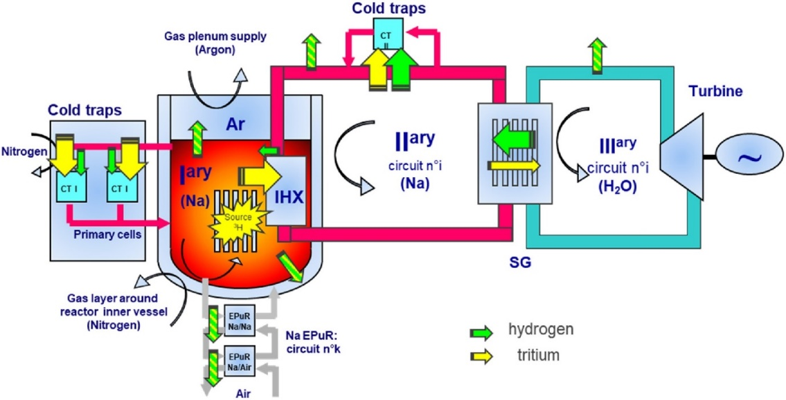

Figure 2 - Layout of a conceptual sodium fast reactor.

Only Fort St. Vrain reactor used titanium sponge getters to remove Q2, but they resulted poorly effective [4]. Concluding, the most used way for tritium removal in HTGRs foresees the transformation of Q2 into Q2O, in high-temperature copper oxide beds, and the following adsorption of the tritiated water in molecular sieve beds, at room temperature.

As far as fusion reactors are concerned a preliminary design of CPS, relevant to the European Test Blanket Modules (TBMs) Helium Cooled Lithium Lead (HCLL) and Helium Cooled Pebble Bed (HCPB), to be tested in ITER, was carried out in [3]. The CPSs of some particularly interesting HTGRs were analysed. The proposed reference process for helium purification of the TBMs foresees three steps: the oxidation of Q2 and CO into Q2O and CO2, respectively, using a copper oxide bed, the adsorption of Q2O and CO2, using a molecular sieve bed, and the adsorption of the remaining impurities, using a heated getter. The CPS proposed for ITER fusion reactor foresees, to remove tritium, the same devices of the helium-cooled fission reactors.

In the past, the tritium concentration in the primary cover gas of Sodium Fast Reactors (SFRs) was considered very low in the reactors using a steam generator, due to the efficiency of the cold traps for the tritium removal [11]. The control of tritium released in the primary sodium coolant is important to reduce its concentration in the cover gas and in the secondary loop, via permeation through the intermediate heat exchanger. The use of cold traps is an effective method to remove hydrogen and tritium from the primary coolant. For this reason, no dedicated device for the tritium removal was considered necessary for the cover gas purification systems. For the main part of the radioactive elements, in the last years, the evolution of the industrial techniques and the application of optimization principles have allowed the reduction of the releases in the environment.

Tritium permeation from breeder material to the Water Coolant System (WCS) in Water Cooled Lithium Lead (WCLL) Breeding Blanket (BB) [8] and from Liquid metal to the Primary Heat Transfer Systems (PHTS) [7] of fission reactors is one of the technological issues to be solved in order to demonstrate the safe operation of new generation reactors. Since the tritium extraction from the Water Coolant System is more challenging and expensive than the extraction from the lead alloys, it is mandatory to use a protective coating on the walls of heat exchanger pipes to minimize the tritium permeation rate. Moreover, a protective coating can prevent the corrosion of the steel by the action of liquid metal. The required permeation reduction factor (PRF) for fusion application is at least 100 in order to reduce tritium permeation from liquid metal (LiPb of WCLL BB and Pb for Lead Fast Reactor) to the water system.

Alumina anti-permeation coatings have been developed based on Pulsed Laser Deposition process, with gas phase PRF approaching 1.000 and excellent compatibility with Pb, PbBi and LiPb. Preliminary characterisation of the coating was performed under ion irradiation up to 100 dpa, neutron irradiation and thermal cycle. However, a more accurate experimental characterisation at relevant Fusion and Fission operative conditions is required in order to validate the coating for the specific process. The experimental validation has to be supported by a detailed analysis of the permeation mechanism through coated metallic surfaces in order to define both engineering correlations and a microscopic understanding of the phenomenon over a broad range of temperatures, surface conditions and materials. A database of effective permeabilities and activation energies has to be developed as a support to designers and as a benchmark for mechanistic and system-level modelling.

In the WCLL BB/TBM due to the larger tritium permeation rate into coolant If antipermeation coating will not available a dedicated Water Coolant Purification System has to be designed on the basis of CANDU water detritiation system [13]. In order to ensure a tritium concentration in the coolant below 1.85 × 1011 Bq kg−1 a water mass flow rate to be managed is in the order of a few thousand kg h−1 to respect the limit. The general procedure to recover tritium from water foresees two processes:

* front-end pro-cess in which the tritium is transferred from the aqueous into a hydrogen gas stream
* back-end process for the separation of the hydrogen isotopologues (cryogenic distillation)

In CANDU reactor and ITER, the tritiated water is processed off-line. From a technological point of view, a process able to decontaminate such a large amount of tritiated water is almost impossible to realize and it would be very energy-consuming.

The above-mentioned process could be applied o the tritium purification of GEN IV fast reactor and Fusion reactor to confine the tritium generated at a level as low as reasonably achievable.

References

1. CLIFT, R., Climate change and energy policy: The importance of sustainability arguments, Energy **32** (2007) 262–268.
2. NI, M., *et. al*., Tritium supply assessment for ITER and demonstration power plant, Fusion Engineering and Design **88** (2013) 2422-2426.
3. CIAMPICHETTI, A., *et al.*, The coolant purification system of the European test blanket modules: preliminary design, Fusion Eng. Design **85** (2010) 2033-2039.
4. CASTLE, B., NGNP Reactor Coolant Chemistry Control Study, INL/EXT-10-19533 (2010).
5. SIMON, R., The primary circuit of the DRAGON High Temperature Reactor Experiment, International Conference SMiRT 18, Beijing (2005).
6. CEA, Conception des réacteurs rapides refroidis au sodium, Tech. rep. 2015.
7. TARANTINO, M., *et al.*, Overview on Lead-Cooled Fast Reactor Design and Related Technologies Development in ENEA, Energies **14** (2021) 5157.
8. UTILI, M., *et al*., Development of anti-permeation and corrosion barrier coatings for the WCLL breeding blanket of the European DEMO, Fusion Engineering and Design **170** (2021) 112453.
9. GILARDI, T., *et al.*, Comparison of two modelling tools for the evaluation of tritium and hydrogen transfers in nuclear reactors or complex systems, Fusion Engineering and Design **166** (2021), 112278.
10. CANDIDO, L., *et al*., Design of a Hydrogen/Tritium Permeation Sensor for Gen-IV Sodium Fast Reactors, Vacuum, **191** (2021) 110414.
11. IAEA, International Working Group on Fast Reactors, Specialists’ Meeting on Fast Reactor Cover Gas Purification, IWGFR/61 (1986).
12. Autorité de Sûreté Nucléaire, Livre blanc tritium (2022).
13. SANTUCCI, A., *et al*., The issue of Tritium in DEMO coolant and mitigation strategies, Fusion Engineering and Design **158** (2020) 111759.