Radiation tests on components for the iter project

A. CEMMI¹, I. DI SARCINA¹, B. ESPOSITO², D. INAUDI³, D. MAROCCO², M. PASSERI², S. PODDA², F. POMPILI², M. RIVA², J. SCIFO¹

¹ENEA, Fusion and Technology for Nuclear Safety and Security Department, C.R. Casaccia, Via Anguillarese 301, I-00123 S.Maria di Galeria, (Roma), Italy
²ENEA, Fusion and Technology for Nuclear Safety and Security Department, C.R. Frascati, Via E. Fermi 45, I-00044 Frascati, (Roma), Italy
³SMARTEC, via Pobiette 11, CH-6928 Manno, Switzerland

Email contact of corresponding author: jessica.scifo@enea.it

In this work, neutron detector candidates for the ITER [1] radial neutron camera (RNC), namely scintillator components (crystal and plastic scintillators, optical windows, and photomultipliers (PMTs)) and single-crystal diamond detectors, are investigated to establish their radiation hardness and stability under gamma irradiation. Moreover, irradiation test results on SMARTEC [2] sensors, optical fibres and metallic components used to monitor deformations in the ITER superconducting magnets and vacuum vessel [3], are reported.
All tests were performed at the Calliope facility at ENEA in Rome, a pool-type irradiation plant equipped with a ⁶⁰Co gamma source in a high-volume shielded cell (7 m × 6 m × 3.9 m, Fig. 1). The source emits radiation consisting of two gamma photons with mean energy of 1.25 MeV with a current activity of 1.7 × 10¹⁵ Bq [4]. A Fricke dosimetric system was employed for the determination of the dose rate values during the irradiation tests.
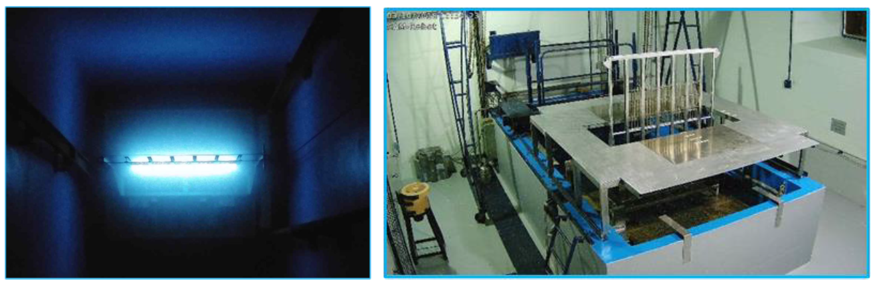
FIG. 1. Cherenkov effect around the 25 source rods in the plane rack (activity of around 70 kCi) (left) and Calliope source rack within the irradiation cell (picture acquired with a remote camera) (right).
During the ITER reactor operation time, the plasma will give rise to high energy neutron and gamma fluxes and this intense radiation field will result in serious radiation damage and activation effects on various detectors components.
The Radial Neutron Camera (RNC) [1] is an ITER diagnostic designed to provide spatially resolved information of the plasma neutron emission and is composed by two separated subsystems: the In-Port, located in one of the equatorial ports of the tokamak, and the Ex-port, located in the interspace area outside the tokamak. The detectors of the RNC will be exposed to high-radiation doses of both gamma and neutrons during the whole ITER lifetime. The expected integrated gamma total dose absorbed by detectors placed along the RNC lines of sight (LoS) is 5.3 MGy in the In-Port and about 100 kGy in the Ex-Port (Si equivalent) [5]. For each LoS the present design foresees one fission chamber and one matrix of diamond detectors in the In-Port and scintillators coupled to photomultipliers (PMTs) in the Ex-Port. In Figure 2 a sketch of the ITER RNC design is provided.
Being the fission chambers intrinsically radiation resistant, only diamond detectors, scintillators with n/γ pulse shape discrimination (PSD) capability, PMTs and optical windows were involved in radiation hardness tests. All samples were characterized before and after irradiation. During the irradiation tests and the measurements, the samples were kept at room temperature and in the dark.
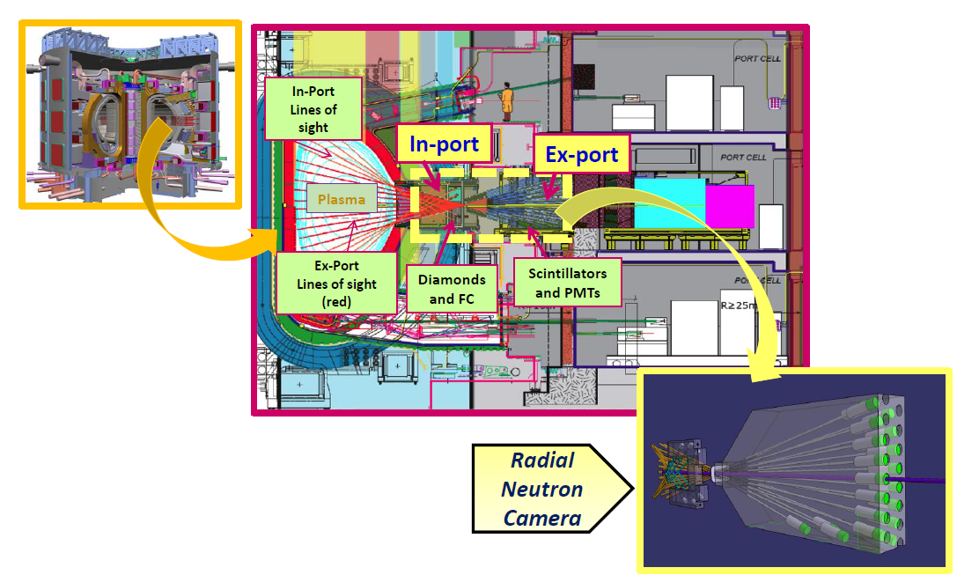
FIG. 2. Detailed sketch of the ITER project design.
The gamma absorbed dose was up to about 100 kGy for scintillators, PMTs and optical windows and about 5 MGy for diamonds, according to the different installation location expected in the RNC. The radiation-induced damage in scintillators, PMTs, and optical windows was analyzed using optical as well as nuclear detection methods. For the scintillators, the damage linearly increased and no saturation effect at the highest dose was observed. A detailed recovery study showed that, although the optical behavior after gamma irradiation for all samples was improved by the thermal treatments, the radiation-induced absorption coefficient was not significantly recovered at the wavelengths of interest. A slight decrease of the PMTs quantum efficiency in terms of PMT anodic current was observed in the range 350–500 nm after irradiation up to 127 kGy. After irradiation at 107 kGy absorbed dose, negligible degradation was observed for the synthetic silica window while for the borosilicate glass window a significant damage on transmittance performances was registered. Recovery studies (carried out in the dark and at room temperature) showed no significant improvement in the performances of the damaged optical window. The analysis of the scintillator + PMT pulse-height spectra and n/γ separation profiles after irradiation indicated a consistent degradation in pulse height (factor ∼2 at 28kGy and a factor ∼4 at 79.5 kGy in plastic scintillators; factor ∼8 for stilbene at 79.5 kGy), the disappearance of PSD already at 28 kGy and a slight recovery after annealing. The Hamamatsu synthetic silica PMT (R7494 Mod), thanks to its gamma radiation hardness properties, showed a constant FOM for n/γ separation and better performances than those of the electron tubes counterparts (ET9814 and ET9107) up to 127 kGy.
Three identical single-crystal diamond detectors were irradiated to evaluate the temporary and permanent effects of the exposition at high-gamma doses. A total dose of 4.7 MGy at high-dose rate (1.4 kGy/h) was delivered to two of the detectors, while a dose of 1.0 MGy, at a lower dose rate (0.3 kGy/h), was delivered to the third detector. Optical inspection showed a deep damage of the contacts of the two detectors irradiated at high dose, with the silver layer detached on most of the surface. Contact damages were visible also on the detector irradiated at 1.0 MGy. Despite the irradiation parameters used in this work were requested for the ITER project purposes, they can be considered like those expected for fission reactors and applications [6,7].
Concerning the vacuum vessel components, the test has been conducted irradiating displacement sensors intended to monitor deformation in the ITER magnets and Vacuum Vessel [8]. A total of 6 MGy absorbed dose has been delivered to the sensors over approximatively 70 days (Fig.3) as well as to 50 m long optical fiber spools (i.e. draka, fibercore, ixblue and peek coated) for around 65 days and to a NiCr metallic wire sample for around 40 days (Fig.4).
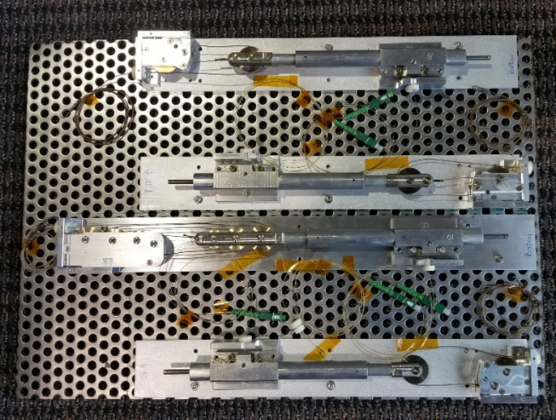

FIG. 3. The sensors ready for the irradiation test.
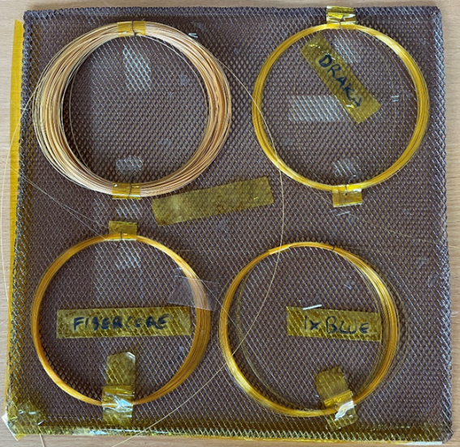

FIG. 4. The 50 m optical fiber spools after the test: peek coated (top left), draka (top right), fibercore (bottom left) and ixblue (bottom right).
The gamma irradiation parameters and absorbed dose for the components are reported in Table 1. Also in this case, it is possible to compare the obtained results with respect to the radiation resistance of optical fibers and sensors applied in the fission nuclear environments, extremely damaging as ITER [9,10].

TABLE 1. GAMMA IRRADIATION TEST PARAMETERS

Item | Initial dose rate [Gy_{Si}/h] | Final dose rate [Gy_{Si}/h] | Irradiation  Time  [h] | Total absorbed  dose  [MGy_{Si}]
Sensors | 3624.5 | 3517.8 | ~1682  (~ 70 days) | 6
Optical fibre | 3930.3 | 3833.5 | ~1554  (~ 65 days) | 6.035
Metallic wire | 3117.6 | 6019.3 | ~988  (~ 40 days) | 6

The tested sensors have been visually inspected and their functional performances have been measured.
No significant damage or degradation have been detected. However, some darkening appeared on the metallic surfaces, but the sensors functional behavior is not affected by this color change, and properly worked, passing the accuracy verification.
Finally, the tested optical fibre spools have been visually inspected and their performances measured at regular intervals during irradiation and at the end of the irradiation test, to check the compliance with the acceptance criteria. To measure the fibre performances, an Optical Time Domain Reflectometer (OTDR, VIAVI model MTS2000, with module SM+MM E4146QUAD, 850 nm wavelength) has been used. No significant damage or degradation have been detected. The insertion losses are below the fixed limit. The full chain (sensor, cable, interrogator) correctly works within the requested accuracy.

Acknowledgment
The work leading to this publication has been partially funded by Fusion for Energy under the Specific Grant Agreement F4E-FPA-327 (Specific Contract 05).
Disclaimer
F4E: This publication reflects only the views of the authors; Fusion for Energy cannot be held responsible for any use of the information contained therein. ITER: The views and opinions expressed herein do not necessarily reflect those of the ITER Organization.

References
- MAROCCO, D.; ESPOSITO, B. et al. System level design and performances of the ITER radial neutron camera. In: Proceedings of 26th IAEA Fusion Energy Conference, Kyoto, FIP/P4-16. 2016.
- https://smartec.ch/en/contact/
- CHOI, C. H., SBORCHIA, C., IOKI, K., GIRAUD, B., UTIN, Y., SA, J. W., ... & SAVRUKHIN, P. (2014). Status of the ITER vacuum vessel construction. Fusion Engineering and Design, 89(7-8), 1859-1863
- FERRARA, G., DI SARCINA, I., CEMMI, A., BACCARO, S. (2019). Gamma irradiation Calliope facility at ENEA-Casaccia Research Centre (Rome, Italy).
- BACCARO, S., CEMMI, A., DI SARCINA, I., ESPOSITO, B., FERRARA, G., GROSSI, A., ... & Riva, M. (2018). Radiation damage tests on diamond and scintillation detector components for the ITER radial neutron camera. IEEE Transactions on Nuclear Science, 65(8), 2046-2053.
- POMPILI, F., ESPOSITO, B., MAROCCO, D., PODDA, S., RIVA, M., BACCARO, S., ... & PASSERI, M. (2019). Radiation and thermal stress test on diamond detectors for the Radial Neutron Camera of ITER. Nuclear Instruments and Methods in Physics Research Section A: Accelerators, Spectrometers, Detectors and Associated Equipment, 936, 62-64.
- AMBROŽIC, K., ŽEROVNIK, G., & SNOJ, L. (2017). Computational analysis of the dose rates at JSI TRIGA reactor irradiation facilities. Applied Radiation and Isotopes, 130, 140-152.
- PONCET, A., RODRIGUEZ-MATEOS, F., INAUDI, D., & BELLI, R. (2012). Fibre optic sensors for the thermo-mechanical instrumentation of the ITER magnets. In 5th European Conference on Structural Control, Genoa, Italy.
- KASHAYKIN, P. F., TOMASHUK, A. L., VASILIEV, S. A., IGNATYEV, A. D., SHAIMERDENOV, A. A., PONKRATOV, Y. V., ... & SEMJONOV, S. L. (2021). Radiation resistance of single-mode optical fibres with view to in-reactor applications. Nuclear Materials and Energy, 27, 100981.
- BERGHMANS, F., FERNANDEZ, A. F., BRICHARD, B., VOS, F., DECRETON, M. C., GUSAROV, A. I., ... & MORIN, A. (1999, January). Radiation hardness of fiber optic sensors for monitoring and remote handling applications in nuclear environments. In Process Monitoring with Optical Fibers and Harsh Environment Sensors (Vol. 3538, pp. 28-39). International Society for Optics and Photonics.

