fusion for the energy market: economic and market considerations

S. TAKEDA
Kyoto University
Kyoto, Japan
Email: takeda.shutarou.55r@kyoto-u.jp

T. GRIFFITHS
Imperial College London
London, UK

R. PREARSON
Kyoto Fusioneering Ltd.
Kyoto, Japan

M. BLUCK
Imperial College London
London, UK

Progress in the development of fusion energy has gained momentum in recent years. However, questions remain across key subject areas that will affect the path to commercial fusion energy. This contribution discusses the following socio-economic areas, drawing from our recent extensive literature review.
(i) Market - when commercialised, what form does fusion take? Where does it fit into a future energy system?
(ii) Cost - compared to other technologies, how much will fusion cost?
(iii) External Factors - why do it?
(iv) Timescales - when is it likely that fusion reaches commercialisation?
1. MARKET
As of 2018, electricity made up only 20% of the world’s total energy demand (which will rise to 25% by 2040 [1]), leaving three quarters of demand available for fusion to potentially fulfil. In terms of potential roles for fusion outside of electricity generation, multiple pathways for techno-economic investigations exist, such as hydrogen, desalination, district heating, use of process heat.
It is still unclear what the nature of the thermodynamic cycles will be for fusion reactors and hence the impact that high temperature cogeneration will have on their operation and economics. Fusion reactors operating at high temperatures could have pre-turbine entry temperatures in excess of 600◦C, much like HTGRs in fission. There would be considerable impact on electrical output due to the extraction of the heat prior to the turbine (much greater than low temperature applications).
Important consideration in non-electric applications are potential barriers to market penetration. Stemming from previous ideas on technology emergence and market diffusion, including by Bonvillian & Weiss, and Gallagher et al., this concept is shown for the fusion context via a traffic light quadrant diagram in Figure 1, whereby the two axes, technology and market, visualise how transitioning from the status quo (existing market, existing technology) to either new technologies and or new markets represents the most challenging evolution for fusion to achieve [2].

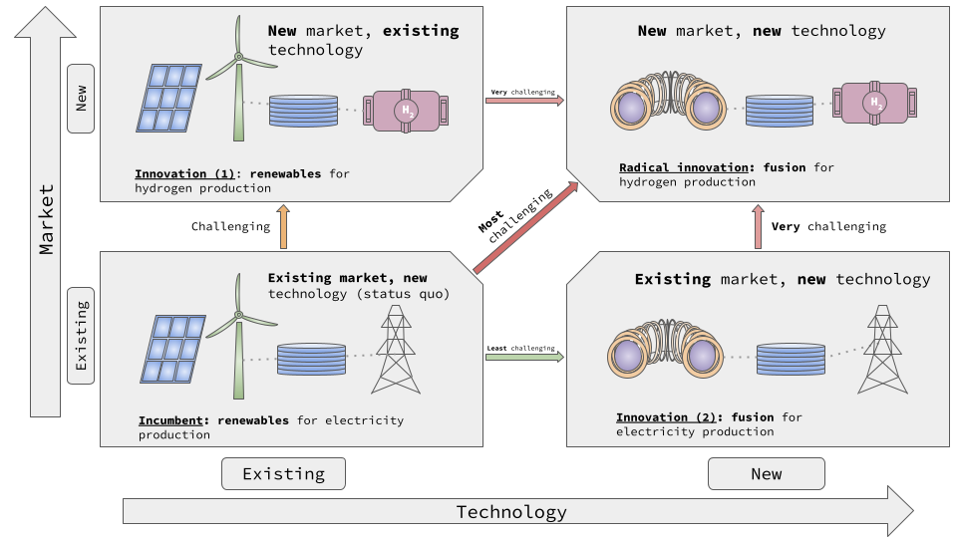
Figure 1: A quadrant diagram demonstrating different market-technology sectors (by authors, based on [2]):
(i) Incumbent: existing technology, existing market, represented by renewables for electricity production.
(ii) Innovation (1): existing technology, new market, represented by renewables for hydrogen production. The transition from the incumbent sector to this one denotes a challenging evolution to achieve.
(iii) Innovation (2): existing market, new technology, represented by fusion for electricity production. The transition from the incumbent sector to this one denotes the least challenging evolution for fusion to achieve.
(iv) Radical innovation: new market, new technology, represented by fusion for hydrogen production. The transition from the incumbent sector to this one denotes the most challenging evolution for fusion to achieve. It is therefore argued that instead, making the transition from Innovation (2) to this sector represents a more achievable, but still challenging evolution.
2. COST
It is predicted that the cost profile, from construction to decommission, will share some similarities with that of fission [3]. Crudely, the construction phase is the most costly, with less funds needed for operations and maintenance phases. Thus, the cost of capital carries the most weight for overall costs, meaning that even compact designs will incur high interest rates. An important aspect for potential financiers to consider in such projects is the associated risk, such as cost escalation, either in capital and or operating phases, or unforeseen drops in plant performance. Webbe-Wood highlights that state owned assets carry the advantage of being able to take on these risks more freely, as cost increases of this type are less severe for them than private enterprises. Additionally, it means that the plant operator turns a profit from energy production and sales without having to leverage any risk [3].
Studies have shown a large range of values varying from 40-165mill/kWh. For comparison, Levelised Cost of Electricity (LCOE) values for renewables and their corresponding studies are given in Figure 2, where the evolution of LCOE estimations are illustrated over time.

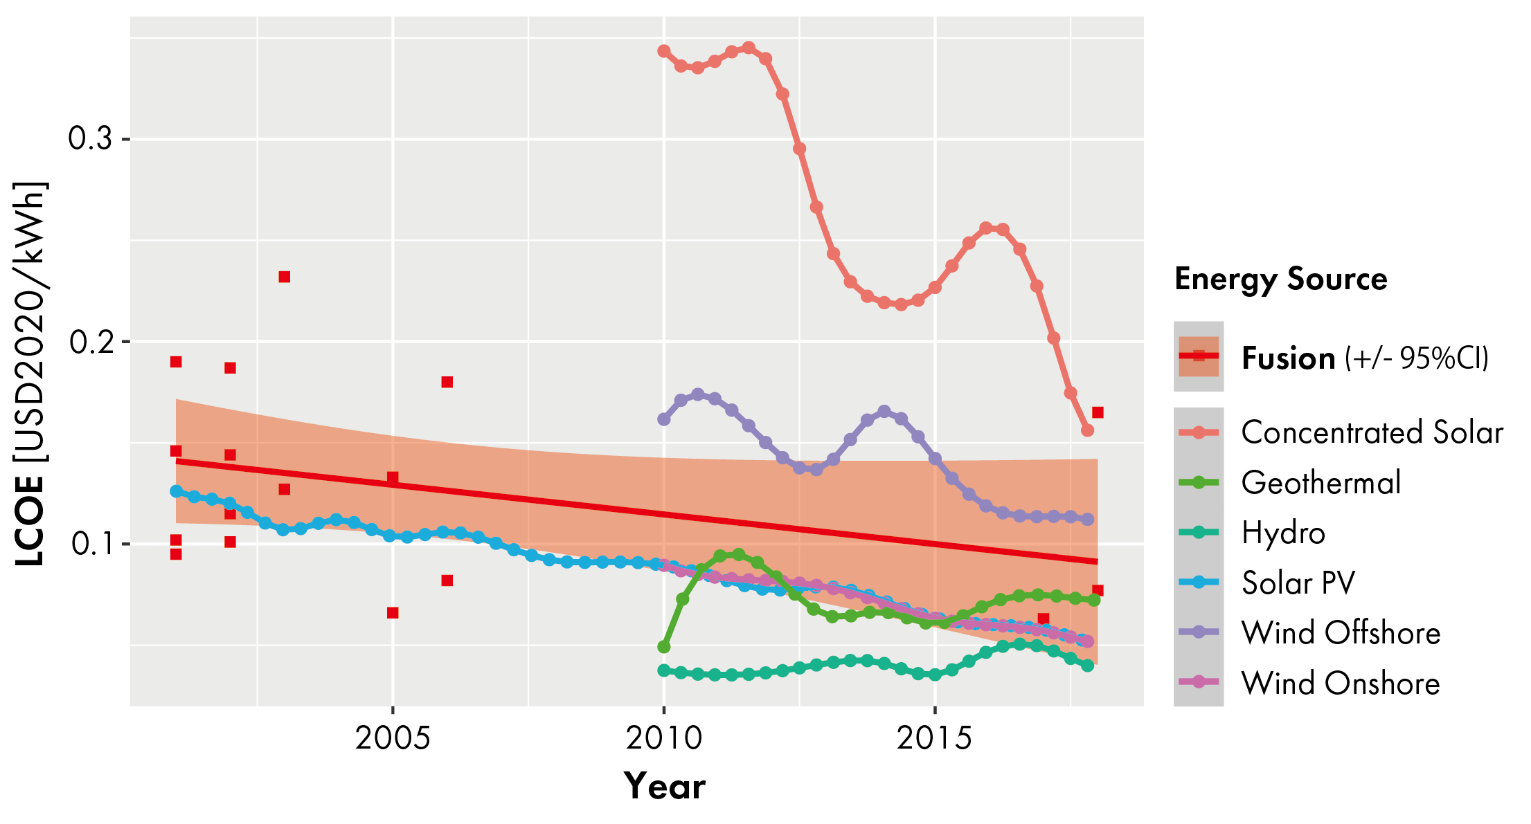
Figure 2. An illustration of the apparent decline in the estimated cost of fusion electricity in the last two decades at the same pace as other renewables, especially Solar PV. (By authors, based on refs [4, 5, 6, 7, 8, 9, 10, 11, 12, 13] for fusion, [14] for renewable sources.)
3. EXTERNAL FACTORS
In terms of energy security and environmental impact, the potential promises of fusion energy are well known. The EU’s EUROfusion research group Socio-Economic Studies for Fusion has explored these areas via scenario based analyses. The reported Greenhouse Gas Emissions estimations for fusion are generally similar to that of fission, as illustrated in Figure 3.
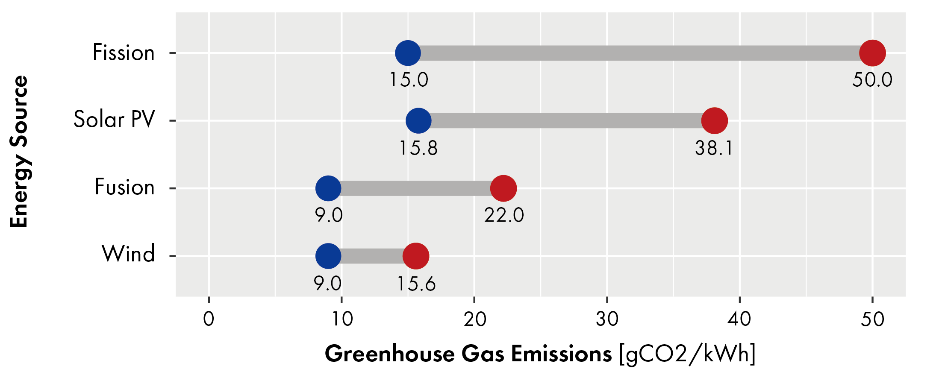
Figure 3. A comparison of carbon emissions for competing technologies. (By authors, based on [15, 16, 17, 18, 19].)
The external review mechanism proposed by Carayannis et al and the adherence to EU taxonomy criteria of sustainable energy sources are certainly positive examples of methods that fusion can use to leverage itself against other energy sources in the global green initiative [20]. In addition, recommendations for public-private partnerships in producing a net pilot plant before 2040 presents a positive step towards achieving greater cost certainty needed for investors [21].
4. TIMESCALE
Studies attempting to estimate the when for fusion come in a variety of forms. For example, it is important to outline that rather than making a prediction for an exact date of fusion commercialisation, studies seek to answer a broader question, such as its role and market share.
In order to upscale infrastructure for economic commercialisation, certain milestones within manufacturing capability might have to be in place. These include consistency in: construction times and reactor lifetime, construction/component replacement capacity, and new power plant iteration timescales.
References
- World Energy Outlook 2019. OECD; 2019.
- Bonvillian WB, Weiss C. Technological innovation in legacy sectors. Oxford University Press; 2015.
- Webbe-Wood D. Funding and financing commercial fusion power plants. In: Commercialising Fusion Energy. Institute of Physics Publishing; 2021.
- Dolan T. Fusion power economy of scale. Fusion Technology. 1993;24(1).
- Cook I, Miller RL, Ward DJ. Prospects for economic fusion electricity. Fus. And Des.
- Delene JG, Sheffield J, Williams KA, Lowell Reid R, Hadley S. An assessment of the economics of future electric power generation options and the implications for fusion. Fusion Technology. 2001;39(2):228-48.
- Sheffield J, Brown W, Garrett G, Hilley J, McCloud D, Ogden J, et al. A study of options for the deployment of large fusion power plants. Fusion Technology. 2001;40(1).
- Tokimatsu K, Asaoka Y, Konishi S, Fujino J, Ogawa Y, Okano K, et al. Studies of breakeven prices and electricity supply potentials of nuclear fusion by a long-term world energy and environment model. Nuclear Fusion. 2002;42(11).
- Tokimatsu K, Fujino J, Konishi S, Ogawa Y, Yamaji K. Role of nuclear fusion in future energy systems and the environment under future uncertainties. Energy Policy. 2003;31(8).
- Ward DJ, Cook I, Lechon Y, Saez R. The economic viability of fusion power. Fusion Engineering and Design. 2005;75:1221-7.
- McNamara S, Team TE. Tokamak Energy and the high-field spherical tokamak route to fusion power. In: APS Division of Plasma Physics Meeting Abstracts. vol. 2019; 2019. p. 8-014.
- Chuyanov VA, Gryaznevich MP. Modular fusion power plant. Fusion Engineering and Design. 2017 11;122:238- 52.
- Entler S, Horacek J, Dlouhy T, Dostal V. Approximation of the economy of fusion energy. Energy. 2018 6;152:489-97.
- IRENA. Renewable Power Generation Costs 2020; 2021
- White SW, Kulcinski GL. Birth to death analysis of the energy payback ratio and CO2 gas emission rates from coal, fission, wind, and DT-fusion electrical power plants. Fusion Engineering and Design. 2000 9;48(3):473-81.
- Tokimatsu K, Hondo H, Ogawa Y, Okano K, Yamaji K, Katsurai M. Energy analysis and carbon dioxide emission of Tokamak fusion power reactors; 2000.
- Banacloche S, Gamarra AR, Lechon Y, Bustreo C. Socioeconomic and environmental impacts of bringing the sun to earth: A sustainability analysis of a fusion power plant deployment. Energy. 2020 10;209.
- Kaldellis JK, Apostolou D. Life cycle energy and carbon footprint of offshore wind energy. Comparison with onshore counterpart. Elsevier.
- De Wild-Scholten MJ. Energy payback time and carbon footprint of commercial photovoltaic systems. Solar Energy Materials and Solar Cells. 2013 12;119:296-305.
- Carayannis EG, Draper J, Iftimie IA. Nuclear Fusion Diffusion: Theory, Policy, Practice, and Politics Perspectives. IEEE Transactions on Engineering Management. 2020:1-15.
- National Academies of Sciences E, 2021 M. Bringing Fusion to the U.S. Grid. Washington, D.C.: National Academies Press; 2021.

