The implementation of the Project and Quality management Systems in the EU supply activities for ITER

K. VOUKELATOU¹, A. RYDZY¹, L. DI PACE^{1*}
¹Italian National Agency for new technologies, energy and sustainable economic development (ENEA), Italy
*presently at International Atomic Energy Agency, Vienna, Austria

Email contact of corresponding author: nadia.voukelatou@enea.it

Background
For the construction of ITER a complex and first-of-a-kind plant, the French Nuclear Safety Authority (ASN), has requested the Domestic Agencies (DAs) of the seven Parties to adopt a Quality Assurance Program according to the French Law stating the general rules for the base nuclear installations [1]. That was also in compliance with the IAEA documents [2, 3]. Consequently, the EU DA Fusion for Energy (F4E) defined the Supplier Quality Requirements in the QA document F4E-QA-115 [4]. The different interconnections of the roles are depicted in the figure below.
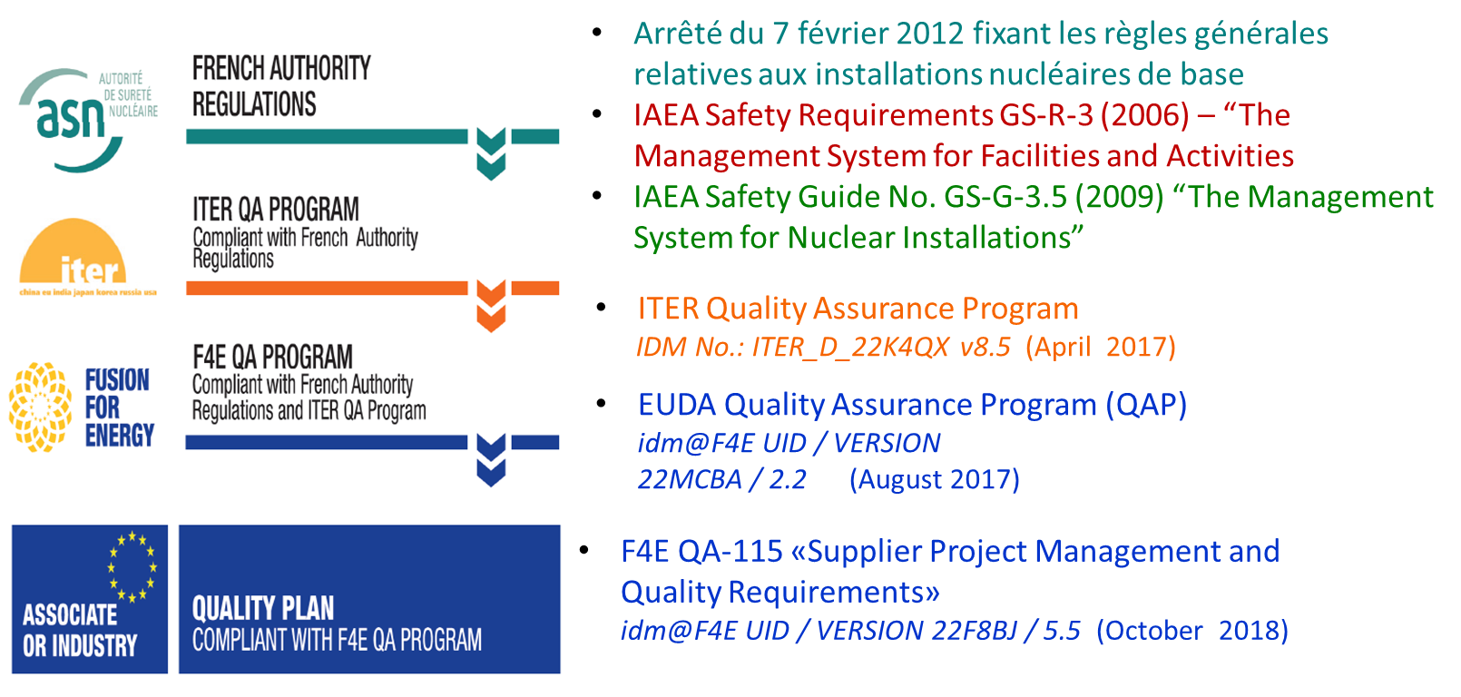
SUBCONTRACTORS
SUPPLIERS

Ever since the ENEA Fusion Department has been involved in the technology transfer of its knowledge in the field of nuclear fusion from the R&D scope to the execution of large projects together with industry, it has been outlined the importance of working by a Quality Management System (QMS) and of applying the principles of the Project Management (PM). On the other side the possibility to get large contract directly from ITER or from F4E was linked to the establishment of a compliant PM & QM System according to its QA document which has evolved through the years until the latest version [4].

Description of the activities performed
The Top Management of the ENEA Fusion Department took in 2009 the voluntary decision to implement a Quality Management System (QMS) in accordance with the requirements of EN ISO 9001 [5] (at that time the version was the one issued in 2008). The ISO 9001:2008 certification was acquired by ENEA in 2011. The implementation of the QMS led the ENEA Fusion Department to prepare and apply a series of procedures, not only for contracts where that was specifically requested by customers, but also aimed to all activities of the entire Department with the effort to involve all the relevant staff. The Quality Manual was prepared and updated accordingly to the changes in the QMS and in the ISO 9001 which moved from version 2008 to the latest issued in 2015 [6]. Namely the major modification in the QMS to fulfil the new version of the ISO standard was to implement the risk-based approach in the planning and execution of the activities. In addition to the Quality Manual, twelve main procedures have been prepared and implemented, dealing with the documented information and records management, the measuring tools management, the performance of internal audits, the management of non-conformities, the carryout of corrective actions and risk management, the management of personnel and procurement, those devoted to the management of the primary processes of the organization (design, development and experimental tests of components and systems for nuclear fusion plants, including construction of related test prototypes), the data analysis aimed at continuous improvement of the effectiveness of the QMS by the adoption of Key Performance Indicators (KPIs) to monitor the QMS. This horizontal approach has demonstrated to be very useful when carrying out contracts with F4E, ITER and EUROfusion when it is compulsory to implement the actions described in the quality plans. In late 2018, F4E requested a combined Project & Quality Management Systems (P&Q MSs) implementation as defined in [4] clarifying the need of applying the Project Management rules for running a given contract. Previously that was requested implicitly under the umbrella of providing a Quality Plan for running a contract. As matter of fact, there was some information, to be provided in this Plan, that were items of deploying a Project Management (PM), like defining at the most possible level of detail the Work Breakdown Structure, providing a Time Schedule and a Risk Plan, presenting the Organization Chart set-up to carry out the activities, the planning of project meetings and the issuing of progress reports, usually on a monthly basis, aimed to monitoring the project.
On the side of quality requirements, it was requested, accordingly to the type of contract, to define those for design, procurement and subcontractor’s management, prototyping, manufacturing, assembly and integration, testing, acceptance and delivery, software qualification.
But this one is a party of the global picture, the one dealing with one of the most important customers; F4E. Similarly, PM & QM systems requirements are also implemented in the contracts with ITER and EUROfusion but at different level than the ones requested by F4E. That suggested the idea that the implementation of a QMS according to the standard like EN ISO 9001:2015 [5] was not mandatory considering the graded approach requested from F4E, ITER or EUROfusion, also in relation to the type of contract (e.g., design or manufacture). So, when it was taken the decision to implement a QMS in the ENEA Fusion Department, it would have been simply possible to apply the quality requirements requested by the customer through the implementation of a QMS tailored for the specific contract. But with the time for some particular contract involving the design or the construction of systems or components classified as Safety Important Class (SIC-1 or SIC-2) [6], it has become mandatory for the potential suppliers to be certified EN ISO 9001:2015 for applying to the call for tender posted by F4E. Forgetting this possibility, the challenge was riskier: to implements a QMS, and after applying the PM methodologies in an environment typically devoted to R&D activities in a rather innovative sector such as nuclear fusion.
In this document it is also proposed to make a comparison of what has been applied in the EU context for supplies relating to the construction of ITER, including analysis and design still necessary, with what is defined in the last two documents issued by IAEA [7] and [ 8]. These are the Quality Management and Project Management Systems in the field of nuclear energy, in the broadest sense of the term, to verify existing synergies with what is applied in nuclear fusion (specifically ITER).
Below is a summary of the experience acquired as a Fusion Department in twelve years of activity in this field, the pros, and cons of this choice, the lessons learned, the suggestions for the continual improvement. They will be more detailed in the final document that will be issued.
- Quality Management System’s implementation is not for free, and it is not yet fully perceived as a long-term investment.
- The Project & Quality Management Systema in the research field are still seen as a “dark object” not fully understood, (excessive formalism by some customers or derived from ISO 9001 itself) or figured out as the "magic wand" to solve all problems.
- There are some difficulties, even objective ones in planning research activities, as they are in most of the cases different from each other, being R&D activities, they do not belong to a series production.
- The management of measurement tools and documents have required a great deal of time and the setting-up of appropriate IT tools. Emphasis has been given to the control of the calibration status of the measurement instrumentation.
- When performing the research activities under the scope of the certification and in compliance with the ISO 9001 requirements, it is still not easy to find the right balance between acting and recording.
- It is very important to employ internal staff to develop and implement the P&Q MS, although not entirely expert in the field but with the intention of becoming one by following the appropriate training, avoid external consultancy for the drafting of documents.
- It is important to write the P&Q MS documents concisely and in line with reality, avoid strictly to describe rules or procedures that will not be implemented.
- Include in the scope of the P&Q MS all the personnel and all the activities, and not just those that are intended for customers.
- Take advantage of the certification phase and surveillance audits to get advice and suggestions.
- Define KPIs to quantitatively measure the implementation of the QMS and the continuous improvement. While it has been achieved for the QMS as a whole, that is not easy for R&D activities, considering their variability.
- Use internal audits, requested by ISO 9001, to transfer information to the staff for the implementation of the QMS.
- Establish in the Top Management Review the priorities for the actions of continuous improvement of the QMS.
- Computerize, as far as possible, procedures and records.
- The approach to the P&Q MS from the Fusion Department has always been generally positive (They are also seen as an opportunity to put order or reorganize more effectively their own work).
- The general principles of P&Q MS were already applied in various situations, even without the formalism required by ISO 9001 (in particular for the management of documents, records, experimental data), this because it is a matter of good work organization rules that can be common to many working realities.
- The bar of requirements and performance within ENEA Fusion Department is moving higher and higher; this in a world that requires doing more with less, even in the world of public research, is a stimulus and a challenge.
- The certification and implementation of a QMS to a single Department of an Organization is not the ideal solution, one should aim to make an entire Organization work within the same QMS.

References
[1] République Française - Arrêté du 7 février 2012 fixant les règles générales relatives’ aux installations nucléaires de base
[2] INTERNATIONAL ATOMIC ENERGY AGENCY, The Management System for Facilities and Activities, General Safety Requirements, 2006 now superseded by Leadership and Management for Safety, 2016
[3] INTERNATIONAL ATOMIC ENERGY AGENCY, The Management System for Nuclear Installations, Specific Safety Guides, 2009
[4] F4E QA-115 F4E-QA-115 - Supplier Project Management and Quality Requirements v5.5; 2 October 2018
[5] ISO 9001:2015, Quality management systems — Requirements, Publication date: 2015-09
[6] F4E-QA-010 – Quality Class Determination and Implementation (QA-010) _22MD99v3.0
[7] INTERNATIONAL ATOMIC ENERGY AGENCY, Quality Assurance and Quality Control in Nuclear Facilities and Activities, TECDOC Series, 2020
[8] INTERNATIONAL ATOMIC ENERGY AGENCY, Management of Nuclear Power Plant Projects, Nuclear Energy Series, 2020

