# Fusion Neutronics Experiments FOR Nuclear Data AND NEUTRONICS TOOLS Validation at the 14 MeV Frascati Neutron Generator

M ANGELONE1, D. FLAMMINI1, R. VILLARI1, M. PILLON1, P. BATISTONI1, S. LORETI1, D. LEICHTLE2, I. KODELI3

1ENEA, C.R. Frascati/Frascati, Italy

2Karlsruhe Institute of Technology, Karlsruhe, Germany

3UKAEA, Abingdon, OX14 3DB, UK

Email contact of corresponding author: [maurizio.angelone@enea.it](mailto:maurizio.angelone@enea.it)

The uncertainty in nuclear data is one of the most important sources of errors in neutronics calculations and consequently in reactor design. The validation of nuclear data and calculation tools is thus of paramount importance to enhance the reliability of the design and to improve the safety aspects. Nuclear fusion reactors will operate burning D-T plasma via the D+T 🡪 4He+n reaction from which 14 MeV neutrons are emitted. The nuclear data for the design and nuclear analysis of fusion reactors are extending up to 20 MeV and up to 30 MeV for neutrons and gammas-rays, respectively. A dedicated effort is ongoing since more than 40 years to improve and validate the nuclear data in such extended energy range. Usually, validation experiments are divided into large categories depending upon the experimental methods adopted e.g. *benchmarks*, *mock-ups, differential, integral, etc..* The experiments are detailed modelled by e.g. Monte Carlo codes. Sensitivity/uncertainty (S/U) analysis of the nuclear data (e.g. cross sections), based on perturbation methods, is often used to complement the analysis of the experiments since S/U analysis represents a sound approach to the quantification of uncertainties associated with the computational results. To allow for these experiments to be widely used for nuclear data and codes validation the SINBAD [1] data base is available since early 1990’s which has the goal to preserve the information on the performed experiments and make them available in a standardised form to the international community.

Many of the neutronics experiments available on SINBAD have been performed at the 14 MeV Frascati Neutron Generator (FNG) located at ENEA C.R. Frascati (Italy). FNG is a 14 MeV neutron source based on the D-T nuclear reaction. A beam of deuterium ions (1 mA, max) is extracted from a duo-plasmatron type ion source at the energy of 30 keV and accelerated up to 300 keV onto a tritiated target. The 14 MeV neutron emission rate is up to 1.0*1011 n/s. FNG started its operation in 1992 and since thirty years has been used to perform fusion relevant neutronics experiments (Table-1) focussed on validating the most used nuclear data libraries (e.g. JEFF and FENDL) and calculation tools (e.g. MCNP, D1S, etc.) to be used for the design of ITER and DEMO. The FNG experiments are of the integral type, that is the response of selected quantities obtained as product of the neutron flux by an energy dependent parameter (e.g. cross section) are measured in well-defined conditions. The FNG experiments available in SINBAD are largely used for validation and testing of cross section files and codes. In this paper some examples of benchmark and mock-up experiments performed at FNG are reviewed. The main outputs of these experiments in terms of nuclear data validation and their impact on the design of fusion facilities will be discussed. Upgraded analysis based on the recent FENDL-3.2a library will be reported too.

As an example the *copper benchmark experiment* [2]is considered here. It is devoted to study the transport properties of copper through integral measurements(e.g. reaction rates) and to provide the experimental database required for the validation of the copper nuclear cross-section data relevant for ITER design calculations, including the related uncertainties.

TABLE 1: LIST OF NEUTRONICS EXPERIMENTS PERFORMED AT FNG

|  |  |  |
| --- | --- | --- |
| **Experiment** | **Year** | **Type** |
| Stainless Steel Experiment | 1992-1993 | Benchmark |
| ITER Bulk Shield Exp. | 1995-1997 | Mock-up |
| ITER Streaming Experiment | 1998-1999 | Benchmark |
| ITER Dose-Rate Experiment | 2000-2001 | Benchmark |
| Silicon Carbide (SiC) Exp. | 2002 | Benchmark |
| Tungsten Experiment | 2003 | Benchmark |
| ITER HCPB-TBM Mock-up Exp. | 2004 | Mock-up |
| ITER HCLL-TBM Mock-up Exp. | 2006 | Mock-up |
| ITER Nuclear Heating Exp. | 2010 | Mock-up |
| Copper Benchmark Exp. | 2014-2015 | Benchmark |
| DEMO WCLL-BB Mock-up Exp. | 2020-2021 | Mock-up |

A block of high purity copper (99.5%) 70x60x60 cm3 in volume was used (Fig. 1b). Height experimental positions were available along the mid-plane of the block (Fig. 1c). Reaction rates, neutron flux spectra and doses were measured. As for all the experiments performed at FNG, the experimental configuration was the result of the pre-analysis performed using MCNP complemented with sensitivity and uncertainty (S/U) analyses performed with deterministic (SUSD3D3) and Monte Carlo codes (MCSEN5). S/U helps to optimize the experimental configuration and to select the best set of activation detectors to study the transport and attenuation properties of copper in the neutron energy range from 14 MeV down to thermal energy relevant to fusion neutronics. The measured reaction rates (RR) were: 197Au(n,)198Au, 186W(n,)187W, 115In(n,n’)115In, 58Ni(n,p)58Co, 27Al(n,)24Na, 92Nb(n,2n)93Nbm. The experimental RR (E) were compared to the calculated ones (C) in terms of C/E ratio. Calculations were performed using MCNP-5 code and JEFF-3.1.1 and 3.2 libraries for transport. Re-analysis using JEFF-3.3 and FENDL-3.2a is presented in this work. As example of results the C/E for 92Nb(n,2n)93Nbm and 186W(n,)187W are reported in Table-2. The data reported in TABLE-2 show a slight improving of the C/E ratio using FENDL-3.2a, therefore the large underestimation for the 186W(n,)187W reaction is still present. The usefulness of the S/U analysis and importance of this experiment for the re-evaluation of the copper cross section for the JEFF file will be also addressed. Uncertainties in the calculated reaction rates due to the uncertainties in the transport cross sections are presented in TABLE 3. Large uncertainties, reasonably consistent with the observed C/E discrepancies, were observed using the covariance data taken from the JEFF-3.3, ENDF/B-VI.8 and TENDL-2013 nuclear data evaluations. The computational uncertainties were of the order of up to 50 %, which is considerably larger than the experimental uncertainties, typically between 5 to 10 % [3]. This suggests that the FNG-Cu benchmark experiment has high potential to contribute to the validation and improvement of future cross section and covariance data evaluations.

SINBAD evaluation of the FNG-Cu benchmark was prepared and is still under review within the SINBAD Task Force. The evaluation includes the description of the experimental configuration, measurement system and experimental results, with a particular focus on a realistic, complete and consistent estimation of uncertainties involved in the measurements and the calculation model. Several computer code inputs (e.g. for MCNP-5 and -6), corresponding both to a simplified and detailed model are included. Furthermore, a CAD file with the reference detailed benchmark model and energy dependent sensitivity profiles of the detector reaction rates with respect to the underlying cross-section data are provided for the convenience of the users.

 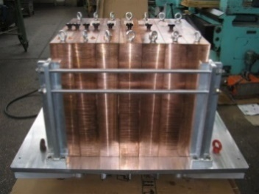 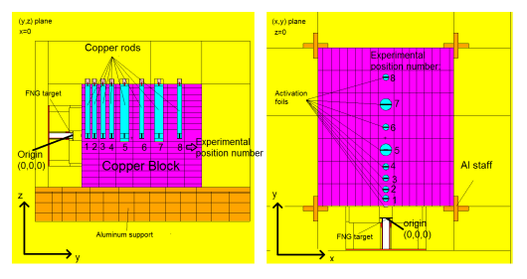

*a) b) c)*

*FIG. 1. A) Picture of the 14 MeV Frascati neutron generator; b) The copper assembly; c) MCNP model in which the experimental positions are shown.*

TABLE 2: CU EXPERIMENT, C/E FOR 92Nb(n,2n)93Nbm and 186W(n,)187W REACTIONS

|  |  |  |  |  |  |  |  |  |
| --- | --- | --- | --- | --- | --- | --- | --- | --- |
|  |  | 92Nb(n,2n)93Nbm |  |  | 186W(n,)187W | | |  |
| **Position**  **(cm)** | **JEFF**  **3.1.1** | **JEFF**  **3.2** | **FENDL**  **3.2a** | **JEFF**  **3.1.1** | | **JEFF**  **3.2** | | **FENDL**  **3.2a** |
| 3.62 | 0.88 | 0.88 | 0.89 | 0.68 | | 0.66 | | 0.71 |
| 7.62 | 0.87 | 0.85 | 0.87 | 0.63 | | | 0.59 | 0.64 |
| 12.61 | 0.89 | 0.85 | 0.89 | 0.56 | | | 0.56 | 0.58 |
| 17.61 | 0.88 | 0.83 | 0.88 | 0.53 | | | 0.49 | 0.54 |
| 25.1 | 0.86 | 0.80 | 0.86 | 0.46 | | | 0.40 | 0.46 |
| 35.10 | 0.83 | 0.75 | 0.83 | 0.44 | | | 0.39 | 0.43 |
| 45.12 | 0.92 | 0.79 | 0.91 | 0.41 | | | 0.37 | 0.41 |
| 57.12 |  |  |  | 0.41 | | | 0.37 | 0.40 |

TABLE 3: CU EXPERIMENT, uncertainties in the calculated reaction rates due to nuclear transport cross section uncertainties.

|  |  |  |  |
| --- | --- | --- | --- |
|  |  | **Uncertainty %** |  |
| **Reaction Rate** | **JEFF-3.3** | **ENDF/B-VI.8** | **TENDL-2013** |
| 58Ni(n,p) -35cm  -57cm | 4.8  9.1 | 13.7  27.2 | 22.9  41.9 |
| 115In(n,n’)-35cm | 8.2 | 9.4 | 12.1 |
| -57cm | 12.7 | 18.7 | 23.5 |
| 27Al(n,α) -57cm | 12.5 | 33.2 | 51.9 |
| 93Nb(n,2n)-57cm | 13.3 | 34.7 | 53.4 |
| 197Au(n,γ) -57cm | 15.3 | 19.9 | 18.6 |
| 186W(n,γ) -57cm | 23.2 | 28.6 | 27.3 |
| 55Mn(n,γ) -35cm |  | 24.9 | 18.8 |

A second configuration analysed in the present work is a mock-up of the *DEMO Water Cooled Lithium Lead (WCLL)* breeding blanket [4]. The WCLL mock-up is made of LiPb (bricks) and EUROFER slabs plus some slabs of Perspex simulating water (the volumetric ratio of the DEMO WCLL_BB materials was used for the mock-up) plus several SS-316 slabs for the back-plates and supporting structure (cage) (Fig. 2a). The mock-up geometry presents strong heterogeneity and was detailed modelled by MCNP (Fig. 2b). The same set of activation foils as for the Cu experiment was used. The mock-up was simulated by the MCNP5_V1.5 code coupled to the JEFF-3.3 library and IRDFF-II dosimetry file for RR calculation. The C/E ratio re-calculated with FENDL-3.2a library will be reported too.

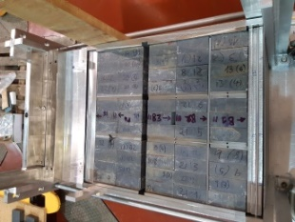 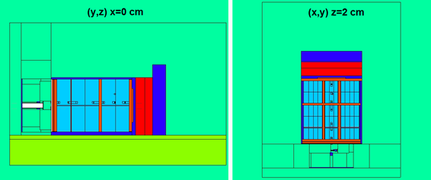

b

a

*FIG. 3. Picture of the WCLL mock-up (left); The MCNP model (right).*

The fusion neutronics experiments at FNG are in routine use within the fusion nuclear data as well as in the fusion neutronics community to benchmark neutron transport cross sections as well as the predictive capabilities of neutronics tools for the design, optimization and safety of fusion devices. The impact of such benchmark and mock-up experiments on neutronics capabilities for ITER, its Test Blanket Module (TBM) programme, and on the European DEMOnstration fusion reactor project will be described. Similarly, the validation results have demonstrated that neutron transport and nuclear response calculations for important design and safety related parameters can be performed with suitable reliability.

The series of mock-up experiments of various breeding blanket configurations (of the helium-cooled pebble bed, helium-cooled lead lithium and most recently water-cooled lead lithium concepts) conducted in joint European efforts under the EFDA, Fusion for Energy and EUROfusion frameworks have been run particularly to test the computational capabilities to predict the Tritium Breeding Ratio (TBR) of a breeding blanket [5]. A TBR in excess of 1 is required for a fusion reactor to guarantee the tritium self-sufficiency of the DT fuel cycle. The results of FNG breeding blanket mock-up experiments have demonstrated via C/E of the calculated vs. measured tritium production rates in the respective breeder material (lithium ceramics or lead lithium eutectic alloy, resp.), that design calculations for the TBR are slightly conservative with typical uncertainties of the C/E ratio of about 4-6% (at 1*σ*).

References

1. KODELI, I., SARTORI, E., SINBAD – Radiation shielding benchmark experiments, *Annals of Nuclear Energy* **159** (2021) 108254.
2. M. ANGELONE et al. Copper Benchmark experiment for testing of JEFF-3.2 nuclear data for fusion applications, EPJ Web of conferences 146 (2017) 09004
3. KODELI, I., ANGELONE, M., FNG Copper Benchmark Evaluation for the SINBAD Database, Fusion Engineering and Design 146 (2019) 312-315
4. D. FLAMMINI et al. Pre-analysis of the WCLL breeding blanket mock-up neutronics experiment at the Frascati neutron generator, Fus. Eng. Des. 156 (2020) 111600
5. BATISTONI P. et al., “Neutronics experiments for uncertainty assessment of tritium breeding in HCPB and HCLL blanket mock-ups irradiated with14 MeV neutrons”. Nucl. Fusion 52(8):083014 (2012)