Hybrid fusion-fission system based on a compact tokamak device with proven technologies

N. BURGIO^{1,2}, G. CIOCARI², A. GANDINI², R. GATTO², V. PELUSO³, C. ROMAGNOLI², A. SANTAGATA^{1,2}, D. TOMATIS⁴
¹ ENEA, CRE Casaccia, Santa Maria di Galeria, Italy
²Sapienza University of Rome, Department of Astronautical, Electrical and Energy Engineering, Rome, Italy
³ENEA, CR Bologna, Bologna, Italy
⁴Université Paris Saclay, CEA Saclay, France

Email contact of corresponding author: renato.gatto@uniroma1.it
A research program on fusion-fission hybrid nuclear systems is presently ongoing as a collaboration between Sapienza University of Rome and ENEA, under the Framework Agreement between the two Institutions, and the CEA at University Paris Saclay. The main objective is the definition of an hybrid system based on a compact tokamak device (e.g., the Columbus concept [1]), and characterized by technology already well-proven in the fission industry. In this hybrid system, the fusion-generated neutrons encounter, in sequence, a first wall, a fission core, a fusion blanket for the production of tritium in case of a D-T plasma, a reflector, and a shield region. For the breeder material in the fusion blanket we are considering ceramic lithium aluminate because of its high degree of chemical stability, and lead and graphite as multiplying and moderating materials with a relatively high thermal conductivity. The cooling fluid is helium, and the structural material is martensitic steel. The material composition of the fission core depends on whether the goal is the burning of minor actinides, or the generation of fissile isotopes, with the use of thorium in the latter case. The adopted methodology is based on the synergetic use of deterministic and stochastic computational tools, with the former used in the initial search for the optimal system solution in terms of material composition and zone dimension, and the latter for final detailed neutronics calculations of the proposed design. The research collaboration has led so far to the following results: (I) the creation of a deterministic computational tool which can perform a variety of optimization studies using results from generalized perturbation theory (GPT); (II) the definition of a computational tool based on the coupling between the neutron flux stochastic solver MCNP and the isotope evolution code FISPACT; (III) the proposal of a methodology to monitor the sub-critical level of the fission core of the hybrid reactor.
(I) Optimization computational tool. Sensitivity functions based on GPT [2,3] can be employed to perform optimization studies to aid in the definition of new concepts of nuclear systems. Following this approach, we are developing a deterministic code to define a first layout of an hybrid system devoted to (i) the fertilization of fissile material, or (ii) the burning of minor actinides present in spent nuclear fuel. The code, which solves the 1-D multi-group diffusion equation, can describe systems with any number of zones, each one containing an homogeneous mixture of materials. The code is coupled with a Bateman solver to follow the long time evolution of the material mixtures under neutron irradiation.
The optimization procedure is based on the formulation presented by Greenspan [4]. The key element is the sensitivity function, which describes the functional relationship between the relative change in the integral parameter R caused by a fractional change in the input parameter P: . In the simplest case, the functional is a reaction rate regulated by the macroscopic cross-section , defined as , where and are the direct and adjoint sources, the direct flux and the importance function satisfy the equations and respectively, with and the multi-group diffusion operator and its adjoint operator, and where the brackets indicate integration over the neutron phase space. For constant external source, the 1st order result for the sensitivity function turns out to be
(1)
As a first application, we consider the problem of maximizing the production of tritium in an hybrid system employing a D-T plasma, taking as control variables the material densities of the elements composing the fusion blanket, P=N_{i,} with i=1,2,…,I, and setting the adjoint source equal to the macroscopic cross-section for the (n,T) nuclear reaction. The functional to be maximized is then written as . The maximization is obtained when any infinitesimal permissible perturbation in the composition of the system (indicated by ) leaves F at its extreme value, [4], where the restraint on the total volume fraction has been used to eliminate one of the control variables. Here, are the “substitution effectiveness functions”, dependent on the sensitivity functions, which give the change in F caused by the substitution of a unit of quantity of material I with the same quantity of material i, for constant volume of the zone. The code finds the maximum value of F by an iterative procedure, at each step of which the direct flux and the importance function need to be re-evaluated in a perturbed material composition.
(II) MCNP-FISPACT coupling. In parallel with the deterministic approach, we have developed a simulation chain based on the stochastic method, with the goal of performing neutronic calculations in complex geometries. The simulation chain consists in the coupling of the MCNP code for particle transport and criticality analysis and the FISPACT code to simulate the evolution of the composition of the fuel, structural materials, and breeders in the system’s continuously changing irradiation conditions. The coupling allows an iterative data exchange process between MCNP and FISPACT, controlled by auxiliary scripts implemented in the programming languages AWK and Octave. All steps, settings, and input data are gathered in one global script that executes the simulations and prints the output files. The process is presented in Fig. 1. At each iteration, the main steps are the followings: an MCNP run to obtain neutron flux and reaction rates in the system; the MCNP output is used to prepare the input file for FISPACT; a FISPACT run provides inventories for the selected materials at different time intervals; a script identifies nuclides that are in both the MCNP cross-section file (“xsdir”) and the FISPACT output file for the chosen time interval; all the nuclides present in both the FISPACT inventory and the “xsdir” file will be directly used to update material compositions in the following MCNP
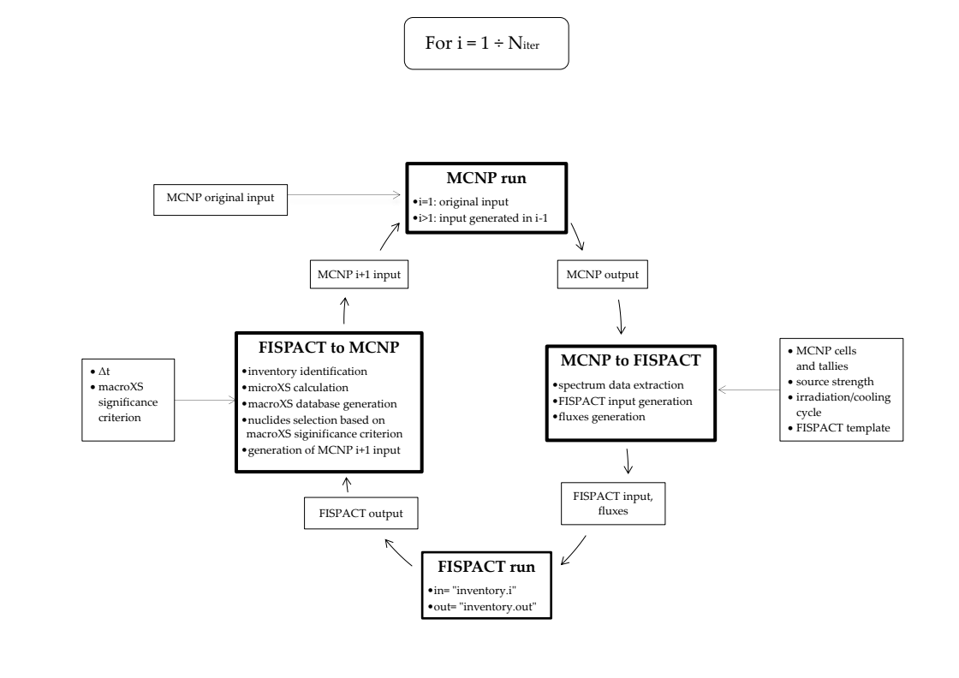

FIG. 1. Iterative scheme of the MCNP-FISPACT coupling.

input file; a MCNP run updates the neutron spectrum. The cycle is repeated as needed. An important feature inserted in the script connecting MCNP and FISPACT consists in the possibility to introduce a “significance criterion” for the selection of only those materials which are relevant for the problem at hand. Presently, the criterion is based on the relative magnitude of the production and absorption macroscopic cross sections of each element, with the option to retain only those elements for which this quantity is above a certain threshold value.
The MCNP-FISPACT coupling has been tested with a sample problem, the geometry of which is shown in Figs. 2(a) and 2(b). The various regions are: 1) neutron source (D-T or D-D), 2) copper dummy, 3) tungsten torus, 4) and 5) first and second wall (K-181 SS with He-4 as refrigerant, 6) fusion blanket (Li-aluminate), 7) fission core: two rings with different composition to get a higher k_{eff} value (0.92) - 1st ring with fresh MOX, 2nd ring with spent PWR MOX after 16.5 years of burn-up (to simulate spent fuel of a PWR), 8) fuel clads (iron), 9) reflector (graphite). The total radial and vertical dimensions are 445 and 400 cm, respectively. The neutron source has been modeled with a circle on the XY plane of radius 150 cm. Several studies have been performed on this sample hybrid model. Here, we report the one comparing the performance of the D-T and the D-D neutron source (14.1 and 2.4 MeV, respectively). The result of this study is reported in Table I, quantifying how much more effective is the D-T source in generating new fissile isotopes.

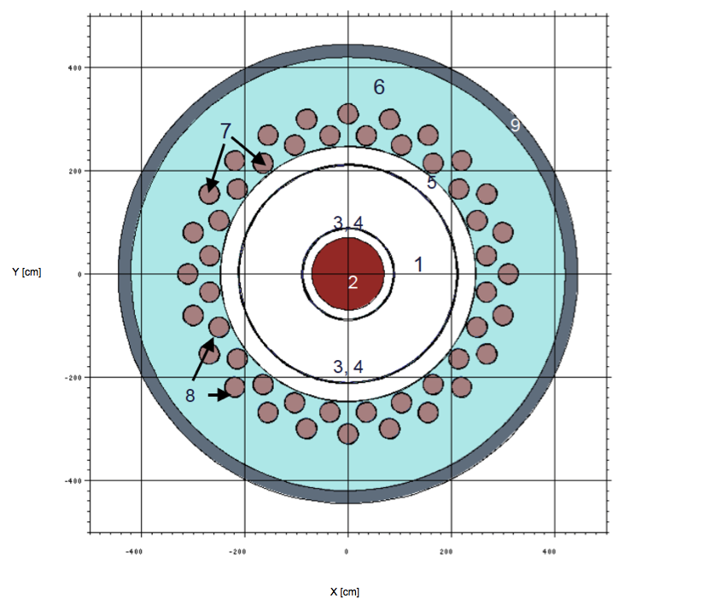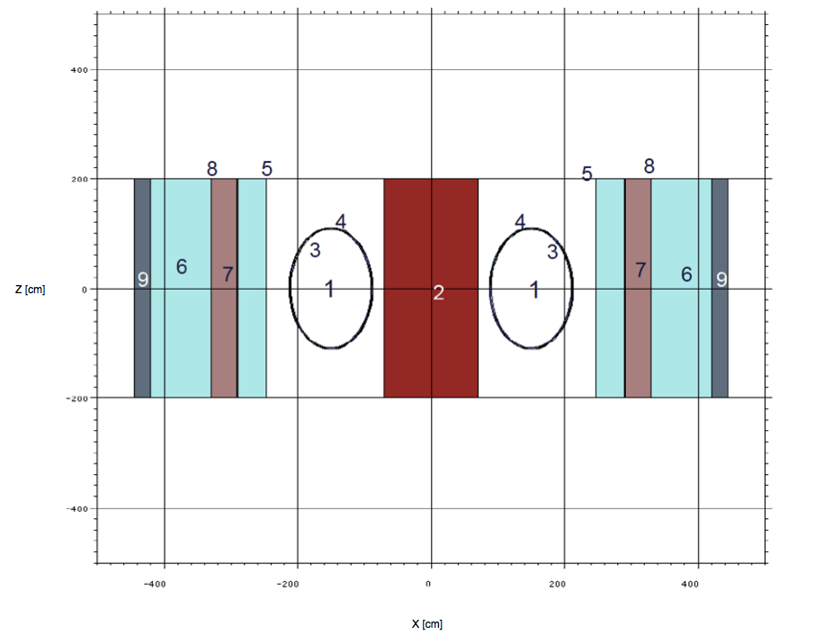

FIG. 2. Fusion-fission hybrid model adopted for testing the MCNP-FISPACT coupling. XY (a) and XZ (b) plane views.
Mass [kg]
 | D-T source, 2nd ring |  | D-D source, 2nd ring
 | ²³⁵U | ²³⁹Pu |  | ²³⁵U | ²³⁹Pu
t=0 | 1.26 | 1390 |  | 1.26 | 1390
10 y of irradiation | 1.83 | 2898 |  | 1.79 | 2477
10 y of irradiation + 10 y of cooling | 2.65 | 2900 |  | 2.49 | 2479
% variation after irradiation | 45.4401 % | 108.4892 % |  | 42.1094 % | 78.2014 %
% variation after cooling | 110.3886 % | 108.6331 % |  | 97.6209 % | 78.3453 %
TABLE I. ²³⁵U and ²³⁹Pu mass [kg] in the 2nd ring of fuel rods in the D-T and the D-D source hybrid reactor model, with source strength of 1e20 n/s.

(III) Sub-criticality monitoring method. Any subcritical system requires a dedicated control system, capable of real-time monitoring of the fission core sub-criticality level. We have adapted the so-called «power control-based sub-criticality monitoring (PCSM)» method, already discussed in the context of ADS systems [5], to fusion-fission hybrids based on the tokamak concept. Formally, the theoretical arguments underlying the proposed monitoring procedure apply equally to ADS and fusion driven systems [6]. The hybrid’s novelty is in the interplay between fission and fusion powers. We propose a method for adjusting fusion power to values consistent with the PCSM procedure using plasma compression/expansion through small alterations of the confining magnetic field [7].
The method consists in : (i) a standard calibration of a dedicated control rod in the fission core - a relationship between a control rod position change and the corresponding reactivity alteration may then be established; (ii) during operation, a small, slow insertion of the control rod and associated adjustment of the fusion neutron source (i.e., fusion power generated in the plasma) to ensure that the ex-core and in-core neutron detector readings are kept constant and the fission power level is unchanged; (iii) an evaluation of the subcritical multiplication factor using the formula
(2)
where represents a small variation of the “external” fusion source, and is the generalized reactivity due to a small change in a dedicated control rod in the fission core. Neutronic calculations based on the multi-group transport equation and the PCSM procedure allowed the sub-criticality evaluation with an accuracy of the order of 0.1%, suggesting that the proposed methodology can be effectively used to determine a hybrid system’s sub-criticality. The enhancement of the fusion neutron source strength required to reset the fission power following the control rod insertion was accomplished using plasma compression. The application of a simple 0-D-plasma power balance equation alongside a screw-pinch modelization of plasma profiles showed that the compression scheme based on inward displacement of the major radius requires minor radius and vertical magnetic field changes of –3.9% and +18.7%, respectively, while the plasma compression scheme based on a reduced minor radius and a fixed major radius requires minor radius and vertical magnetic field changes of –6.3% and +3.6%, respectively. The magnitude of these changes seems to be acceptable from an operational point of view.
References
[1] COPPI B., SALVETTI M.F., Highlights of the Columbus Concept, Massachusetts Institute of Technology R.L.E. Report PTP 02/06, December 2002.
[2] USACHEV, L.N, Perturbation theory for the breeding ratio and for other number ratios pertaining to various reactor processes, J. Nucl. Energy Part A/B 18 (1964) 571-583.
[3] GANDINI, A., A generalized perturbation method for bi-linear functionals of the real and adjoint neutron fluxes, J. Nucl. Energy Part A/B 21 (1967) 755-765.
[4] GREENSPAN, E., Developments in Perturbation Theory, Advances in Nuclear Science and Technology, Academic Press, 9 (1976) 181-268.
[5] GANDINI, A., ADS subcriticality evaluation based on the generalized reactivity concept. — Ann. Nucl. Energy, 31/7 (2004) 813.
[6] CARTA, M., FABRIZIO, V., FALCONI, L., GANDINI, A., IORIO, M.G., PELUSO, V., SANTORO, E., BURGIO, N., The power control based subcriticality monitoring (PCSM) method for ADS reactors, in: RRFM/IGORR 2016, Berlin, Germany, 13-17 March 2016.
[7] BURGIO, N., CARTA, M., FABRIZIO, V., FALCONI, L., GANDINI, A., GATTO, R., PELUSO, V., SANTORO, E., SCIARRETTA, M.B., Subcriticality monitoring in fusion-fission hybrid reactors, Problems of Atomic Science and Technology, ser. Thermonuclear fusion 44 (2021) 27.

