ONLINE neutron measurement systems for in-vessel monitoring in FISSION reactors: applicability to breeding blankets OF DEMO

P. FILLIATRE¹, L. BARBOT¹, C. JAMMES²

¹CEA, DES, IRESNE, DER, Instrumentation Sensors and Dosimetry Laboratory, Cadarache, F-13108 St-Paul-lez-Durance, France
²CEA, DRF, IRFM, STEP, Cadarache, F-13108 St-Paul-lez-Durance, France

Email contact of corresponding author: philippe.filliatre@cea.fr

In-vessel, online neutron measurements are routinely carried out in fission reactors. The usual functions are: early detection of any abnormal situation to improve the reactor dependability and safety, power monitoring, characterization of irradiation conditions in experimental locations of material testing reactors, assessment of the performances in demonstration or prototype reactors. The LDCI of CEA has a more than a decade experience in designing, prototyping and testing neutron sensors and associated acquisition systems in several nuclear facilities with a wide range of demanding conditions (e.g. [1]).
The breeding blankets are a key component of a fusion reactor such as DEMO [2] and are the subject of intense research activities in the framework of the EUROfusion consortium [3]. Various designs are considered, among which the WCLL (water-cooled lithium lead) and HCPB (helium-cooled pebble bed). The environmental conditions are very demanding, nevertheless some of those, as the neutron flux and the temperature, are close to what is encountered in sodium-cooled fast neutron reactor, for which France through CEA has gained a 50 year experience (e.g. [4]), in the last decade with the ASTRID project.
The present communication outlines a strategy to conceive an online neutron measurement system for the DEMO breeding blankets, which involves the following points:
- Definition of the expected functions and performances.
- Evaluation of the operational constraints.
- Identification of the possible sensor types according to their state of the art.
- For each sensor type, identify the assets and blocking points.
The functions of a breeding blanket are: tritium production, coil shielding and heat extraction. The first and second one are directly related to the neutron transport, hence a neutron measurement system could be assigned the following function: deliver a reliable neutron flux monitoring to monitor and demonstrate the performances of the breeding blanket. Since the neutron flux inherently depends from time and space, the instrumentation has to deliver an online signal and to be spatially distributed (i.e. has several sensors achieving local measurements). A rough spectral discrimination of the contributions from the ⁶Li(n,α)t and ⁷Li(n,n’α)t reactions could be a valuable addition. A large dynamic range is also wished to follow both DD and DT plasma phases over the whole breeding zone.
Discussing the performances of the measurement system mainly consists in quantifying the requirement of that function. Here is a tentative set to start the study:
- Neutron flux uncertainty: 10% at 1σ.
- Neutron flux spatial distribution: 10% everywhere, how it translates into the number of sampling points depends on the expected spatial resolution, the need for local redundancy and is constrained by the little room available.
- Temporal resolution: 1s, compliant with foreseen ramp-up, pulse phase and ramp-down.
- Dynamic range: five decades of flux up to 10¹⁴ n/cm²/s.
- Lifetime: 3 years, as for the breeding blanket units themselves.

The identified main operational constraints, applicable to the sensors and cables are:

- Gamma flux: 10¹⁴ γ/cm²/s, coming from activation of the surrounding structures.
- Radiation damages: up to 10 dpa (at front wall) per year at full power.
- Integration constraint: since instrumentation should be integrated within the breeding blankets without degrading their performances, sensor size and cable passage are a major concern to be investigated in a joint effort with the conception of the breeding blankets themselves. Miniaturizing sensors down to few millimetres is certainly a key.
- Temperature: it strongly depends on the location and on the breeding blanket design, ranging roughly from 300 to 1000°C.
- Magnetic field: it ranges from 3.4 T (outboard blankets) to 8.3 T (inboard blankets).

Three sensor types are promising, namely: the Self-powered Neutron Detectors (SPND), the High-temperature fission chambers (HTFC), the Optical Fission Chambers (OFC).

SPNDs have been widely used in thermal nuclear reactors as on-line neutron flux monitors since 1960. They are highly appreciated because they are small, robust and without required bias voltage. However, their dynamic range is usually low. Generally, they have a coaxial geometry with a central electrode, called emitter, surrounded by an insulator and an external concentric electrode, called sheath or collector (see Fig. 1). This sensitive part is connected to the measuring system by an integrated mineral insulated cable. The SPND total output current, when irradiated in a mixed neutron and gamma field, is always a sum of partial currents coming from the following reactions in all involved materials: the delayed response due to (n,β⁻) reaction within the emitter, their instantaneous response due to the (n,γ)(γ,e) reaction and the (γ,e) reactions induced by the gamma field.

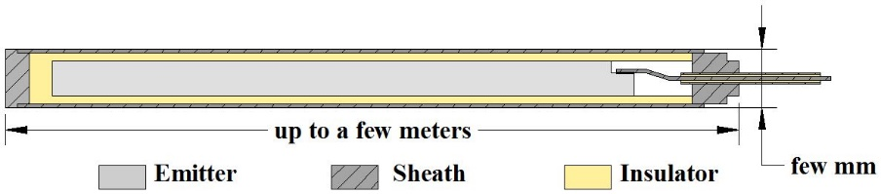
FIG. 1. Sketch of a typical SPND.
The MATiSSe toolbox (Monte cArlo Tool for SPND Simulations [5]) has been developed at CEA in the perspective of irradiation experiments in the future Jules Horowitz Reactor (JHR). It identifies and transports all possible free electron creation sources. The collected current along with the respective contribution of each reaction are then assessed as functions of the geometry and choice of materials. The signal evolution with emitter depletion can be computed as well. Once validated, the MATiSSe toolbox was used in 2016 to study the feasibility of SPNDs in sodium-cooled fast reactors for detecting local change in neutron flux distribution. Starting from an existing platinum emitter SPND, simulations showed an almost undelayed and linear response to a power excursion. Providing material and geometry optimizations, the study successfully demonstrated the usage of SPNDs as in-core detectors in fast reactors at full power [6], with temperatures about 550°C and neutron flux about 10¹⁵ n/cm²/s. However, this was possible since in this location the activation contribution to the gamma field is negligible with respect to the one from the fission events within the fuel. This will not be the case in DEMO breeding blankets, implying that the gamma field should be estimated by a separate sensor (e.g. a Self Powered Gamma Detector) for an eventual subtraction of its contribution.

A fission chamber is a versatile neutron sensor, the principle of which is sketched on Fig. 2. It consists in one or several pairs of electrodes, often cylindrical, on which a fissile material is deposited, ²³⁵U being the most common choice. This fissile deposit, under a neutron flux, yields fission fragments that ionize a filling gas, e.g. argon, at one or few bars. The electron-ion pairs drift towards their respective electrodes under a bias voltage, inducing a measurable electric signal that is continuously collected by a mineral cable. The sensor specifications can be fitted to various operational conditions and purposes through simulation tools. An asset of fission chambers is that their signal can be conditioned in several way by the acquisition chain, the relevancy of those depending on the counting rate, pulse width and noise: namely pulse mode, current mode, and Campbelling/high-order cumulant modes.
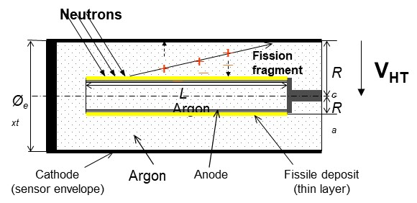
FIG. 2. Sketch of a typical fission chamber.
At CEA, a more than a decade effort in joining theoretical, modelling and experimental studies to conceive fission chambers for dedicated applications resulted in simulation codes, namely CHESTER [7] and COSICAF [8]. The choice of various isotopes, fissile or fertile, to retrieve a rough spectral discrimination and the correction of the sensitivity for depletion and isotopic evolution under a high flux have received a special attention [9, 10]. Also, the CEA fission chamber workshop in the CHICADE facility has gained the unique know-how of designing and manufacturing prototype fission chambers with specific designs and various deposits in terms of mass and isotopic composition with a controlled precision. A major outcome is the experimental demonstration at the MINERVE reactor of the ability of a fission chamber to monitor the neutron flux over 8 decades, with a departure from linearity less than 5% [11], by the simultaneous use of pulse and Campbelling/high-order cumulant modes with the MONACO acquisition system [12]. In those modes the rejection of the gamma-induced signal is inherently excellent.

The development of high temperature fission chamber (HTFC) has been carried out by the CEA from the early 1980s to the late 1990s to meet the needs of the sodium-cooled fast reactors and revived in the 2010s in the framework of the ASTRID project with Photonis [13]. The operational conditions that those sensors should met are severe, with similarities to those expected in the breeding blankets, in terms of temperature (430°C to 550°C) and neutron flux (10⁹ to 10¹⁵ n cm⁻² s⁻¹, with an energy distribution close to the Watt fission spectrum). The HTFC designed for the ASTRID reactor features only one cable with alumina insulator carrying both signal and bias voltage and two electrodes pairs to allow a large fissile mass (up to 1g) compatible with high dynamic applications. It is compatible with thermal expansion and can be inserted directly into the sodium without an external protection case. Dpa as high as 90 have been considered in conception studies but is still to be experimentally explored. To address the issue of partial discharges, a discrimination method has been proposed [14] and experimentally validated, with the LINAC neutron source of CEA and an oven up to 800°C.
The major drawback of this HTFC design for use in breeding blankets is its size (∅=48mm). Miniaturization is not straightforward: for instance, the choice of a single cable without a guard ring implies the existence of a leakage current, which increases when the thickness of insulator decreases. However, in the past Photonis crafted smaller fission chambers, the CFUE22 and CFUE 32 (∅=7mm) that have been qualified to work in pulse, fluctuation and current mode up to 600°C and equivalent thermal fluence of 10¹⁹ n/cm². Another drawback, is the potential effect of the magnetic field and induced electric fields on moving charged particles and bias voltage, which has to be assessed by simulation and experimental means.
The optical fission chambers (OFC) have been developed very recently at CEA within the framework of the ASTRID programme [15]. The physical phenomenon at stake in an OFC is the scintillation of a noble gas (e.g. argon) alongside the slowing down trajectory of a heavy ion. The resulting photons (in the visible-to-near-infrared spectrum) can be transported outside the irradiation zone by an optical fibre towards an avalanche photodiode or a silicon photomultiplier for conversion into an electric signal. This sensor is inherently immune to electromagnetic perturbations, since there is neither a bias voltage nor moving electric charges. The linearity is also very good by physics, in the absence of such processes as spatial charges, avalanche or recombination. An experimental campaign at ORPHEE and CABRI reactors demonstrated the linearity of the response up to 7 decades, with a rejection of the gamma flux contribution similar to the one of classical fission chambers in pulse mode [16].
The heavy ion can be produced by a neutron induced fission event in a fissile deposit, as for a fission chamber: hence, a rough neutron spectrum discrimination can be achieved by using fissile and fertile isotopes in combination. Indeed, the CEA has conceived a multipoint sensor for which a patent request has been made (see Fig. 3). The principle is to accommodate for several cavities inside the same cylindrical envelope, each cavity acting as a separate sensor at its own location. Then measurements in several points with rough spectrum discrimination is achievable with a single sensor.
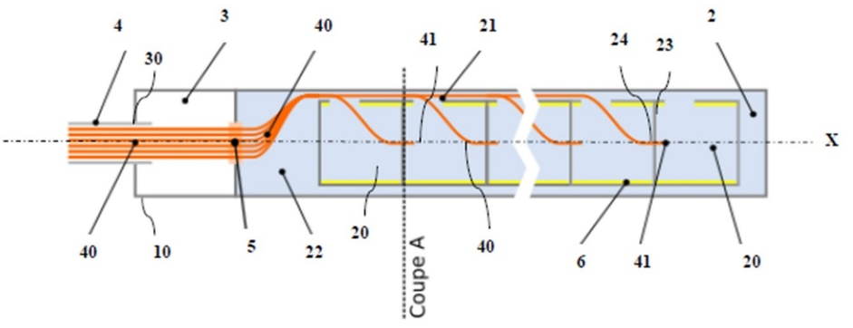
FIG. 3. Sketch of a multipoint OFC.
However, several issues have to be worked on. One can cite: the feedthrough sealing of a bundle of optical fibres, for which an efficient technology has yet to be validated; the rejection of the thermal noise coming from the blackbody radiation spectrum.
The three considered sensor types are certainly worth considering for a measurement system in DEMO breeding blankets, provided a research and development effort is made. This effort comprises theoretical and simulation developments, experiments at laboratory scale and eventually dedicated campaigns with larger scale facilities partially representative of the DEMO conditions.
Acknowledgement: This work has been carried out within the framework of the EUROfusion Consortium, funded by the European Union via the Euratom Research and Training Programme (Grant Agreement No 101052200 — EUROfusion). Views and opinions expressed are however those of the author(s) only and do not necessarily reflect those of the European Union or the European Commission. Neither the European Union nor the European Commission can be held responsible for them.
References
- Filliatre P., Lamirand, V., Geslot, B., Jammes, C., Experimental study of columnar recombination in fission chambers, Nucl. Inst. Meth. A 817 (2016) 1–6 and references therein
- Barucca, L. et al., Pre-conceptual design of EU DEMO balance of plant systems: Objectives and challenges, Fus. Eng. Des. 169 (2021) 112504
- Boccacini, L.V., et al., Objective and status of EUROfusion DEMO blanket studies, Fus. Eng. Des., 109-111 (2016) 1199-1206
- Tenchine, D., Some thermal hydraulic challenges in sodium cooled fast reactors, Nucl. Eng. Des., 240 (2010) 1195-1217 and references therein
- Barbot, L., et al., “Experimental validation of a Monte Carlo based toolbox for Self-powered neutron and gamma detector simulation in the OSIRIS MTR”, PHYSOR 2016, Sun Valley, USA
- Verma, V., et al., Self-Powered Neutron Detectors as in-core detectors for Sodium-cooled Fast Reactors, Nucl. Inst. Meth. A 860 (2017) 6
- Filliatre P., et al., A Monte Carlo simulation of the fission chambers neutron-induced pulse shape using the GARFIELD suite, Nucl. Inst. Meth. A 678 (2012) 139
- de Izarra, G., et al., “COSICAF, a fission chamber simulation tool for academic purposes”, ANIMMA 2019, Portoroz, Slovenia, EPJ Web of Conferences 225, 10003 (2020)
- Filliatre P., et al., Reasons why Plutonium 242 is the best fission chamber deposit to monitor the fast component of a high neutron flux, Nucl. Inst. Meth. A 593 (2008) 510
- Geslot, B., et al., New measurement system for on line in core high-energy neutron flux monitoring in material testing reactor conditions, Rev. Sci. Ins., 82 (2011) 033504
- Elter Z., et al., Performance of Higher Order Campbell methods, Part I & Part II, Nucl. Inst. Meth. A 821 (2016) 66 and 835 (2016) 86
- Barbot, L., et al., “MONACO v2: Multipurpose and Integrated Data Acquisition System for On-line Neutron and Gamma measurements”, ANIMMA 2019, Portoroz, Slovenia, EPJ Web of Conferences 225, 03012 (2020)
- Jammes, C. et al., Assessment of the high temperature fission chamber technology for the French fast reactor program, IEEE Trans. Nucl. Sci., 59 (2012) 1351
- Hamrita, H., et al., Rejection of partial-discharge-induced pulses in fission chambers designed for sodium-cooled fast reactors, Nucl. Inst. Meth. A 848 (2017) 109
- Lamotte, M., “Study of optical signals produced in fission chambers and evaluation as neutron measurement system for a Generation IV reactor”, PhD, Université de Grenoble Alpes, 2021
- Lamotte, M., de Izarra, G., Jammes, C., Pulse-reactor core monitoring with an innovative optical neutron detector, Nucl. Inst. Meth. A 995 (2021) 165086

