NUCLEAR FUEL PROCESSING USING FAST FUSION NEUTRONS PRODUCED IN A SPHERICAL TOKAMAK.

M. NIETO-PEREZ^{1,2}, S. MAHAJAN³, M. KOTSCHENREUTHER³

¹Ken and Mary Alice Lindquist Department of Nuclear Engineering - Pennsylvania State University, University Park, PA, USA
²CICATA Queretaro _Instituto Politecnico Nacional, Queretaro, Mexico
³Institute for Fusion Studies – University of Texas at Austin. Austin, TX, USA

Email contact of corresponding author: mnieto@psu.edu

Nuclear power faces two important technical challenges: increase the availability of fissile material beyond the existing natural uranium, and safely disposing of partially burned nuclear fuel. Although some nuclear reactor designs can operate with natural uranium as fuel, most commercial reactors require enriched fuel. A single PWR reactor requires between 150 and 250 tons of fuel, with the fuel assemblies staying inside the reactor for a period between 18 and 24 months. During refuelling, 1/3 of the assemblies come out permanently, so the net consumption of fuel is in the range 25 – 50 tons/yr. According to the IEA BLUE map scenario [1], if the level of uranium usage remains at its present value (no growth), reasonably assured reserves (RAR) and inferred reserves (IR) of uranium will be depleted by 2100.

To extend nuclear power availability, it is required to artificially breed fissile material. Fissile isotopes can be produced by exposing natural fertile material, such as ²³²Th and ²³⁸U, to fast neutrons; irradiation of fertile material with neutrons having energies between 10 keV and 1 MeV is desirable when the purpose of the irradiation is to breed fissile material. Three options are available as alternatives to produce fast neutrons [2]: accelerator-based sources (spallation process), fusion reactors running with deuterium and tritium mixtures, and fast neutron spectrum reactors. Accelerator-based systems produce a point-like source, which leads to significant issues associated with heat removal and neutron damage near the point source. Switching between several targets may help mitigate these problems, but even with those strategies the heat removal and neutron damage problems remain [3]. Fast reactors, unlike accelerator- or fusion-based systems, are susceptible to reactivity accidents if adequate control measures are not taken [4], which implies an added operational risk, not present in the subcritical systems.

Fusion systems have been proposed in the past as fast neutron sources in the context of neutronics testing facilities for the development of practical fusion reactors [5]; these devices are designed to produce up to 2-4 MW/m² of neutron wall loading over large areas. A important disadvantage of a first-generation fusion-based system is the need to breed tritium. The tritium burned in the fusion reactor will produce one neutron, and this neutron will be required to replenish the spent tritium, leaving no excess neutrons to carry out other tasks such as transmuting fertile isotopes into fissile ones. Therefore, fusion-based systems require neutron multiplication and a minimization of the neutron leakage.

In this work, neutron transport simulations are coupled to nuclear reaction kinetics calculations to evaluate the feasibility of using a fusion-based 200 MW neutron power source for the purpose of enriching natural ThO₂/UO₂ with fissile isotopes (²³³U in the case of Th fuel, ²³⁹Pu in the case of U fuel) so it can be used as fuel in standard thermal nuclear reactors. The geometry for the neutron source is a spherical tokamak design from the University of Texas at Austin which has been previously evaluated as a minor actinide burner [6]. Figure 1 shows a cut view of the fast neutron irradiator design.

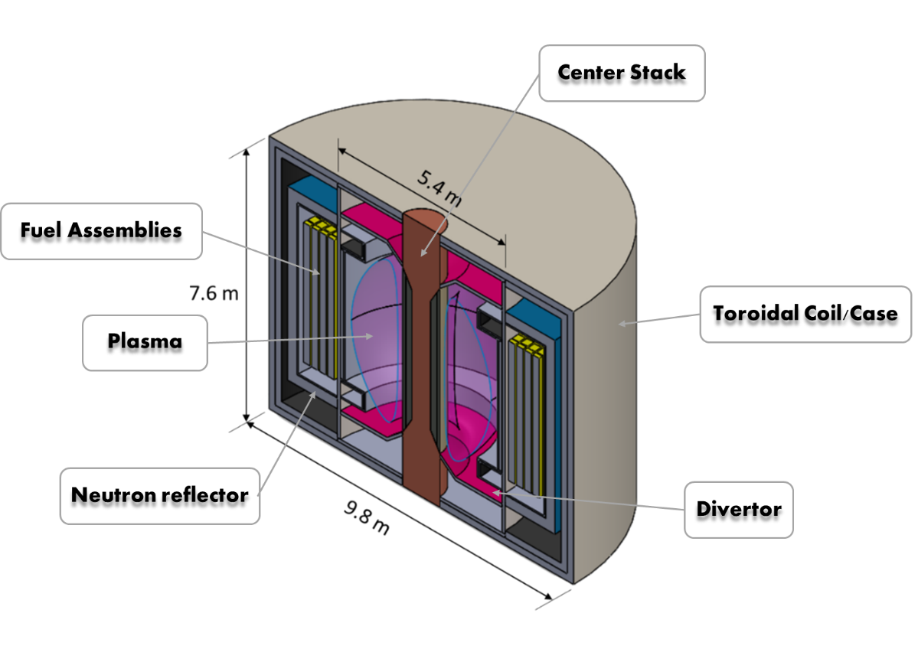
FIG. 1. Fast neutron irradiator for nuclear fuel assemblies based on a spherical tokamak fast neutron source.

Two figures of merit are defined to assess the performance of the system: tritium self-sufficiency and fissile material production rate; configurations which do not achieve tritium self-sufficiency or cannot boost the fissile material content to the desired level in a reasonable amount of time are not considered attractive. The sensibility of these two metrics to geometry parameters such as wall thicknesses and material choices is evaluated in this work. For these exploratory studies, the geometry is kept simple (i.e. no fuel bundle structural details, simple cylindrical walls) and homogeneous material distributions are assumed in all cases.

The irradiator performance metrics are evaluated using three distinct computer codes: ASTRA, MCNP and ORIGEN. ASTRA is used to estimate the temperature and density profiles in the confined plasma given operational parameters and a suitable mass and energy transport model [7]. With those profiles, the volumetric neutron source is calculated. The MCNP code [8] is used to solve the multigroup 3D neutron transport equation using the neutron source calculated from the ASTRA results and material composition in all regions of space. As an output, MCNP will give the neutron flux in the relevant regions of the domain, binned in accordance with the energy structure defined for the neutron tally. The ORIGEN code, part of the SCALE suite of nuclear codes [9], solves a set of extended Bateman equations to track changes in isotope population due to both radioactive decay and neutron-induced process. ORIGEN uses the ENDF/B-VII cross section database and the energy-resolved neutron flux information from MCNP to make the nuclear reactor kinetic calculations. Once the time defined for the depletion calculation has elapsed, ORIGEN generates the new isotopic composition as output. This new composition will be communicated to MCNP for recalculating the neutron flux given these new compositions. The process is repeated itratively until the system is simulated for the whole irradiation time. Figure 2. Shows a flow diagram of the simulation scheme used to evaluate the fast neutron irradiator performance.

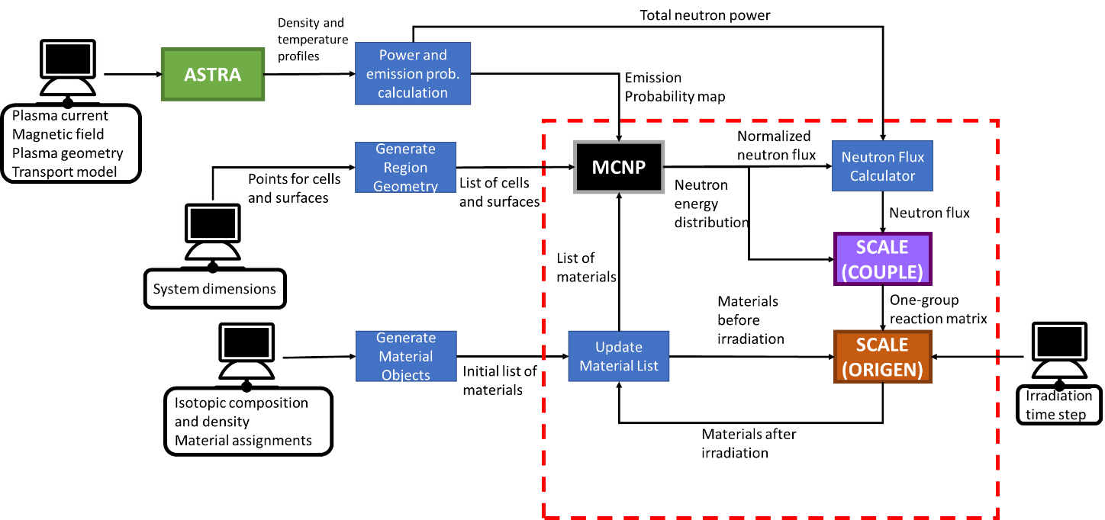

FIG. 2. Block diagram of the simulation scheme using ASTRA, MCNP and SCALE. The terminal represents user input and dark boxes represent data manipulation blocks. The portions inside the dashed rectangle are within the main program loop, tasks outside the loop are done once at the beginning of the simulation.

By changing the neutron multiplier and tritium breeding materials, as well as some geometrical parameters, combinations that fulfil both viability criteria for tritium and fissile material breeding have been found Two breeding materials (Li and Li2O) and two neutron multiplying materials (Be and FLiBe) were considered for inclusion in the irradiator, and they were evaluated by calculating values of tritium breeding ratio (TBR) and time to enrichment (TE). It was found that the Li/FLiBe combination with thin (0.05 cm thickness) side wall gave the best performance by reaching a TBR of 1 and a time to 5% enrichment of 24 months. The highest reactor support ratio is considered the most attractive, given that the primary purpose of the irradiator is to breed fuel; of course, at the same time, the tritium self-sufficiency of the neutron source needs to be ensured as well. A higher TBR puts less burden on the tritium recovery efficiency, at the cost of breeding less fuel. The decisive argument as to which system configuration works best would be an analysis of energy expenditure: energy demand for tritium recovery will increase as TBR decreases, and energy output from fissile material will increase as RSR increases. There must be an optimal point, and such analysis will be the focus of future work.

References
[1] INTERNATIONAL ENERGY AGENCY. Energy Technology Perspectives 2010: Scenarios and Strategies to 2050, OECD Publishing, Paris (2010).
[2] M. SALVATORES. “Physics features comparison of TRU burners: Fusion/Fission Hybrids, Accelerator-Driven Systems and low conversion ratio critical fast reactors”. Ann. Nuc. En. 36, (2009) 1653–1662. DOI: 10.1016/j.anucene.2009.09.011
[3] W. M. STACEY. “Transmutation missions for fusion neutron sources”. Fus. Eng.Des. 82, n. 1, (2007) 11-20. DOI: 10.1016/j.fusengdes.2005.12.005
[4] K. TUČEK, J. CARLSSON, H. WIDER. “Comparison of sodium and lead-cooled fast reactors regarding reactor physics aspects, severe safety and economic issues”. Nuc. Eng. Des. 236, (2006) 1589-1598. DOI: 10.1016/j.nucengdes.2006.04.019.
[5] C. E. KESSEL, J. P. BLANCHARD, A. DAVIS, L. EL-GUEBALY, N. GHONIEM et al. “The fusion nuclear science facility, the critical step in the pathway to fusion energy”. Fus Sci. Tech. 68, (2015) 225-236. DOI: 10.13182/FST14-953
[6] M. KOTSCHENREUTHER, P. M. VALANJU, S. M. MAHAJAN, E. A. SCHNEIDER. “Fusion–Fission Transmutation Scheme—Efficient destruction of nuclear waste”. Fus. Eng. Des. 84, (2009) 83–88 (2009). DOI: 10.1016/j.fusengdes.2008.11.019
[7] G. V. PEREVERZEV, P. N. YUSHMANOV. “Automated System for TRansport Analysis (ASTRA)”. Report IPP 5/98, Max-Planck-Institut Fur Plasmaphysik. Munich, Germany, 2002.
[8] X-5 MONTE CARLO TEAM. “MCNP - Version 5, Vol. I: Overview and Theory. Report LA-UR-03-1987”, Los Alamos National Laboratory. Los Alamos, NM, USA, 2003.
[9] W. A. WIESELQUIST, R. A. LEFEBVRE, AND M. A. JESSEE. “ SCALE Code System”. Report ORNL/TM-2005/39, Version 6.2.4, Oak Ridge National Laboratory, Oak Ridge, TN, 2020.

