Synergy between nuclear fusion and fission technology for developments of reactor’s materials and waste management

S. Hussain¹, Z. Ahmad² and R.Khan³
¹Pakistan Tokamak Plasma Research Institute, Islamabad, Pakistan
²Pakistan Tokamak Plasma Research Institute, Islamabad, Pakistan
³Pakistan Tokamak Plasma Research Institute, Islamabad, Pakistan

Email: shahid92_pk@yahoo.com

In near future it is expected that idea of commercial fusion power plant / reactor will be materialized and fusion will not be just a dream. Currently, apart from the ITER which is already a multinational joint venture, several countries have started conceptual and physics design of their DEMO (China, Korea, EU etc). Additionally several private organizations are now in fusion business and are claiming to achieve fusion sooner than expected.

Most of the physics issues related to fusion reactor have been addressed however material related challenges are yet to be solved and it can cause major hurdle in reactor development. Tritium storage, its handling and radioactive waste management are also important issues.

Nuclear fission power reactors are in use from decades. Scientists and engineers are working for the development of advanced modular fission reactor. In Fission and fusion some issues are common e.g. CANDU type fission reactor produce Tritium which will be used as fuel in fusion reactors, management of radioactive waste produced in fission reactor and fusion reactor, and plasma facing material for fusion and materials for the fission core, development of structure materials, both for fission and fusion reactors. Therefore, synergies for fusion and advanced fission reactor development could be realized for rapid progress in these two areas

We have identified two R&D areas for synergies; the non-nuclear testing of materials, with different scenarios and waste management using plasma torch.

First wall and structural materials (Tungsten, Inconel, Molybdenum etc.) [1] of fusion reactor are tested under the influence of high temperature and high particle flux [2, 3]. The samples of Tungsten, Inconel and Molybdenum are exposed to the high heat, high particle flux beam of protons emerging from the accelerator. To avoid from the radioactive effect, beam of protons is used instead of beam of neutrons. However equivalence impact of neutrons is calculated and its effects on materials (Tungsten, Inconel and Molybdenum) are studied. Initial results with SEM and Xrd analysis to understand micro level changes will be reported.

Radioactive waste management is one of the major challenges faced by the nuclear industry, also frequently envisioned by IAEA. Thermal plasma processing is one of the technologies that can be used to decrease the amount of radioactive waste stored and also safe to the environment [4, 5]. One of the process is the vitrification of waste (transformation into compact glassy slag) through high power plasma torches (converts electrical energy into thermal up to 10000ºC). Using such torches, the low and intermediate level radioactive waste is reduced in volume by ~50 times as compared to the untreated waste, over 10-times that of pre-compacted waste and by a factor of at least 2 for previously super-compacted wastes. This results in decreased storage requirement for nuclear repositories, minimum risk of contamination and eliminates the need of pre-disposal processes like segregation, pre-treatment, incineration compaction etc. resulting in large saving in financial expenditures. Many countries such as India, Russia, USA, UK, Bulgaria and Japan have already developed such facilities. Plasma torches are based on highly advanced technology, and require extensive R & D.

We have started extensive R&D activities to establish technological infrastructure for radioactive waste management facility. A prototype plasma torch (250 W, 4kV DC & Temp. ~500 ºC) has been developed for demonstration. Further, the development of 3kW high current water cooled DC plasma torch is in progress.
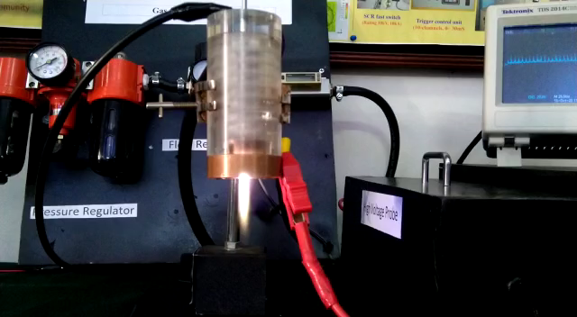

FIG. 1. 250W HV plasma Torch developed at PTPRI

REFERENCES

[1] G. A. Cottrell, R. Pampin, and N. P. Taylor, “Tungsten Armor in Fusion Power Plants”, Fusion Sci. Technol., 50 (2006).

[2] Y. Kikuchi et al., “Surface modifications on toughened, fine-grained, recrystallized tungsten with repetitive ELM-like pulsed plasma irradiation”, J. Nucl. Mater., 463 (2015) 206–209.

[3] D. T. Blagoeva et al., “Development of tungsten and tungsten alloys for DEMO divertor applications via MIM technology”, J. Nucl. Mater., 442, no. 1-3 SUPPL.1 (2013), S198–S203.

[4] E. Gomez, D. A. R., C.R. Cheeseman, D. Deegan, M. Wise, A.R. Boccaccini, "Thermal Plasma Technology for the Treatment of Wastes: A Critical Review", Journal of Hazardous Material (2008).

[5] A. Mosse, N. Z., "Application of Thermal Plasma for Waste Treatment", Laporan (2012).

