**MANAGEMENT OF NORM CONTAMINATED HYDROCARBON WASTES IN GABON**

P. Ondo Meye1, 2 *, C. Chaley1, M. F. Lekogo Edzougou1, G. H. Ben-Bolie2

1 Direction Générale de la Radioprotection et de la Sûreté Nucléaire, Ministère de l’Énergie et des Ressources Hydrauliques, B.P. 1172, Libreville, Gabon.

2 Laboratory of atomic, molecular and Nuclear Physics, Department of Physics, Faculty of Science, University of Yaounde I, P.O. Box10 812, Yaounde, Cameroon.

* Corresponding author: [p.ondomeye.dgrsn@gmail.com](mailto:p.ondomeye.dgrsn@gmail.com)

Poster ID: P-S7-110

**ABSTRACT**

In Gabon, the experience of the regulatory authority regarding radiological safety of Naturally Occurring Radioactive Material (NORM) is relatively new. In the oil and gas industry the NORM encountered include scales and sludge formed in the inner surface of production equipment and pipelines. Contaminated soil with NORM as a result of uncontrolled disposal of production water may also be of concern. The main radionuclides involved include Ra-226, Ra-228 and Pb-210. The present paper describes the radiological safety measures put in place for the management of NORM contaminated hydrocarbon wastes from a local oil company, from their storage in authorized waste storage installations to their transport for their disposal in a dedicated centre in Europe.

**IINTRODUCTION**

Gabon is an oil producing country since the 1960s. The year 1956 is marked by the operation of the first oil fields of Ozouri and Pointe-Clairette. In 1973, the Grondin oil field production reaches 10 million tonnes per annum. In 1998, the peak oil production in the country was close to 350 000 barrels per day [1]. This relatively large oil production throughout the years may have generated significant amounts of naturally occurring radioactive material (NORM) originating from the reservoir rock and usually encountered during production, maintenance and decommissioning. The presence of these NORM under the form of various solid and liquid wastes generally results in the need to control occupational and public exposures. In Gabon, various types of NORM waste, generated during oil and gas industry operations, have been identified (Figure 1):

* Hard scale contaminated equipment, usually tubing;
* Sludge waste resulting from tank cleaning.

A local company is offering cleaning of contaminated tubing using ultra high-pressure water jetting (Figure 2). This will ultimately generate hard scales and contaminated water that will need to be properly stored in a controlled area.

NORM contaminated soil as a result of uncontrolled disposal of production water might also be a concern in the country.

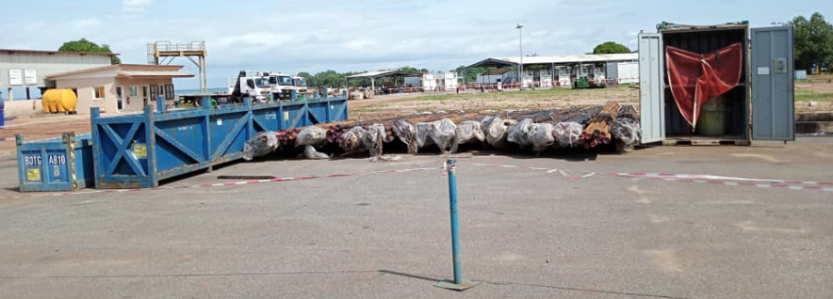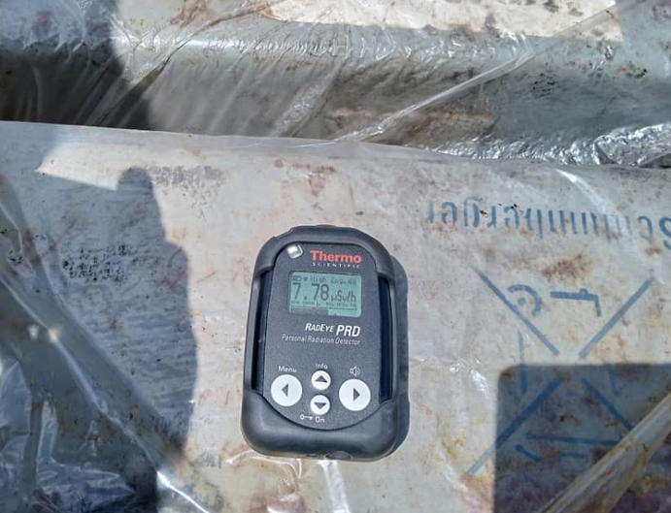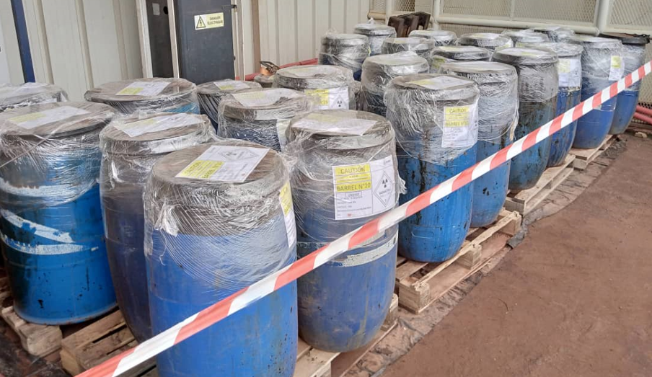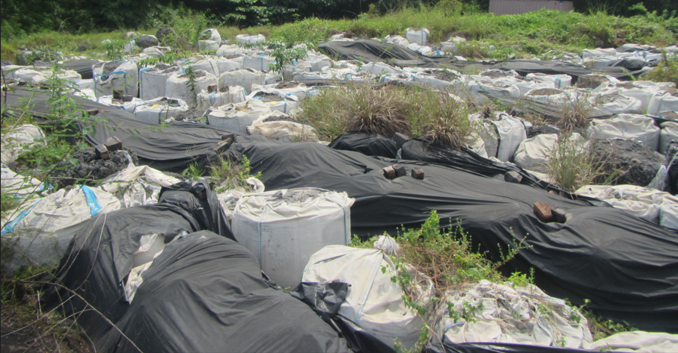

**b)**

**a)**

Figure 1: NORM Waste currently identified in the oil and gas industry in Gabon; a) hard scale contaminated equipment; b) sludge temporarily stored in drums or big-bags.

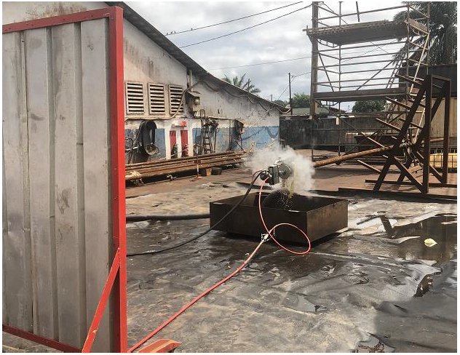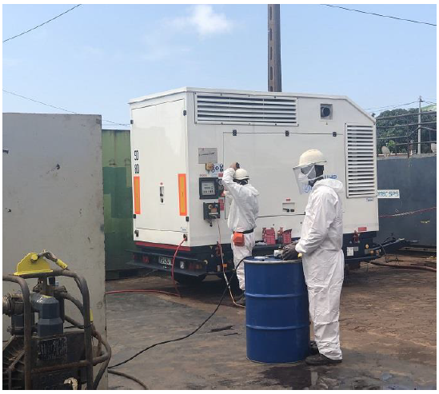

Figure 2: A local company solution for cleaning NORM contaminated tubing using ultra high-pressure water jetting

The General Directorate for Radiation Protection and Nuclear Safety (DGRSN), the regulatory authority in Gabon, has initiated, together with the other relevant ministerial departments (those in charge of oil and the environment), a discussions with oil and gas producers in order to find local solutions for the management of NORM wastes. For now, these wastes are stored at the operator’s premises or at a temporarily authorized waste operator.

The present paper describes the radiological safety measures put in place for the management of NORM contaminated hydrocarbon wastes from a local oil company, from their storage in temporarily authorized waste storage installations to their transport for their disposal in a dedicated centre in Europe. Particularly, radiological assessment of the storage installations, workplace and individual monitoring are presented.

**I. STAGE I: INITIAL SITUATION**

**I.1 The oil company**

The oil production activities of the company in question have mainly generated NORM contaminated sludge. These NORM wastes resulted from the cleaning of the tanks of a floating production storage and offloading (FPSO) ship which operated for the oil company in Port-Gentil, Gabon. On March 2019, these wastes were stored in approximately 700 Flexible Intermediate Bulk Container (FIBC) bags (commonly termed big bags) on the site of a waste treatment centre located in the city of Port-Gentil. These wastes, not properly conditioned, not stabilized in their container, and representing approximately 740 tonnes and a volume of 623m3, were placed on a mound already containing hydrocarbons and plastic waste, without proper management of the space (Figure 3).

**I.2 The waste treatment centre**

The waste treatment centre were established since 2009 in Port-Gentil. This company has an industrial treatment centre for waste from oil and oil-related activities. The oil company contacted the DGRSN for assistance regarding the transport of the NORM waste generated by its activities to the site of the waste treatment centre. To respond to the urgency of the prevailing situation (release of the FPSO ship containing the waste, decongestion of the premises of the transport company where this waste was stored), the waste treatment centre agreed to receive the said waste although the prescriptions contained in its authorization prohibited it because of its radioactive nature. It should be noted that the criteria for receiving the NORM packages at the waste centre entrance was that, at any point on the outer surface of a package, the dose rate does not exceed 5 µSv/h. Therefore, these packages were classified as excepted packages (UN code 2910) [2].

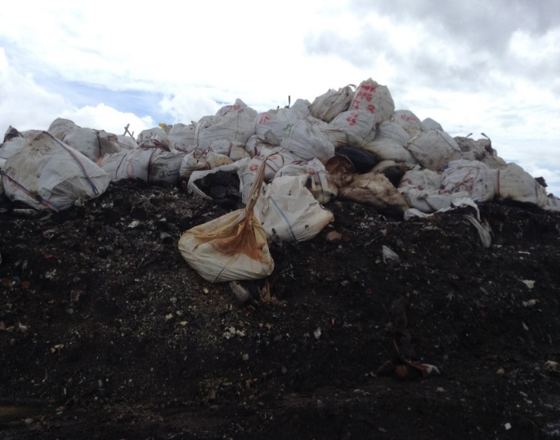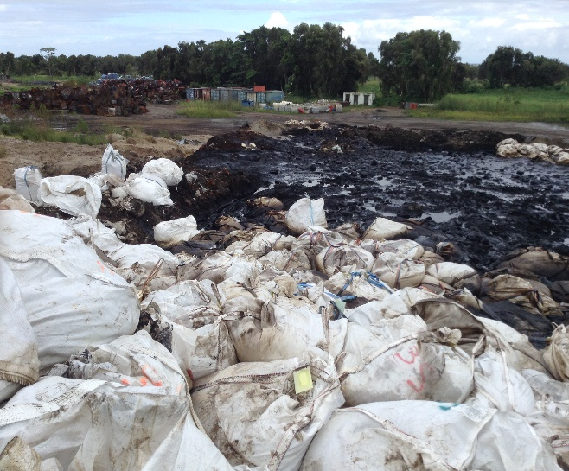

Figure 3: Generated NORM sludge that were stored in FIBC bags on the site of the waste treatment centre.

The DGRSN pointed out that these wastes were stored in this waste treatment centre on an exceptional basis and that their incineration on this site was not authorized. The principle that the producer of the wastes, the oil company in this very specific case, is primarily responsible until they are disposed was applied [3, 4].

Field visits were conducted and dose rate measurements were carried out throughout the facility. The features of the radiation equipment used and the measurement results are given in Tables 1 and 2, respectively.

Table 1: Features of the radiation equipment used during the field visits.

|  |  |  |  |  |  |
| --- | --- | --- | --- | --- | --- |
| Type | Brand | Model | Date of last calibration | Dose rate range | Energy range |
| Portable spectrometer | ATOMTEX | AT6102A | 15/01/2019 | 0.01µSv/h-100 mSv/h | 50-3000 keV |
| Survey meter | RadEye | PRD | 15/01/2019 | ≤ 250 µSv/h | 60 keV-1.3 MeV |

The field visits revealed the following:

* Radioactive materials had already been received in the centre as the presence of radioactivity was detected in various places;
* The dose rates recorded were not attributable solely to the presence of the oil company's wastes;
* The biotopes impacted by the presence of radioactive materials on the site were: the soil, water bodies near the settling basins and around the perimeter of the site, cassava plants grown near the site;
* The FIBC bags containing the NORM wastes from the oil company were deposited pell-mell above a mound that already contained other waste of various kinds (Figure 3);
* NORM wastes received from the oil company were not stabilized in their container (risk of dispersion of radioelements, migration of radioactivity);
* The area around the mound was now to be considered a supervised area to which the access was to be regulated;
* The radioactivity observed at the level of the incinerator was explained by the fact that an attempt to incinerate radioactive materials has already taken place at the site;
* Within another oil company’s yard in the centre, the presence of NORM contaminated pipes was observed. They were stored without demarcating the boundary of the area; two FIBC bags containing NORM wastes were also observed; the area with the highest level of radioactivity of the entire site was located within this yard.

Table 2: Results of dose rate measurements carried out during the field visits.

|  |  |  |
| --- | --- | --- |
| Measurement point | Dose rate (µS/h) | Range (µSv/h) |
| Entry of the facility | 0.03 ± 0.02 | 0.02 – 0.05 |
| Settling basin No. 1 | 0.04 ± 0.02 | 0.03 – 0.07 |
| Settling basin No. 2 | 0.17 ± 0.18 | 0.05 – 0.44 |
| Settling basin No. 3 | 0.07 ± 0.04 | 0.03 – 0.13 |
| Settling basin No. 4 | 0.06 ± 0.01 | 0.05 – 0.06 |
| Mound above which the wastes of the oil company were deposited | 0.36 ± 0.35 | 0.14 – 0.88 |
| Waste storage yard of another oil company | 1.13 ± 2.15 | 0.1 – 5.5 |
| Around the incinerator | 0.13 ± 0.09 | 0.05 – 0.22 |

The following prescriptions were issued:

* Build, on the site of the waste treatment centre, in an environment whose dose rates should be of the order of background radiation, an area dedicated to the adequate storage of the above-mentioned NORM wastes; the built structure must meet radiological safety conditions [5];
* Reconditioning of the said NORM wastes in compliance with good practices in this area [5];
* Perform dosimetry monitoring of the storage area [3-6];
* The workers assigned to the various tasks must benefit from individual dosimetry monitoring and must undergo training on the radiological risks involved [3-6];
* The personal protective equipment to be used must be adapted to the risks incurred [3-6];
* Store the NORM contaminated pipes and the two FIBC bags, found in the yard dedicated to another oil company, using appropriate delineation of areas and warning signs [5].

**II. STAGE II: TRANSFER TO ANOTHER STORAGE AREA**

**II.1 Prior radiological assessment**

The waste treatment centre designated the new storage area in agreement with the DGRSN recommendations. At the centre's request, the DGRSN carried out a prior radiological assessment, consisting mainly in measuring gamma dose rates in the designated area. The radiation equipment used are those given in Table 1. The dose rates were measured by grid over an area of approximately 50m × 40m. For each square of 5m × 5m area, the measurement was carried out at the intersection of the diagonals (Figure 4).

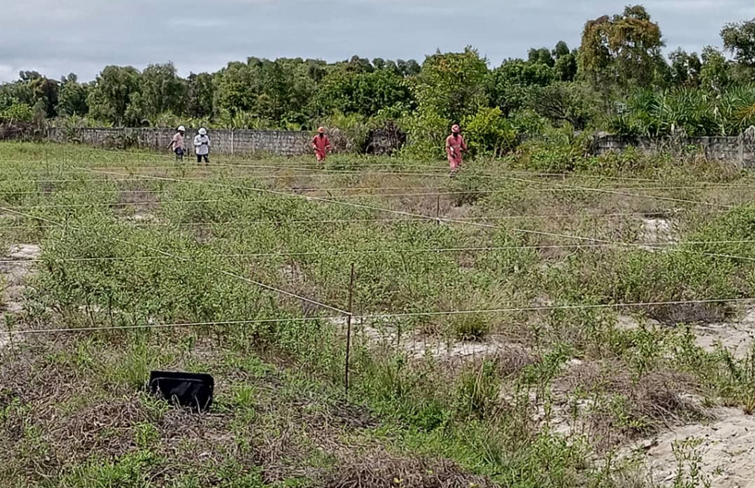

Figure 4: Image of the gridded surface (mesh area 5m × 5m).

The mean value ± standard deviation of the dose rates measured was 0.018 ± 0.001 µSv/h. This value indicated a relatively low natural background radiation level and, consequently, that the site assessed was not subject to radioactive contamination.

**II.2 Transfer of the NORM wastes**

To comply with the first prescription mentioned above, a local operator was entrusted with the task of reconditioning the wastes and moving them to the new storage area.

The NORM wastes were first packaged in UN-certified big bag type packaging with 4 lifting points with a capacity of 1m3, tested according to ISO 21898:2005 standard [xx]. They also have waterproof double envelopes. However, during the field visits, it was noted that the containment of some big bags was broken. In order to move the waste from the initial zone to the new storage zone, it had been proposed to create 5 sealed cells beforehand, the purpose of which was to reduce the following potential risks:

* Pollution and contamination of soil, water and air inside and near the site;
* Transfer of radioactivity in the environment.

The local operator was in charge of carrying out the construction of these cells. Two types of cell have been built to fulfil two functions (Figure 5):

* 1 10m × 10m × 0.2m volume conditioning cell. It was intended to repackage old FIBC bags into new larger ones;
* 4 5m × 10m × 0.2m volume storage cells. Their purpose was to store reconditioned FIBC bags pending the delivery of 40-foot and 20-foot containers (volume: 12m × 2.44m × 2.59m = 65 m3 and 6.10m × 2.44m × 2.59m, respectively) in which they were ultimately to be stored before their shipment abroad.

Waterproofing of the ground and the inner basin was ensured by the use of a 1mm High Density Poly Ethylene (HDPE) membrane. To avoid any infiltration of water during rainfall, a HDPE membrane cover was used for each cell. The cover was placed on the cells in such a way to create an upper dome to avoid the stagnation of rainwater. Delineation of the supervised area and placement of radiological warning signs were carried out to restrict access to non-authorized persons. The temporary installation has occupied an area of 2250m²:

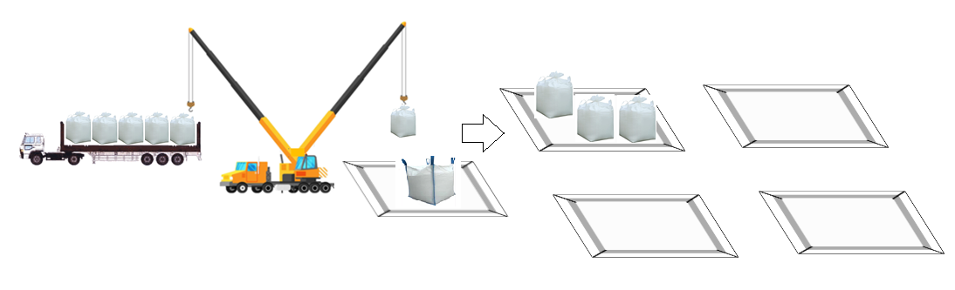

Figure 5: Repackaging of FIBC bags and temporary storage pending delivery of 40-ft and 20-ft containers.

**III. STAGE III: SHIPMENT OF THE NORM WASTE FOR FINAL DISPOSAL**

**III.1 Transfer to a local storage centre**

The oil company finally decided to move the NORM waste stored in 40-ft and 20-ft containers from the waste treatment centre to a local storage centre. After the containers were moved, a final radiological assessment was carried out in the area where they were stored. Gamma dose rate measurements showed that there was no radioactive contamination in this area. Also, before moving the containers to the new storage centre, an initial radiological assessment was carried. The dose rates measured was compatible with natural background radiation levels.

**III.2 Classification of packages**

It was essential to characterize the NORM waste in order to classify the packages to be shipped according to IAEA regulations for transport of radioactive material [2]. The characterization revealed that the waste contained mainly two radionuclides: 226Ra and 228Ra (Table 3). The requirements that were taken into account to classify the NORM waste packages were the following:

The radioactive material may be classified as low specific activity material of group I (*LSA-I*) if

* 1. The value of *A2* given in [2] is unlimited;
  2. The radioactive material in which the activity is distributed throughout and the estimated average specific activity does not exceed 30 times the values for the activity concentration specified in [2].

As it was considered that in the NORM sludge involved the radionuclides from the uranium and thorium decay chains were in secular equilibrium, values of *A2* for U (natural) and Th (natural) were used [2]. Since these values are unlimited, the packages containing the NORM wastes (45 40-ft containers and 1 20-ft container) were classified as *LSA-I*.

As shown in Table 3, the activity concentrations derived from the measured activities of 226Ra + 228Ra and gross weight of the NORM packages are significantly lower than 30 times 10 Bq/g, the value specified in [2] for 226Ra and 228Ra. Hence the classification of the packages as *LSA-I*.

Table 3: Results from the characterization of the NORM waste involved.

|  |  |  |  |  |  |
| --- | --- | --- | --- | --- | --- |
| Radionuclide | Activity (MBq) | Gross weight  (kg) | Concentration (Bq/g) | Minimum concentration (Bq/g) | Maximum concentration (Bq/g) |
| 226Ra + 228Ra | 112.7 ± 62.8 | 18317.8 ± 1972.0 | 6.2 ± 3.2 | 2.6 | 18.8 |

**III.3 Shipment of the packages**

Due to the covid-19 pandemic, the shipment of the NORM waste was considerably delayed. The administrations concerned, including the DGRSN, were invited to attend the sealing of the containers which took place on July 26, 2021, in Port-Gentil.

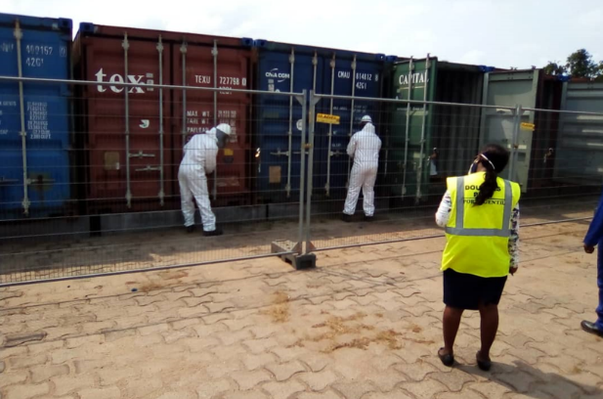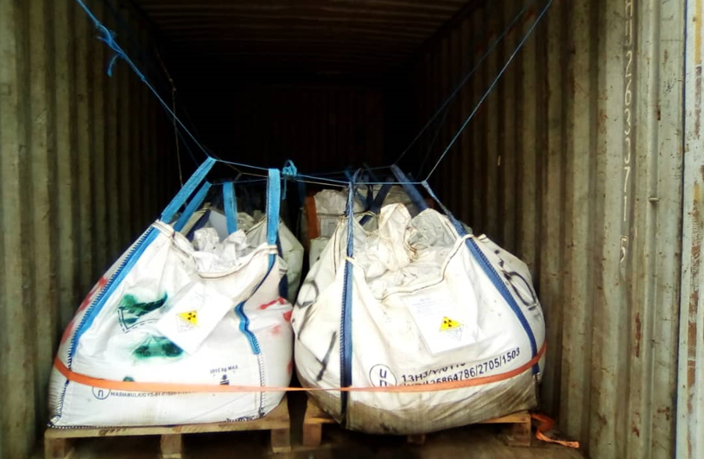

Figure 6: Sealing of containers before their shipment.

From the discussions with the oil company and the review of the documents submitted, the DGRSN noted the following points:

* The consent of the Gabonese authorities for the shipment of the NORM waste abroad was given;
* The NORM waste was classified as *LSA-I* (UN 2912), the consignee therefore recognized the radiological nature of the packages;
* The destination country provided the oil company with the documents relating to the shipment;
* The waste was intended to be treated in three different centres (two landfill centre and one incineration centre);

**CONCLUSION**

The objective of this paper was to describe the radiological safety measures put in place for the management of the NORM wastes produced by a local oil company. This is a successful example of NORM wastes management in the oil and gas industry, from their generation to their disposal overseas. The other oil companies may follow this example although a sustainable national strategy for NORM waste disposal might be a more suitable solution.

**REFERENCES**

[1] Africa Energy. Gabon: Invest in the Energy Sector of Gabon. Africa Energy Series. Gabon Special Report 2020.

[2] International Atomic Energy Agency. Regulations for the Safe Transport of Radioactive Material. IAEA Specific Safety Requirements No. SSR-6 (Rev. 1). IAEA (2018).

[3] Décret No. 000361/PR/MMEPRH du 6 mai 2005, fixant les principes généraux de prévention et de protection des travailleurs, des patients, du public et de l’environnement contre les rayonnements ionisants.

[4] International Atomic Energy Agency. Radiation Protection and Safety of Radiation Sources: International Basic Safety standards. IAEA Safety Standards No. GSR Part 3. IAEA (2014).

[5] International Atomic Energy Agency. Radiation Protection and the Management of Radioactive Waste in the Oil and Gas Industry. IAEA Safety Reports Series No. 34. IAEA (2003).

[6] International Atomic Energy Agency. Occupational Radiation Protection. IAEA Safety standards series No. GSG-7. IAEA (2018).