- Introduction
The materials used in construction that come from rock or soil minerals may contain a certain amount of radionuclides from natural radioactive chains. The radioactive materials present in construction materials, although they are of natural origin, their concentration can be modified by the action of man. The objective of the present study was the radiological characterization of a sandstone reservoir. This natural aggregate comes from the tilling of a deposit located east of Havana and is subjected only to mechanical processes and is used as raw material in construction.

- General characteristics of the deposit

The field under study is divided into two sectors (east and west) and has two processing plants, in addition to a mud dam.

This deposit is found in a formation generally made up of calcareous sandstone sequences (very fine, fine, medium and coarse grained), rarely by organogenic and polymorphic limestone. The underlying rocks are composed of monocrystalline tufites, fine-medium grained conglomerates. Intercalations of sandy clay and shale lenses are also observed.
The mining works in the quarry consist of the removal, transfer and storage of the material.
For this, the following basic processes are carried out: the preparation of the rocks for the excavation, the excavation - loading, the transfer of the material (the sterile rocks to the dumps and the ore to the plant) and the primary preparation of the material and its benefit.

- Methodology for radiological characterization

In order to characterize potential occupational doses to quarry workers, gamma dose rate monitoring was conducted throughout the site. The equipment used to measure the dose rates was the STEP OD 02. The OD-02, which is a manual local dosimeter for the measurement of the directional dose/equivalent dose rate and the environmental dose/equivalent dose rate in fields of mixed irradiation (X-ray radiation, gamma, as well as qualitatively, beta radiation). Monitoring consisted of continuous gamma dose rate measurements throughout the work area.
For the evaluation of the doses due to external irradiation due to permanence in the workplace, a conservative scenario of permanence of the workers in their workplace of 2000 hours per year was assumed.
The effective dose by external irradiation was estimated according to the expression:
$E=\overset{˙}{E}×t$
where:
E effective dose integrated by external irradiation (µSv);
$\overset{˙}{E}$ maximum dose rate measured at each workstation (µSv/h);
t hours of work in the year.

Process samples were also taken for laboratory analysis: uncrushed rock crushed rock, washed sand (final product), water used in the process, and sludge produced from sand washing.

Measurements of radon gas in air and water were made, using Alpha Guard DF2000 continuous measurement equipment.

All samples were analysed at the CPHR Environmental Radiological Surveillance Laboratory. The treatment of these samples was carried out using a laboratory procedure and they were analysed by high-resolution gamma spectrometry to determine the environmental radionuclides of interest. For these measurements, a gamma spectrometric system from the supplier Baltic Scientific Instruments was used, with a hyperpure germanium detector with 40% efficiency. The calibration of the system was performed by means of Monte Carlo simulation, using the mixed method, where the gamma photopic efficiency is determined by mathematical simulation with the help of an energy-dependent transfer factor that is obtained from the measurement of a curve experimental. The simulation was performed with the DETEFF software, validated for this purpose, and the quantitative analysis of the data obtained was performed with the SpectraLineGP software, version 1.6.8315.

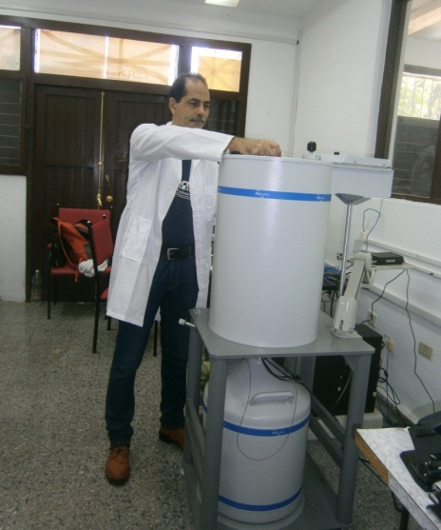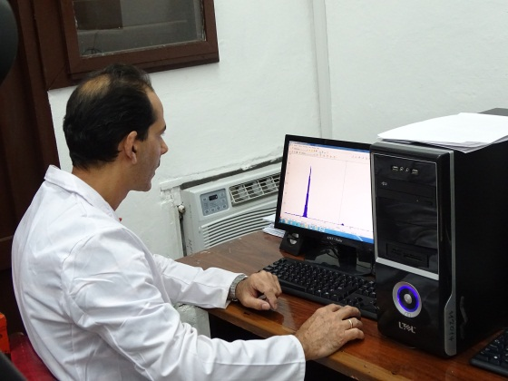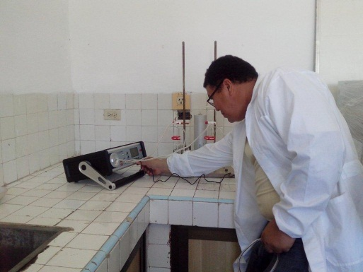

- Results and Discussion
Table No.1 Gamma dose rate measurement in the different areas

Monitoring point | Gamma dose rate (μSv/h) | Dose at 1m (mSv/year)
Background | 0,02 | -
Facility entrance | 0,66 | 1,320
Point 1 | 0,97 | 1,940
Point 2 | 0,90 | 1,800
Point 3 | 0,74 | 1,480
Point 4 | 0,78 | 1,560
Point 5 | 0,08 | 0,160
Point 6 | 0,05 | 0,100
Point 7 | 0,28 | 0,560

As can be seen, at some of the monitored points in the quarry, taking into account the extreme assumption of 2,000 hours of permanence in the same workplace, the doses exceed 1mSv as the internationally recommended reference level. These values may be given because at the time of the measurement the winds were blowing in the direction of that side of the quarry, bringing with it higher concentrations of suspended dust.

Table No.2 Activity concentration levels of the most significant gamma emitters in the samples taken.

Sample | Activity concentration ± u (Bq/kg)
Sample | Pb-210 | Ra-226 | K-40 | Th-234
Raw material | 55±17 | 24±1 | 72±4 | 31±8
Stone crushed | 86±20 | 20±1 | 59±4 | 35±8
Finished product | 61±19 | 20,7±0,9 | 54±4 | 38±8
Process Water | 55±22 | 0,45±0,17 | 2,9±1,3 | 14±7
Sludge | 56±17 | 3±0,3 | 8,2±1,6 | <15
The values that appear after the “<” sign correspond to the Minimum Detectable Activity (MDA) calculated for 95% confidence.
u: combined uncertainty.

Table No.3 Radon-222 gas activity concentration levels.

Matrix | Monitoring point | Activity concentration ± u*
air | Point 1 | 8 ± 4 Bq/m³
air | Point | 20 ± 7 Bq/m³
air | Point 6 | 15 ± 6 Bq/m³
air | Point 7 | 17 ± 10 Bq/m³
air | Background | 8 ± 4 Bq/m³
water | Process Water | 0,036Bq/L
water | Accompanying water of the sludge | 0,041Bq/L
water | Background | 0,22Bq/L

- Conclusions
- The ²²⁶Ra, ²¹⁰Pb, ²³⁴Th and ⁴⁰K values found in the analyzed samples are below the internationally recommended values from which remedial measures must be taken or some type of regulatory control must be established over the presence of radioactive materials of natural origin. .
- The values of ²²²Rn determined in air are well below the levels recommended for members of the public in the Basic Radiological Safety Standards of the International Atomic Energy Agency.
- Taking into account the results obtained, it can be concluded that no type of regulatory control is considered necessary for the site studied, as long as the considerations under which the studies were carried out do not vary.

