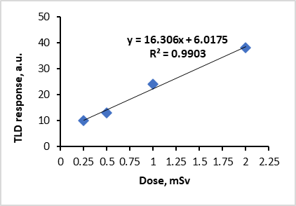
BACKGROUND AND GOAL

METHODS AND MATERIALS
- To measure hand doses for nuclear medicine personnel (radiology technologists), calibrated thermoluminescent dosimeters (TLD-100 (LiF:Mg, Ti)) were used.
- TLD-100 chips were calibrated with ¹⁸F source in a dose range of 0.25-2 mSv.

- Background and Goal of the present work

The extremity exposure monitoring of nuclear medicine personnel is essential to control exposure in the workplace, to ensure that legal limits are not exceeded, to predict extremity doses and, if possible, to optimize workflow. Distribution of the doses over hand is nonuniform and the obtained doses by Hp(0.07) passive dosimeter can be significantly lower compared to fingertips, especially working with positron emission radionuclides.

The goal of this study was to assess the extremity exposure of nuclear medicine personnel working with automatic infusion system dedicated for 18F-FDG radionuclide administration.

The extremity exposure monitoring of nuclear medicine personnel is essential to control exposure in the workplace, to ensure that legal limits are not exceeded, to predict extremity doses and, if possible, to optimize workflow. Distribution of the doses over hand is nonuniform and the obtained doses by Hp(0.07) passive dosimeter can be significantly lower compared to fingertips, especially working with positron emission radionuclides.
The goal of this study was to assess the extremity exposure of nuclear medicine personnel working with automatic infusion system dedicated for 18F-FDG radionuclide administration.

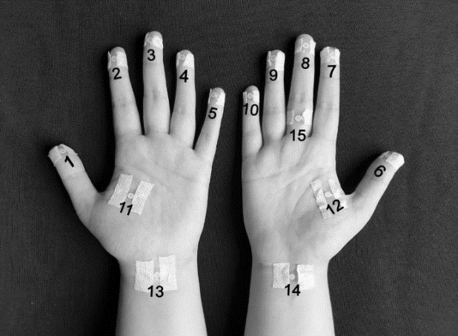
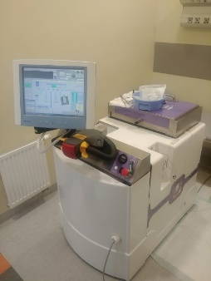
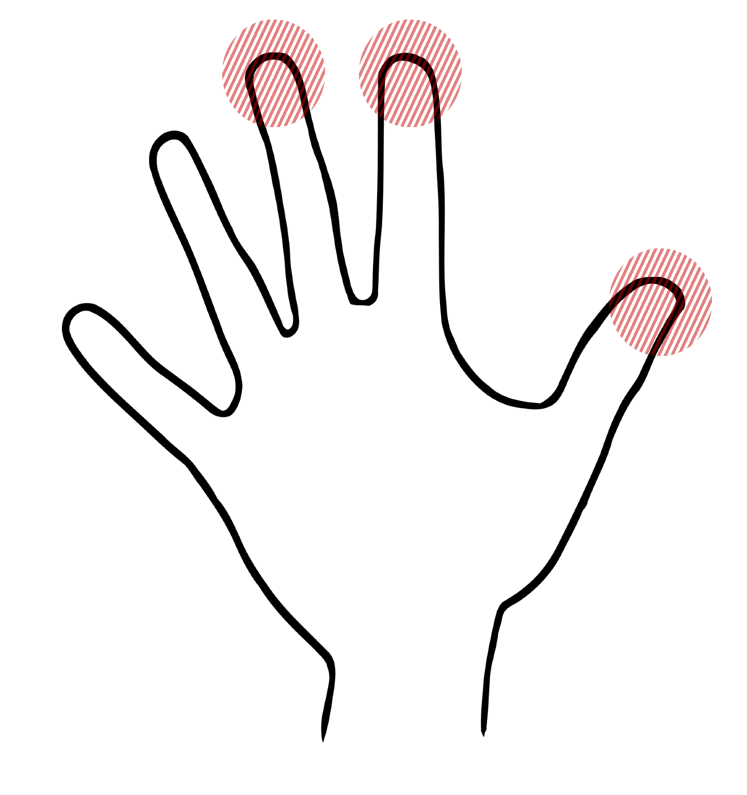
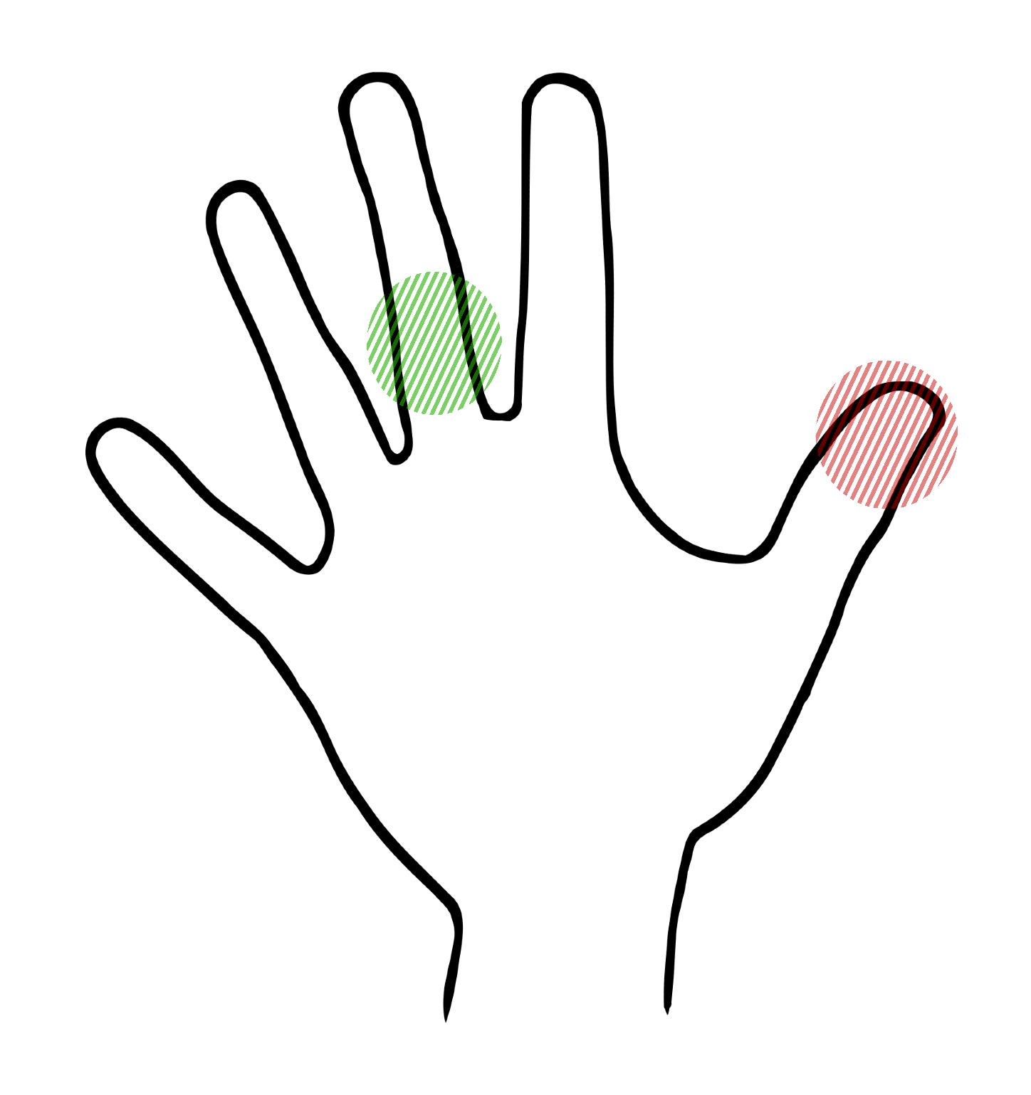
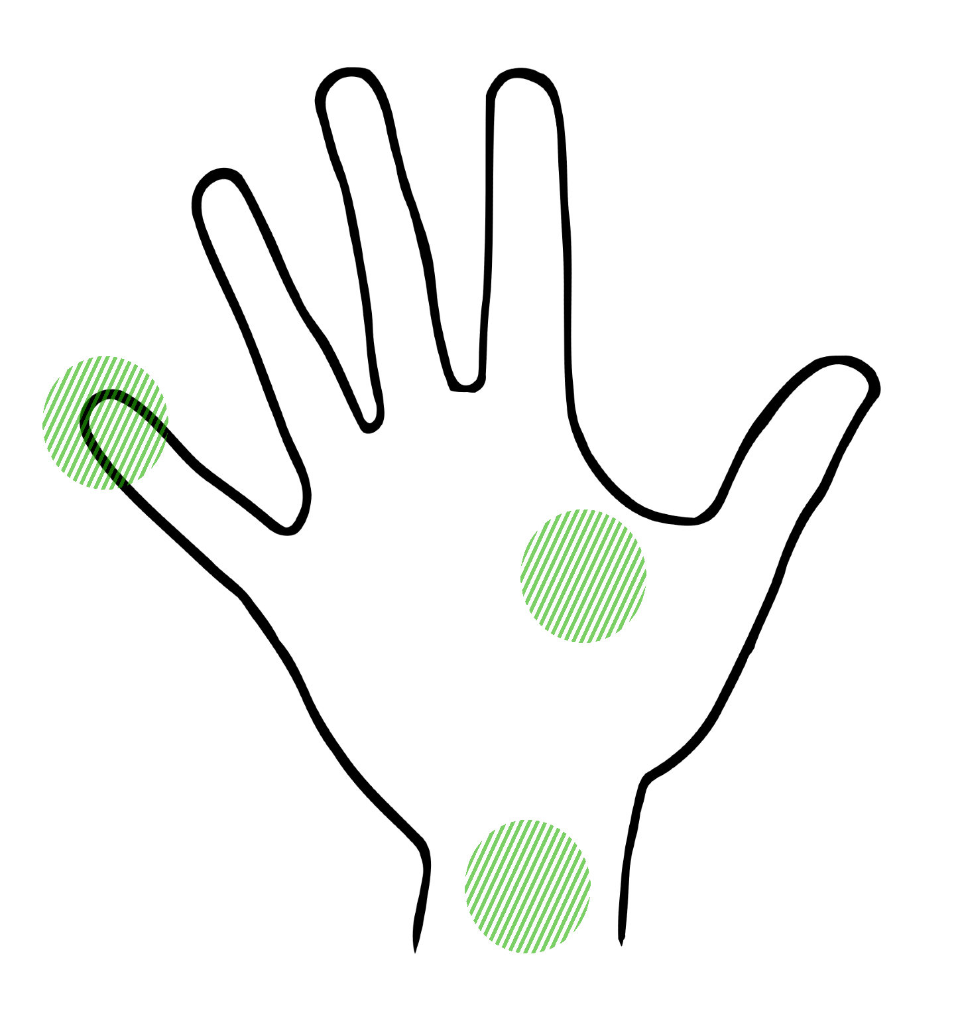

- During the work with ¹⁸F, the distribution over different points of hands did not differ significantly. The average of the left hand and the right hand resulted in the dose of 28 ± 13 and 28 ± 7 µSv/GBq, respectively.
- The highest doses were observed by the right hand thumb tip, index finger tip and middle finger tip resulting in doses of 39±15; 39±15; 38±12 µSv/GBq, respectively.
- The ratio between the maximum fingertip dose and the dose obtained from a typical monitoring position (base of the middle finger of the dominant (right) hand) varied between 1.3-1.7 arbitrary units.

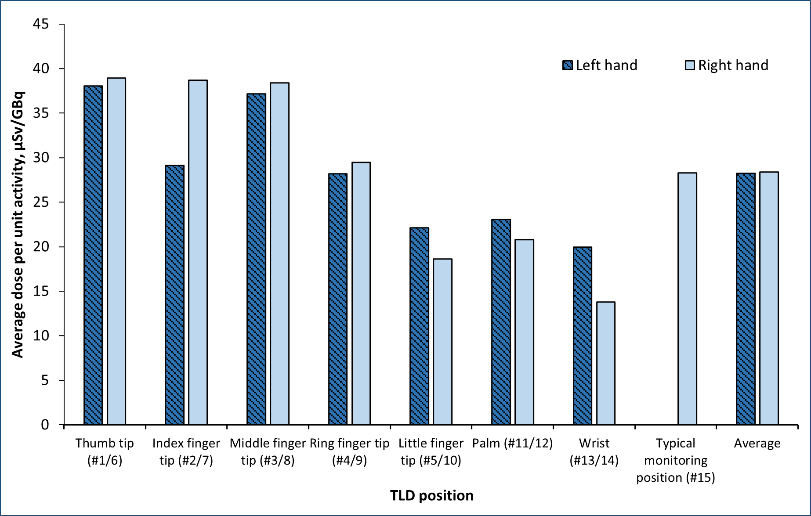
RESULTS

CONCLUSIONS
Hand dose distribution of different TLD positions
- Dosimeters were attached to both hands on the palm side at 15 locations (on fingertips, palm and wrist of each hand and at a typical monitoring position (base of the middle finger of the dominant (right) hand (#15).
- Working process include ¹⁸F-FDG administration in injection room with the automatic injection/infusion system IRIDE (Comecer).
- The right hand was the dominant hand of all radiology technologists.
Calibration curve of ¹⁸F
IRIDE injection/infusion system
TLDs positions on the palms
  - The most exposed parts while working with open radioactive sources are fingertips of thumb, index finger and middle finger, thus, monitoring of these points would be the most expedient.
- It was found that the maximum fingertip doses were 1.3-1.7 times higher compared with the doses from typical monitoring position (base of a middle finger of the dominant hand).

  - The least exposed hand parts are the palm, the wrist and the fingertip of the little finger.

