- Background
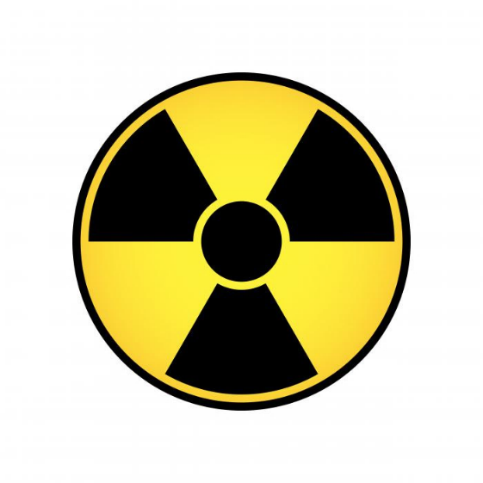

The purpose of this study is to investigate the risk assessment of lens radiation injury of nuclear medicine (NM) workers from the relationship of averaged eye lens dose to affect the prevalence of radiation-associated posterior lens opacities or cataract upon the new dose limit. The lens of eye dose measurement techniques were developed to detect gamma and beta rays from radioisotope followed IAEA Technical Document No. 1731(2013), a measurement value of personal dose equivalent at 3 mm depth with a dosimeter should worn as close as possible to the eye and calibrated on a head shape phantom.

- Materials and Methods

2.1. Materials
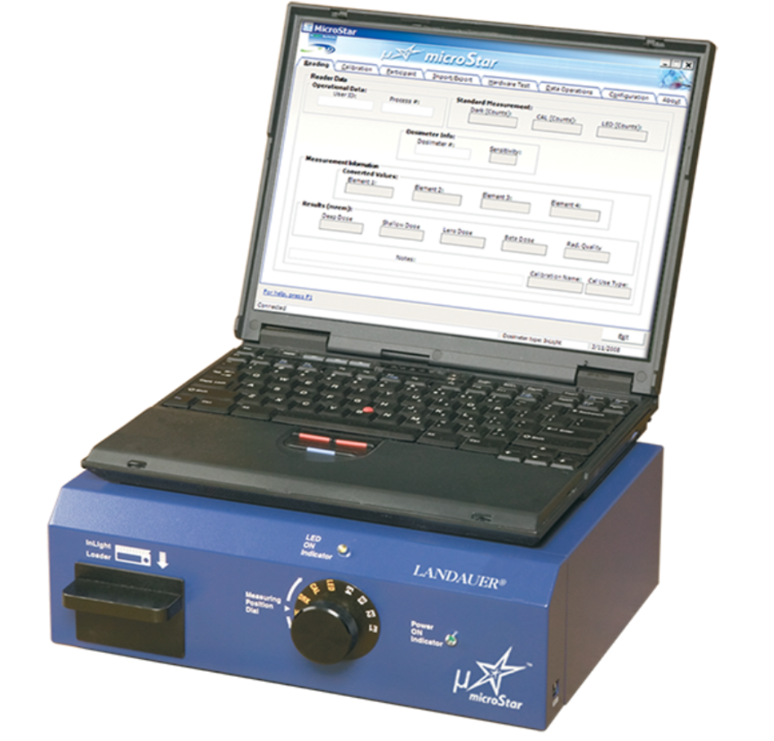
Optically Stimulated Luminescent Dosimeter, OSLD, Model nanoDot have been used for eye lens dose measurement and calibrated in the cylindrical phantom (20 cm in diameter). NanoDot was designed for measuring a small, single point radiation exposure normally worn on a wrist or a finger as shown in figure 1.
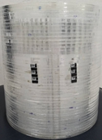

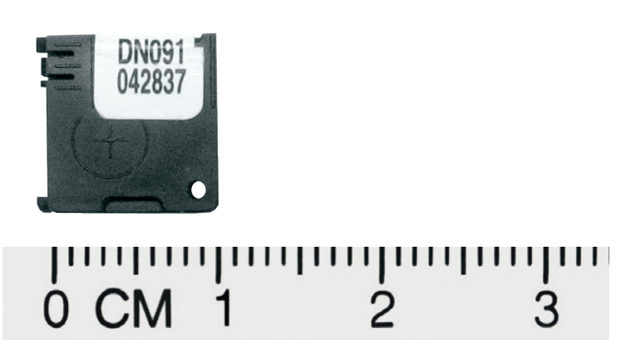
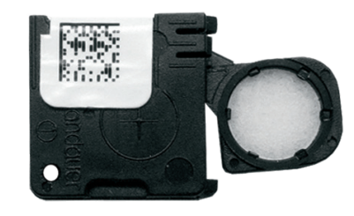

(a) (b) (c)

FIG 1. Cylindrical phantom(a), nanoDot dosimeters(b) and a MicroStar reader(c).
  - Calibration and Methods
NanoDots used in this study were calibrated by Thailand Institute of Nuclear Technology (TINT). The irradiated nanoDot dosimeters were read out by a microStar reader.
- First, the photon beam qualities were calibrated from gamma-ray source of 137Cs. Three nanoDot dosimeters were inserted into the cylindrical phantom holes representing an eye. These dosimeters were irradiated at Secondary Standard Dosimetry Laboratory (SSDL), TINT. The delivered air kerma value was 2.0 mGy at 0 degree angle of incidence. This value was traceable to Physikalisch-Technische Bundesanstalt (PTB), Germany. Delivered (Hp(3)) dose using the conversion coefficients from ISO 4037:2019 part 3 was performed.
- Second, the correction factor of Hp(3)/Hp(0.07) for beta particles which energies above 700 keV was performed by exposing with 90Sr/90Y. The nanoDot dosimeters were inserted at the depth of 3 mm in a cylinder phantom to evaluate Hp(3) while dosimeters to evaluate Hp(0.07) were inserted in a ring holder on ISO rod phantom. The delivered dose was 5 mSv at 0-degree angle of incidence. The correction factor of Hp(3)/Hp(0.07) was evaluated from average count readings.
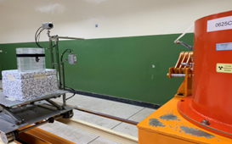
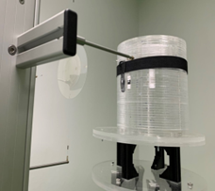
FIG 2. Irradiation of Cs137(left) and 90Sr-/90Y sources (right) to nanodot dosimeters in term of eye lens dose.

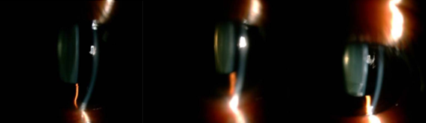
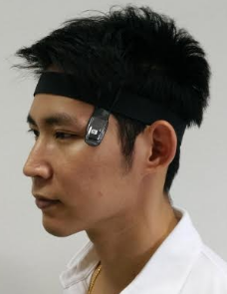
- The annual eye doses measurement were performed for 56 NM staffs in 6 Nuclear Medicine Sections as shown in figure 2. 31 NM workers who received the highest eye doses were chosen for eyes examination by experienced ophthalmologists using slit-lamp. Posterior subcapsular cataract (PSC) was graded according to a modified Merriam-Focht scoring system and a grading score of 1 and above in either eye was considered as early cataract by radiation effect.
score=0 score=0.5 score=1

FIG 3. The lens of eye dose measurement with head band set (left) and Merriam-Focht scoring system shown grading score of 0 to 1 (right).


- Results and discussion

3.1. The correction factor to estimate the lens of eye dose, Hp(3)
The correction factor to estimate eye dose measurement from radionuclides which emitted gamma rays such as Tc-99m and electrons energies above 700 keV as I-131 were 0.998 and 0.412 respectively.
Table 1. The estimate doses of Hp(3) from radionuclides were evaluated from correction factor.
Radionuclides | Delivered does  (mSv) | Estimated dose  (mSv)
Ga-68 | 5.00 | 4.87
I-131 | 2.00 | 1.94
Tc-99m | 2.00 | 1.89

  - The average of eye lens doses measurement and PSC grade
Table 2. The average of eye lens doses on left and right sides (mSv) of 56 NM staffs.
N=56 | The lens of eye dose (mSv)
N=56 | Left Eye | Right Eye
Volunteers (56) | 1.74(0.07-6.14) | 1.75(0.09-2.21)
Median= | 0.78 | 0.80
Table 3. 31 NM workers and 60 control subjects were chosen for eyes examination. PSC was graded from Left and Right Eyes.

 | With lens opacity (grade > 1)  (N= 14) | Without lens opacity (grade 0-0.5)  (N= 17)
Age, mean (SD); years | 43 (10.61) | 32.5 (6.98)
Sex (Male : Female) | 3:4 | 5:13
Unilateral (%) | 7 (22.6) | -
Bilateral (%) | 7 (22.6) | -
Relative Risk | 6.77 | -

  - The risk assessment of the lens of eye for NM staffs from lens opacities evaluation
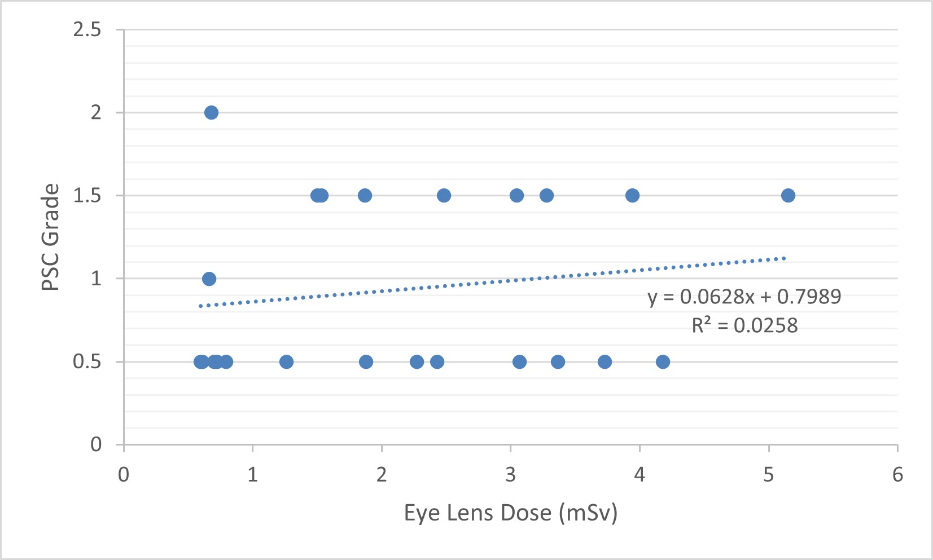 | FIG 4A Eye lens dose on left eye with lens opacity grading.
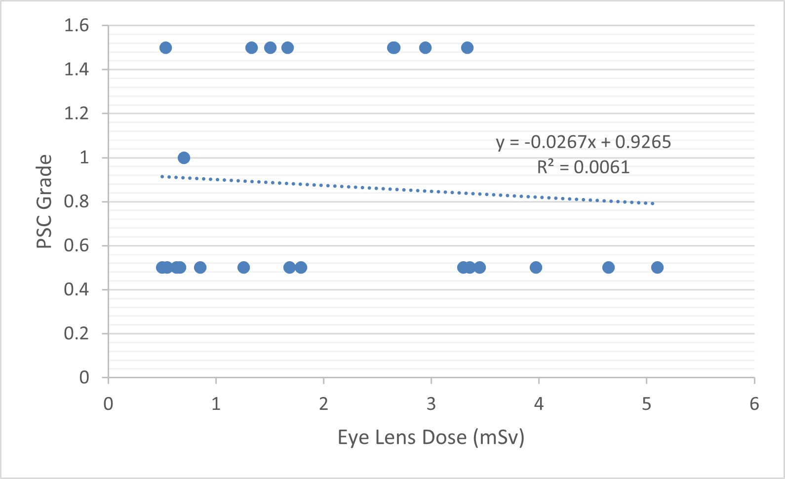 | FIG 4B Eye lens dose on right eye with lens opacity grading.
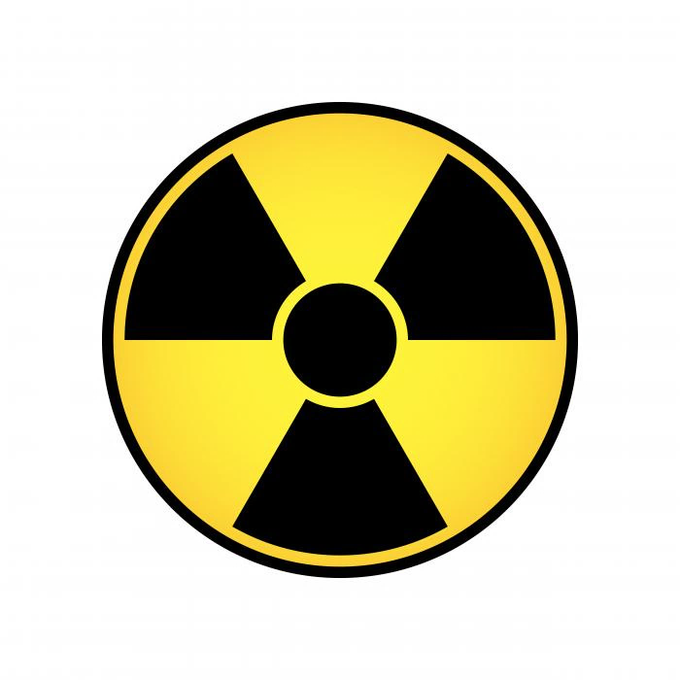
- The averaged eye lens doses in mSv were measured for 56 NM staffs. The values eye lens dose, Hp(3), using nanoDots from the left eyes, the average and range were 1.74(0.07-6.14) mSv, and the median was 0.78 mSv, the average and range of right eyes lens dose were 1.75(0.09-2.21)mSv, the median was 0.80 mSv as shown in Table 2.
- The relative risk of NM staffs was calculated by the ratio of incidence risk among an exposed group and incidence risk among a non-exposed group. Relative risk was 6.77 (95% confidence interval 2.435 to 18.846).

The Office of Atoms for Peace, Thailand, announced in the Royal Gazette (2018) with the reduction of the dose limits and recommended to Individual Monitoring Service laboratory for development of the lens of eye dose calibrated at eye adjacent instead of wearing dosimeter at whole body which not represented to real dose.

- Conclusions and Acknowledgements
The conclusions of this research shown the NM workers who received high dose might be found the opportunity of cataract when getting older from the results of PSC grades above 1.0 score. From 31 NM workers were found the prevalence of radiation-associated posterior lens opacities in the left and right eyes were 7 (22.60 %) and (22.60 %) respectively. The eyes examination was kindly provided by Department of Ophthalmology, Faculty of Medicine, Chulalongkorn University.

