# Heavy ion beams at ITEP for reactor materials irradiation resistance

T.V. Kulevoy

Organization – ITEP – NRC Kurchatov institute

Moscow, Russia

Email: kulevoy@itep.ru

The simulation experiments for investigation of reactor material irradiation resistance are ongoing at heavy ion linear accelerator HIPr (Heavy Ion Prototype) in Institute for theoretical and experimental physics (ITEP – NRC “Kurchatov institute”) for over fourteen years. The heavy ion beams (Fe, V, Ta, Cu) with energy 101 keV/nuclon are used for experiments. The second beam line for hydrogen and helium ion beams is under development. The atom-probe tomography is used for the samples investigation. The main results as well as the current status and future steps for the experimental setup development are presented and discussed.

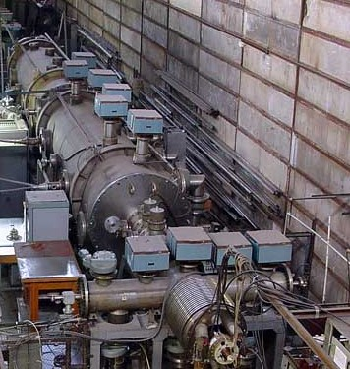 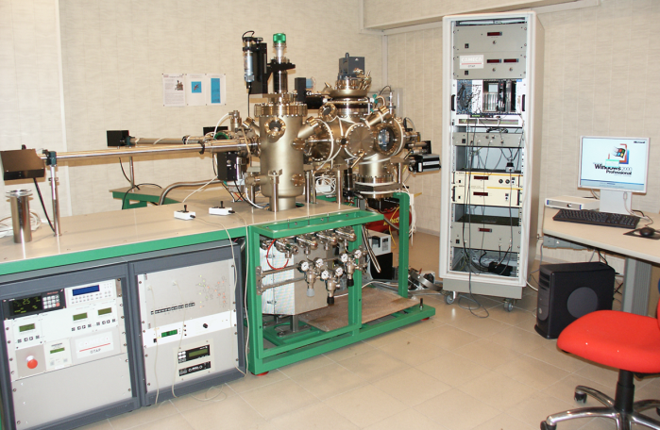

*FIG. 1. Left – linear accelerator HIPr, Right – atom-probe tomograph.*