# Electron Beam-Based Leather Tanning

Sadiq Setiniyaz

Engineering Department, Lancaster University, Lancaster, UK

Cockcroft Institute, Daresbury Laboratory, Warrington, UK

Email: s.saitiniyazi@lancaster.ac.uk

Robert Apsimon

Engineering Department, Lancaster University, Lancaster, UK

Cockcroft Institute, Daresbury Laboratory, Warrington, UK

One of the key process in the leather tanning is creation branching between protein chains by using the tanning agents, which is similar to the cross-linking of polymers in end results, but the processes is achieved via chemical reactions. The process requires the hides to be rotated in a chemical bath inside a drum for hours, which consumes a lot of energy. The excess chemical bath is discharged as effluent, which can harm the environment if not treated properly. Water treatment creates extra costs for tanneries.

The water, chemical, and energy usage can be reduced if electron beam is used for tanning the hide. The hide is soaked in a chemical bath so the tanning agent can penetrate the hide prior to electron beam irradiation treatment. The hide then is placed on a conveyer belt for irradiation as show Fig. 1.

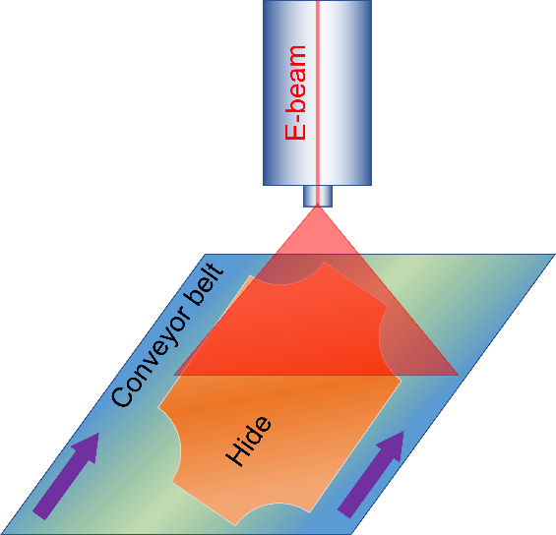

FIG. . Diagram for electron beam-based leather tanning.