The improved deign for the mobile hot cell for the conditioning of spent high activity radioactive sources

Gao Chao
China Institute for Radiation Protection
Taiyuan, China
Email: cau-227@163.com

An Hong-xiang
China Institute for Radiation Protection
Taiyuan, China

Liu Jian-qin
China Institute for Radiation Protection
Taiyuan, China

Abstract
The stumbling block on the international level was the management of Spent high activity radioactive sources (SHARS) because of its high potential radiological risk. Since 2006, the International Atomic Energy Agency (IAEA), cooperated with its Member States, has developed several mobile technologies and facilities for the conditioning of SHARS. In 2009, IAEA cooperated with China Institute for Radiation Protection(CIRP) to develop a Mobile Hot Cell(MHC) specifically to deal with SHARS. A pilot conditioning operation with an activity of an around 1000 Ci Co-60 irradiator sources had been carried out in September, 2010 that the sources were handled and conditioned very successfully. In 2017, the same MHC hasl been used to realize the conditioning of Co-60 medical source. The performance testes conducted by the team from China Institute for Radiation Protection (CIRP) showed that the mobile hot cell meets all performance requirements.
However, MHC adopt inner and outer carbon steel plates filled with river sand as the shields. It would require about one week to assemble or dismantle, but the actual conditioning operations may only take one to two days, which has severely impacted the popularization and application of MHC.
From the perspective of the structural design of MHC, a design scheme of the combination of fixed concrete wall and metal plate is proposed, which can greatly improve the assemble and dismantle efficiency. After the conditioning is completed, the concrete part can be filled and reserved for other purposes, such as being used as a radwaste receiving and temporary storage warehouse.

1.INTRODUCTION
SHARS are usually Cobalt-60, Cesium-137 sources arising from teletherapy devices, irradiators or Thermo Electrical Generators. Because of many reasons, e.g. no fitable transport containers, no return money or no return contracts, SHARS are usually interim stored in the user’s premises rather than returned to the producers. The handling and conditioning of high activity sources in developing countries had always been a problem since there was no available infrastructure (national or multinational) to allow for the safe and secure handling of bare SHARS. Even if the hot cell producing the new high activity sources can be used for the SHARS conditioning, it is impossible because of the lack of the fitable transport containers for the SHARS. This has been made possible with the introduction of the Mobile Hot Cell (MHC) capable of handling such high activity sources. Following the pilot operation and the international peer review of the MHC, the conduction of the first two operations in Sudan and Tanzania have paved the way to further utilization of the concept by Member States as well as the initiation of further development for the design to be safer, more efficient and conduction of operations in a smoother manner.
With the prevailing situation over the last few years emphasizing a strong need for the security of radioactive sources some Member States (Brazil, China India, Malaysia, and Uzbekistan) have expressed interest in having more information on the know-how and possibly develop their own mobile hot cell to conduct operations within their boarders. From the initial discussions it was identified that other design requirements that were not considered for the first mobile hot cell had to be considered.
The detailed design for CIRP`s MHC was developed by CIRP in 2009. (See Fig.1). It can be seen from the figure that a large number of tie bars and multiple metal plates in it greatly hinder the loading and unloading of river sand as shielding material, and greatly reduce the efficiency of installation and disassembly. The following design will be carried out on the premise of reducing the volume of the installation part and improving work efficiency.
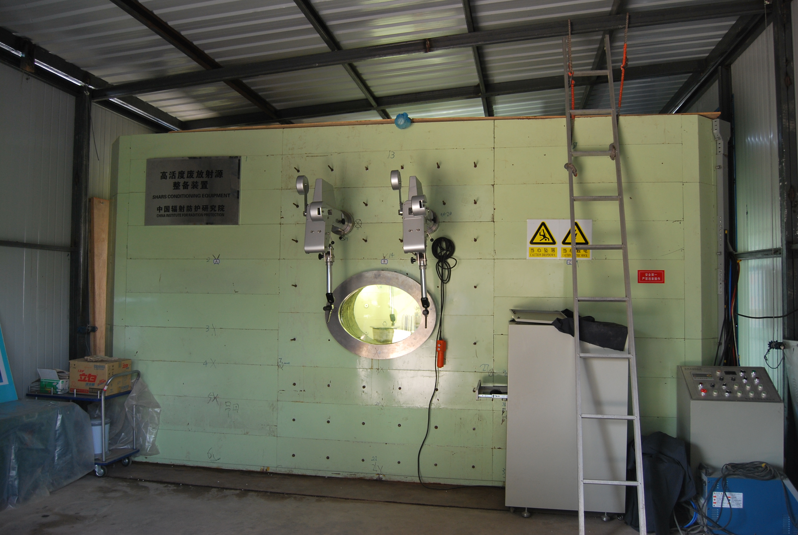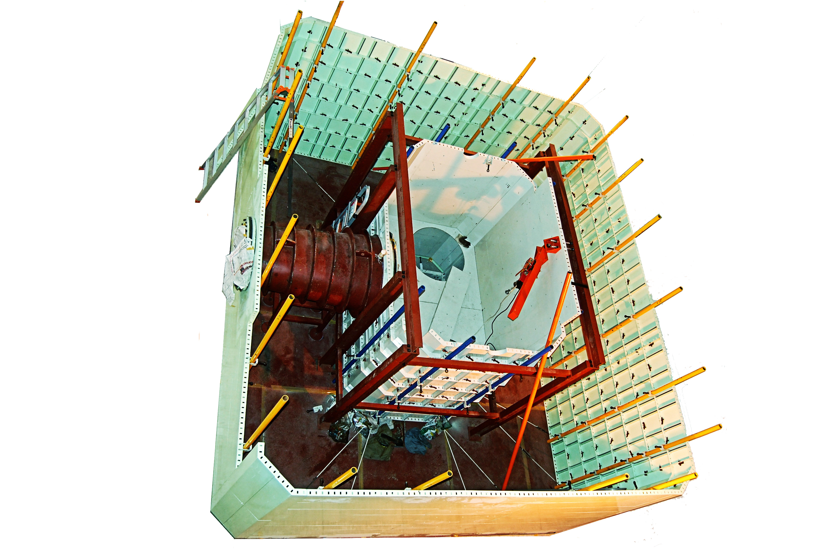
FIG.1 CIRP`s MHC and the inner layout

2.MHC schematic design

2.1 design conditions
Design conditions for MHC for conditioning of SHARS are that:
(1) The conditioning objects are 1000 Ci ⁶⁰Co spent radioactive sources;
(2) The annual dose constraints for workers are 6 to 8mSv;
(3) The conditioning operations are done twice a year, each time taking ten days, twenty minutes every day, totally 6.7 hours, counting as 7 hours.
(4) The operating dose rate limit is less than or equal to 1mSv/h; and
(5) The unit is convenient to assemble and disassemble, reliable and safe.

2.2 Design scheme
The improved design for the MHC for the conditioning of SHARS is technically the same as the first and second SHARS units. The same as the first and second SHARS units, it also uses the structure that the cavity between the inner and outer walls is filled with river sand as shielding materials. The difference is changing the single carbon steel plate wall into a combination of fixed concrete and demountable carbon steel walls. In this way, it not only meets requirements for the SHARS conditioning operations, but also fully reduces the time for assembling and dismantling the conditioning unit and improves work efficiency. The conceptual design of appearance is shown in Figure 2 in which carbon steel walls are in green, and concrete walls are in other colors.
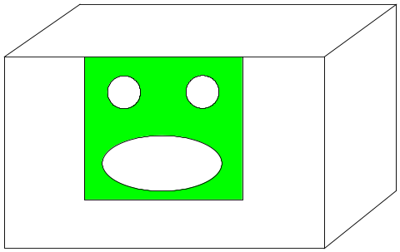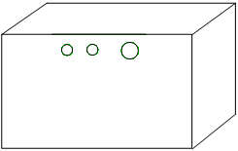
Fig. 2 Concept drawing of the improved design for MHC
The MHC for the conditioning of SHARS (hereinafter referred as the conditioning unit) consists of the shield, a viewing window and manipulators through the shield, an internal workbench, Jib crane and accessories. The main components are described as follows.

3.SHIELD design

3.1 Shield wall
Apart from sites on the front wall where manipulators and the viewing window are installed and sites on the rear wall where through-wall pipes are installed, prefabricated concrete walls are used elsewhere to reduce time for assembling and dismantling the conditioning unit on site.
The improved shield will be in falling design; the shield is located in the underground foundation which has been done in advance. The baseline is located at 350 mm under the ground and the operator position for 830 mm below the ground. If need to condition the industrial irradiation sources, need to place temporary container inside the MHC, the temporary container position for 550 mm below the ground. The front wall higher than 450 mm respectively above the ground consist of carbon steel plates, and the others consist of concrete walls.
The wall drawings of the improved unit are shown in Figures 3 and 4, where carbon steel plates are in green, concrete walls in gray, and mounting holes in white. With regard to the structure of the MHC where it is carbon steel, the concrete walls and carbon steel plates’ interface should be designed and manufactured in a simple form to be provided to the constructor of the concrete work. This is to make sure that the mobile equipment including the Carbon steel plates will fit properly during construction. This require preservation of angles between the inner and outer walls and good fit (alignment within each wall). All carbon steel plates are linked with concrete walls by the fixed carbon steel plates. The steel structure need to be well integrated with the concrete structure for performance and mechanical stability. The fixed carbon steel plates are used to hold the structure using the carbon steel sheets and the concrete walls together and aligned. The fixed carbon steel plate is 10 mm-thick, 80 mm-width and 1620 mm-height, fixed with the concrete wall by expansion bolt, decorated outer of the outer front and inner of the inner front wall. To locate carbon steel sheets (both physically and geometrically)。Also, the vertical supporting pipes, steel cables (rods) and U-shaped buckles (used to support the Carbon steel plates) can be substantially simplified due to the limited carbon steel plates to be supported. All carbon steel plates have round holes for fixed with concrete walls by expansion bolt. Specific design as shown in figure 5.
All holes are enhanced to ensure safe operations of MHC. The source transfer channel near the outside wall side set lead shield, lead shield is fixed in the concrete wall. The cable pipe, tool pipe and ventilating pipe are designed in S-shaped. The cable and tool pipes are made of carbon steel, with both ends being positioned and fixed on the wall by threaded adjusting nuts. The outer ends are provided with threaded end caps to keep the holes close.
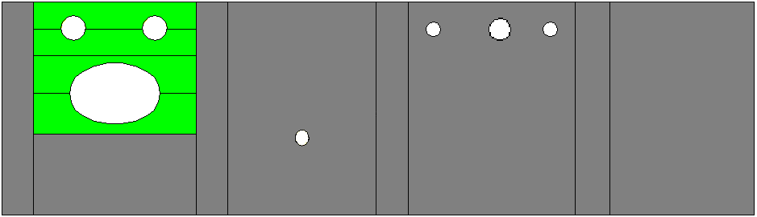
NQ1
NQ2
NQ3
NQ4
NK1
NK2
NK3
NK4
NK5
NK6
NK7
Front wall Right wall Rear wall Left wall
Fig. 3. Inner wall improved design layout drawing
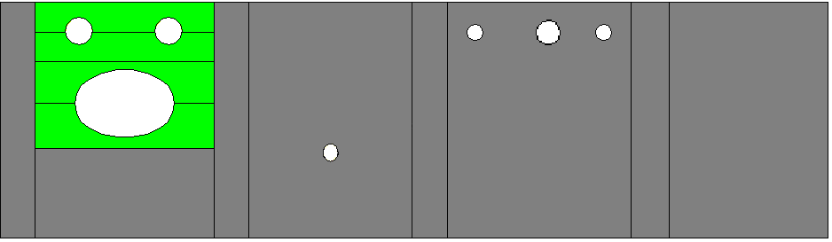
WQ1
WQ2
WQ3
WQ4
WK1
WK2
WK3
WK4
WK5
WK6
WK7
Front wall Right wall Rear wall Left wall
Fig. 4. Outer wall improved design layout drawing

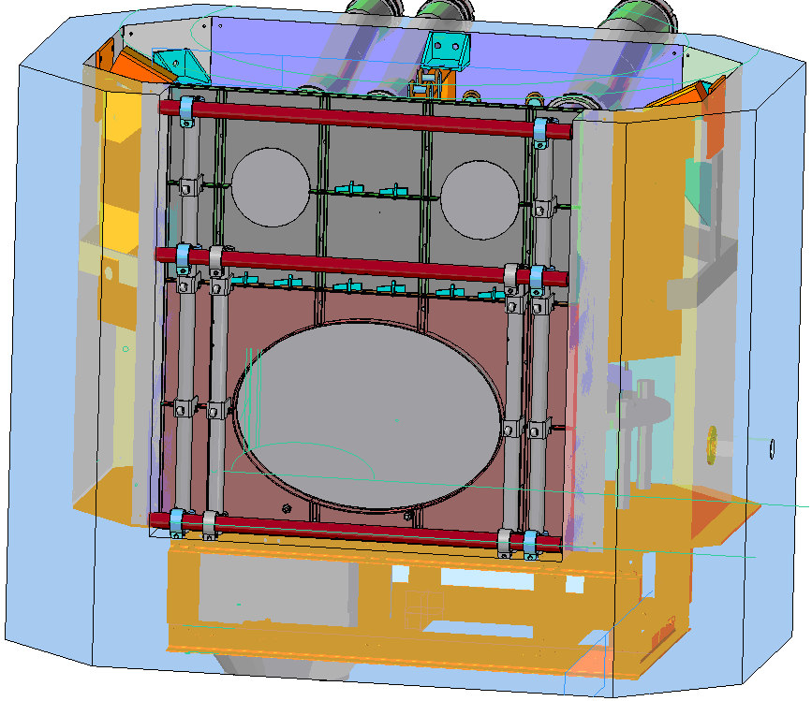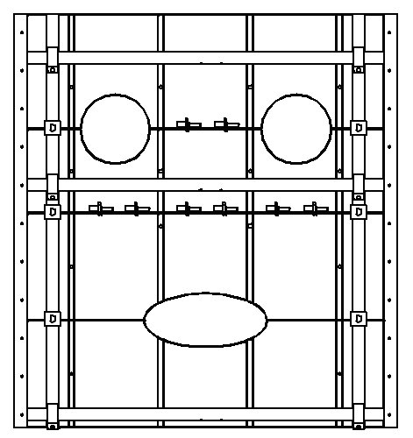
Joint plate
Supporting pipe
Fig. 5. Carbon steel plates and concrete wallsspecific design

3.2 Roof
Roofs are arranged at the top of the unit and are demountable cover plates. The two 60mm-thick carbon steel roofs which adopt L-shaped stepped design with one side vertical to another side, in order to match with each other, shield rays and facilitate disassembly and assembly. An emergency hole (diameter 160mm) is reserved on the back roof to use external cranes once the Jib crane breaks down. Usually, emergency holes are blocked with lead plugs. The carbon steel roofs for the roof can be made to rest on the concrete walls. Since the option of a concrete wall is adopted there is no need for the I-beam frame. This gives much simplification and will reduce the time for top support assembly and disassembly. See Figure 6 for drawing of the roof structure and emergency holes.The steel structure for the roof can be prefabricated for the constructor of the concrete work to make sure that the dimensions are followed properly. Roof slabs can be made locally. The roof slabs also can be made above the MHC and not embedded in it. This will provide further space within the cell.
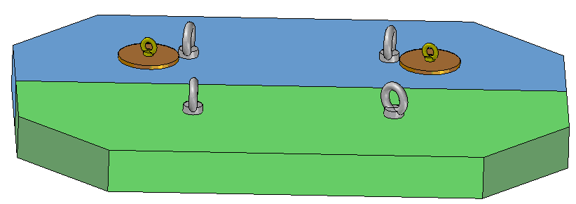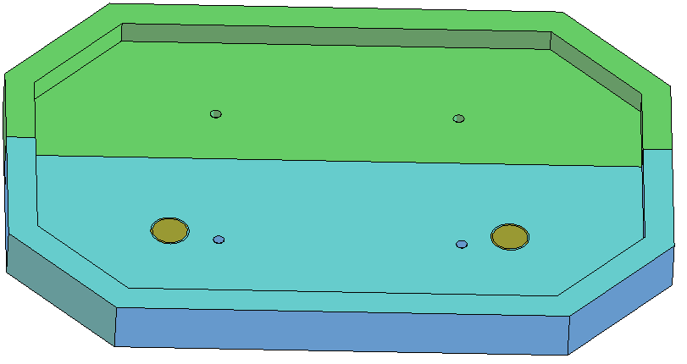

Lead plug & Emergency holes
Fig.6. Drawing of structure and emergency holes

4.Conclusion
The improved design for the mobile hot cell for the conditioning of SHARS is technically the same as the MHC.Iit also uses the structure that the cavity between the inner and outer walls is filled with river sand as shielding materials. The difference is changing the single carbon steel plate wall into a combination of fixed concrete and demountable carbon steel walls. Specific design concept map as shown in figure 7.The MHC except for carbon steel in the middle of the front wall, the other parts are concrete walls, carbon steel plate thickness 3 mm, and the concrete wall thickness 200 mm, the space between inside and outside wall filled with river sand, white space is effective work area in the MHC, 1200 mm × 2100 mm × 2100 mm; overall dimension is 3400 mm × 4300 mm × 4300 mm; inner wall height is 1950 mm, exterior wall height is 2070 mm, inside the wall all corners of 135 °. MHC installation lay on a concrete platform, concrete platform most is located at 350 mm below the surface, as the installation of MHC; Part of the concrete platform is located at 830 mm below the surface, as the operator work position near front wall.The carbon steel plates on the front wall have observed holes for the window and manipulators. Tools pipe, ventilation pipe, cable holes are on the back concrete wall, the transfer channel holes are on the right concrete wall. The design of through-shield equipments takes radiation safety and diversity of the SHARS to be conditioned into account.
New design of the MHC has smaller size and shape than the original design, and most of the work can be completed by the demander. Such approach can substantially reduce the volume of sand, make the concrete structure usable later on as a temporary or emergency shield and substantially reduce the assembling and disassembling time.
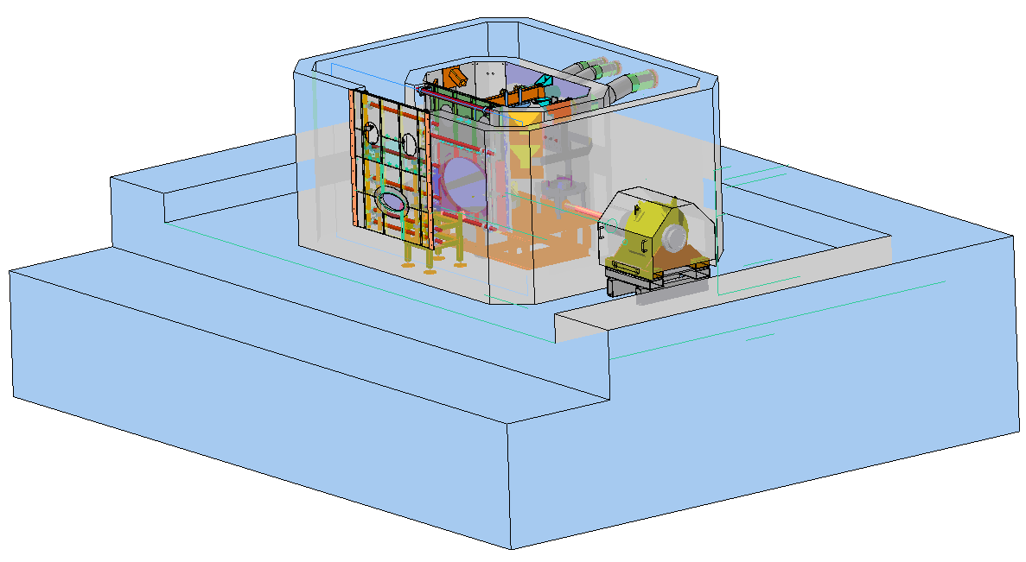
Fig. 7. Concept drawing of the improved design for the SHARS unit
ACKNOWLEDGEMENTS
The authors wish to thank all those involved in the SHARS project at CIRP, especially Mr. Muhammad. Al-Mughrabi from IAEA, Mr. Juan Carlos Benitez-Navarro from IAEA.

