Advisory Mission on Regulatory Infrastructure for
Radiation Safety and Nuclear Security

Responding to a real need, IAEA, through the Department of Nuclear Safety and Security, established the “Advisory Mission on Regulatory Infrastructure for Radiation Safety and Nuclear Security (RISS)” Service, to advise and where appropriate, provide support to States in their efforts to establish or improve national regulatory infrastructure for radiation safety and nuclear security. Radiation safety refers to the safety of radiation sources (generators and radioactive material), whereas nuclear security refers to the security of radioactive material.
States might request a RISS when they identify a need for advice, assistance and support in one or more areas of regulatory infrastructure. A RISS might be an agreed task within an IAEA assistance programme.
RISS are conducted in countries where significant actions are necessary for the country’s regulatory infrastructure to meet the provisions of the IAEA safety standards and nuclear security guidance, the Code of Conduct on the Safety and Security of Radioactive Sources and its supplementary Guidance. A RISS might be conducted in States with essentially no regulatory infrastructure for radiation safety or nuclear security.
As the establishment and development of a national regulatory infrastructure for radiation safety and nuclear security requires a long term commitment of national resources and an exercise of government control over previously unregulated activities, awareness and support from the highest levels of government are desirable.
The scope of each advisory mission is adjusted according to the specific needs and interests of the requesting State and aims to support the establishment and improvement of its national regulatory infrastructure for radiation safety and/or nuclear security. The scope of a RISS can be tailored to cover safety or security or both. Regulatory requirements for radiological emergency preparedness and response (as indicated in the Code of Conduct for the Safety and Security of Radioactive Sources) may be included in the scope of the mission in addition, upon request by the host country.
A RISS provides the opportunity for discussion of regulatory technical issues within the agreed scope, together with advice for supporting the establishment or improvement of a national regulatory infrastructure for radiation safety and nuclear security by:
- Evaluating the status of the national regulatory infrastructure for radiation safety and nuclear security against IAEA safety standards, nuclear security guidance and other relevant IAEA publications;
- Providing advice on any identified needs for improvement;
- Preparing a report that includes observations, recommendations, and an action plan for strengthening the national regulatory infrastructure for radiation safety and nuclear security in line with IAEA safety standards and nuclear security guidance. The action plan describes those activities considered fundamental for strengthening the national regulatory infrastructure for radiation safety and nuclear security in the host country.
A RISS is performed by an international team that includes IAEA staff and senior regulatory and technical experts with knowledge and extensive experience in the areas to be addressed during the mission.

The RISS process is described in the figure below.

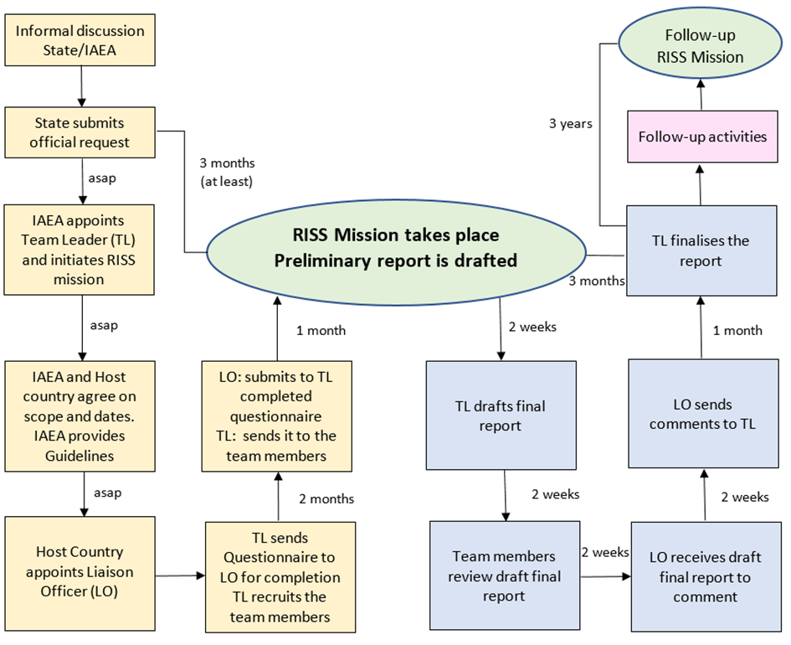

To encourage consistency and comprehensiveness in the preparation and conduct of a RISS, by both, the advisory mission team, and the host country, RISS Guideline [1], pre-mission questionnaires to be answered by the host country, and a mission report template have been prepared.
RISS supersedes the Advisory Mission on Regulatory Infrastructure for Radiation Safety Advisory (AMRAS), previously offered by IAEA.

References
INTERNATIONAL ATOMIC ENERGY AGENCY, Advisory Mission on Regulatory Infrastructure for Radiation Safety and Nuclear Security - Guidelines, IAEA Service Series, to be published.

