SAFETY AND SECURITY OF RADIOACTIVE SOURCES IN NEPAL

Kanchan P Adhikari¹
¹National Academy of Medical Sciences, Bir Hospital, Kathmandu, Nepal

ABSTRACT
In Nepal, radioactive sources are mainly used in the medical field. Small quantities of low-activity radioactive sources are used in research and education. In 2005, 2006, 2010, 2016 and 2017 Ministry of Education, Science & Technology (MoEST) has completed five projects and on inventory of radioactive sources being used in Nepal. Similarly, in 2020, Department of Health Services, Ministry of Health & Population has completed one project on inventory of radiation sources being used in Kathmandu and Bhartpur, Chittwan. A study was designed to determine the actual number of radioactive sources including country of origin, date of installation, source number, activity etc. After becoming a member country of the International Atomic Energy Agency (IAEA), the responsibility of Nepal has increased many folds. The United Nations (UN) Security Council Resolution 1540, which is binding on all member states, contains obligations regarding accounting and physical protection on nuclear materials as well as commitments to prevent trafficking in weapons-related material and their delivery systems. Radioisotopes in hospitals, academic institutions, research laboratories etc. in Nepal are categorized per IAEA Technical Document TECDOC-1344. While some significant steps have been taken to secure high activity radioisotopes in Nepal, with the help of the United States Department of Energy’s Office of Radiological Security (ORS), many challenges lie ahead in securing Nepal’s radioactive sources. The creation of comprehensive regulations governing the use, storage, transportation, and disposal of radiological material, educating and maintaining a qualified workforce, adequate funding for the installation and maintenance of safety and security systems, suitable accountability, and the promotion of a security culture will all be important to ensure the continued safe and secure use of radiological sources. Despite all the impending challenges, Radioactive Substances (Utilization and Regulation) Act 2020 has materialized effective as of July 2020. This has created a path for establishment of regulatory body which ultimately pave the way for rules and regulations for safety and security of radioactive materials in Nepal.
Becoming a member country of IAEA, has enabled us for the support and speed up of the creation of appropriate conditions in the field of radiation safety and security. In transport safety & security, previous Nuclear Materials Regulatory Directive, 2015 and the newly enacted Radioactive Substances (Utilization and Regulation) Act 2020 contain provisions for the establishment of requirements and standards for the transport of radioactive material, based on the IAEA’s Safety Standard
Key words: act, radioactive materials, radiation, radiological security, regulations

INTRODUCTION

Radiation is a fact of life, existing from the first days of earth. In every aspect of our day today life, we encounter some form of radiation. In Nepal, we are using ionizing radiation in the form of X-rays or gamma rays. Nuclear science in Nepal is slowly but steadily contributing in all-around development efforts in different fields likes agriculture, animal science, environment, physics, chemistry, biology, food science, geology and medicine. In the year 2006, 2010, 2016 & 2017 MoEST has completed different projects on inventory of radioactive materials being used in Nepal [1] [2] [3]. Studies were designed to find out the actual number of radioactive sources in Nepal including date of installation, country of origin, source number, activity etc. The inventory of radioactive isotopes in Nepal is concerned with the current status of radioactive materials and where they reside. It is also concerned with radiation safety and security of these radioisotopes. The main purpose of the inventory efforts was to find out the status of radioactive isotopes at the different locations of the respective facilities. The objective of making an inventory of radioactive materials is to investigate the present status of radioactive materials being used in Nepal, to ensure the proper condition of radioactive materials. The surveys also helped to gain an understanding of the radiation worker’s views on radiation. The inventory of radioactive isotopes used in different institutions includes imported radioisotopes used mainly for medical purpose, calibration and research proposes. This inventory does not include natural occurring radioactive isotopes. The IAEA encourages all governments “to take steps to ensure the safety of radiation sources and the security of radioactive materials”. As a first step towards securing the radioisotopes in Nepal we have conducted a survey of imported radioactive sources which is the first step required for subsequent safety and security measures taken in future.

Use of Radioactive materials in Nepal

Radioisotopes are widely used in medicine, agriculture, industry and other scientific research activities throughout the world. In Nepal their use is almost solely confined to the medical field, mainly in radiation therapy and nuclear medicine. In radiotherapy, a tele-therapy unit destroys malignant tumors with gamma radiation from a radioisotope such as cobalt-60. Of the six radiotherapy centers in Nepal, two currently use cobalt-60 for treatment of cancers. Similarly, brachytherapy, destroys cells by placing the sealed radioisotope directly into the tumor. Of the six radiotherapy centers providing this treatment, four currently use radioisotope Irradium-192. Other radioisotopes are used for medical diagnostic purposes including technetium-99m* (Tc-99m) and FDG-18. Five facilities across Nepal offer services using these radioisotopes. Additionally, there are some institutions where radioactive materials in micro curie level are being used for academic and calibration purposes.

CURRENT STATUS

In Nepal the use of radioactive isotopes is very limited. In 1972, first use of radioisotope in medicine was started at Parapokar Maternity Hospital, Kathmandu. At that time, radium source was used for brachytherapy for cervical cancer patients. In 1987, use of a radioisotope in medicine was started with the establishment of Nuclear Medicine Imaging Centre at NAMS, Bir Hospital. At that time Tc-99m from Mo-99/Tc-99 generator was the only source. These of Cobalt-60, was first introduced in 1991 with the establishment of a Cobalt Tele-therapy machine at NAMS, Bir Hospital, Kathmandu [4]. Other types of radioactive materials being used in medicine include Irridium-192 for brachytherapy, Tc-99m from Mo-99/Tc-99 generator and Iodine-131 for nuclear medicine. Medicine is the predominant use of radioactive isotopes Nepal. The Central Department of Physics, Central Department of Chemistry, Department of Food Technology & Quality Control and Nepal Academy of Science and Technology each use some low-activity (micro curie) radioisotopes. Nepal does not have any nuclear power plants or nuclear facilities and no nuclear material (e.g. uranium, plutonium) is present in the country.

Nepal began the process of securing category 1 radiological sources in June 2008 by partnering with the United States Department of Energy’s Global Threat Reduction Initiative (GTRI), now the Office of Radiological Security (ORS) [5]. As a first step towards securing the radioisotopes in Nepal, physical security system was installed with the help of ORS. In June, 2008 the first Physical Protection Security Systems (PPSM) in Nepal were installed at the National Academy of Medical Sciences (NAMS) Bir Hospital, B.P Koirala Memorial Cancer Hospital and Bhaktapur Cancer Hospital. These initial upgrades were completed in September, 2009. These three sites use Cobalt-60 Tele-therapy machines for cancer treatment. Later, installation of a PPSM was performed at the Manipal Teaching Hospital to protect a Cobalt-60 tele-therapy machine. PPSMs were also installed to protect sealed radioactive sources used for Brachytherapy at Bir Hospital, Om Hospital and Bhaktapur Cancer Hospital. In 2018, a PPSM was installed with the help of ORS to protect a Caesium-137 source used for blood irradiation at Civil Service hospital of Nepal. Recently, one disused Cobalt-60 source was successfully repatriated to the country of origin for disposal.

Table 1: Institutions having physical protection security system

Site Name | Source Type
NAMS Bir Hospital, Kathmandu | Cobalt- 60 (recently disposed)  Iridium -192
Bhaktapur Cancer Hospital, Kathmandu | Cobalt- 60  Iridium -192
B.P. Koirala Memorial Cancer Hospital, Bharatpur | Cobalt- 60  Iridium -192
Manipal Teaching Hospital, Pokhara | Cobalt- 60
Om Hospital & Research Center, Kathmandu | Iridium -192
Civil Service Hospital of Nepal, Kathmandu | Caesim-137

Representatives from the Nepal have also attended regional security awareness seminars organized by ORS since beginning cooperation in 2008. Nepal has adopted and is signatory to the following nuclear related international activities: UN Security Council Resolution 1540, The Treaty on the Non-Proliferation of Nuclear Weapons (NPT), Comprehensive Nuclear Test-Ban Treaty (CTBT) originally signed in 1996, and the IAEA Nuclear Security plan: TECDOC-1335.

After some delay, the Radioactive Substances (Utilization and Regulation) Act was passed by both houses of Parliament and signed into law effective July, 2020. This has paved the way for the formation of a regulatory agency responsible for effective supervision and implementation of radioactive regulations for safety and security.

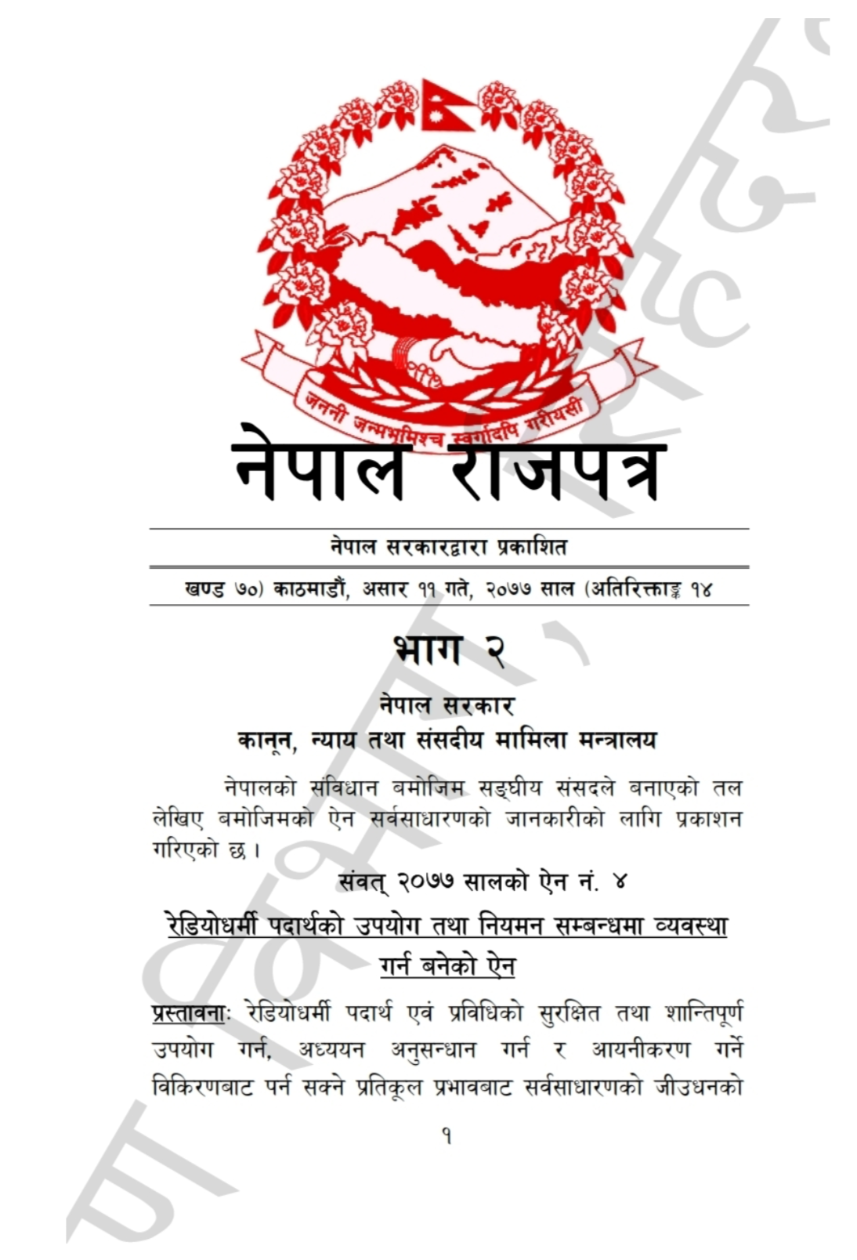
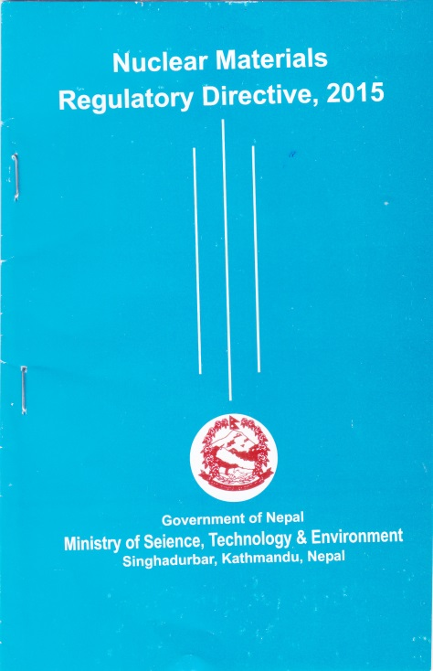
(a) (b)

FIG. 1. (a) Nuclear Materials Regulatory Directive, 2015 (b) Radioactive substances (Utilization And Regulation) Act 2020

In Nepal we are using category 1 and category 2 sources in medical field and security system has been installed to protect all category 1 radioactive sources being used in Nepal with the help of the United States, Office of Radiological Security (ORS) to reduce the likelihood of malicious act.

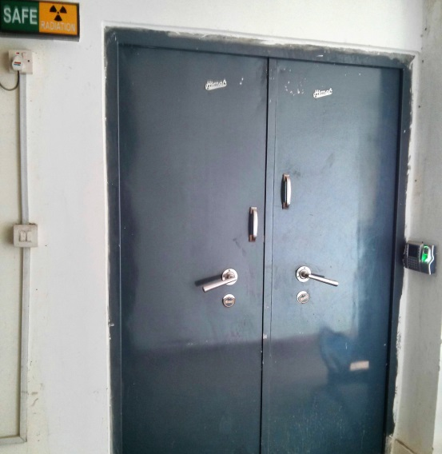
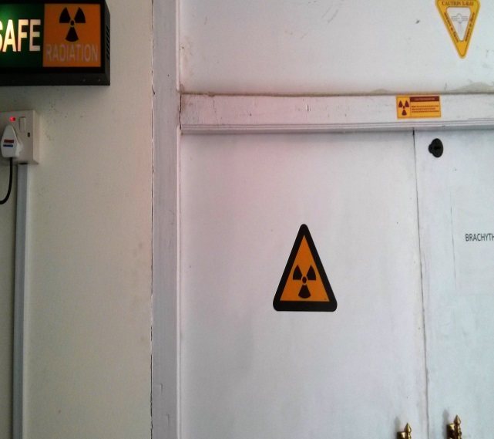
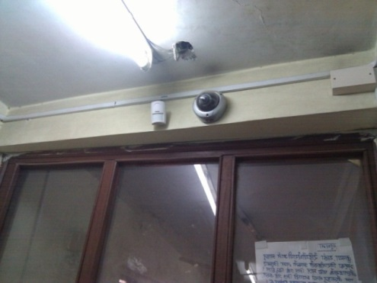
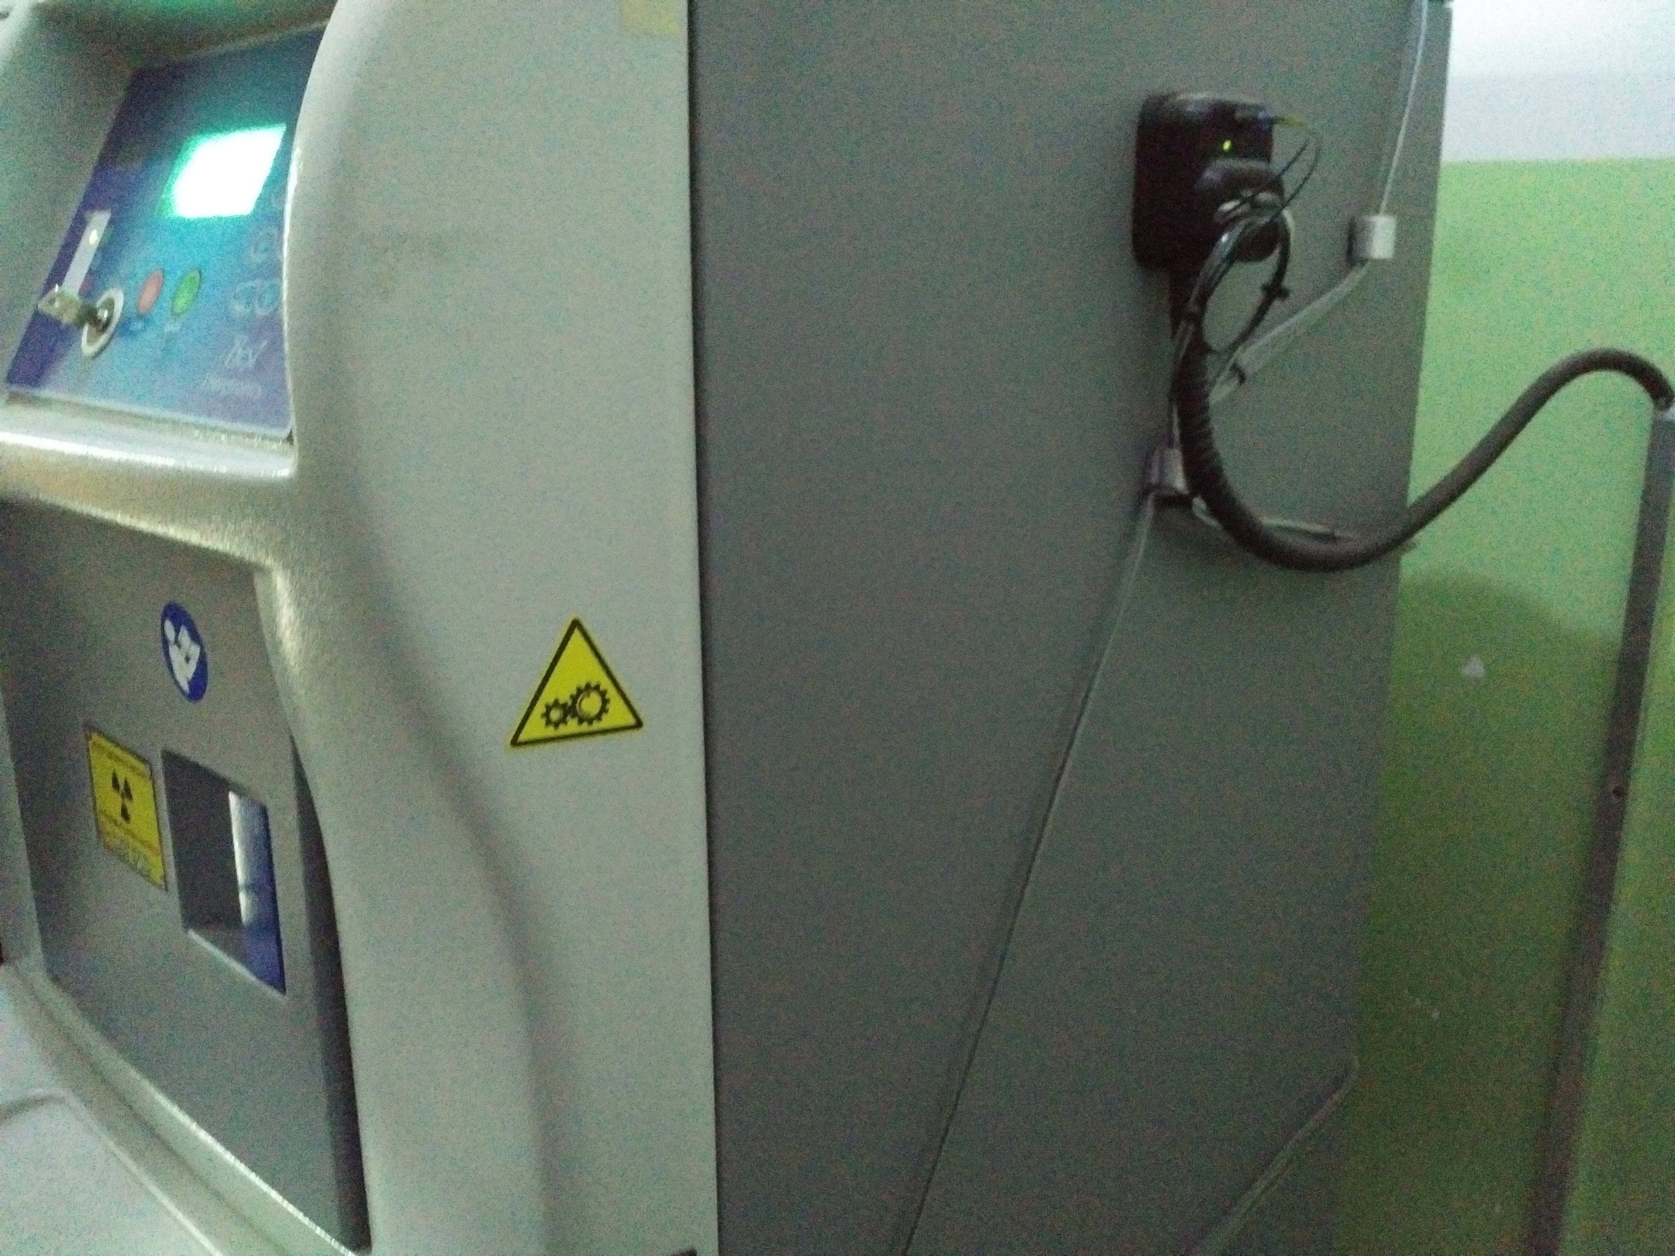

Figure 2: Physical Security system installed with the help of US DOE Office of Radiological Security Program in Nepal

ISSUES & CHALLENGES

The vast majority of radioactive sources are used in well-regulated environments. Now is the time for the establishment of a radiation regulatory board or commission for developing and monitoring of essential nuclear safety and radiation control infrastructure in the country. As per “Radioactive Substances (Utilization and Regulation) Act 2020” in Section two there is a provision of establishment of separate regulatory body. [8]
The most essential introduction of Nuclear or Radiation law is now already a law of land and the process for developing regulations has already been started now it’s time for its subsequent enforcement for providing licenses, establishment of other concomitant radiation rules and regulations, code of radiological practice, supervision of quality assurance and radiation protection program, transportation and disposal of radioactive waste. In law, there is the provision of separate regulatory body in the act which is now in application for administrative requirements (notification, authorization, review and assessment, inspection and enforcement) and technical requirements (occupational protection, public protection, medical exposure, radioactive waste management, transport of radioactive materials, security of radioactive materials and emergency preparedness and response. [7]

In absence of regulatory system, qualified experts, budget to maintain security equipment, it is a challenge to maintain and sustain PPSM system installed at different centers with the help of US DOE ORS program.

In absence of regulatory infrastructure, some hospitals are having problem in purchase and transportation of radioactive material for use in medical purposes. Even though with high budget was allocated for decommissioning and disposal of Cobalt-60 disused source for country of origin for disposal, NAMS, Bir hospital had faced a big challenge for disposal which costs huge efforts and time. News report on the disappearance of radioactive Iradium-192 disused source en route to Kathmandu for safety disposal to the country of origin, Belgium, has raised a big question on safety & security of radioactive sources used for medical purposes in Nepal [6]. Due to the lack of security awareness and security culture and poorly secured facilities, it’s another challenge to maintain security system intact for end user, institutions and concerned ministries. There is yet another challenge to identify national secure storage place where we can securely store disused sources buried at the premises at B.P.K Memorial Cancer Hospital, Bharatpur as well as Radium source buried at Teku Hospital, Kathmandu. The best way for country like Nepal, to move towards the use of alternative technologies if available. e.g. shifting from Co-60 tele-therapy units to linear accelerators, phasing out cesium-137 blood irradiation for X-ray radiation technology or Ultraviolet radiation. There are many benefits of using alternatove technology as they are very safe to use and need no security system and less regulatory paper works.

CONCLUSION

In conclusion radioactive source security is needed to bring high level attention and timely action by the government. Unsecured radioactive sources are causing deaths and serious injuries in many countries of the world. The most important nuclear law entitled “Radioactive Materials (Uses & Regulation) Act 2020” is already a law of the land in 2020. Now, it is the time for establishing a radiation regulatory body for developing and monitoring of essential Nuclear Security and in the country. In 2015, MoEST has issued Nuclear Materials Regulatory Directive on 2015 to manage radioactive materials to manage all nuclear related activities in Nepal. Radioactive materials are mostly used in the medical field as indicated by four different projects works on inventory of radioactive materials being used in Nepal. As a member of IAEA, the responsibility of Nepal has increased many folds. The UN Security Council Resolution 1540, which is binding on all member states, contains obligations regarding accounting and physical protection on nuclear materials as well as commitments to prevent trafficking in weapons-related material and their delivery systems. Radioisotopes in hospitals, academic institutions, research laboratories etc in Nepal comes under different categories. As a first step towards securing the radioisotopes in Nepal, Physical Security system has been installed with the help US DOE Office of Radiological Security (ORS) at all category 1 sources. But, still there are a lot of challenges in securing radioactive sources like proper rules and regulations, qualified manpower, maintenance of security equipment. It is found that security culture should be a to lack of regulations, which some institutes are not following. We will have to look towards the use of alternative technologies if available. e.g. shifting from Co-60 tele-therapy units to linear accelerators, phasing out cesium-137 blood irradiation for X-ray radiation technology or Ultraviolet radiation. IAEA has published a number of reports that describe the human health consequences of uncontrolled sources. IAEA encourages all governments’ parties “to take steps to ensure the existence within their territories of effective national systems of control for ensuring the safety of radiation sources and the security of radioactive materials”. The IAEA’s International Basic Safety Standards for Protection against Ionizing Radiation and for the Safety of Radiation Sources specifically requires that: “a periodic inventory of movable sources be conducted at appropriate intervals to confirm that they are in their assigned locations and are secure” [8][9].

REFERENCES
[1] “Final Report on Present Status of Nuclear Materials used in Nepal”, Submitted to Ministry of Environment Science and Technology by National Academy of Medical Sciences (Bir Hospital), Kathmandu (2006).
[2] “Status of Radioisotopes in Nepal - A Survey for the Preparation of Inventory”, Submitted to Ministry of Science and Technology by Central Department of Physics, Tribhuvan University, Kirtipur (2010).
[3] “Inventory of Radioisotopes in Nepal” Submitted to Ministry of Science and Technology by Central Department of Physics, Tribhuvan University, Kirtipur (2016).
[4] Adhikari K.P. Radiation Regulation in Nepal: A challenging Journey. J Radiation Regulator, RPD Publishing 1:7-10;2013
[5] IAEA, Categorization of Radiation Sources (Revised), IAEA-TECDOC-1344, Vienna (2003).
[6] Of Radioactive Materials: Safety And Security Concerns published on The Himalayan Times, National Daily Newspaper, 25th May, 2014.
[7] Radioactive Substances (Utilization and Regulation) Act 2020, Nepal

[8] International Basic Safety Standards for Protection against Ionizing Radiation and for the Safety of Radiation Sources, Safety Series No. 115, IAEA, Vienna (1996).
[9] IAEA, Draft Revised Code of Conduct on the Safety and Security of Radioactive Sources, IAEA, Vienna (2003).

