- Background
The use of radiation sources has over the years increased exponentially due to technological advancement over decades; these material are being subjected to the requirement that, the use should overall do more good than harm. Application of these sources can be found in medicine, agriculture, industry (mining, oil and gas, breweries and other bottling companies), education and research and many more. The application in the Oil and gas and petrochemical industries starts from non-destructive testing/radiography testing during construction phase of a project to use of radioactive source instruments for level indication, density measurement etc. during Industrial operations. The techniques such as radiotracers as well as radiological techniques known as Non-Destructive Test can effectively contribute to the reduction in cost of drilling and production operations as well as effective means to determine leakage and defects in the pipes and connection. Despite its numerous beneficial uses, it is associated with hazard.

- Objectives
This work is aimed at
- Ensuring the safe and secure use of radiation technology in the oil and gas industry in Ghana.
- Educating stakeholders on the hazard of radiation
- The need to comply with regulatory requirements in order to fulfil international obligation.

- Regulatory Requirements
The Nuclear Regulatory Authority, Ghana which is the sole Authority mandated by law to regulate all activities involving the use of nuclear and other radioactive material in Ghana was established by an Act of parliament, Act 895 in 2015. The Authority has also drafted a number of regulations to aid authorised persons comply with regulatory requirement.

3.1 Inspection Program
The Nuclear Regulatory Authority draw up an annual inspection plan for inspectors to go on site to verify regulatory compliance. The inspection intends to assess how the operator ensure safety and security of the radioactive material.
The flowchart below shows the process involved in conducting inspection.
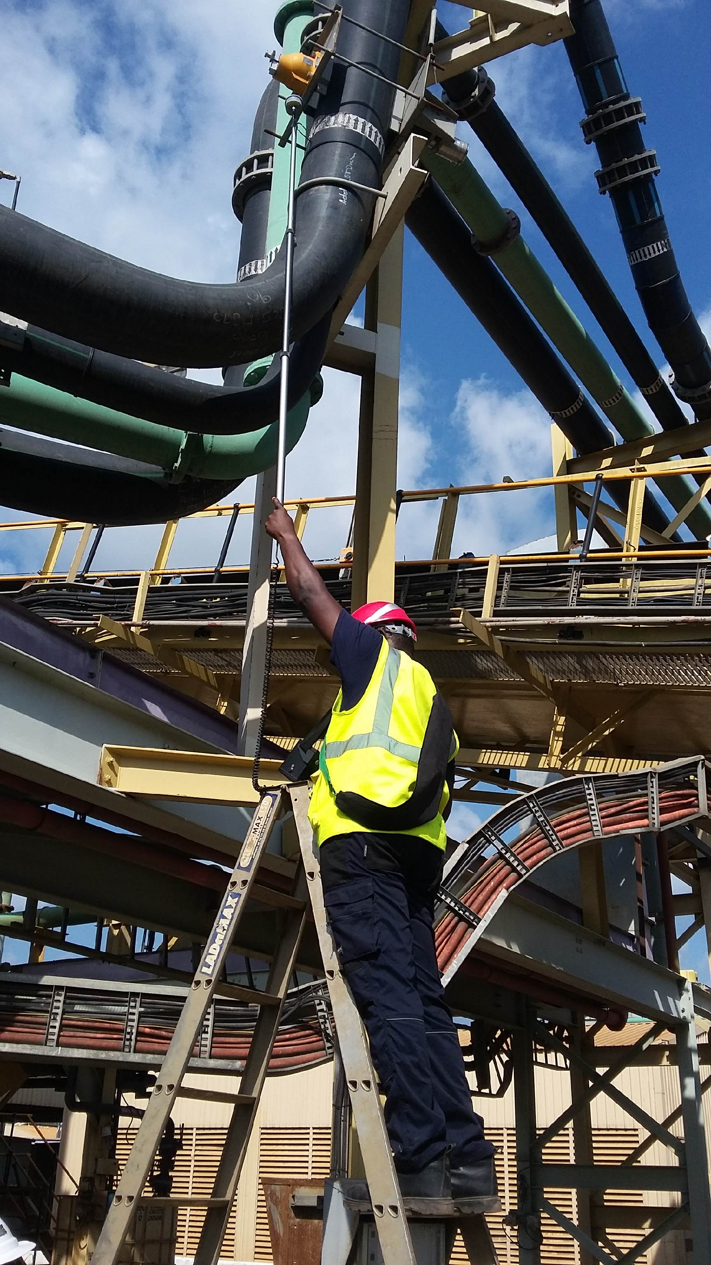

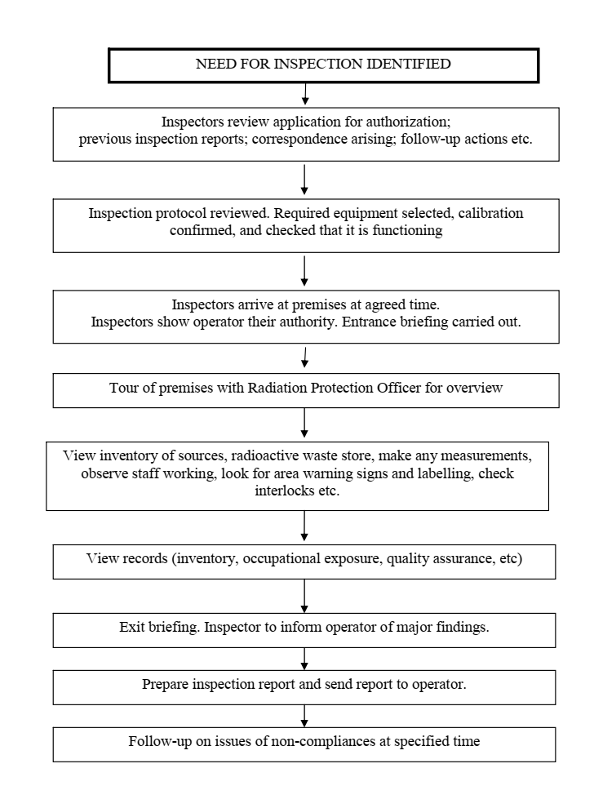
3.2 Enforcement
The Authority follow up on the non-compliance issues and corrective actions raised during the inspection. This ensures that the operator has corrected all the concerns raised during the inspection on safety and security.
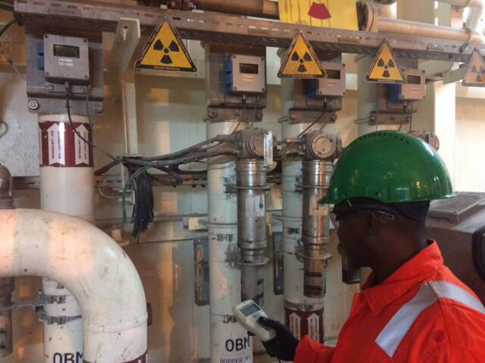
- Safety and Security Culture in the oil & Gas industry
The Oil and Gas industry maintain a high level of safety and security culture in the work environment. This culture is further strengthen by certification from various governmental agencies. The Nuclear Regulatory Authority has drafted a safety and security culture programme document that ensure organizations adhere to the safety and security culture policies outlined in the document.

