Zimbabwe experience in the management of disused

sealed radioactive sources

A MUZONGOMERWA
Radiation Protection Authority of Zimbabwe
Harare, Zimbabwe
Email: amuzongomerwa@rpaz.co.zw

I. MAYIDA & N MANJERU
Radiation Protection Authority of Zimbabwe
Harare, Zimbabwe

Abstract

Sealed radioactive sources have been used in medical, research and industrial applications in Zimbabwe for socioeconomic development. The country has a return to supplier policy as a requirement for all import of sources. When they become disused, sources are stored at respective facilities pending return to manufacturer. To date the country has over 200 disused sources stored within the licensed holders with the facilities failing to return them to suppliers, these are still under regulatory control. They could not be returned to supplier because they are either legacy sources that were imported before existence of the regulatory body, damaged sources, failure to identify documentation and the supplier or because of the high cost of sending them back. Noting the vulnerability of sources being stored at facilities and the challenges of the return to supplier policy Zimbabwe set out to create a lasting solution to the management of disused sealed radioactive sources. This paper outlines deliberate actions taken by government to improve the safety and security of disused sources in Zimbabwe and the accompanying impact of these strategies. These include the establishment of an interim waste storage facility while the centralized radioactive waste management facility is being established and the strengthening of temporary storage facilities for licensed holders. Financial provisions for management of disused sources and other radioactive waste have been incorporated in the Radiation Protection Amendment Bill. The safety and security of disused sources in Zimbabwe has been strengthened because of these interventions and no incidences involving disused sources have been recorded after the interventions.

INTRODUCTION
Sealed radioactive sources have been used in Zimbabwe in the manufacturing, construction, mining, research industries for economic development. Prior to importation the sources are issued with an importation permit, with conditions for return to suppler agreement when the sources have become disused or at the end of their useful life. Since its inception in 2010 the regulatory body has ensured adherence to these provisions. However, some sources were imported into the country prior to the establishment of the regulatory body, these neither have return to supplier agreements nor do they have the documentation accompanying the sources. Further, some companies have since folded operations and are financially incapacitated to send the sources back to the suppliers.

To date the country has over 200 of these disused legacy sources stored within the licensed holders. Though these are still under regulatory control, most of the sources have continued to be temporarily stored at licensed holders. The possibility of source’s vulnerability to theft, loss, or inappropriate management exists even in the presence of regulatory provisions. A few cases of damage to the sources while in storage, loss of the sources and weak radiation safety measures have been recorded. Measures had to be put in place to deal with the overreliance of the return to supplier policy through deliberate government policy directives. Government set out to strengthen the management of disused sealed radioactive sources from facility to national level as set out by the International Atomic Energy Agency (IAEA) Supplementary Guidance on the Management of Disused Sources [1] and the Radiation Protection Act (Chapter 15:15) [2].

MANAGEMENT MEASURES

Interim Waste Management Facility
The Regulatory Body was assigned the responsibility to manage orphan sources through its Technical Services Department. An interim facility to manage these sources was set up by the regulatory body at its Head Office site, with capability for receiving, processing, and conditioning of sources. This consisted of 3 ISO containers, one for source recovery from devices, and another for encapsulation and conditioning of recovered sources and the third for final storage of the sources. The interim facility has managed to house up to 40 vulnerable disused sources as well six (6) drums of conditioned radium from hospitals, neutron, and gamma sources from industry. Adequate security systems have been put in place that meet requirements.

To manage damaged and legacy sources, Zimbabwe in collaboration with IAEA undertook a demonstration exercise to condition disused sources that has been damaged by a fire and those that were vulnerable. This resulted in the recovery of 66 sources and conditioning them according to international requirements. The sources have been encapsulated to produce Special Form Capsules and packaged as Type A packages stored in the interim radioactive waste management facility. The packaging met the IAEA safety standard on Regulations for the Safe Transport of Radioactive Material [3]. The interim facility and the storage container housing conditioned material is shown in Fig 2.1 below.
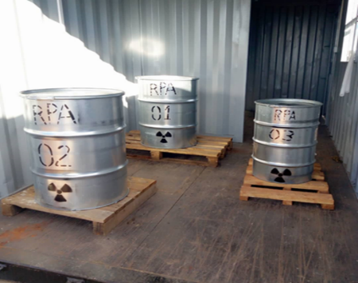
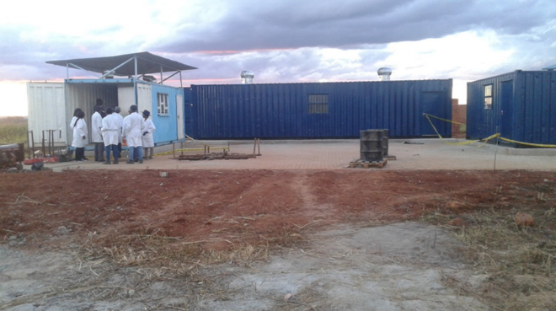

Fig: 2.1: (Left) Interim Radioactive Waste Storage Facility during conditioning operation, (Right) Drums containing conditioned sources.

Strengthening Temporary Storage at Facilities
The Regulatory Body’s Technical Services Department has been providing guidance on set up of adequate temporary storage to facilities for the safe storage of legacy disused sealed radioactive sources, including that that are having challenges returning to supplier. This is to ensure licensed holders meet the requirements for storage of sources. This has significantly reduced the risk of loss, theft, and inadequate control of the sources. One such facility assistance is shown in Fig 2.2 below.

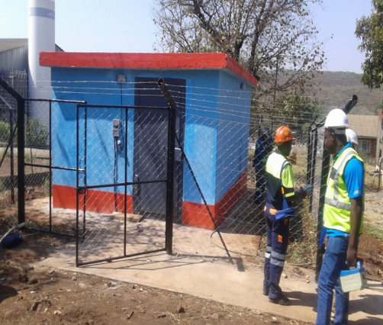

Fig 2.2: Upgrading of temporary storage facility housing over 20 disused sources.

Establishment of a Centralised Radioactive Waste Management Facility
For the long-term management of radioactive waste and disused sources, Zimbabwe is developing a national centralised radioactive waste management facility to recover, process and store radioactive waste and disused sealed radioactive sources for long term as highlighted in Fig 2.3. This has been developed with IAEA expert support and using reference design for a centralized spent sealed sources facility [4] and funding from central government. The facility will receive radioactive waste from licensed holders to ensure their proper handling and storage prior to return to supplier or for long term. Capability to handle high activity sources has also been incorporated. Physical protection measures have been strengthened through IAEA expert support.
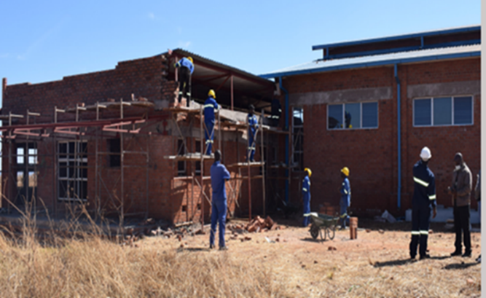

Fig 2.3: Centralised waste management facility under construction.

Inclusion of Financial Provisions for Management of Waste
The Act is being reviewed to strengthen radiation safety and incorporate and security and safeguards provisions. The Radiation Protection Amendment Bill has provided for the establishment of financial mechanisms through a waste management fund management of radioactive waste and disused sources. The objective of the Fund is to hold such levies as shall be prescribed in trust for the purpose of enabling the repatriation, management, storage, or disposal of radioactive sources previously in the custody of an authorised person who by reason of insolvency or any other event is incapable of discharging his or her obligations to repatriate, manage, store or dispose of the sources concerned. This shall ensure Zimbabwe has resources in place to ensure the cradle to grave management of sealed radioactive sources imported into the country and radioactive waste.

CONCLUSION
In conclusion the provisions for strengthening management of disused sealed radioactive sources in Zimbabwe allowed for the development of adequate infrastructure for receiving, recovery, processing, and storage of disused sources. The interim storage facility allowed for immediate arrangements for improving safety and security of sources while the centralised radioactive waste management facility presents long term measures for management of radioactive waste and disused sources. The implementation of provisions in the supplementary guidance on the management of disused sources have been essential.

References
- INTERNATIONAL ATOMIC ENERGY AGENCY, Guidance on the Management of Disused Radioactive Sources, 2018
- Radiation Protection Act [Chapter 15:15] of 2004, Zimbabwe.
- INTERNATIONAL ATOMIC ENERGY AGENCY, Regulations for the Safe Transport of Radioactive Material, Specific Safety Requirements, IAEA Safety Standards Series No. SSR-6, IAEA, Vienna 2012 Edition.
- INTERNATIONAL ATOMIC ENERGY AGENCY, Reference design for a centralized spent sealed source facility, IAEA-TECDOC-806, IAEA, Vienna (1995).

