TWENTY YEARS OF EXPERIENCE IN THE

MANAGEMENT OF DISUSED SEALED RADIOACTIVE

SOURCES IN CUBA

M. SALGADO MOJENA
Centre for Radiation Protection and Hygiene
Havana, Cuba
Email: cphrmercedes@ceniai.inf.cu

N. GONZALEZ, J.C. BENITEZ, J.M. HERNANDEZ, R. CASTILLO, J. MENDOZA, G. TURRUELLA
Centre for Radiation Protection and Hygiene
Havana, Cuba

Abstract

Disused sealed radioactive sources (DSRS) in Cuba, when cannot be returned to a supplier, are transferred to the Centre for Radiation Protection and Hygiene (CPHR), the Waste Management Organization in the country. Since the beginning of nineties, DSRS have been collected and transported to the Radioactive Waste Management Facilities for their safe and secure management. During the first years, the DSRS were stored in the facility as received. Later the characterization and conditioning of the sources have been carried out, following different approaches. At present, the sources of categories 3 to 5 are being removed from the devices, characterized and conditioned in stainless steel capsules for their safe storage. The DSRS of categories 1 and 2 are stored in their devices, as the required technology is not in place for their safe conditioning. The reuse of the DSRS is another option implemented when all the requirements are complied. The paper illustrates the progress of Cuba in the safe management of DSRS in the last 20 years.

INTRODUCTION
Sealed radioactive sources (SRS) are widely used in Cuba in industry, medicine and research. The national regulations establish that when the SRS are declared disused, they have to be returned to the original supplier. The reuse of the sources by other Licensee is also authorized. When these options are not available, the disused sealed radioactive sources (DSRS) are transferred to the Centre for Radiation Protection and Hygiene (CPHR), the organization responsible for the management of DSRS and radioactive waste in Cuba. DSRS are collected by the CPHR and transported to the Waste Management Facilities, for characterization, conditioning and safe storage. The first national collections of DSRS were carried out in the beginning of nineties, when the centralized Waste Storage Facility was put in operation.
At the beginning, the DSRS were stored in the facility as received. Around the year 2000 the DSRS were characterized, and a rigorous record keeping was implemented. In line with the IAEA Guidance on the management of DSRS [1], the conditioning of DSRS is required in order to increase the safety and security during the long term storage. The DSRS of categories 3 to 5 were first conditioned by emplacement the devices with the DSRS inside concrete lined 200-litre drums. They were not immobilized to allow retrievability for further conditioning and disposal. Later on, and following the IAEA recommendations, the DSRS of categories 3 to 5 started to be conditioned by encapsulation [2-4].
The DSRS of categories 1 and 2 are not being conditioned, but in some cases it was necessary to transfer the sources from the user´s facility to adequate shielded containers for their transportation to the Waste Management Facility and safe storage.

Characterization of disused sealed radioactive sources
Several sources received in the facility in the earlier collection campaigns did not have the required information about the radionuclide contained and activity. It was essential to establish adequate control over DSRS at the Waste Storage Facility, and consequently the creation of proper inventory of DSRS became a high priority. The first tasks were to characterize the “unknown sources” and implement an appropriate system for record keeping. Portable spectrometers were used for identification of the radionuclides (for gamma emitters). The activity was estimated from dose rates measured at a certain distance from the source. More precise activity calculation is carried out during the conditioning process, as explained below. An updated inventory of DSRS is kept at the CPHR.

CONDITIONING OF CATEGORIES 3-5 DSRS

Conditioning of DSRS in concrete lined drums
First conditioning operations of DSRS of categories 3-5 containing short lived radionuclides (T1/2 < 30 years) consisted in emplacement of the devices containing the radioactive sources (mainly nuclear gauges and other devices from industrial applications) in concrete lined drums. The number of devices in a package depended on the dimensions of devices and the total activity of the sources, ensuring the compliance with the acceptance criteria previously defined and approved by the Regulatory Body. The devices were not immobilized with cement, to allow the DSRS remained retrievable for further processing. The drums were closed with lid closing mechanism. The information about the devices and the DSRS conditioned in each package was recorded. More than 600 DSRS were conditioned following this procedure.
The fact that most of these devices have been stored in the facility for more than 20 years, together with the environmental conditions they were exposed to during their service lifetime (mostly in industries), has resulted in the corrosion and deterioration of the majority of devices. This situation increases the risk of sources being stuck inside the devices, source leaking and radioactive contamination in the facility.
Consequently, devices containing category 3-5 sources are nowadays being dismantled in order to remove the associated radioactive sources, for their characterization and conditioning by re-encapsulation. This procedure is explained below.

Conditioning of DSRS by re-encapsulation
The conditioning process consists of removing the sources from the devices, characterizing (verification of the radionuclide, dose rate measurements, activity estimation and leak testing by smear samples) and placing in stainless steel capsules. The conditioning plan is previously prepared, containing the devices to be dismantled and the sources to be placed in each capsule, depending on the radionuclide, activity and dimensions of the sources, as well as the activity limits established in the safety assessment. The capsules are sealed by welding the lid. After checking that the capsules are leak-tight, they are placed in suitable containers. The conditioning process results in waste packages, suitable for safe and secure storage and does not preclude subsequent preparation for disposal or even return to suppliers for recycling. The CPHR is authorized by the National Regulatory Body for this practice.

Conditioning of Ra-226 and other sources containing long lived radionuclides
Radium-226 sources were the first to be conditioned, in 2007, following this methodology [2]. Most Ra-226 sources were coming from medical applications (brachytherapy sources). The total quantity of Radium stored at the Waste Management Facilities was not accurate, so the first task was to characterize all the sources and to update the inventory. The Ra-226 sources were segregated in groups and placed in individual lead containers, so that the total activity per group was around 1.85 GBq (50 mCi). This is the activity of Ra-226 to be conditioned per capsule [3]. Since some Ra-226 DSRS were leaking and storage containers were contaminated, adequate safety measures were taken when handling Ra-226 sources to avoid the spread of contamination and for protection of the operators.
Relevant equipment for Radium conditioning operations was provided by the IAEA. Other important equipment and consumables were locally procured or manufactured by the CPHR. The Radium conditioning was not included among the operations initially authorized under the License for the Radioactive Waste Management Practice. Therefore, it was necessary to apply for an additional specific authorization for these operations. The documentation supporting this application included the operational procedures, the corresponding Safety Report and the Emergency Plan. The preparation of suitable and adequate workplaces to handle the sources was a basic principle observed in order to avoid unnecessary occupational exposure and spread of contamination. The documentation was evaluated by the Regulatory Body and the authorization was granted to the CPHR.
Radium sources in Cuba were conditioned following the methodology recommended by the IAEA [3]. All disused Ra-226 sources (1071 in total, among them 1009 brachytherapy needles and tubes) with an estimated total activity of 188 GBq (5 Ci) were conditioned in 84 capsules that were placed in 9 lead shielded containers, which are stored in 5 waste packages.
Other DSRS containing long lived radionuclides (mainly Am-241) are being conditioned following the same methodology [2]. These sources have been removed from lightning conductors, smoke detectors and some nuclear gauges. The activities of sources contained in radioactive lightning conductors and smoke detectors are relatively low, so they would not cause high external occupational exposure. However, spread of contamination is a definite risk to be dealt with, so the risk of inhalation during the handling of these sources was considered. More than two hundred radioactive lightning conductors, containing Am-241 or C-14 sources, were dismantled and the DSRS were characterized and conditioned. Thousands of ionization smoke detectors were also managed in the Waste Management Facilities.

Dismantling of nuclear gauges and conditioning of associated DSRS of categories 3-5
As mentioned before, nuclear gauges and other devices containing category 3-5 sources stored in the facility were corroded and deteriorated (Fig. 1), so it was necessary to dismantle the devices to remove the associated radioactive sources, for their characterization and conditioning for safe long term storage. These operations started in 2015. An IAEA expert mission was received to advice during the first device dismantling operations.

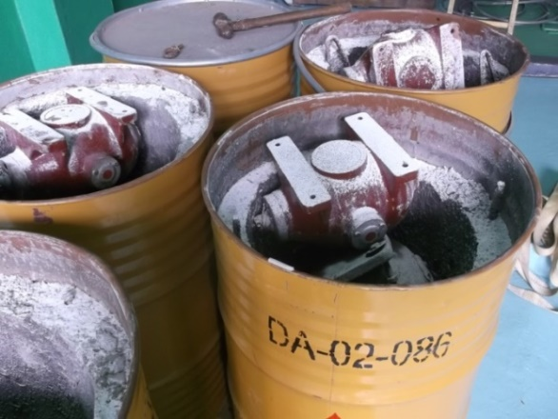 | 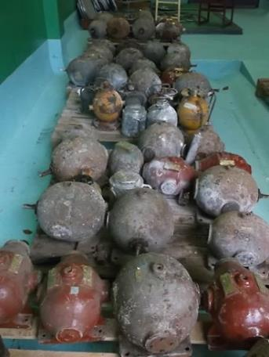
FIG. 1. Situation of devices stored in the facility in 2015 (devices were removed from the concrete lined drums)

Preparatory activities are essential for the safe implementation of dismantling and conditioning operations. These include:
- Acquire the necessary stainless steel capsules, as well as other materials and consumables,
- Design and construction of shielded containers to store the conditioned capsules,
- Design and construction of specific tools, to facilitate the dismantling operations and to optimize the operator doses,
- Prepare the work places, guarantying:
      - Adequate shielding (for gamma or neutron radiation, according to the radionuclide of the sources to be handled),
      - Ventilation, if required,
      - Containment of radioactive contamination (cover the surfaces prone to contamination with plastic sheets, use a tray covered with absorbent paper to handle the source for characterization, etc.)
- Prepare the documents requested by the Regulatory Body to apply for authorization:
      - Operational procedures for dismantling the devices to remove the associated DSRS, characterization and encapsulation of the sources, as well as the leak testing and storage of the conditioned capsule,
      - The conditioning plan,
      - Radiation protection program,
      - Safety assessment that included the dose estimations for normal operations and potential doses in accidental situations. Several postulated events were considered. The risk matrix methodology was used for the safety analysis,
      - Emergency plan.

These documents were evaluated by the Regulatory Body and the authorization was granted. The dismantling of devices to remove the radioactive sources and the characterization and conditioning of the associated DSRS are included among the operations authorized in the Licence of the Radioactive Waste Management Practice. This conditioning methodology is based on the latest IAEA recommendations [4].
Dismantling and conditioning operations started after the License was granted. The devices containing neutron sources (Am/Be, Pu/Be and Ra/Be) were dismantled. The 44 DSRS recovered from these devices were conditioned in 8 stainless steel capsules that were sealed by welding the lid and leak tested. The conditioned capsules were stored in a shielded container (Fig. 2).

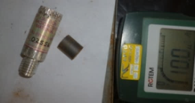  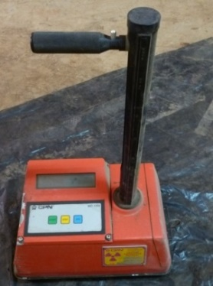 | 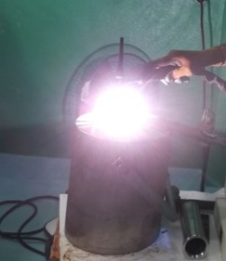  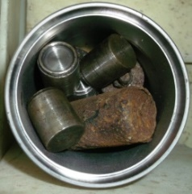 | 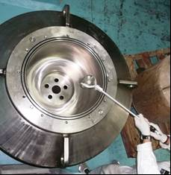
FIG. 2. Dismantling of devices containing neutron sources and conditioning of the DSRS

A significant number of devices stored in the facility contain Cs-137 DSRS, for example: nuclear gauges, calibration and teaching devices, etc. These devices are being dismantled and the DSRS conditioned (Fig. 3).

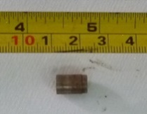  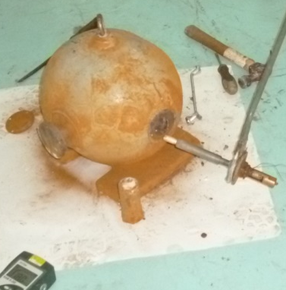 | 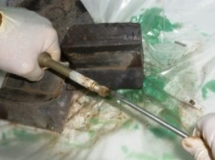  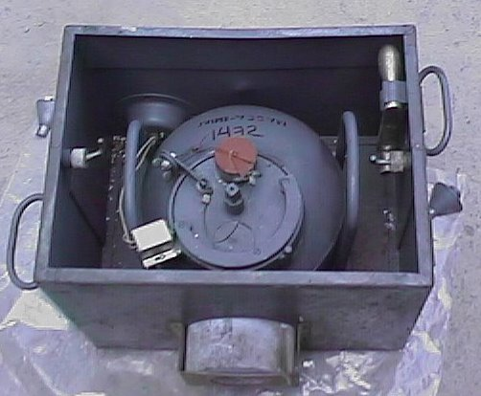 | 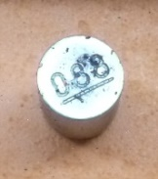  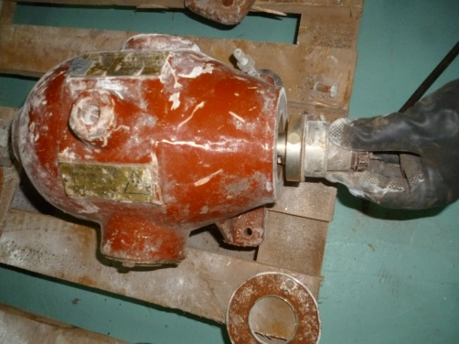
FIG. 3. Examples of devices containing Cs-137 DSRS. Source removal operations
Cuban experts have provided support to several other Member States around the world in the safe management of their DSRS of categories 3-5. Expert Missions through different IAEA Technical Cooperation Projects have been carried out to assist in their capacity building, the development of operational procedures, safety assessment and licensing of the field operations, including removal of DSRS from devices, characterization, encapsulation and safe storage.

management OF high activity disused radioactive sources
Teletherapy devices and irradiators containing high activity sources (categories 1-2) were received in the Waste Management Facilities. After more than 20 years stored in the facility, some sources have already decayed to categories 2 or 3. No sources of category 1 are stored at present, but because of the significant number of category 2 DSRS, they still represent a risk in the facility and have to be managed safely and securely.
These DSRS are stored inside their devices, as the required technology is not in place for their safe conditioning. Some of the disused high activity sources were transferred from the user´s facility (from two irradiation facilities) to adequate shielded containers for their transportation to the Waste Management Facility and safe storage.

reuse of the DSRS
The reuse of sources is allowed by the national legislation, complying with regulatory requirements and duly authorized by the Regulatory Body. The Secondary Standard Dosimetry Laboratory (SSDL) at the CPHR is equipped with a teletherapy Unit model Theratron Phoenix (with a Co-60 radioactive source) used for the calibration of therapy level dosimeters.
On the other hand, a teletherapy unit model Theratron 1000E is in operation in the Radiotherapy Department at the Medical Research Centre in Havana. This equipment uses a Co-60 radioactive source provided by Theratronics International Limited. After about 10 years in operation and because of the radioactive decay, the old source is replaced by a new one. The old source, declared disused by the hospital, has been transferred to the CPHR for use in the SSDL for calibration purposes. This operation has been carried out twice, in 2006 and 2017, complying with the regulatory requirements and authorized by the Regulatory Body. The Co-60 sources declared disused by the CPHR were then returned to the supplier. The reuse of DSRS allows to extend the useful life of the radioactive sources and to reduce the cost, as the country does not have to acquire a new source.

Conclusions
Adequate infrastructure exists in Cuba for the management of disused radioactive sources. The conditioning of DSRS of categories 3-5 guaranties the safety and security of the radioactive sources during the long term storage. Necessary actions have to be taken for the safe management of high activity radioactive sources.
References
- INTERNATIONAL ATOMIC ENERGY AGENCY Guidance on the Management of Disused Radioactive Sources IAEA, IAEA/CODEOC/MGT-DRS/2018, Vienna, (2018).
- SALGADO, M., et al., “Experience in the management of disused radioactive sources in Cuba”, Safety and Security of Radioactive Sources: Maintaining Continuous Global Control of Sources throughout Their Life Cycle (Proc. Int. Conf. Abu Dhabi, United Arab Emirates, 2013), IAEA, Austria (2015).
- INTERNATIONAL ATOMIC ENERGY AGENCY, Conditioning and Interim Storage of Spent Radium Sources, IAEA-TECDOC-886, Vienna (1996).
- INTERNATIONAL ATOMIC ENERGY AGENCY, Management of Disused Sealed Radioactive Sources, IAEA Nuclear Energy Series, No. NW-T-1.3, Vienna (2014).

Mr. J.C Benítez is currently employed by the IAEA

