Safety and security interface within the Cameroon centralized storage facility

J. F. BEYALA ATEBA
National Radiation Protection Agency (NRPA)
Yaounde, Cameroon
Email: bajeanfelix@yahoo.fr

A. SIMO
National Radiation Protection Agency (NRPA)
Yaounde, Cameroon

Abstract

According to the section 5(3) of the law N° 2019/012 of 19 July 2019 to lay down the general framework for radiological and nuclear safety, nuclear security, civil liability and safeguards enforcement, which states that: “the State shall establish the following nuclear policy principles …recognition of the urgent need to manage radioactive waste in order to protect current and future generations against excessive impacts…”, the Republic of Cameroon has established with the support of the International Atomic Energy Agency (IAEA) and the Department of Energy of United States of America (DOE/USA) the centralized storage facility for safe and secure management of disused sealed radioactive sources (DSRS). The installation consists of a 40 feet container and a 20 feet container. Safety measures planned to be taken will allow to dismantle and to load category 3 to 5 DSRS in the P-60 capsule and to transfer the capsule to the lead shield and then the whole will be transferred to the 200l drum for the safe and secure storage. The 200l drum packages will be locked, sealed and labelled according to the measured dose rates at 1 meter. Security measures are in place and take into account delay and detection measures as well as the response procedure. It can be mentioned that, the planned safety measures will contribute to improve security through the use of adequate seals and lock mechanisms. In addition, the robust and heavy 200l drum which are planned to be used increase the difficulty for an adversary to remove or sabotage the packages.

INTRODUCTION
The Republic of Cameroon centralized storage facility consists of two ISO containers used as source storage room and source conditioning room respectively. An on-site alarm monitoring station is also one component of the facility. The facility has been designed in order to manage disused sealed radioactive sources (DSRS) in safety and security manner. Safety measures and security measures must be designed and implemented in an integrated manner so that security measures do not compromise safety and safety measures do not compromise security [1].
In order to reduce and protect the disused sealed radioactive sources (DSRS) located at the Centralized storage facility, the security enhancements are based on performance objectives from IAEA Nuclear Security Series No. 11 namely Security of Radioactive Sources [2]. The security enhancements have been incorporated into the source storage room, source conditioning room and on-site alarm monitoring station.

2. SECURITY MEASURES INCORPORATED

2.1 Security measures within the source storage room
The entry door to the storage room (D1) has been equipped with two high security padlocks that must be removed before the door can be opened. Each door has a balanced magnetic switch installed. A motorized steel security shutter (D2) has been installed at opening of the storage room. The door uses an electro-magnetic locking mechanism integrated with access control system. An area radiation sensor has been installed on the wall near the entry/exit to the source storage room and connected to the intrusion system. One (1) biometric fingerprint reader programmed for two authorizations to allow access has been installed at the entrance door. Three (3) color CCTV cameras have been installed. The first one C1 covering the inside of entry door D1 and the shutter door D2 and two others C2 and C3 viewing the stored sources and inside of shutter entry door. Three (3) dual technology (passive infrared and microwave) motion sensors have been installed in the storage room and entry area to detect entry into the room. A fixed duress button, which is resistant to accidental triggering during normal operations has been installed in the source storage room. A tamper indicating device has been provided on the source storage rack such that any unauthorized access and removal of the source will trigger an alarm. An alpha-numeric keypad has been installed for arming, disarming, and alarm monitoring of the security system near source storage room entry area. A steel cage system enclosing the source containers inside of the storage room has been constructed. The access doors are secured with a high security padlock and a tamper indicating device. The cage has been permanently attached to the storage container to prevent easy removal from the storage room. A wall mounted air conditioning unit to protect the security equipment in the source storage room from overheating has been installed.

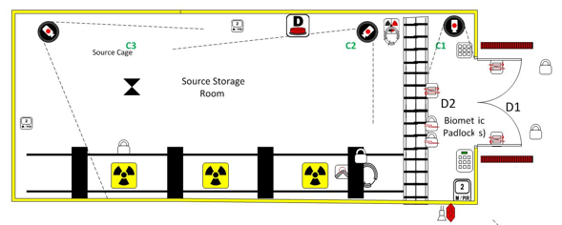 | 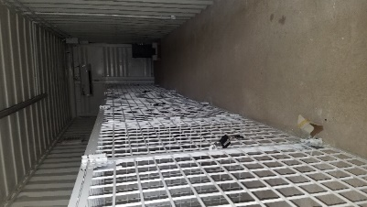
Figure1: Security design within the source storage room | Figure 2: Inside view of the source storage room
2.2 Security measures within the source conditioning room
A steel door (D3) is installed to the conditioning room. A CCTV system with one (1) color CCTV Camera (C4) within the source conditioning room focused on the source and the inside of the entry door and one (1) outdoor CCTV Camera (C5) focused on the exterior entrances to the source storage and source conditioning rooms are installed. Two (2) dual technology (passive infrared and microwave) motion sensors are installed in the source conditioning room to detect entry into the room. A security grating cage for placement of the sources that are in the conditioning process is installed. The box has a high security padlock and have a device that alarms upon tamper indication. The door is equipped with a high-security balanced magnetic switch (BMS).
An alpha-numeric keypad for arming, disarming, and alarm monitoring of the security system is installed.

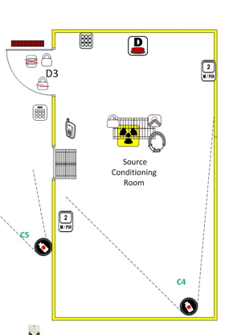 | 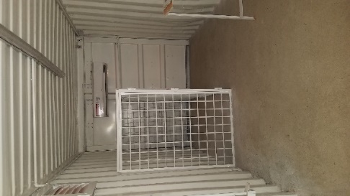
Figure 3: Security design within the source storage room | Figure 4: Inside view of the source conditioning room
2.3. Alarm Station
Two (2) digital portable radios are available for onsite communication. One (1) digital video recorder system with automatic playback capability of pre- and post-alarm events is installed. The CCTV system installed is monitored from the guard station and cameras are recorded with a minimum of 96 hours per channel. A CCTV system with one (1) color CCTV camera (C6) is installed within the room focused on the security equipment. An electro-magnetic locking mechanism is installed on the door. The door is equipped with high-security balanced magnetic switches (BMS) installed on the inside of the door to prevent tampering. A CCTV monitor has been provided to allow all devices installed to be monitored from this station. A high security lock box to store the backup key to the biometric access control system is provided.

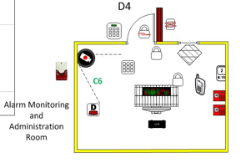
Figure 5: Security design within the alarm monitoring station

3. SAFETY MEASURES TO BE IMPLEMENTED DURING MANAGEMENT OF DSRS

According the national waste management policy and strategy, the existing facility allow on to manage category 3 to 5 low activity disused sealed sources and to send back to the suppliers, category 1 to 2 disused sealed sources. Safety management of DSRS requires, a minimum of radiation protection equipment, miscellaneous and consumables. The main are given below [3]:
- Dose rate detector with telescopic arm;
- Alpha, beta, low energy X-ray and gamma-ray contamination monitors;
- Portable Gamma Spectroscopy detection system for isotope identification;
- Tongs for the source conditioning capsule manipulation;
- lead shields;
- small lead pots for source segregation;
- mirrors;
- OSL dosimeters;
- Shielding storage containers ;
- Standard Stainless steel (SS) capsules;
- 200l drum;
- Ect.
Operational measures planned consist in different steps. First of all, a wipe test on the source associated equipment must be performed in order to check its radioactive contamination status. If the measured value is less than 4 Bq/cm² for beta emitter (respectively less than 0.4 Bq/cm² for alpha emitter) contamination of the equipment may not be suspected. The second step is the characterization of the source through the estimation of the source activity in order to have total activity to be transferred to the P60 capsule. The third step is the transfer of the DSRS from their respective devices to the P60 capsule which is the special form radioactive material (SFRM) with identification code of CZ/1031/S-96 made in two varieties, Am1.P60 and Cs7.P60. All measurements and observations must be recorded in the Passport Sheet for the special form radioactive material.

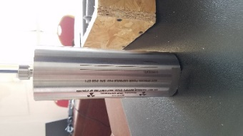 | 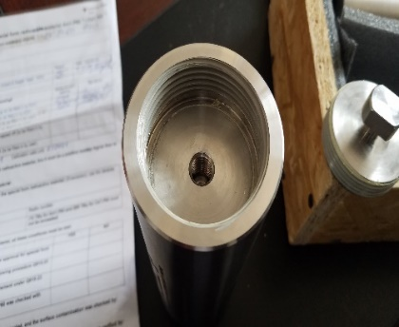 | 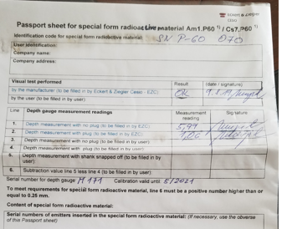
Figure 6: P60 Capsule | Figure 7: P60 capsule without the threaded cap | Figure 8: Passport sheet for SFRM

By using tongs, DSRS must be transferred into the capsule according to the limit of activity, then capsule must be closed and the special form certificate duly filled and signed. The P60 capsule containing DSRS must be transferred to the designated position in the lead shield which is transferred to the 200l concrete drum. The drum is closed and sealed. The ambient dose rates at 1 meter to the drum must be recorded in order to categorize the package and to choose the label to be pasted on it. Thus the last step was the transport of sources contained in the drum to the storage area.

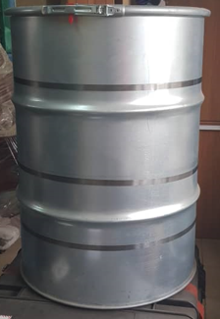
Figure 9: Empty 200l drum

4. CONCLUSION

Within the Republic of Cameroon centralized storage facility, Safety measures planned to be taken consist of dismantling category 3 to 5 sources from their associated equipment and transferring them to the P-60 capsule which must be transferred to the lead shield and then the whole to the 200l drum. The 200l drum packages must be locked, sealed and labelled according to the measured dose rates at 1 meter. Security measures in place have been incorporated into the source storage room and source conditioning room respectively in order to implement nuclear security functions within the facility. The planned safety measures will contribute to improve security through the use of adequate seals and lock mechanisms. In addition, the robust and heavy 200l drum which are planned to be used increase the difficulty for an adversary to remove or sabotage the packages.

ACKNOWLEDGEMENTS
The authors thank the International Atomic Energy Agency (IAEA) and the Department of Energy of United States of America (DOE/USA) for their support in the framework of the establishment of the Republic of Cameroon centralized storage facility.
References
- EUROPEAN ATOMIC ENERGY COMMUNITY, FOOD AND AGRICULTURE ORGANIZATION OF THE UNITED NATIONS, INTERNATIONAL ATOMIC ENERGY AGENCY, INTERNATIONAL LABOUR ORGANIZATION, INTERNATIONAL MARITIME ORGANIZATION, OECD NUCLEAR ENERGY AGENCY, PAN AMERICAN HEALTH ORGANIZATION, UNITED NATIONS ENVIRONMENT PROGRAMME, WORLD HEALTH ORGANIZATION, Fundamental Safety Principles, IAEA Safety Standards Series No. SF-1, IAEA, Vienna (2006).
- INTERNATIONAL ATOMIC ENERGY AGENCY, Security of Radioactive Sources, Nuclear Security Series No. 11, IAEA, Vienna (2009).
- INTERNATIONAL ATOMIC ENERGY AGENCY, Technical manual for Conditioning of spent low activity sources, IAEA, Vienna (2019).

