ASSESSMENT OF RADIATION DOSE RATE LEVELS AND RADIATION RISK AT THE COBALT -60 UNIT, KOMFO ANOKYE RADIOTHERAPY CENTER, GHANA.
Addison E. C. D. K.^{1a, 2}, R. A. Opoku^{1b}, Addison C.E.B.N. ^{2c}, Aniagyei W.I .^{2d}
- Physics Department, Kwame Nkrumah University of Science and Technology, Kumasi, Ghana.
- Oncology Directorate, Komfo Anokye Teaching Hospital, Kumasi, Ghana.
ª Email: ektaddison@gmail.com
^{b} Email: opokuasamoahrichard@gmail.com
^{c} Email: Clementaddison96@gmail.com
^{d} Email: wilmaaniagyei@gmail.com

Abstract
A study to estimate the Annual Effective Dose Equivalent (AEDE) and Excess Lifetime Cancer Risk (ELCR) due to the existence of the artificial cobalt-60 radioactive source producing ionizing radiation levels within the radiotherapy facility in Komfo Anokye Teaching Hospital (KATH), Ghana. The study was conducted using a portable OD-01 Ionization Chamber Survey Meter. Varying measurement of absorbed dose rate (ADR) in the air between 5 m and 40 m was carried out within the cobalt 60 bunker around the radioactive source and fifteen locations within the radiotherapy facility. The estimated Absorbed Dose Rate in the air within the cobalt-60 bunker from 5 m to 40 m around the Cobalt-60 source was 0.299 ± 0.001 to 0.977 ± 0.005 μSv/h with an average of 0.498 ± 0.005 μSv/h. The estimated annual effective dose equivalent within the Co-60 bunker ranged 1.100 mSv/yr to 3.595 mSv/yr around the cobalt-60 source. Radiation dose levels of 0.268 ± 0.008 μSv/h to 0.678 ± 0.005 μSv/h with an average of 0.440 ± 0.004 μSv/h was measured around the selected fifteen locations. Comparably, values of 3.85 10⁻³ to 12.5810⁻³ and 3.45 × 10⁻³ to 8.73 × 10⁻³ for Excess Lifetime Cancer Risks were estimated within the cobalt and the fifteen locations within the facility respectively. The absorbed dose values at 5 m, 10 m, and 15 m within the Co-60 bunker and the location Co-60 bunker as part of the locations in the facility exceeded the permissible limit of 0.57 as recommended by ICRP. The AEDE and ELCR values were within the permissible limits as recommended by ICRP. The implication of the AEDE and ELCR data obtained is that the Cobalt-60 unit and its surrounding is radiation safe but the probability of staff within occupational exposure developing cancer from the Absorbed dose and background ionizing radiation is high over a lifetime. It is nonetheless suggested that absorbed dose level monitoring and assessment of the Radiation Therapy Technologist (RTT) and other staff around the unit be checked from time to time. It is also suggested the Occupational Staff such as RTTs spend minimal time in the bunker.
This research verified the safety of the cobalt-60 radioactive sources and the concept of the determination of the Annual Effective Dose Equivalent (AEDE) and Excess Lifetime Cancer Risk (ELCR) contributing to checking the occupational and public exposures within the facility.
Keywords: Annual Effective Dose Equivalent, Excess Lifetime Cancer Risk, Cobalt-60 source, Absorbed Dose Rate (ADR), Background Ionizing Radiation (BIR)

- INTRODUCTION
Emeka (2003) in (Harb 2016) stated that radiation in hospitals originates from two main sources; medical exposures, and cosmic radiation, terrestrial radiation, and radioactivity from the background. This implies that individuals around such areas are continually exposed to ionizing radiation spontaneously which cannot be avoided. The Background ionizing radiation emanates from both natural and man-made sources. Cosmic, terrestrial, and radioactivity from long-lived radionuclides from the earth's crust and everywhere in the environment make up the natural sources of ionizing radiation and has been established by (Bamidele 2013) to have some considerable exposure on humans. Man-made sources of ionizing radiation are produced artificially for nuclear reactors and medical purposes and the background ionizing radiation from these sources can cause significant effects especially on humans within medial exposure which can be stochastic and non-stochastic effects (Niu 2011). Radioactive sources such as Cobalt -60, iridium-192, caesium-137, strontium-90, and americium-241 are used in medicine for radiotherapy purposes. In the sources and effects of ionizing radiation report by (UNSCEAR 2008), it was clearly stated that the global estimated average dose of background ionizing radiation received by humans is about 0.274 µSv/hr, of which 80% comes from nature, while the remaining 20% results from exposure to man-made radiation sources. One of the known harmful effects of ionizing radiation is cancer. It is known to be the top-tier source of death and leading public health problem (Akram et al. 2018). In a research study by Ferlay, (Ferlay et al. 2010) and Jemal (Jemal, Bray, and Ferlay 1999), it was estimated that 20 million new cancer cases may be expected globally in 2020. Following this study, 19.3 million new cancer cases were estimated in the year 2020 with female breast cancer as the most frequently diagnosed cancer and lung cancer remaining the principal cause of cancer death (Sung et al. 2021). Through research, methods were discovered which can solve this public health problem. (Ravichandran 2009) research stipulated that 60% of patients require radiotherapy, which is a major modality of cancer treatment as a palliative or curative intent. Cobalt-60 is a teletherapy machine that is easy to handle, has the advantage of reduced maintenance running costs and downtime as compared to linear accelerators. As Co-60 decays, gamma radiation is emitted which is used to treat cancer in radiation therapy, and its scatter radiation might have effects on individuals working around such units over a long period. Some of the hospital workers in clerical department, nurses, and cleaners also work around these radioactive sources and are indirectly exposed to these radiations. Long-term exposure to such radiation can later cause free radical formation cancer, chromosomal transformation, potential hereditary effects in the offspring of persons exposed to such radiation. Given the fact that they are exposed to some amount of radiation, there is therefore the need for assessment of the radiation level and its impact due to its biological effects on tissues. Ionization following release of charged particles and free radicals due to interaction between energetic ionizing radiation and biological tissues causes DNA alteration (Emelue 2014).
This present study is aimed at assessing and measuring the background radiation absorbed dose rate in air in the Cobalt-60 bunker and some selected locations within the oncology department. The measured dose rate is further used to calculate the annual effective dose equivalent (AEDE) received by workers and visitors within the study area. The excess lifetime cancer risk (ELCR) associated with the exposure is also estimated. The result acquired from this study is compared with the standard recommended value to know the radiological health effects. The result will also serve as radiation baseline data for the area since there has not been any radiological study of the area.

- MATERIALS AND METHOD OF MEASUREMENT
A portable OD-01 survey meter was used to measure the Absorbed dose rate in μSv/h recorded around and within the Cobalt-60 unit at the Oncology directorate of Komfo Anokye Teaching Hospital. The survey meter is a compact device consisting of a display and control unit, probe, device support, 0.7 m of connecting cable and USB cable, and software for measurement evaluation via personal computer (PC). It measures photons up to 15 MeV and beta radiation of energies from 6 keV up to 2 MeV. It also measures the equivalent dose rate in the range of 0 μSv/h to 2000 mSv/h and dose in the range of 0 μSv to 2000 μSv employing air opened ionization chamber. The meter was calibrated in a beta radiation field according to ISO 6980 and photon radiation fields according to ISO 4037-1 (homogeneous radiation field) by STEP Sensortechnik und Elektronik Pockau GmbH, Siedlungsstraße 5-7, D-09509 Pockau.
At different distances away from the radioactive source (Cobalt-60 teletherapy machine), ten (10) readings were taken within a time interval of 2 minutes in air at different positions in each location when the beam was OFF and the average value was considered to be the gamma dose rate at that distance. Background Ionizing Radiation (from the Cobalt-60 source) of fifteen (15) selected locations in the oncology department was also measured using the portable OD-01 survey meter. The selected locations within the facility were the Nuclear medicine bunker, Simulator room area, Administration area, Conference room area, Linac maze, Linac control console room, Chemotherapy room area, Nurses office area, Dosimetry room area, Nuclear Medicine room area, Records area, Patients waiting for area Radiotherapists area, OPD area and the Cobalt -60 bunker room. Figure 1 shows the layout of the oncology department. The gamma radiation levels were measured both inside and outside the rooms and the surrounding areas at a reference height of 1 meter above the ground level in the open air. To cover the whole area, ten (10) to fifteen (15) measurements were taken with a period of 2 minutes interval at different points in each location and the mean value was the average Absorbed Dose Rate for the location. The average absorbed dose rates (ADR) were used to calculate the Annual Effective Dose Equivalent (AEDE) in mSv/yr received by workers and visitors. The AEDE was computed using the relation;
AEDE (mSv/yr) = 4600(h/y) (T) X 0.8(OF) x 0.001(CF) X ADR (μSv/h) (1)
Where T is the total time in hours per year (4600), OF is the occupancy factor, CF is the dose conversion factor and ADR is the absorbed dose rate. For this work, an outdoor occupancy factor of 0.8 (UNSCEAR, 2008) was used. Based on the values from the AEDE, the excess lifetime cancer risk (ELCR) was calculated using the equation:

ELCR = AEDE (mSv/yr) x DL (70 years) x RF (0.05) (2)
where AEDE is the annual effective dose equivalent, DL is the duration of life and RF is the risk factor or fatal cancer risk per Sievert. For stochastic effects from low dose background radiation, ICRP 103 suggested the value of 0.05 for the public exposure ( ICRP 2007)
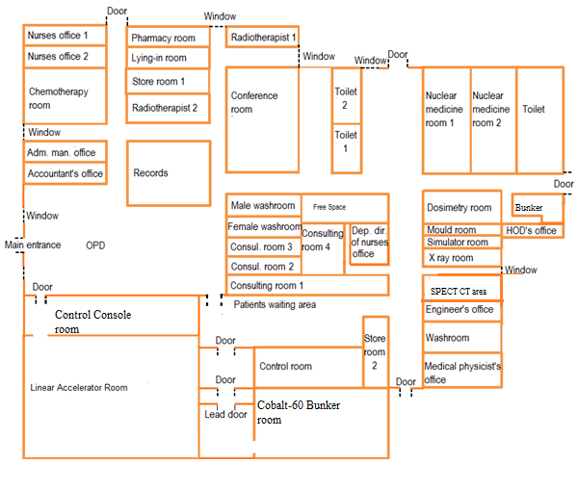
Figure 1: Layout of the KATH Oncology Department.
- Results and Discussion
The results of the measured Absorbed Dose Rate, Background Ionizing Radiation, the calculated Annual Effective Dose Equivalent and Excess Lifetime Cancer Risk are presented in Tables 1 and 2 and graphically distributed in Figures 2,3,4,5,6 and 7 for within the Cobalt-60 unit at different distances and around at selected locations within the oncology directorate.

Table 1: The Absorbed Dose Rate (ADR), Annual Effective Dose Equivalent (AEDE), and Excess Lifetime Cancer Risk (ELCR) at different distances from the Cobalt-60 teletherapy machine within the Bunker
Distance from the source (m) | 5 m | 10 m | 15 m | 20 m | 25 m | 30 m | 35 m | 40 m
No. of readings taken | 10 | 10 | 10 | 10 | 10 | 10 | 10 | 10
Exposure dose rate in air (μSv/h) (Range) | 0.971-0.982 | 0.593-0.628 | 0.648-0.659 | 0.405-0.417 | 0.368-0.372 | 0.341-0.345 | 0.312-0.321 | 0.296-0.301
Exposure dose rate (μSv/h)  (Mean) | 0.977±0.005 | 0.612±0.014 | 0.655±0.005 | 0.410±0.009 | 0.370±0.002 | 0.343±0.006 | 0.317±0.004 | 0.299±0.001
Annual Effective Dose Equivalent (mSv/yr) | 3.595 | 2.252 | 2.410 | 1.509 | 1.362 | 1.262 | 1.167 | 1.100
Excess Lifetime Cancer Risk (x10⁻³) | 12.58 | 7.88 | 8.44 | 5.28 | 5.28 | 4.42 | 4.08 | 3.85

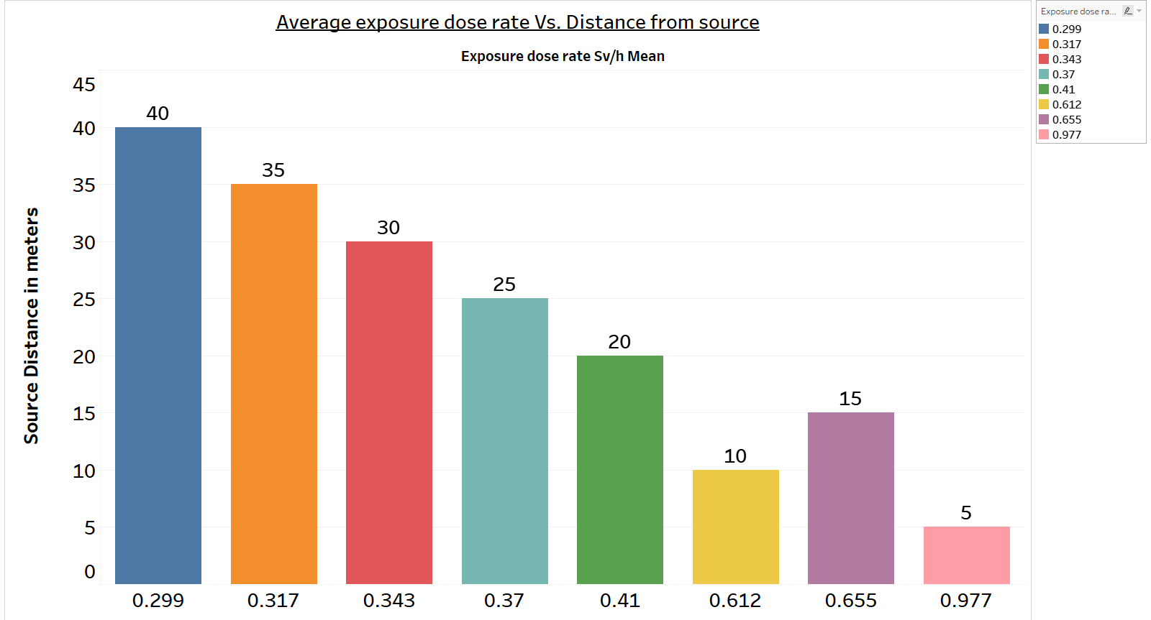
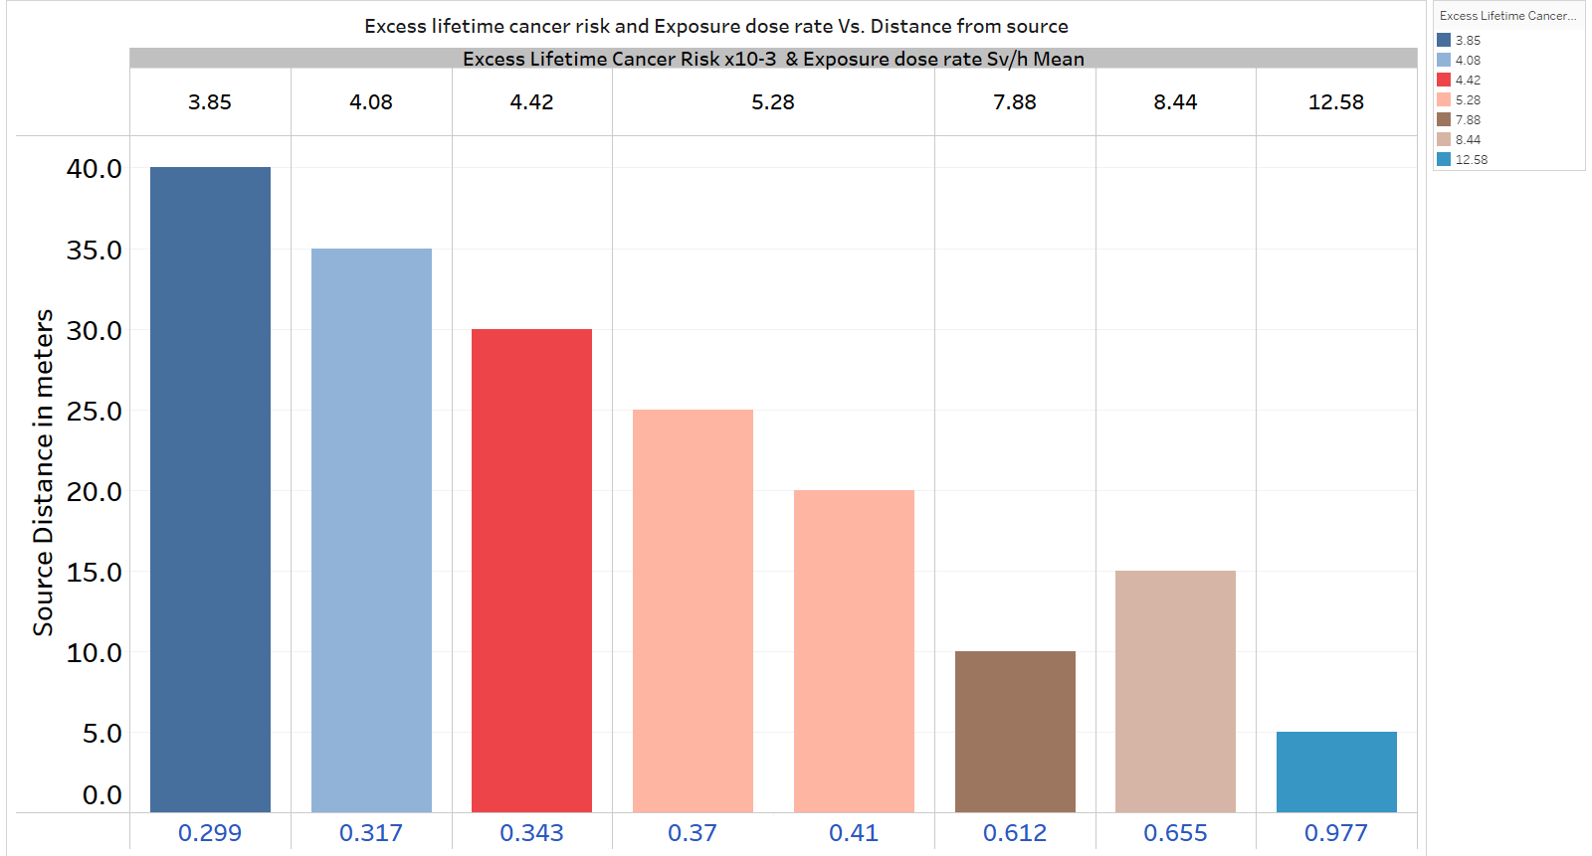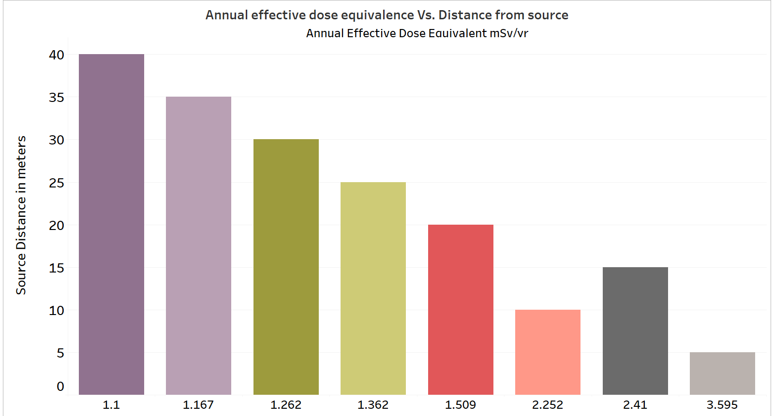
Table 2. The absorbed dose rate, annual effective dose equivalent, and excess lifetime cancer risk at selected locations within the radiotherapy facility
Location | The absorbed dose rate in the air (μSv/hr) |  | Annual effective dose equivalent (mSv/yr) | Excess lifetime cancer risk (x10⁻³)
 | Range | Mean
Nuclear medicine Bunker | 0.492-0.521 | 0.512±0.004 | 1.884 | 6.59
Simulator room area | 0.430-0.477 | 0.466±0.001 | 1.715 | 6.00
Administration area | 0.309-0.320 | 0.313±0.007 | 1.152 | 4.03
Conference room area | 0.452-0.481 | 0.469±0.003 | 1.726 | 6.04
Linac maze | 0.508-0.524 | 0.515±0.002 | 1.895 | 6.63
Control console room | 0.558-0.571 | 0.564±0.002 | 2.076 | 7.27
Chemotherapy room area | 0.313-0.322 | 0.317±0.003 | 1.167 | 4.08
cobalt bunker room | 0.650-0.698 | 0.678±0.005 | 2.495 | 8.73
Nurses office area | 0.254-0.283 | 0.268±0.008 | 0.986 | 3.45
Dosimetry room area | 0.447-0.482 | 0.463±0.001 | 1.704 | 5.96
Nuclear medicine room area | 0.457-0.475 | 0.467±0.002 | 1.719 | 6.02
SPECT-CT Console Area | 0.457-0.473 | 0.467±0.005 | 1.719 | 6.02
Records area | 0.265-0.297 | 0.281±0.001 | 1.034 | 3.62
Patients waiting area | 0.491-0.521 | 0.509±0.003 | 1.873 | 6.56
Radiotherapist area | 0.288-0.318 | 0.302±0.006 | 1.111 | 3.89
OPD | 0.433-0.471 | 0.455±0.003 | 1.674 | 5.86
Minimum |  | 0.268±0.008 | 0.986 | 3.45
Maximum |  | 0.678±0.005 | 2.495 | 8.73
Average |  | 0.440±0.004 | 1.621 | 5.67

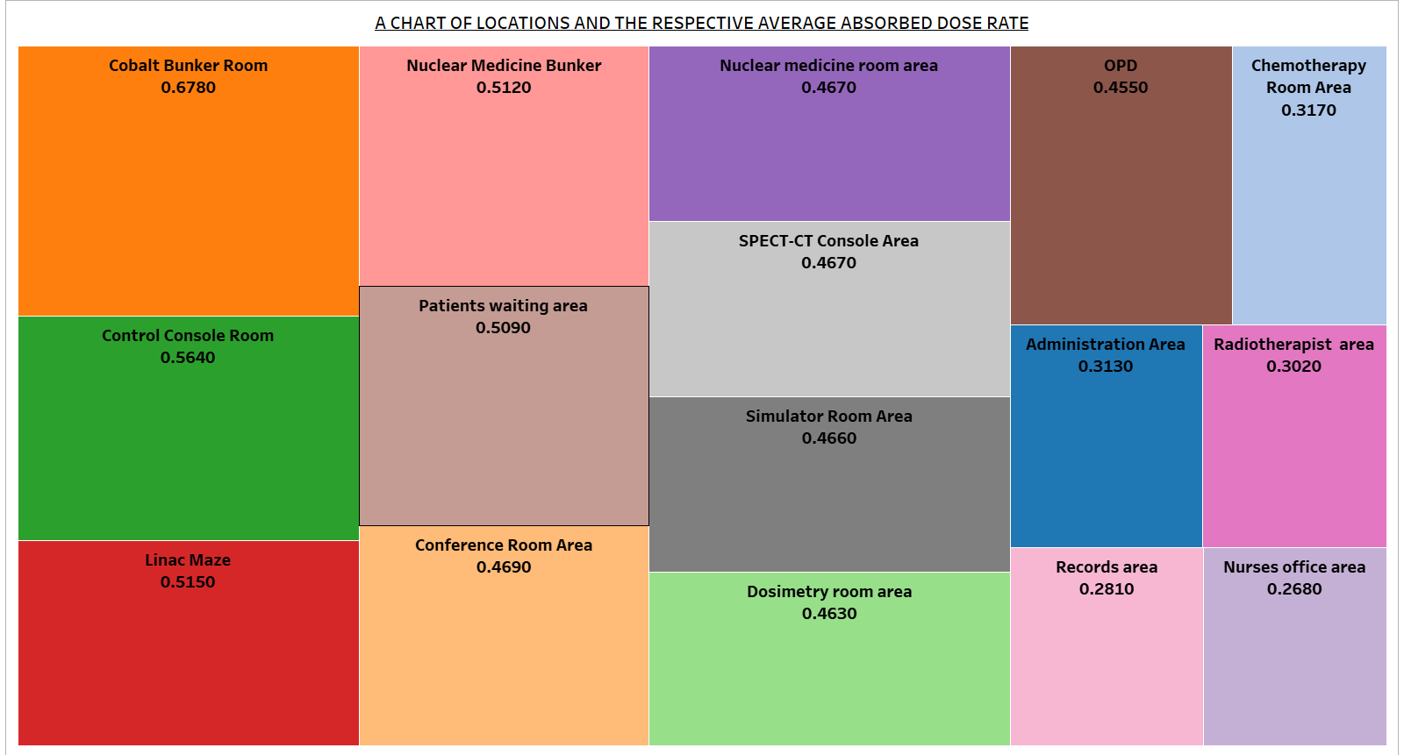
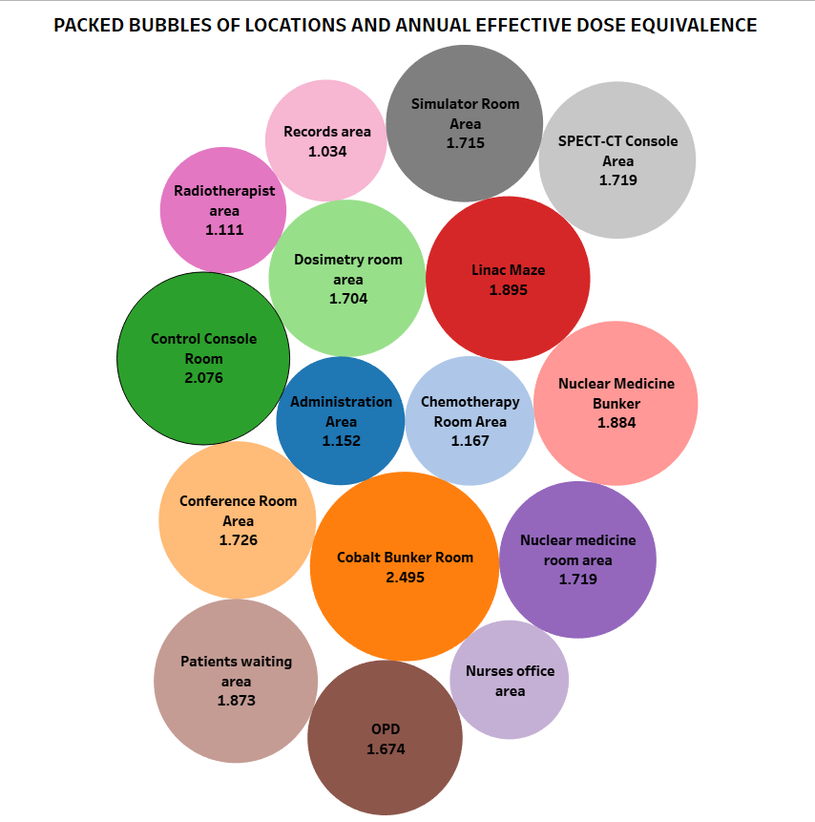
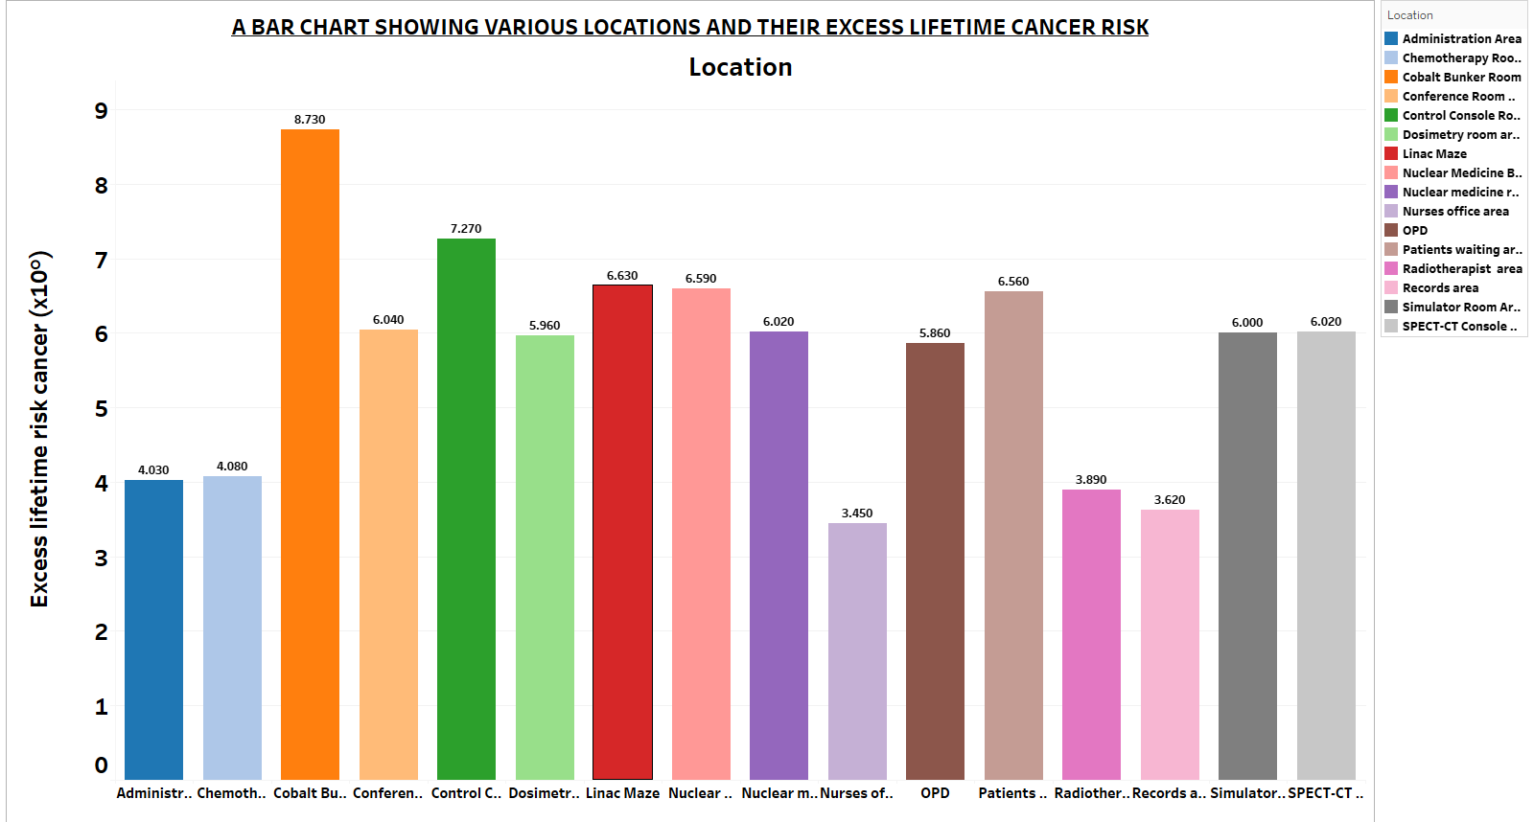

Table 1 shows the absorbed dose rate readings, the annual effective dose equivalent estimated, and their corresponding excess lifetime cancer risk at different distances from the radioactive source. It was observed that the absorbed dose rate ranged from 0.299±0.001 μSv/h to 0.977±0.005 μSv/h with an average of 0.498±0.005 μSv/h for different distances away from radioactive source when the beam was OFF and therefore background radiation. A mean dose rate value of 0.997±0.005 µSv/h at a distance of 5 m was displayed as the highest absorbed dose rate whilst the mean value of 0.299±0.001 µSv/h at a distance of 40 m showed the lowest absorbed dose rate range as presented in figure 2. The dose rate at different distances from the radioactive source displayed a relatively low level of background ionizing radiation except for some distances (5 m, 10 m, and 15 m) which depicted high background radiation levels above the ICRP maximum permissible limit. The other recorded values were within the ICRP maximum permissible limit of 0.57 μSv/h (Streffer 2007). The high dose rates recorded at these distances were attributed to scattered radiation from the radioactive source when the beam was ON for treatment. From figure 2, it was observed that the intensity of the radiation decreased as the distance of measurement increased. This indicates that the inverse square law relating to radiation measurement concerning distance was confirmed. At a distance of 15 m from the radioactive source, a higher absorbed dose was observed more than at 10 m from the source. The annual effective dose equivalents ranged from 1.100 mSv/yr and 3.595 mSv/yr. The maximum AEDE estimated was found to be 3.595 mSv/yr at a distance of 5 m and a minimum AEDE of 1.100 mSv/yr at a distance of 40 m. The annual effective dose equivalent values were above the safe limit of 1 mSv/yr for the public exposure but below for occupational exposure with the permissible limit of 20 mSv/yr (Streffer 2007). The excess lifetime cancer risk values were calculated using equation 2. The maximum excess lifetime cancer risk for occupational and public exposure was found to be 12.58x10⁻³ at a distance of 5 m whereas the minimum excess lifetime cancer risk was found at a distance of 40 m with a value of 3.85x10⁻³. The excess lifetime cancer risks estimated were above the standard permissible limit of 0.29 mSv/yr (Taskin et al. 2009); as shown in figure 4.

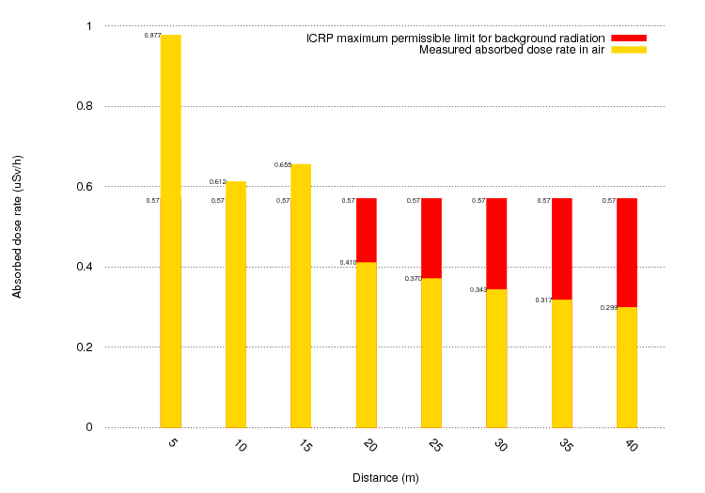Figure 2. The absorbed dose rate at different distances from the radioactive source distribution

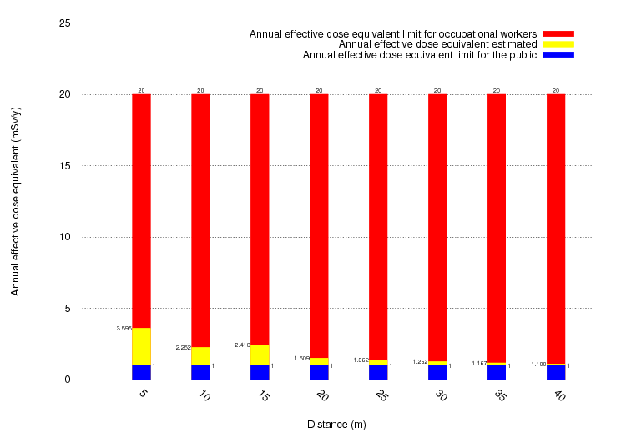
Figure 3. Annual effective dose equivalent at different distances from the radioactive source distribution
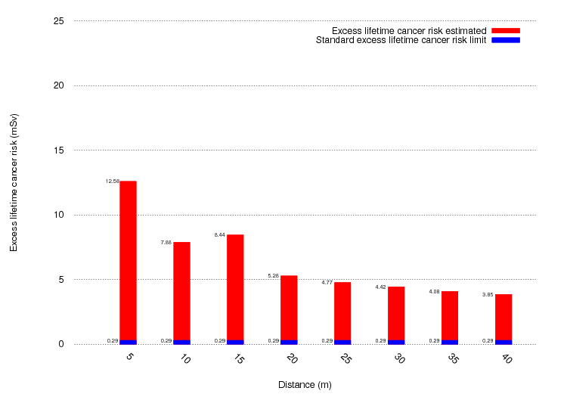
Figure 4. Excess lifetime cancer risk at different distances from the radioactive
Source distribution.

Figure 5. The distribution of absorbed dose rate at selected locations within the radiotherapy facility.

Figure 6. The annual effective dose equivalent distribution at selected locations within the radiotherapy facility.

Figure 7. The excess lifetime cancer risk distribution at selected locations within the radiotherapy facility.

From Table 2, The absorbed dose rates in air varied from 0.268±0.008 μSv/h to 0.678±0.005 μSv/h with a mean value of 0.440±0.004 μSv/h. The overall mean absorbed dose value was within the ICRP maximum permissible limit of 0.57 μSv/h (Streffer 2007). As shown in Figure 5, the highest absorbed dose rate is 0.678±0.005 μSv/h whereas the nurse’s office area showed the lowest absorbed dose rate of 0.268±0.008 μSv/h. The scattered radiation levels in the radiotherapy facility were relatively lower and within the ICRP permissible limit in most of the selected locations. The maximum and minimum scattered radiation recorded in the radioactive room and the nurse’s office area respectively indicates that occupational exposure to the Cobalt-60 source has a higher probability than public exposure. The average absorbed dose rate was used to estimate the annual effective dose equivalent (AEDE) for workers within occupational exposure and those within public exposure within the study area. UNSCEAR generally uses 4600 hours per year instead of 8760 hours per year due to work shifts and overtime (UNSCEAR 1993). The estimated values of the annual effective dose equivalent ranged from 0.986 mSv/yr to 2.495 mSv/yr with an average value of 1.62 mSv/yr. The mean AEDE value was found to be approximately 1.6 times higher than the annual effective dose equivalent limit of 1 mSv/yr for public exposure (Streffer 2007) and approximately 20 times lower than the annual effective dose equivalent limit of 20 mSv/yr for occupational exposure (Streffer 2007). The mean value from the radioactive source room showed the highest AEDE whereas the nurse’s office area showed the lowest AEDE as shown in figure 6.
In a study carried out by (Temaugee et al. 2014), cancer types may tend to grow after exposure to ionizing radiation and by epidemiological means be detected. Cancer advancement due to ionizing radiation exposure is a stochastic effect. The probability of an individual developing cancer over a lifetime of radiation exposure is known as the Excess lifetime cancer risk (ELCR). The estimated values of the excess lifetime cancer risk for scattered ionizing radiation exposures ranged from 3.45x10⁻³ to 8.73x10⁻³ with an average value of 5.67x10⁻³. The estimated mean value for the ELCR was approximately twenty times higher than the standard value of 0.29x10⁻³ for natural ionizing radiations (Taskin et al. 2009). This implies that the probability of occupational exposure or public exposure of an individual in the oncology directorate at the Komfo Anokye Teaching hospital over a lifetime is high.

- Conclusion
This study was mapped out to estimate the annual effective dose and excess lifetime cancer risk due to absorbed dose rate levels and background ionizing radiation within and around the cobalt-60 Unit in the Oncology department of Komfo Anokye Teaching Hospital. Radiation safety monitoring and assessment have become issues of great concern since at high doses, ionizing radiation is carcinogenic and it is essential to determine dose levels to control and evaluate the health implications. The study revealed that the measured gamma dose values (from Absorbed Dose Rate and Background Ionizing Radiation), the annual effective dose equivalents, and excess lifetime cancer risks were determined. The mean AEDE estimated for within and around the cobalt-60 unit were found to be approximately 1.6 times higher than the permissible Annual Dose Equivalent limit of 1 mSv/yr for public exposure (Streffer 2007) and approximately 20 times lower than the annual dose equivalent limit of 20 mSv/yr for occupational workers (Streffer 2007). The excess lifetime cancer risks were also found to be 20 times higher than the average standard value of 0.29x10⁻³ for natural ionizing radiations (Taskin et al. 2009). This is observed as such due to the concentration of cobalt source and time spent around the source. The calculated excess lifetime cancer risk values were elevated due to scattered radiation from the radioactive source and the increased natural background radiation in the facility. Both scattered radiation and natural background radiation should be examined and the workers and people living in the facility should be made aware of the high cancer risk so that the necessary protective measures would be put in place to minimize it. The excess lifetime cancer risks were high and above natural background limit but in terms of occupational exposure, it implies that AEDE and ELCR values is that the Oncology directorate is radiation safe for any immediate radiological health effects due to absorbed dose from BIR, but the probability of stochastic effects over a life time in the quarry environment is very high. It was also observed that the radiation doses were inversely proportional to the distances between the machine and the observation point hence recommended that distance from source if possible, should be observed, minimal time should be observed by occupational workers, periodic ADR monitoring and evaluation of radioactivity concentration of the cobalt source should be accessed by the Medical Physicist. However, there was no significant change in the radiation levels when the teletherapy machine was turned at various gantry angles. The background radiation levels in the oncology facility were higher as compared to other research works at the teaching Sohag hospital, Egypt (Harb 2016), some hospitals in Jos (Jwanbot et al. 2012), and the kwali general hospital, Abuja (James et al. 2015); however, not extreme to produce any significant radiation hazard to occupational workers for the short term but repeated exposure could lead to cancer. It was concluded that occupational workers such as an oncologist, medical physicist, technicians, nurses, and maintenance workers have a probability of occupational exposure effects when exposed to radiation for long a period and hence the need for radiation monitoring and protection.

REFERENCES
Akram, Muhammad, Hafiz Muhibb Ullah Zulkafal, Saima Altaf, Khalid Iqbal, Muhammad Afzal Khan, and Saeed Ahmed Buzdar. 2018. “Radiation Absorbed Dose for Cobalt-60 Gamma Source in Phantoms for Different Materials.” Journal of the Pakistan Medical Association 68 (2): 264–67.
Emelue, H. 2014. “Excess Lifetime Cancer Risk Due to Gamma Radiation in and Around Warri Refining and Petrochemical Company in Niger Delta, Nigeria.” British Journal of Medicine and Medical Research 4 (13): 2590–98. https://doi.org/10.9734/bjmmr/2014/7180.
Ferlay, Jacques, Hai Rim Shin, Freddie Bray, David Forman, Colin Mathers, and Donald Maxwell Parkin. 2010. “Estimates of Worldwide Burden of Cancer in 2008: GLOBOCAN 2008.” International Journal of Cancer 127 (12): 2893–2917. https://doi.org/10.1002/ijc.25516.
Harb, S. 2016. “Evaluation of Radiation Doses and Radiation Risk in Teaching Sohag Hospital, Egypt.” Journal of Nuclear and Particle Physics 6 (4): 88–93. https://doi.org/10.5923/j.jnpp.20160604.03.
James, IU, IF Moses, JN Vandi, and UE Ikoh. 2015. “Measurement of Indoor and Outdoor Background Ionising Radiation Levels of Kwali General Hospital, Abuja.” Journal of Applied Sciences and Environmental Management 19 (1): 89. https://doi.org/10.4314/jasem.v19i1.12.
Jemal, Ahmedin, Freddie Bray, and Jacques Ferlay. 1999. “Global Cancer Statistics: 2011.” CA Cancer J Clin 49 (2): 1,33-64. https://doi.org/10.3322/caac.20107.Available.
Jwanbot, D.I., M.M. Izam, G..G.. Nyam, and I.S. Agada. 2012. “Evaluation of Indoor Background Ionizing Radiation Profile in Some Hospitals in Jos, Plateau State-Nigeria.” Journal of Natural Sciences Research 2 (7): 35–40. https://www.iiste.org/Journals/index.php/JNSR/article/view/2763.
L.Bamidele. 2013. “Measurement of Ionizing Radiation Level in a High Altitude Town of Imesi-Ile, Osun State, Southwestern, Nigeria.” Medwell Journals 7 (4–6): 79–82.
Niu, Shengli. 2011. “Radiation Protection of Workers.” https://www.ilo.org/global/topics/safety-and-health-at-work/resources-library/publications/WCMS_154238/lang--en/index.htm.
Ravichandran, R. 2009. “Has the Time Come for Doing Away with Cobalt-60 Teletherapy for Cancer Treatments.” Journal of Medical Physics 34 (2): 63–65. https://doi.org/10.4103/0971-6203.51931.
Streffer, C. 2007. “The ICRP 2007 Recommendations.” Radiation Protection Dosimetry 127 (1–4): 2–7. https://doi.org/10.1093/rpd/ncm246.
Sung, Hyuna, Jacques Ferlay, Rebecca L. Siegel, Mathieu Laversanne, Isabelle Soerjomataram, Ahmedin Jemal, and Freddie Bray. 2021. “Global Cancer Statistics 2020: GLOBOCAN Estimates of Incidence and Mortality Worldwide for 36 Cancers in 185 Countries.” CA: A Cancer Journal for Clinicians 0 (0): 1–41. https://doi.org/10.3322/caac.21660.
Taskin, H., M. Karavus, P. Ay, A. Topuzoglu, S. Hidiroglu, and G. Karahan. 2009. “Radionuclide Concentrations in Soil and Lifetime Cancer Risk Due to Gamma Radioactivity in Kirklareli, Turkey.” Journal of Environmental Radioactivity 100 (1): 49–53. https://doi.org/10.1016/j.jenvrad.2008.10.012.
Temaugee, S T, T A Daniel, K O Oladejo, and S Daniel. 2014. “Assessment of Public Awareness of the Detrimental Effects of Ionizing Radiation in Kontagora , Niger State, Nigeria.” International Journal of Science and Technology 4 (7): 134–41.
“The 2007 Recommendations of the International Commission on Radiological Protection. ICRP Publication 103.” 2007. Annals of the ICRP 37 (2–4): 1–332. https://doi.org/10.1016/j.icrp.2007.10.003.
UNSCEAR. 1993. Sources and Effects of Ionising Radiation 1993. Report to the General Assembly.
UNSCEAR 2008. “Sources and Effects of Ionizing Radiation United Nations Scientific Committee on the Effects of Atomic Radiation UNSCEAR 2008 Report.” New York. https://doi.org/10.1093/oxfordjournals.rpd.a079988.

