IAEA GUIDELINES ON THE PREPARATION,
PRESENTATION AND SUBMISSION
OF VIRTUAL PRESENTATIONS

International Conference on the Safe and Secure Transport of Nuclear and Radioactive Materials
(CN-280)
(In-person event with the possibility of remote connection)

This document provides guidance for the preparation and submission of pre-recorded video presentations (‘virtual presentations’), including Technical Specifications for Video Recordings (annex 1) and Using Microsoft PowerPoint (annex 2).
1. Preparation
Authors who have been selected for an oral presentation should record their presentation using Microsoft PowerPoint (annex 2). The duration of the presentation must not exceed 15 minutes.

- Submission

Virtual presentations must be uploaded to a file sharing platform such as OneDrive or Dropbox. The link to the file must be sent by email to I.Ostrouska@iaea.org and A.Dervoz@iaea.org by 15 October 2021. This will allow sufficient time for the Secretariat to check the compatibility of the video presentations with the technical specifications and to ensure suitability for broadcasting before the start of the conference.

Presentations attached to e-mails cannot be processed.

Mandatory:
Authors must also submit a full paper in Word format via the IAEA-INDICO file submission by 08 October 2021. No other format or late submissions will be accepted. Format and specifications of the full papers are located on IAEA-INDICO. The IAEA will dispatch notifications of its review of the full papers by 15 October 2021. The deadline for revised papers to be submitted through the IAEA-INDICO system is 22 October 2021.
Virtual presentations will be made available together with abstracts on the IAEA Conference App prior to the conference. Please sign and return the attached Release Form by email to I.Ostrouska@iaea.org and A.Dervoz@iaea.org.
For questions, please contact: I.Ostrouska@iaea.org and A.Dervoz@iaea.org.

Attachment: Release of Video Presentation

TECHNICAL SPECIFICATIONS —
PRE-RECORDED VIDEO
(VIRTUAL) PRESENTATION
1. Video Quality:
· Pre-recorded presentations must be made using Microsoft PowerPoint 2016 or a later. version (see further instructions for Microsoft PowerPoint in Annex 2).
· Format: MPEG-4 Video (*.mp4).
· Format: Slide Ratio 16:9.
· Full HD 1080 x 1920 Pixels (if for any reason it is not possible to save the file at 1080p the file must at the very least be saved at 720p to avoid issues with video quality and with playback).

2. Suitable location / background /preparation:
· Record with as much natural light as possible. If it is too dark or the light is unbalanced, turn on the room light and position a desk lamp or other light source. The speaker should be evenly lit and brighter than the background.
· Find a quiet location. Eliminate any background noise (e.g., switch off air conditioning and close windows to block traffic noise).
· Dress appropriately as if present at the conference.
· Practice the presentation before recording the final version.

3. Audio:
· If using a clip-on microphone fasten it at chest height.
· If possible, use Bluetooth headphones with a built-in microphone or a headset to improve sound quality.

4. Frame the video shot:
· If using a laptop with a built-in camera rest the device on a stable surface; make sure the camera is straight with the lens just below eye level.
· If using a webcam, camera or phone mount the device on a tripod if you have one; film horizontally (landscape) and not vertically (portrait mode); make sure the camera is straight with the lens just below eye level.

5. Record the video:
· The speaker should look directly into the camera lens to maintain eye contact with the viewers.
· After pressing the ‘Record’ button, there should be a time gap of at least 3 seconds before the speaker starts to speak. Stop the recording at least 3 seconds after the speaker has finished.

6. Playback to check the video recording:
· For sound quality purposes, headphones should be used to check if the recorded sound is clear and understandable.
· Check if the speaker is in focus and her/his exposure looks even.
· Consider re-recording if the video and/or sound quality are not good.

USING MICROSOFT POWERPOINT –
PRE-RECORDED (VIDEO)
VIRTUAL PRESENTATION
- Prepare your presentation:
Use the conference PowerPoint template provided to you by the IAEA which is prepared in the following format: widescreen, ratio 16:9
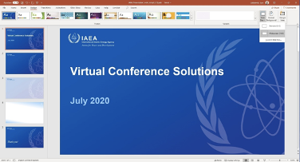
- Record your presentation using the Slide Show Function:
· Follow the guide in Annex 1 for preparing and setting up your computer and camera
· Open your presentation
· Select Slide Show
· Select Record Slide Show
· Select Record from Beginning
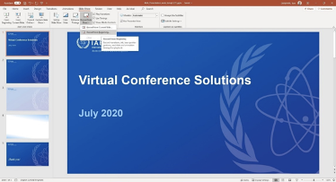

- Recording your video presentation:
· After following the above steps, you will be taken to a presenter screen
· You will see the video projected on the bottom right corner of the slides

Navigating the presenter screen

· Along the top of screen, you will see from left to right:
- Record button – press to start the recording
- Stop button – press to stop the recording
- Replay button – press to replay the recording
- Notes dropdown – you can view your presenter notes here
- Clear recording button – you can clear the recording here should you not be satisfied
- Settings button – Here you can access your microphone and camera settings

· Along the bottom of the slides, you will see from left to right:
- Eraser – To remove anything drawn in real time on the slides
- Pen and Highlighter - You can use the two pens as a pointer or to draw on the slides in real time
- Colour Selection - You can use the colour pad to select the colour of the pen
- Microphone Button – You can mute your microphone by pressing this button
- Camera Button – You can switch off your camera at any time by pressing this button
- Camera Preview Button – You can switch of the camera preview at any time by pressing this button
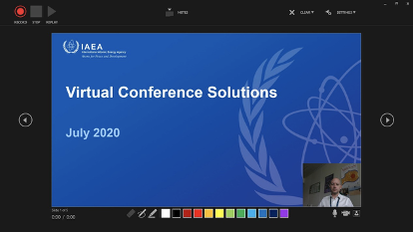

Recording your presentation
· To begin recording your presentation press the record button on the top left corner
· The presenter screen will countdown from 3 seconds and then begin to record
· Record your presentation moving through your slides one at a time
· Once you have finished press the stop button on the top left corner
· You can preview your presentation by pressing the replay button on the top left corner
· Once you are satisfied with the recording close the presenter screen, you will return to the main PowerPoint screen and the recording will be automatically inserted into the slides

- Exporting your pre-recorded video presentation as an MPEG-4 Video (*.mp4) file:
· Go to the File tab
· On the left side of the screen select Export
· Then select Create a Video

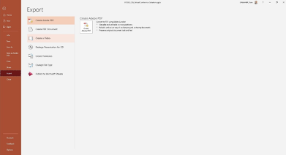

· The file should be saved as Full HD 1080x1920 Pixels or at the least 720p / maximum 1080p
· Keep selected Use Recorded Timings and Narrations
· Press Create Video

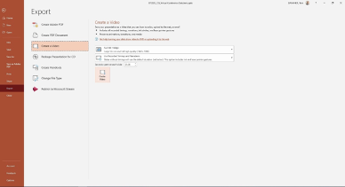

· A Save As dialogue box will appear
· Choose the location where you would like to save the recording
· Ensure the Save as type is MPEG-4 Video (*.mp4)
· Press the Save button to save the file (it will take a few minutes to export the video)
· The file is ready to be previewed and then forwarded to the IAEA via OneDrive or Dropbox

